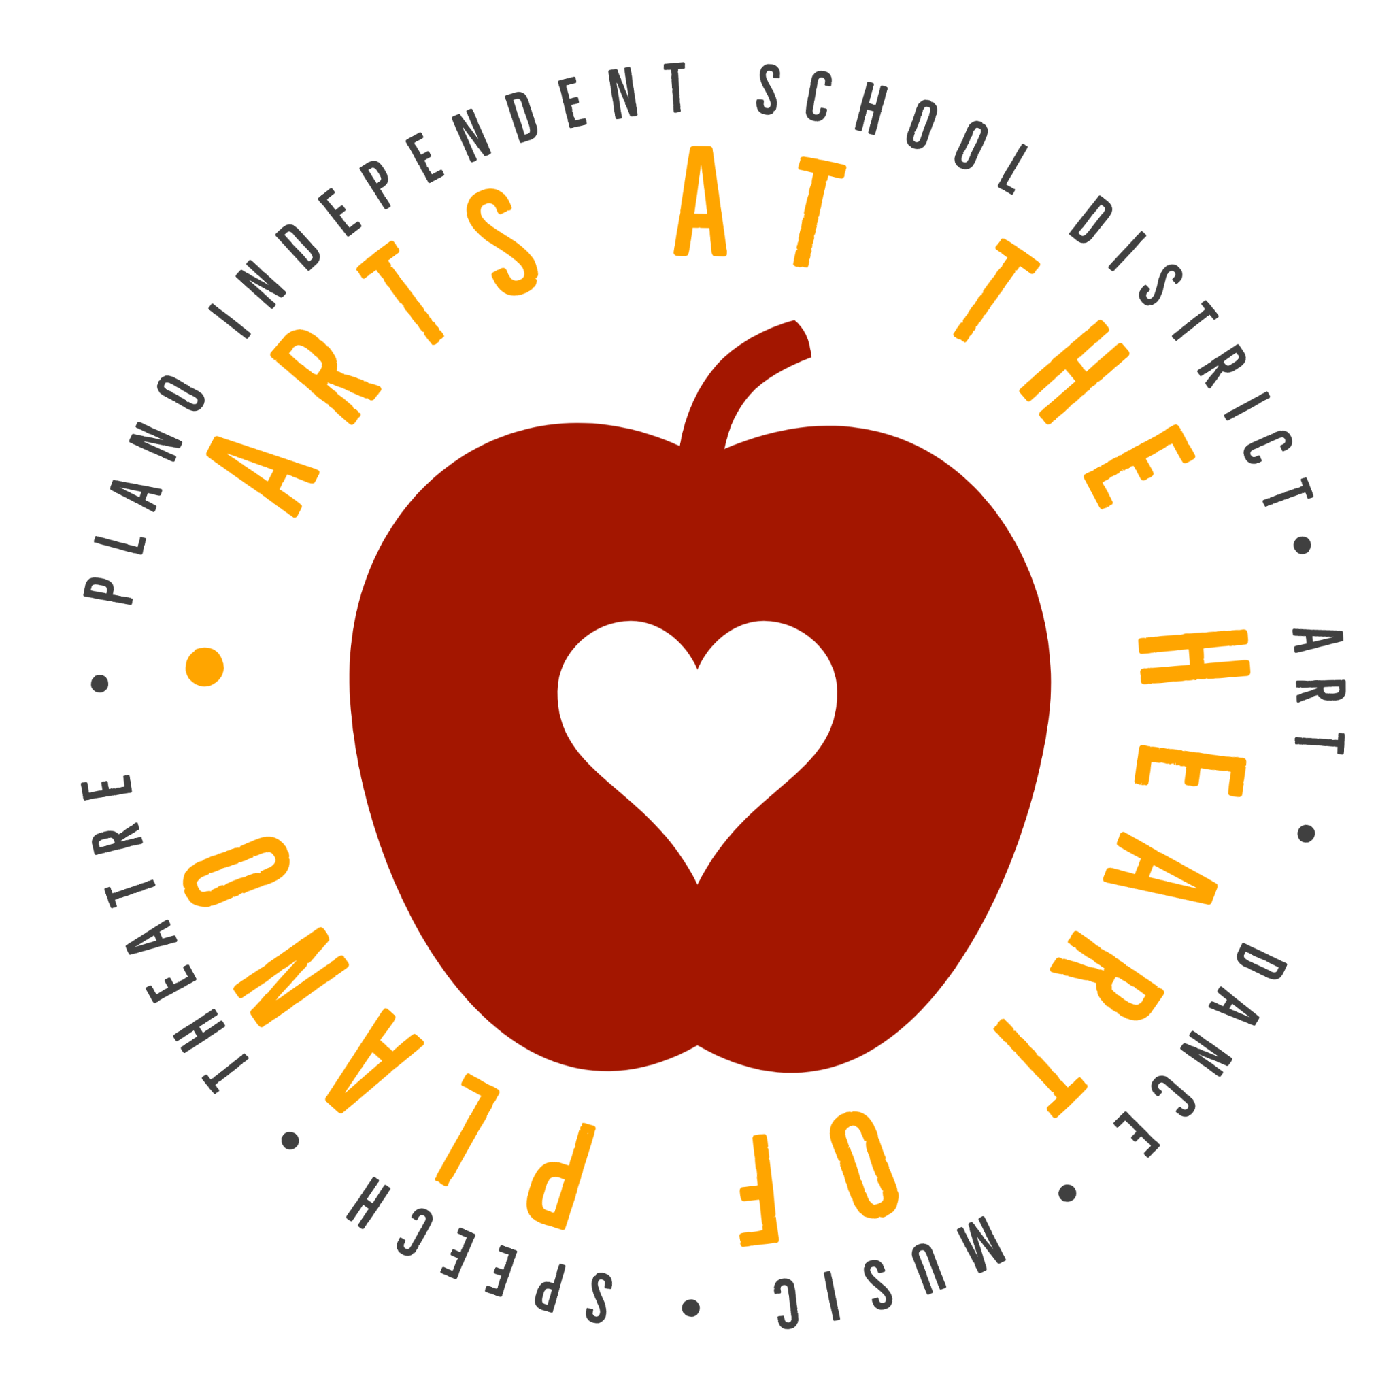
Supporting Your Student Artist in Plano ISD

Take your children to art exhibits.
- Public art in Plano
- The ArtCentre of Plano
- Dallas Museum of Art
- Nasher Sculpture Center
- SMU Meadows Museum

Talk with your student about the art.
When looking at works of art such as a painting, drawing, or sculpture ask your student to:
- Describe what they see: colors, shapes, patterns, lines, people, objects, the setting, etc.
- Describe how the work of art makes them feel: what about the art makes them feel that way?
- Describe the mood of the work of art: what about the art sets that mood?
- Describe the art’s setting: time of year, time of day, period of time. How can they tell?
- Consider what questions they have about the work of art: what do they wonder about when looking at the art? Then, discuss together.

Be an enthusiastic audience for your child’s artistic efforts.
- Try to have a ready supply of basic art supplies at home.
  - Drawing paper/sketchbook
  - Pencils and colored pencils
  - Scissors
  - Glue
  - Watercolors
- Hang your student’s art in your home.
- Take pictures of all your student’s art and keep a digital portfolio of it so you can see their artistic development over the years.

Encourage your child to participate in arts activities at school.
- Take art courses! Check out the middle school and high school course catalogs for full course offerings in Plano ISD.
- Have your student join the art club, National Junior Art Society, or National Art Society.
- Go see your student’s work on display, open houses, art exhibits, big art day, etc.
- Take your extended family and friends with you to celebrate your child’s accomplishments.
- Encourage your child to participate in a variety of art opportunities offered by your schools. Here are a few examples:
- TEAM - Grades K-5  - Jr. VASE - Grades 6-8  - VASE - Grade 9-12  - Scholastic Arts - Grades 7 -12 | - Plano ISD Kindness Card Contest - Grades K-12  - Plano ISD MLK Diversity Art Contest - Grades K-12  - Toyota Dream Car – Grades 2-10  - PTA Reflections – Grades K-12

Be accepting and encouraging of your child’s artistic efforts.
- For young children, the arts have no right or wrong answers. The arts provide avenues for children to feel positive about themselves as they build creative confidence.
- Ask your student what they created, and have them share the story behind it and the process they used to create it.
- When asked if you like your child’s work, ask instead if he or she likes it.
- Give specific feedback about your student’s art, about what you see, such as lines, shapes, color, patterns, etc.

