Getting Started in Write Source
After installing the WriteSource program from the App Depot, the program will be launched from the Language Arts folder in PISD Apps.

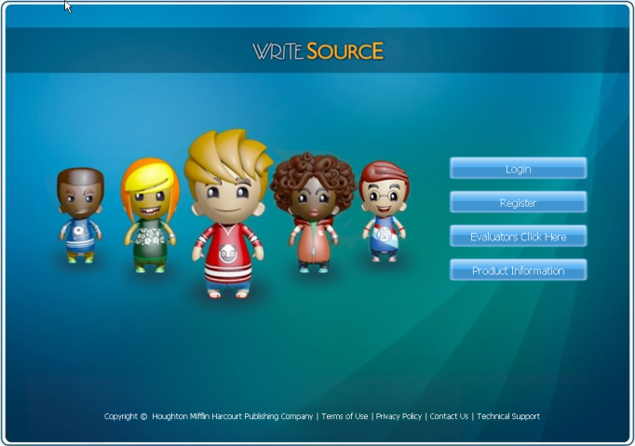
Login
Click the Login button.
Teacher’s Login: PISD email address
Teacher’s Password: employee ID number.
To locate your employee ID number, enter www.pisd.edu/employeeid in your browser’s address bar, and type your Social Security number and birth date in the fields provided.

Adding Students to Your Class
- Click the Manage Class tab at the top of the Dashboard.

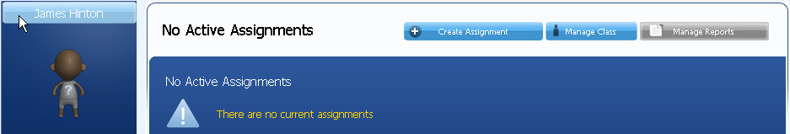
- Click the Students tab from the Class Management Screen.
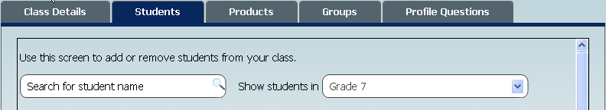

- Select your grade level from the drop-down menu on the right side of the window. Select your students’ names from the list and click the arrow button to move the students from the Available Students box on the left to the Students in Class box on the right. To select more than one student, press and hold the Ctrl key, and then click each name.
Alternatively, you can use the Search for student name field by typing all or part of a student’s name. Click Save and Next when finished.
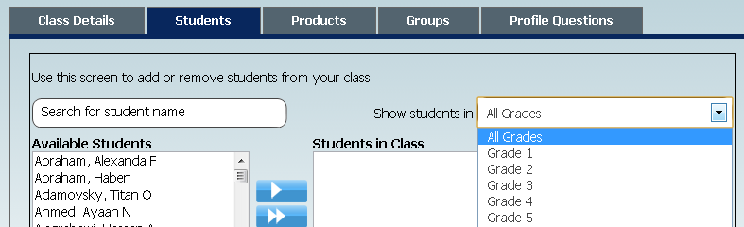
Students may be assigned to only one class at a time.

Because students are uploaded at the district level, never use the Create a New Student Link. Names of new students should be automatically uploaded every few days. If you find that a student who has been at your campus for a week or more does not have access to WriteSource, please email Nancy Watson – nancy.watson@pisd.edu.

Please do not change your or your students’ passwords, even though it may look as though it is possible do so.

For more information about the Write Source program, see http://www.hmhelearning.com/langarts/writesource/na/index.php

Allocating Products to Your Class
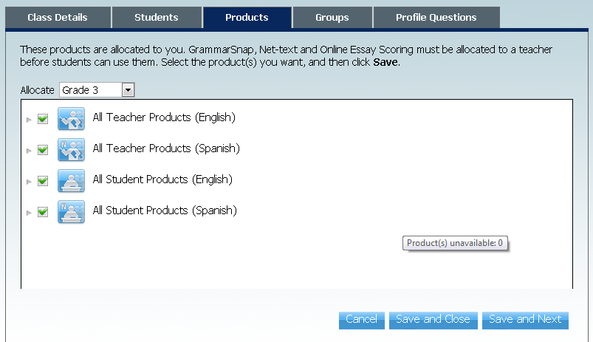
- After you have selected your students, click the Products tab. Check all four available boxes; click Save and Next.

- If desired, you can create groups within your class to facilitate differentiation. Click Add a Group. Give the group a name and move the students (already in your class) to the Group List box. Click Save and Next.
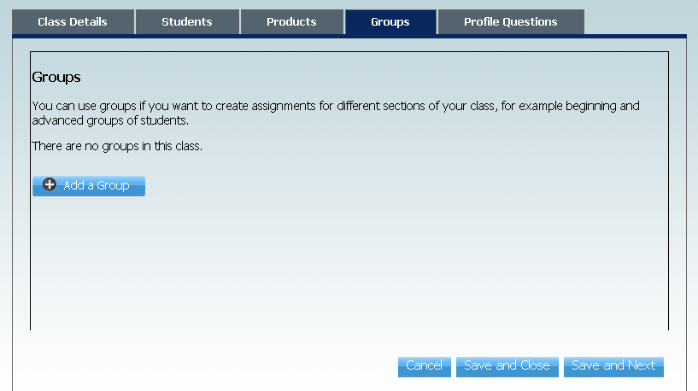

Student Log In
- Install WriteSource from the App Depot and launch from the Language Arts folder in PISD apps.
- Select a state from the dropdown list (first time only).
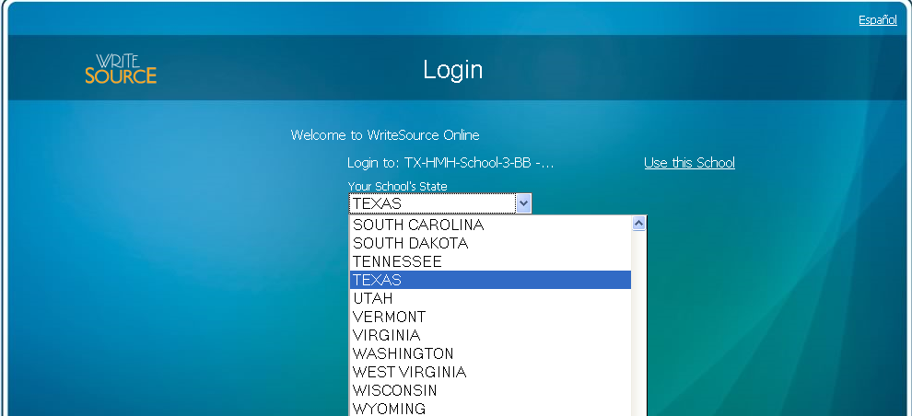
- Enter the school name: (First time only)
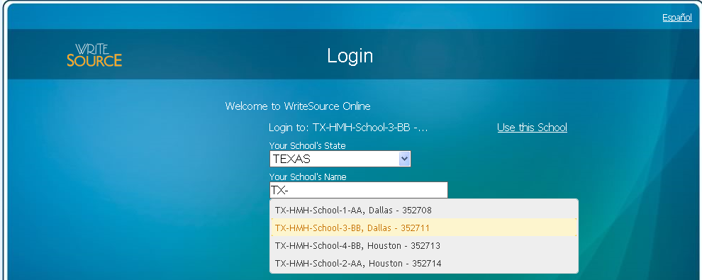
The school list is filtered using predictive text as the student enters characters in the school name field. State and school selections are saved to the computer, so the next time the students log into Write Source from the same computer, they should not have to select a school. (Students could, of course, subsequently log in to a different workstation, but will have to enter school information again.)
Important Note: Locating the correct school name can be tricky for some schools because students have to start typing the entire school name – i.e. Thomas Wesley Andrews or Loreta Hickey. Additionally, some schools from different cities have the same name. It would be VERY possible for a student to select the wrong “Davis Elementary,” for example, because you have to scroll down in the window before the Plano Davis Elementary school appears.
-After selecting the correct school, students log in to WriteSource with their student ID # in both fields.
-Teachers have to add students to a class before students will be able to see anything.
- After the correct school has been selected, the students use their student ID# as both the user name and the password.
For more information about Write Source, see http://www.hmhelearning.com/langarts/writesource/na/index.php

