­­­ 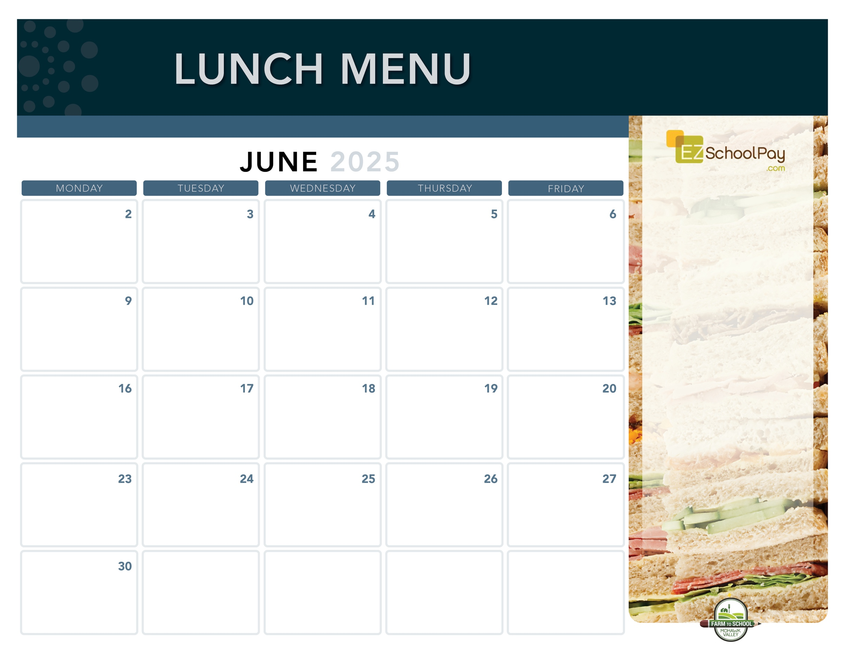

**11:30 Dismissal**

**No Lunch**

**Last Day of School**

**11:30 Dismissal**

**No Lunch**

**No**

**School**

**Crispy Chicken**

**or Chicken Parm Sandwich**

Tuna Salad Sandwich

Broccoli

**Philly**

**Cheesesteak**

Deli Ham Sandwich

Green Beans

**Ham & Cheese**

**on a Pretzel Bun**

Deli Turkey Sandwich

Corn

**Boneless**

**Chicken Bites**

Goldfish Crackers

Tuna Salad Sandwich

Broccoli

**Pizza Party!**

Cheesy Cheese or

Chicken, Bacon & Ranch Pizza

Caesar Salad

**Sauquoit Valley Elementary School**

**Chili**

**with Tortilla Chips**

Deli Turkey Sandwich

Corn

**Pulled Pork Sandwich**

**with Macaroni & Cheese**

Honey Lime Slaw

Mixed Deli Sandwich

**No**

**School**

**11:30 Dismissal**

**No Lunch**

**Available Daily**

Fresh Entree Salads

Party Plates

Peanut Butter & Jelly Sandwich

Fresh Sandwiches

Assorted Fresh Fruit

Vegetable Cruncher Cups

Variety of Fresh Fruit & Juice

Ice Cold New York State Milk

Plain or Chocolate

**Local Items this Month**

Milk, Yogurt, Corn, Carrots, Green Beans, Miss Mila’s Cookie

Local items are indicated with a star on the menu

OHM BOCES Food Service is an Equal Opportunity Employer.

**Pizza Party!**

Cheesy Cheese or

Sausage Pizza

Green Salad

**Utica’s Famous**

**Chicken Riggies**

Deli Ham Sandwich

Green Beans

**Homestyle**

**or Garlic Pam**

**Chicken Tenders**

Buttered Noodles

Tuna Salad Sandwich

Broccoli

**Backyard BBQ**

Hamburger or Cheeseburger

Mixed Deli Sandwich

Tater Tots

Oreo Whip

**Max Pizza Sticks**

**with Dipping Sauce**

Deli Ham Sandwich

Green Beans

**Taco Tuesday**

Beef Tacos

Lettuce, Tomato & Cheese Cup

Deli Turkey Sandwich

Street Corn Salad

**Crispy Chicken**

**Sandwich**

Tuna Salad Sandwich

Broccoli

**Pizza Party!**

Cheesy Cheese or

Garlic Pizza

Green Salad

**Juneteenth –**

**No School**

Lunch is Free | Menu is subject to change | For more information, contact hdussault@oneida-boces.org