­­­ 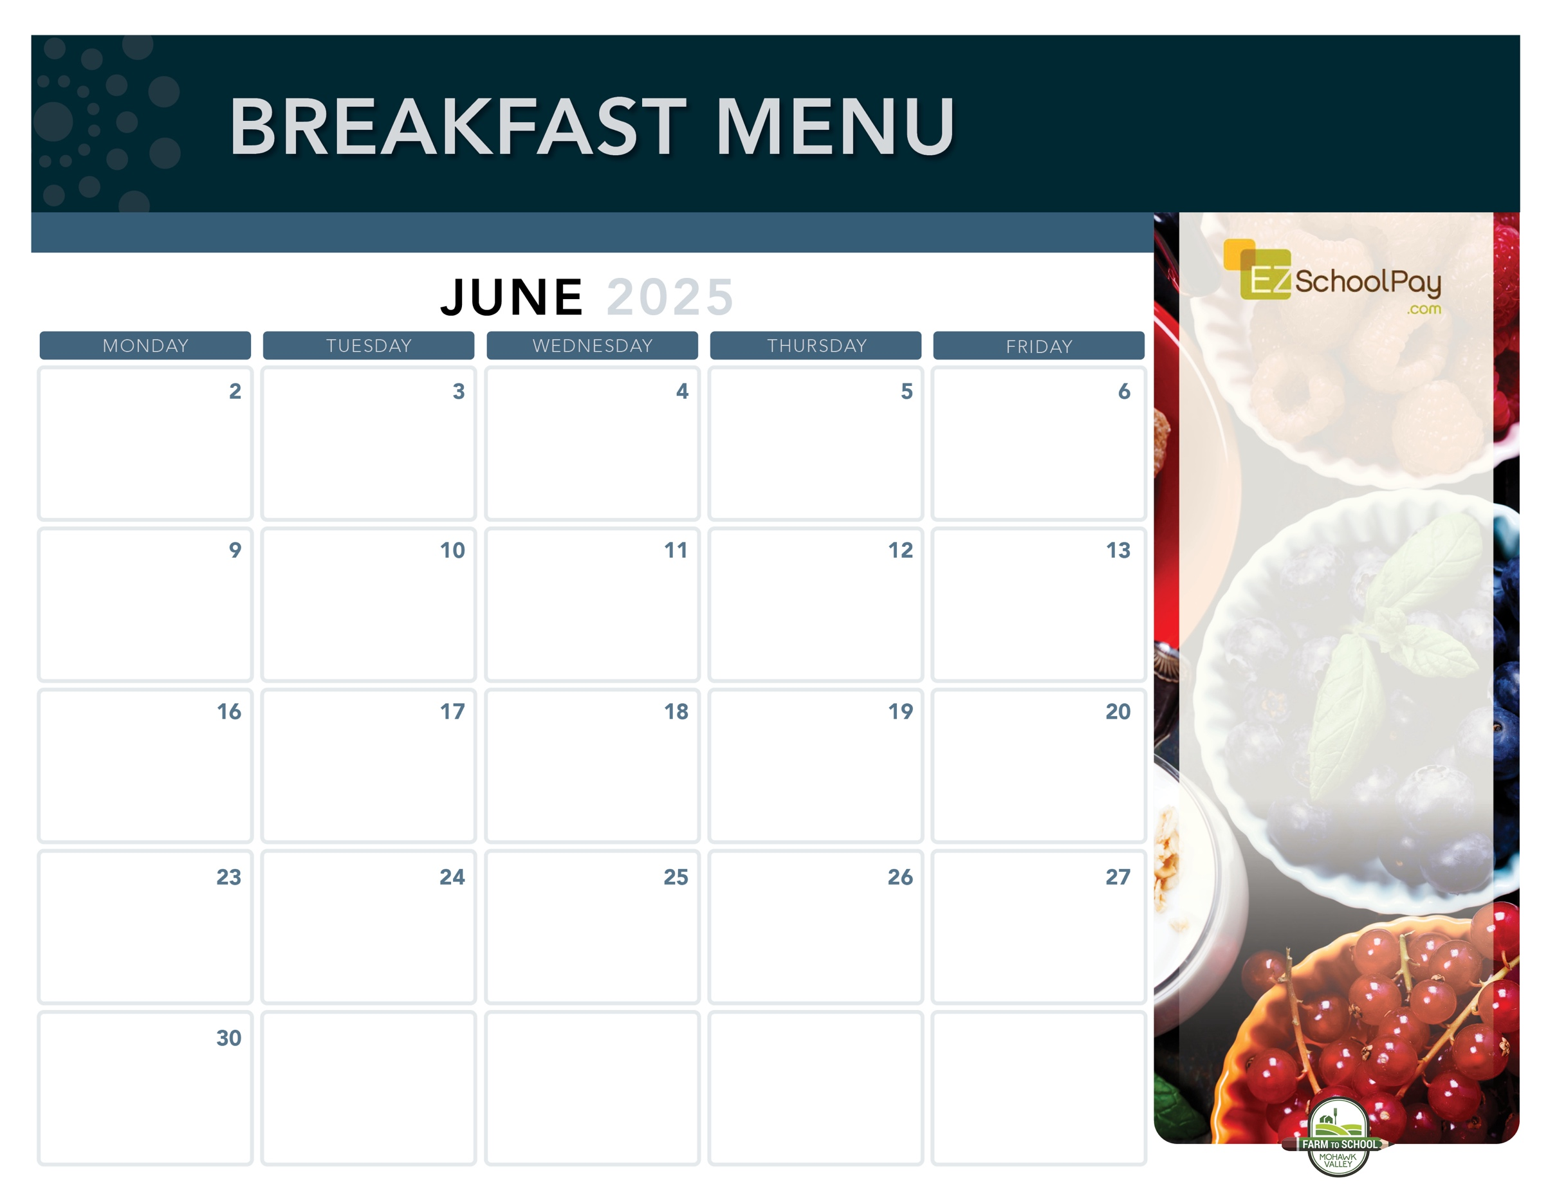

Assorted

Breakfast Items

**11:30 Dismissal**

**Last Day of School**

Assorted

Breakfast Items

**11:30 Dismissal**

Assorted

Breakfast Items

**11:30 Dismissal**

**No**

**School**

Pancake

Sausage Stick

Berry

Smoothie

**Sauquoit Valley Elementary School**

Assorted Whole

Grain Muffins

& Yogurt

**Junetheenth –**

**No School**

Snackin’

Waffle

**Available Daily**

-Yogurt

-Assorted Whole

Grain Cereals

-Fresh Fruit

-Chilled Fruit Juice

-Ice-Cold New

York State Milk

Plain or Chocolate

OHM BOCES Food Service is an Equal Opportunity Employer.

**No**

**School**

Mini

Cinni

Breakfast

Sandwich

Whole Grain Bagel

with Cream Cheese

Scrambled Eggs &   
Whole Grain Toast

Nature Valley

Oatmeal Round

Whole Grain

Pancakes

Assorted

Breakfast Items

Fruit

Frudel

Berry

Smoothie

Snackin’

Waffle

Good

Morning Wrap

Breakfast is Free | Menu is subject to change | For more information, contact hdussault@oneida-boces.org