Scene-Plotter
Step 1: Use index cards, a piece of paper, a blank Word doc., or below. Close your eyes and picture possible scenes of your story. Jot each different scene idea.

Step 2: Organize the scenes into three piles: BEGINNING, MIDDLE, and END, based on where they will occur in the story.
BEGINNING | MIDDLE | END

Step 3:
Create a timeline, plot diagram, or numbered list of your scenes in order.
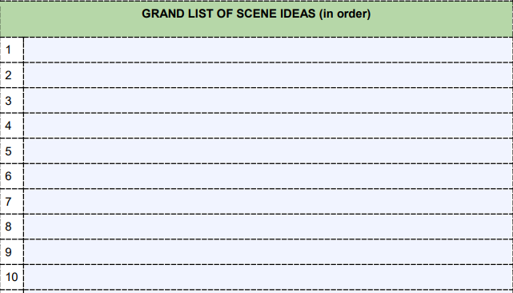

Step 4: GET TO WORK DRAFTING!!!

