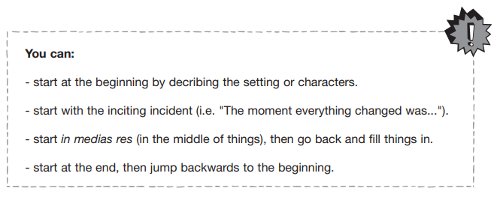
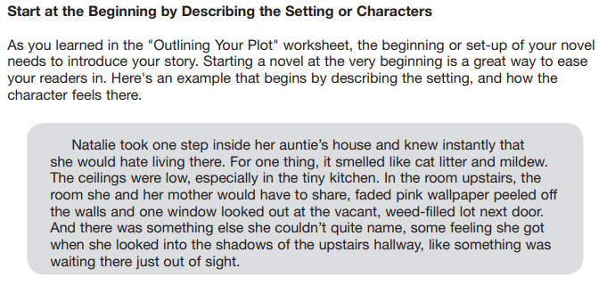
Give it a Try!
________________________________________________________________________________________________________________________________________________________________________________________________________________________________________________________________________________________________________________________________________________________________________________________________________________________________________________________________________________________________________________________________________________
__________________________________________________________________

