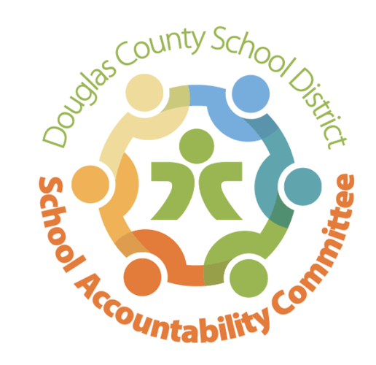2024-2025

Ranch View Middle School

School Accountability Committee (SAC)

**Agenda for meeting on:**

Date: 5/12/25

Time: 4:15-5:15

Location: RVMS Library

**Meeting Logistics:** Erin Turley (3 minutes)

* Introductions
* Quorum

**Celebrations & School-Wide Past Happenings:** Erin Kyllo (10 minutes)

* John Irwin Award, School of Excellence
* Recap of the 1st Annual RVMS Career Day
* Recap of Grizzly Gives Week
* Recap of CMAS Testing (opt out numbers, etc.)
* Recap of iReady Testing
* Pod Wars update
* Staff Appreciation (May 5-9)
* Choir performed our National Anthem at the Rockies game (May 10)
* 8th Grade Moving Up Ceremony: May 9

**New Business:** Erin Kyllo (40 minutes)

* Parent survey - coming
* SAC Elections (?Vice Chair)
* Updates on the upcoming 2025/2026 School Year
  + Staffing Update
  + 6th grade transition ideas
* School-wide Happenings:
  + Honor Roll Assembly: May 7 & 8
  + Choir, Band, Orchestra Concert: May 13
  + 8th Grade Science Fair: May 14
  + Yearbook Distribution: May 15
  + Park Day: May 21
  + Battle to the Pods & 8th Grade Color Run: May 22
  + Last day of School: May 23
  + NY/DC Trip: May 25-30
  + International Trip to Greece: June 3-11

**Standing Reports:** (20 minutes)

* Teacher Report: Craig Moody
* DAC (District Accountability Committee): Kate Welsh
* PIT Crew (Parent Teacher Organization) Report: Lyndsi Kocher
* Community Report: Jenny Parks
* Principal’s Wrap-Up: Erin Kyllo

**Open forum for guests:**  (5 minutes)

* Community Members (3 min. max)

**Next SAC Meeting: 2025/2026 SAC Meeting Dates TBA**