RIALTO UNIFIED SCHOOL DISTRICT

LIDA M. HENRY ELEMENTARY MEDIA, VISUAL & PERFORMING ARTS SCHOOL

PARENT-STUDENT
HANDBOOK

2024 - 2025

470 East Etiwanda Avenue
Rialto, CA 92376
(909) 820-7909

Dr. Natasha Jones Mr. Solomon Barber
Principal Program Specialist
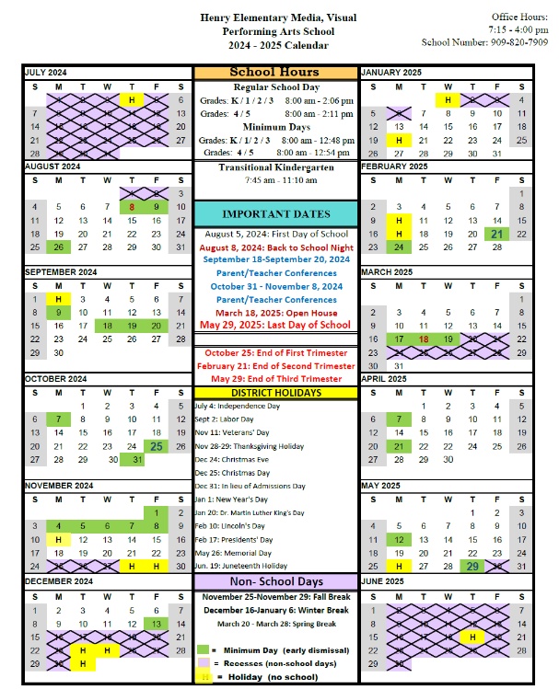
Table of Contents

Principal’s Welcome Letter Pg. 4
Henry Elementary Mission Statement Pg. 5
Student Wellness Policy Pg. 6-7
Staff Information Pg. 8
School’s Information Pg. 9-14
Heath Office Procedures Policy Pg. 15
Trimester Awards Policy Pg. 16
Emergency Procedures Pg. 17
Student Code of Conduct Pg. 18-26
Environmental Safety Policy Pg. 26
Student Discipline – Education Code Pg. 27-33
Dress Code Policy Pg. 34
Henry Elementary House Participation Pg. 35-39
PBIS Expectations Pg. 40-47
Bullying Complaints & Procedures Pg. 48-49
Safety Services Memorandum Pg. 50
Cell Phone Policy Pg. 51
Title 1 Engagement Policy Pg. 52

Welcome to the 2024-2025 school year!
We are set for the most exciting year yet at Henry. We are now Henry, Media, Visual & Performing Arts School. This year, Henry will have its first media team consisting of fourth and fifth grade students. They will be sharing the latest school news and events with our students and staff and actively delivering information to our families through our social media outlets. While I know you appreciate hearing from me as the Principal, I believe you will enjoy hearing from our students even more.
Henry will also be integrating visual and performing arts further into our classroom learning. As our students read engaging books and write, these experiences will also connect to painting, drawing, creating, and performing arts opportunities. I hope this new beginning excites you as much as it does us. Henry Day will be every Thursday, and we encourage our students to wear their new Henry shirts. If you have not purchased one yet, they are available at our online spirit store, linked in our Instagram bio, posts, and on our website.
Our theme this year is “The Start of a New Beginning.” We will be writing new chapters for Henry, promising to motivate our students towards their greatest successes. Our Henry Houses now focus on Media and Visual and Performing Arts. All of our students and staff are part of a house: Allegro—the House of Music, Creare—the House of Performing Arts, Illuminatio—the House of Art, and Relevé—the House of Dance. We will gather on the blacktop weekly in houses to chant and celebrate our teams. Families are encouraged to join us and even purchase a house shirt to get involved. House lunch will take place every Friday, providing students the opportunity to sit with peers from their house, fostering new friendships. Henry house shirts are available for purchase. If you need your child’s house information, please contact the office at (909) 820-7909. Our teachers can also provide that information to you.
We recognize that these efforts are most effective with our families' support. I encourage you to become a volunteer at Henry and get more involved. Our PTA is already planning meetings, fundraisers, and events for the year. Additionally, we have a School Site Council and an English Language Advisory Council. These parent committees meet on the third Tuesday and Wednesday of the month at 8:30. They provide feedback on events, resources, and contribute to decisions on school planning and funding. Henry has a place for all students and families! I hope you will join us in our celebrations throughout the year. We have many successes to come! Please feel free to contact me with any questions at the Henry office (909) 820-7909.

Sincerely,
Dr. Natasha Jones Principal

RIALTO UNIFIED SCHOOL DISTRICT

Lida M. Henry
ELEMENTARY MEDIA, VISUAL & PERFORMING ARTS SCHOOL
“Henry Hawks”

470 E. Etiwanda Ave.
Rialto, CA 92376
(909) 820-7909
________________________________________________

MISSION STATEMENT

At Henry Elementary, Media & Visual Arts Academy, our goal is to ignite academic, social, and emotional growth through the enriching influence of theater. We strive to foster success in a lively, inclusive, and dynamic setting.

- Striving for excellence and achieving high standards
- Fostering a culturally diverse and captivating learning atmosphere
- Promoting both academic and personal triumphs
- Staff dedicated to inspiring a lifelong passion for learning
- Building a lasting connection that strengthens the community
- Encouraging students to embrace local and global responsibilities.

At Henry Elementary, Media & Visual Arts Academy, our mission is to ignite academic, social, and emotional growth through the transformative power of theater. We aim to nurture success in a vibrant, welcoming, and dynamic environment by:
- Striving for excellence and setting high standards
- Cultivating a culturally diverse and engaging learning atmosphere
- Promoting both academic and personal achievements
- Inspiring a lifelong love of learning through dedicated staff
- Building lasting connections that strengthen our community
- Encouraging students to embrace local and global responsibilities

Office Staff
Dr. Natasha Jones , Principal
Mr. Solomon Barber, Program Specialist

School Office Hours: 7:15 a.m. - 4:00 p.m. Monday through Friday

School Secretary: Rocio Espinoza
Clerk Typist II: Violet Borrego
Health Clerk: Maria Sierra
School Nurse: Cynthia Nwadike

Student Wellness Policy

All parents are invited to participate in the Rialto Unified School District Wellness Council. All parents may obtain information regarding the Wellness Council and how they may participate via the District Webpage, Annual Parent Notification, School Parent/Student Handbook, etc.
The District will use electronic mechanisms, such as email or displaying notices on the district’s website, as well as non-electronic mechanisms, such as newsletters, presentations, or distributing other correspondence, to ensure that parents/students, representatives of the school food authority, teachers of physical education, school health professionals, the school board, school administrators, and the general public are actively notified of and provided an opportunity to participate in the development, implementation, and periodic review and update of the local school wellness policy.

If you are interested in participating on the RUSD Wellness Council, please contact Student Services at 909-873-4336 extension 2371.

Mission
The educational mission is to improve the health of the school community by creating a variety of educational opportunities to establish life-long healthy eating habits and physical activity. The mission shall be accompanied by serving nutritious foods on District property, providing nutrition education to promote a healthy lifestyle and promoting physical activity.

Responsibilities
The Rialto Unified School District Board of Education recognizes the important connection between a healthy diet and a student’s ability to learn effectively to meet high achievement standards in school. The Board also recognizes the school’s responsibility in creating an environment that fosters healthy nutrition and physical activity.

Nutrition Education
- Nutrition education that is ethnically appropriate will be integrated into other areas of the curriculum such as math, science, language arts and Social Studies.
- The staff responsible for nutrition education will have the opportunity to participate regularly in professional development activities to deliver an effective nutrition education program as planned.
- Nutrition education curriculum will meet the standards set by the Health and P.E. Framework.
- Nutrition education will involve sharing information with families and broader community to impact students and the health of the community positively, including sharing information on the District website.
- School District will provide health information to families to encourage them to teach their children about nutrition.

Physical Education
- Physical activity will be integrated across curricula and throughout the day. Physical movement can be made a part of science, math, Social Studies and Language Arts.
- Physical Education courses will promote an environment where students learn, practice, and are assessed on developmentally appropriate motor skills, social skills, and knowledge of nutrition and health.
- Time allotted for physical activity will be consistent with State Standards.
- A daily recess period will be provided in grades P-5.
- Physical Education includes the instruction of individual activities as well as competitive and non-competitive team sports to encourage life-long physical activity.
- Equipment is available for all students to participate in Physical Education. Facilities on school grounds will be safe and well maintained.
- The school provides a physical and social environment that encourages safe and enjoyable activities for all students, including those who are not athletically gifted and/or interested in athletics.
- Students will work toward performing within their “fitness zone” in order to achieve and maintain physical active lifestyles.

Other School Based Activities
- After-school programs will encourage physical activity and healthy habits.
- Support for the health of all students is demonstrated by providing health clinics, health screenings, and help to enroll eligible children in Medi-Cal and other state children’s health insurance programs.
- District will organize a local Wellness Committee composed of families, teachers, support staff, administrators and students plan, implement, and improve nutrition and physical activity in the school environment.
- The Nutrition Services Department will work with the Student Advisory Committees to open a line of communication regarding healthy eating.

Nutrition Guidelines for All Foods on Campus
- All foods and beverages sold or served during school hours shall meet nutritional standards and other guidelines set by the Federal and State Government and the School Board.
- Nutrition Services will take every measure to ensure that student access to foods and beverages meets federal, state, and local laws and guidelines. Nutrition Services will offer a variety of age appropriate healthy food and beverage selections for elementary schools, middle schools, and high schools.
- Food items served and sold shall reflect the cultural diversity of the student body.
- Nutritious and appealing foods such as fruits, vegetables, and whole grain products shall be available during the school day.
- Nutrition information for products offered in snack bars, a la carte, and vending machines is readily available.
- The sale of soft drinks, candy, and any non-compliant food items are not allowed from midnight to 30 minutes after school.
- Nutrition education is encouraged during classroom snack times, not just during meals.
- Advertising of foods or beverages must be consistent with the established nutrition environment standards.
- All food and beverage items sold or given away by school organizations must have prior School Board approval.

Eating Environment
- All schools will foster an environment that allows adequate time for eating while promoting positive behavior, good manners and respect for fellow students.
- All personnel will adhere to the District’s Customer Care Promise to interact in a courteous, caring and positive manner that ensures all people will be treated with dignity and respect.
- Lunch periods are scheduled as near the middle of the school day as possible.
- Cafeterias include enough serving areas so that students do not have to spend too much time waiting in line.
- Drinking water is available for students at meals.

Child Nutrition Operations
- The Nutrition Services Program will ensure that all students have affordable access to the varied and nutritious foods they need to stay healthy and become life-long learners.
- The school will strive to increase participation in the available Federal Child Nutrition Programs (e.g. school lunch, school breakfast, after-school snack.)
- Students are encouraged to start each day with a healthy breakfast. Breakfast programs will be offered at all schools. Pilot programs such as breakfast during testing and universal free breakfast in the classroom may be offered as funding allows.

Food Safety/Food Security
- All foods made available on campus comply with the State and local food safety and sanitation regulations. Plans and guidelines of the Hazard Analysis and Critical Control Points (HACCP) are implemented to prevent food illness in schools.
- For the safety and security of the food and facility, access to the food service operations is limited to Nutrition Services staff and other authorized personnel.

Annual Review
- The Wellness Committee shall evaluate the established District-wide Wellness Policy and report the findings annually to the Superintendent.
- The District will revise and update the Wellness Policy as needed.

This institution is an equal opportunity provider. Revised/Approved 1.19.18

Lida M. Henry Elementary Media, Visual & Performing Arts School

STAFF ROSTER 2024 – 2025
Administrators & Classified Personnel

Dr. Natasha Jones Principal
Solomon Barber Program Specialist
Rocio Espinoza Secretary
Violet Borrego Clerk Typist
Ana Zarate Lopez Categorical Project Clerk
Maria Sierra Health Clerk
Jose Gonzalez AM Custodian
Edward Robinson PM Custodian
Mark Blackmon PM Split Custodian
TBA Psychologist
Brittney Brown Speech Teacher
Cynthia Nwadike School Nurse
Dana Husbands Library Technician
TBA Instructional Technology Assistant

Teachers:

Name | Grade |  | Name | Grade
Mary (Katy) Moetell | TK |  | Julie Ruffin | 3rd
Zulema Gandy | K |  | Esmeralda Garnica | 3rd
Pamela Jones | K |  | Lisa Edwards | 3rd
Sergio Infante | 1st |  | Joseph Alvarez | 4th
Gina Hall | 1st |  | Raymond Rubalcava | 4th
 |  |  | Keith Shattuck | 4th
Mercedes Perez | 2nd
Lourdes Ortiz-Nunez | 2nd |  | Andre Marshall | 5th
 |  |  | Delicia Shattuck | 5th
Lisa Lane | SDC 1/2/3 |  | TBA | VAPA
Layla Cherradi | SDC 3/4/5 |  | Merrilee Taylor | VAPA
Cherylnn Turan | RSP
 |  |  | Xiomara Reyes | Instructional Strategist
 |  |  | Trina Olson | Reading Specialist
 |  |  | Sonna Umeojiako-Udealor | Reading Specialist

LIDA M. HENRY ELEMENTARY MEDIA, VISUAL & PERFORMING ARTS SCHOOL

OFFICE HOURS:
7:15 AM – 4:00 PM Monday through Friday; except holidays.

SCHOOL HOURS:
Students (TK & Kindergarten & grades 1-5) may arrive on campus after 7:15 A.M. and enter the cafeteria.

SCHOOL DISMISSAL: On Regular School Days, Grades Kinder - 3 dismiss at 2:06 P.M., Grades 4 - 5 dismiss at 2:11 P.M. On Minimum Days, grades K-3 will be dismissed at 12:48 P.M. and grades 4-5 will dismissed at 12:54 PM TK IS NOT AFFECTED BY THE MINIMUM DAY SCHEDULE.

CONTACTING YOUR CHILD DURING SCHOOL HOURS
and STUDENT TELEPHONE USE: If you have homework, lunch, money, jackets, etc. to be delivered to your child after school has started, please leave these items in the office. Telephone calls are not transferred to the classroom during instruction. Please note: The office telephone is for business use and emergency situations only.

IMPORTANT PARKING LOT SAFETY PROCEDURES:
- Entering Campus – Respect the red-curb Fire Lane by not parking in the Red Zone. In order to ensure that all emergency vehicles will have immediate access to Henry School in case of an emergency, we need your support to ensure that cars no longer utilize areas that are not designated for parking, even for quick visits to the office or to pick up/drop off anyone. Violators are subject to penal code citations.

- If you walk your child to the gate, you may park in a designated parking space or find a parking space on any surrounding street.

- Anyone parking in a designated disabled space must display their disabled person placard from the Department of Motor Vehicles. Do not leave children unattended in cars, double park, or park behind cars already parked in designated parking spaces.

- Students are required to cross the street at any designated crosswalk.

- School personnel will not allow students to cross the parking lot or street without an adult escort.
All students who are walkers or bike riders will enter through the Etiwanda Street gate. Bike riders must wear required safety gear. All car riders may choose to drop-off students at the Etiwanda Gate or park in a designated parking space in the Henry School parking lot. Students who arrive on campus after the tardy bell rings at 8:00 a.m. are considered tardy and will need a tardy pass from the office.

AFTER-SCHOOL STUDENT PICK-UP:
All students in grades 1-5 who are walkers or car riders are to exit from the Etiwanda Street gate. Daily arrangements need to be made for each child to be picked up on time. Parents may park along Etiwanda Avenue (please do not block driveways or double park). All drivers are responsible for adhering to penal code regulations and are subject to citation if they are found in violation. If you are disabled and have a parking permit, please notify your child’s classroom teacher, and your child will be waiting for you at the bench located between the school office and the front of the school. Supervising personnel will be on duty before and after school at the Etiwanda Avenue gate.

Students must leave campus when school is dismissed, unless other arrangements have been made in writing between the parent and teacher or the student is registered to attend the Think Together Afterschool Program. Supervision is not available for students after school. Students are expected to go directly home at dismissal.

BUS RIDERS:
In order to ensure safety of all students, buses will utilize the main parking lot for after school pick up unless you have a disabled person parking permit and notify the classroom teacher to make sure that your child waits at the bench located between the office and the
D-wing.

All bus riders in grades 1-5 are supervised and will line up in the hallway designated for their assigned bus route. All children will line up in a single file line while waiting for their bus to arrive. We are not able to hold the buses in order to find a student on the bus.

Due to the distance involved with bus transportation, it can take up to 30 minutes for students to be dropped off at their designated stop. If your child is not home within a reasonable amount of time, please call the school office. If the child is not at school, please check with friends or neighbors. If you still do not have any results, you may want to call the appropriate authorities. If you find your child, please call the school. Otherwise, we will continue our search.

BUS TRANSPORTATION: School District guidelines state that bus transportation will be provided for kindergarten students living more than one mile from school and students in grades 1-5 living more than one and a half (1 1/2) miles from school. Bus riders are to ride their designated bus only. All students must have a bus pass to ride to and from school. Kindergarten students are only released to adults (18 and over), or they will be returned to the school.

The responsibility for discipline on the school bus rests primarily with the bus driver. It is our wish to make sure that your child is transported safely to and from school. The rules for bus riding are as follows:

- Students shall be seated safely after boarding the bus and must remain seated while the bus is in motion. The driver may move students from one seat to another as his/her judgement dictates for safety purposes.

- Safe and respectful behavior is required at all bus stops and while loading or unloading.

- All parts of the students must be completely inside the bus at all times, including hair and clothing.

- Vulgar and offensive language is not permitted.

- Students crossing the street after unloading the bus must follow the procedures and cross safely with an adult.

- Unauthorized student riders are not permitted to ride the bus.

ATTENDANCE: Consistent and on time attendance is necessary for students to make academic progress.
Perfect Attendance Breakfast: We are offering a perfect attendance pancake breakfast for our students at the beginning of the month. With our first reward in September. Perfect attendance is define as no absences, tardies, or early release days within each month.
Absence Procedures: We realize from time to time children become ill. When your child is absent from school, please send a note the day he/she returns to school giving the child’s full name, days absent, reason for absence and the teacher’s name or call the school office at 909-820-7909.
Please make an effort to schedule medical and dental appointments after school or during vacation breaks. If your child must be absent for an appointment, please bring him/her to school for the remaining portion of the day. If your child is going to be absent for unavoidable reasons for 5 days or more, please request an independent study contract. Contracts must be signed by the teacher, parent, student, and approved by administration at least one week prior to your child’s absence. Notification shorter than one week may result in denial of independent study, possibly causing your child to be dropped from school and you must re-enroll your child. Full day absences can be recovered through the Saturday Step-Up Program.

INDEPENDENT STUDY CONTRACT:
If you are planning to take your child out of school for 5 days or more, please contact your child’s teacher and the school office in advance and request an Independent Study Contract. If your child is ill for an extended time, please contact the office, due to the fact that they may be eligible for home hospital services. All Independent Study Contracts must be approved prior to the requested date of leave and approved/signed by the classroom teacher, parent, student, and administrator. Upon approval, the teacher must have a minimum of three days in order to prepare student assignments. Approved contracts must be returned by the agreed upon date or the work will not be accepted. The student’s absences will remain unexcused. The amount of credit given for work returned will be at the discretion of the teacher, and it could be less than the number of approved contract days. If the student does not return by the agreed upon date, they may be dropped from the school roster and will require the student to be re-enrolled.

EARLY RELEASE OF STUDENTS: If you need to take your child out of school during the school day, please go to the school office to sign your child out of school. If your child returns to school that same day, please sign him/her back in. Photo identification is required for a student to be released to an authorized adult. Parent/guardians or persons authorized on the emergency card must come into the office to sign out the student. No student without your consent will be released to anyone not on the emergency card or disaster card. Please keep the information on the emergency card current. If you make ANY change in your child’s normal routine, please send a note with your child to give to your child’s teacher when he/she comes to school that morning.

TARDY POLICY: The line-up bell rings at 7:55 a.m. and at 8:00 a.m. students will be escorted from the blacktop to their classrooms by their teacher. Students who arrive on campus after 8:00 are considered tardy and must have a tardy slip from the office or the classroom teacher.

DID YOU KNOW THAT YOUR CHILD IS ALSO A TRUANT WHEN HE/SHE IS LATE?
Education code Section 48260 defines a “truant” as:
“Any pupil subject to compulsory full-time education or to compulsory continuation education who is absent from school without valid excuse more than three days or tardy in excess of 30 minutes on each of more than three days in one school year is a truant…”

Education Code Section 48260.5 states that districts, upon a student’s initial classification as a truant, must notify the student’s parent or guardian (Appendix A), by any reasonable means, of the following:

- That the student is truant.
- That the parent or guardian is obligated to compel the attendance of the student at school.
- That parents or guardians who fail to meet this obligation may be guilty of an infraction and subject to prosecution pursuant to Education Code Section 48290.

EMERGENCY CARDS: A current emergency card will be kept on file for each student enrolled at the school. The information on the card will only be used by school personnel and will not be released to the public. Please keep the school informed of any changes on the emergency card. Any changes need to be made in person, not over the phone. Students will only be released to adults (18 years of age or older) whose names are on the child’s emergency or disaster card. The student Emergency Card will be used in case of a school emergency or natural disaster. Please make sure the card is filled out completely and returned to the school. Students will only be released to adults listed on their Emergency Card.

EMERGENCY PREPAREDNESS: Both fire and disaster drills (earthquake drills) are practiced regularly. A site Disaster Plan is adhered to which is in alignment with the District Disaster Plan. During an actual emergency, no student will be released to anyone without proper identification and who is not on the Emergency Card(s). Please keep current information on the card.

TOBACCO-FREE WORKPLACE: District Policy KGA mandates that effective July 1, 1995, smoking or other use of tobacco products shall be prohibited in all District facilities and vehicles and at all times on District grounds. This applies to all employees, students, visitors, and other persons at any activity, or athletic event on property owned, leased, or rented by or from the District.

CAFETERIA SERVICES: BREAKFAST AND LUNCH PROGRAM
All students enrolled within the Rialto Unified School District qualify to receive free breakfast and lunch through the CEP program. In order to participate, all families must complete the online enrollment verification process. For more information, please contact the school front office. Monthly breakfast and lunch menus will be made available in the front office.

Breakfast is served to students in their classroom starting at 8:00AM. Students are not allowed to bring soda to school or family size bags of chips.

CAFETERIA EXPECTATIONS: Each child eating hot lunch must line up alphabetically within their class and enter in a single-file line. Everyone is expected to be respectful and to pick up their own trash. Students are not permitted to share food with their classmates or peers. According to the State of California Lunch Program only Henry staff members are permitted in the school cafeteria during the school day. Food is not allowed to be taken outside of the school cafeteria per Nutrition Services and State of California regulations.

1. Students wait in line with their classmates.
2. Students will use respectful tones inside.
3. Students will be polite and use table manners.
4. Students will clean their area before being dismissed.
5. Students will raise their hand and show they are ready to line up. Students are to throw trash into the containers, stack trays, and return to their seat.

STUDENT LUNCH DROP OFF:
If you are bringing a lunch for your student, please make sure it is dropped off to the front office by 10:30 A.M. Please be sure your child is aware that you are bringing a lunch so that they can pick it up before their scheduled time.

LOST AND FOUND (located near the cafeteria door): The Lost and Found is located near the school cafeteria. If your child has lost an article of clothing or a lunch box, please have your child check the Lost and Found for the lost item. Please label all articles of clothing, backpacks, and lunch boxes with your child’s name. All unclaimed items will be donated to the Rialto Child Assistance in December and June.

SCHOOL COMMUNICATIONS
Always check with your child to see if there is a notice that has been sent home for parents. These notices may contain important information regarding minimum days, no school, school pictures, special events, etc. The school calendar will list minimum days, conference days, and other important information. Parents of students receiving awards at the trimester awards assemblies will be notified by the teacher. The district’s Blackboard telephone communication system is also utilized when needing to notify parents of additional information.

HOMEWORK:
Your child’s teacher will provide you with their homework procedure for the year. Homework is given with the understanding that it will enhance classroom learning and provide students with reinforcement of material learned in class. Classroom procedures are at the discretion of the teacher.

PARENT PARTICIPATION AND VOLUNTEERS
There is a significant positive impact on student achievement when schools and parents work together. You can become involved in your child’s education in a number of ways, which include:
- Provide a quiet place for your child to complete homework.
- Check your child’s homework.
- Model reading for your child; read all school communications and read daily to your child.
- Take your child to the library.
- Volunteer in the classroom, on study trips, etc.
- Join PTA, School Site Council, English Language Advisory Committee
- Attend school functions: Parent-Teacher Conferences, Back to School Night,
Open House, Awards Assemblies, parent education activities, etc.

WHAT TO DO IF YOUR CHILD IS HAVING A PROBLEM AT SCHOOL: In the event that you develop concerns over a problem occurring at school, please make an appointment to discuss the situation with the classroom teacher. If the problem should continue, please make an appointment or call the principal or assistant principal.

PARENT INVOLVEMENT: We are proud of our school and welcome visitors and parent volunteers to our classrooms. The law now requires all parent volunteers working with students in the classroom to be fingerprinted and pass a TB test. Following this screening, you will be approved to volunteer in the classroom for the current school year. Parents must coordinate with the classroom teacher to schedule a time to volunteer. Please contact the school office for an application, if you are interested in volunteering. All persons wishing to visit a classroom for any reason must sign in at the school office and receive a Visitor’s Pass. If you are planning an unannounced visit, you may observe in the classroom for a maximum of 30 minutes. Longer visits need to be arranged with the teacher at least 24 hours in advance. If a classroom is testing, parents will be asked to either wait or come back at a later time.
PTA (PARENT-TEACHER ASSOCIATION):
All parents are invited to join our PTA. The PTA supports the school by providing various activities which can include study trips, awards, ribbons, trophies, book fairs, classroom libraries, and many other special extras. Please support the school through your PTA membership. Contact your child’s teacher if you are interested in joining the PTA.
PARENT-TEACHER CONFERENCES:
Parents will be asked to attend at least one parent-teacher conference during the school year to discuss their child’s progress. Please make every effort to attend these conferences. Teachers will schedule parent-teacher conferences on minimum days. We encourage you to contact your child’s teacher; call the school at 820-7909 to schedule a parent-teacher conference at any time during the school year.

REPORT CARDS:
Report cards are uploaded to the parent’s, ParentVue account three times a year, once at the end of each trimester. After six weeks of every trimester, progress reports are also uploaded to the parent’s account for students not meeting grade level standards or regarding behavior concerns.

Decisions regarding promotion in grades K-5 are based on meeting expected grade level standards. Student acquisition of grade level standards shall be described using five performance or achievement levels.

HEALTH OFFICE AND MEDICATIONS:
Our school nurse is at Henry Elementary School one day per week and is on call for emergencies. We have a Health Clerk who provides first aid for minor injuries. If your child needs to take medicine during school hours, the following California State Health Department guidelines must be followed:

- Physician’s recommendation for medication must be signed and kept on
file in the school office and resubmitted yearly.
- Only prescription medication can be administered.
- The prescription must be in the child’s name.
- Medicine must be in original container with prescription label attached.

RIALTO UNIFIED SCHOOL DISTRICT
Board of Education

Policy Code: J, H, C, and D 10-24-90 Revised

Date of Adoption: 04-05-78 06-04-97 Revised

STUDENT MEDICATIONS

- Medications will be given to a student only as a result of a written request from a physician and parent/guardian.

- Over-the-counter medications such as aspirin, shall not be administered by school personnel unless there are signed requests from a physician and parent/guardian and medication is in a properly marked container.

- Medical conditions that require frequent monitoring, testing, and treatment may be performed by designated site personnel, licensed nurse or the student depending on the physician’s orders.

- Injections required on an emergency basis will be administered by school staff upon written requests from the parent/guardian and a physician.

- Non-emergency situations requiring an injection will be performed by a licensed nurse upon written request of a physician and parent/guardian.

STUDENT ACCIDENT INSURANCE FORMS: The Rialto Unified School District does not automatically cover medical or dental expenses for a pupil injured at school or in school activities. Special student insurance is available at the beginning of each year and when all new students register; coverage is optional. This optional insurance may cover certain student-related injuries that occur during the school day. Applications for low-cost medical and/or dental insurance are available in the school office. If this is not purchased, parents are responsible for medical costs.

CONTAGIOUS DISEASES: Any contagious diseases must be reported to the school office as soon as known or suspected.

HEAD LICE (PEDICULOSIS): Anytime a child in a classroom is found to have head lice, that child may not return to school until that condition has been cleared through the school health office. The Health Clerk’s hours are from 7:30 a.m. to 2:00 p.m., Monday through Friday.

Henry Trimester Awards

- Trimester 1: Exceptional Attendance and Citizenship Awards

- Exceptional Attendance Awards:
  - Platinum Attendance (0 absences/ tardies/early release trimester 1)
  - Gold Attendance (1 absence/ tardies/early release trimester 1)
  - Silver Attendance (2 absences/ tardies/early release trimester 1)

- Trimester 2 & 3:: Exceptional Attendance, Citizenship Awards, Academic/Celebration of Learning Proficiency (tardies and early release are included with absences)

- Exceptional Attendance Awards:
- Platinum Attendance (0 absences/tardies/early release per trimester)
- Gold Attendance (1 absence/tardies/early release per trimester)
- Silver Attendance (2 absences/tardies/early release per trimester)
- Bronze Attendance (3 absences/tardies/early release per trimester):

(*Step up during the trimester will account for attendance make-up. Students with more than five tardies and/or early release in any trimester will disqualify them for attendance awards. Only certificates will be provided for recognition of attendance each trimester.)

- Citizenship (SEL/PBIS) Awards (one student per class selected by the teacher)
- Officer Hawk: Demonstrates safety and is a model for students.
- Honorable Hawk: Demonstrates responsibility and is a model for students.
- Admirable Hawk: Demonstrates respect and is a model for students.

- Academic Awards:
- Champion Hawk = Proficient in in ELA and/or Math
- Rising Hawk= Approaching Proficient (students receive this award one time for math and reading)
- Aspiring Hawk = Emerging (students receive this award one time for reading and math)

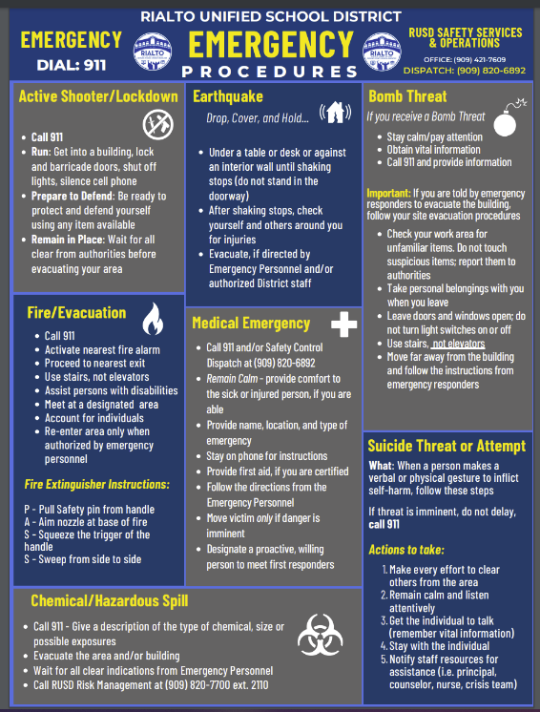

STUDENT CODE OF CONDUCT

SCHOOL SAFETY RULES:
The school rules are included in this packet. Please read and review these rules with your child. All students at Henry Elementary School are expected to behave in a way that is conducive to a safe and orderly learning environment. Each classroom teacher establishes rules and conduct guidelines for their class; however, the school rules are enforced throughout the school by all staff members.
Education Code, Section 85291.5 gives administrators the authority to adopt rules and procedures so that a safe environment may be created for student and staff.

- The first morning bell rings at 7:55 A.M. Students are to be in their classrooms ready to learn at 8:00 A.M. After the 8:00 A.M. bell rings, they are considered tardy.

- Students and adults will respect people and property.

- The use of obscene/vulgar language and gestures are not permitted.

- Fighting, including play fighting is not permitted.

- Students must keep hands, feet, and objects to themselves.

- No personal property is permitted, except for school supplies or by permission from school staff (including make-up).

- Students are to dress according to school dress code. (see Dress Code)

- Students are to maintain proper hygiene: bathe regularly, wear clean clothes, and have
clean hands and hair.

- Students in grades 3-5 may ride bicycles to school. (State law requires the use of a helmet)

- Bikes, Skate boards and scooters must be walked while on campus or held and padlocked in the bike rack.

- Hair may not be sprayed with any color that might attract undue attention and/or cause a distraction to the educational process.

- Make-up is not to be worn at school.

- Fake/acrylic nails are not to be worn at school.

- Each school site allows for outdoor use of articles of sun-protective clothing that meet the following guidelines:

- Hats may be worn during passing periods, lunch time, outdoor assemblies, outdoor Physical Education, and to/from school;
- Sun-protective hats must have brims of one to three inches, all the way around the head. Crowns shall be no more that two inches above the head, made of a soft material and foldable. Hats and tie strings must be white, tan, gray, or black. The hat must be unadorned except with the approved school logo.
- These sun-protective items may not be worn during class time or in school buildings.

GENERAL PLAYGROUND RULES:

- All students are to play in designated areas of playground and field.

- Balls and jump ropes are not permitted on sidewalks.

- Students are not permitted in the areas in front, behind, between portables, or on portable walkways before school, during recess periods, or without teacher permission.

- Students are not to play in restrooms.

- Students are not to play between school buildings.

- Students must have a pass to leave class or designated playground areas.

- The only objects allowed to be thrown are rubber balls. (no rocks, sticks, sand, wood chips, etc.)

- Contact sports are not permitted.

- Playground equipment going over the fence is to be reported to the teacher on duty.

- No running on blacktop, through hall areas, between buildings or on play structure.

11. Kicking of playground balls is permitted on the field only.

- Students are to freeze when the bell rings. When the whistles blows, students must walk
directly to their classroom line.

- No playing or drinks after the bell rings. Balls and other playground equipment must be
held.

- No jumping off or standing on picnic tables and swings.

- No jumping off the play structure.

TOYS/WEAPONS:
Toys are not to be brought to school except with teacher permission. We have found that problems frequently occur and can result in items being lost, stolen, or broken. Toys include but are not limited to: dolls, cars, radios, stuffed animals, electronic pets, sports cards, footballs, electronic games, etc. If toys are brought to school with teacher permission, they are to remain in the classroom and are not to be taken out during recess. If toys or personal items (including cell phones) are lost or stolen, they do not become the responsibility of the school. Cell phones are not to be on during the school day. Students are not to make or receive telephone calls or text messages during the instructional day (including recess).

MENTAL HEALTH SERVICES FOR STUDENTS
As required by Education Code, school districts are required to notify students and parents or guardians of students on how to access available mental health services on campus or in the community. The following information in bold will be printed on the back side of student Identification cards for students in grades 6 through 12.
Crisis Walk-In Clinic, 909-421-9495
850 East Foothill Blvd., Rialto, CA 92376
211 San Bernardino County, 2-1-1
National Suicide Prevention Lifeline, 1-800-273-8255
The Crisis Text Line, which can be accessed by texting HOME to 741741
Rialto Unified Safety Office, 909-820-6892
California Youth Crisis Hotline, 1-800-843-5200

BULLYING:
The Rialto Unified School District is committed to providing a safe working and learning environment; takes seriously bullying or any behavior that infringes on the safety or the well-being of students, employees or any other persons within the District’s jurisdiction; and will not condone retaliation in any form when bullying has been reported. District policy continues to require all schools and personnel to promote among students and staff mutual respect, tolerance, and acceptance.

The California Department of Education (CDE) has developed and made available to school districts a policy model on the prevention of bullying and on conflict resolution. These policies are developed for the purpose of incorporating them into a district wide school safety plan. The attached documents are a sample policy for Bullying Prevention & Conflict Resolution, and Student Code of Conduct for Rialto Unified School District.

Rialto Unified School District
Bullying (Cyberbullying) Prevention (Policy model):
(Ed. Code 48900(a),(k),(o),(r),(s)

The Rialto Unified School District believes that all students have a right to a safe and healthy school environment. The district, schools, and community have an obligation to promote mutual respect, tolerance, and acceptance.

The Rialto Unified School District will not tolerate behavior that infringes on the safety of any student. A student shall not intimidate or harass another through words or actions. Such behavior includes: direct physical contact, such as hitting or shoving; verbal assaults, such as teasing or name-calling; and social isolation or manipulation.

The Rialto Unified School District expects students and/or staff to immediately report incidents of bullying to the principal or designee. Staff is expected to immediately intervene when they see a bullying incident occur. Each complaint of bullying should be promptly investigated. This policy applies to students on school grounds, while traveling to and from a school-sponsored activity, during the lunch period, whether on or off campus, and during a school-sponsored activity.

To ensure bullying does not occur on school campuses the Rialto Unified School District will provide staff development training in bullying prevention and cultivate acceptance and understanding in all students and staff to build each school’s capacity to maintain a safe and healthy learning environment.

Definition of Harassment and Bullying:
Harassment or bullying of students or staff is an extremely serious violation of the Student Code of Conduct. It can also be a violation of criminal law. The District will not tolerate unlawful bullying and harassment on school grounds, or when traveling to and from school or a school sponsored activity, and during lunch period, whether on or off campus, or sending insulting or threatening messages by phone, e-mail, websites, or any other electronic or written communication. The physical location or time of access of a computer-related incident cannot be raised as a defense in any disciplinary action initiated pursuant to this policy.

“Harassment” means any threatening, insulting, or dehumanizing gesture, use of data or computer software, or written, verbal or physical conduct directed against a student or employee that:
- Places a student or employee in reasonable fear of harm to his or her person or damage to his or her property
- Has the effect of substantially interfering with a student’s educational performance, opportunities, or benefits
- Has the effect of substantially disrupting the orderly operation of school

"Bullying,” means systematically and chronically inflicting physical hurt or psychological distress on one or more students or school employees. It is unwanted and repeated written, verbal, or physical behavior, including any threatening, insulting,
or dehumanizing gesture, by an adult or student, that is severe or pervasive enough to create an intimidating, hostile, or offensive educational environment; cause discomfort or humiliation; is carried out repeatedly and is often characterized by an imbalance of power; or unreasonable interference with the individual’s school performance or participation; and may involve but is not limited to:
1) Unwanted teasing or taunting (verbal or non-verbal)
2) Social exclusion
3) Threat
4) Intimidation
5) Stalking
6) Physical violence
7) Theft
8) Sexual, religious, or racial/ethnic harassment
9) Public humiliation
10) Destruction of property

“Cyberbullying,” sometimes referred to as internet bullying or electronic bullying, is defined as the “willful and repeated harm inflicted through the medium of electronic text”. It may involve:
- Sending mean, vulgar or threatening messages or images;
- Posting sensitive, private information about another person;
- Pretending to be someone else in order to make that person look bad; and
- Intentionally excluding someone from an online group.
Teachers should discuss this policy with their students in age-appropriate ways and should assure them that they need not endure any form of bullying. Students who bully are in violation of this policy and are subject to disciplinary action up to and including expulsion. (Ed. Code 32261 Legislative findings, declarations, and intent; Ed. Code 48900, 48900.2, 48900.3, 48900.4, 48915(a) and 48915(c)).
Each school will adopt a Student Code of Conduct to be followed by every student while on school grounds, or when traveling to and from school or a school-sponsored activity, and during lunch period, whether on or off campus.
The Student Code of Conduct includes, but is not limited to:

● Any student who engages in bullying may be subject to disciplinary action up to and including expulsion.
● Students are expected to immediately report incidents to the principal or designee.
● Students can rely on staff to promptly investigate each complaint of bullying in a thorough and confidential manner.
● If the complainant student or the parent of the student feels that appropriate resolution of the investigation or complaint has not been reached, the student or the parent of the student should contact the principal. The school system prohibits retaliatory behavior against any complainant or any participant in the complaint process.
● Students are to resolve their disputes without resorting to violence.
● Students, especially those trained in conflict and peer mediation, are encouraged to help fellow students resolve problems peacefully.
● Students can rely on staff trained in conflict resolution and peer strategies to intervene in any dispute likely to result in violence.
● Students needing help in resolving a disagreement, or students observing conflict may contact an adult or peer mediators
(give location where listing of designated staff and students is posted)
● Students involved in a dispute will be referred to a conflict resolution or peer mediation session with trained adult or peer mediators. Staff and mediators will keep the discussion confidential.
● Conflict resolution procedures shall not supplant the authority of staff to act to prevent violence, ensure campus safety, maintain order, and discipline students.

The procedures for intervening in bullying include, but are not limited to:

- District-wide training provided for students, staff, parents, and concerned
community members about bullying awareness and prevention strategies.
● All staff, students and their parents will receive a summary of this policy prohibiting bullying; at the beginning of the school year, as part of the student handbook and/or information packet, as part of new student orientation, and as part of the school system’s notification to parents.
● The school will make reasonable efforts to keep a report of bullying and the results of investigation confidential.
● Staff are expected to immediately intervene when they see a bullying incident occur.
● People witnessing or experiencing bullying are encouraged to report the incident; such reporting will not reflect on the victim or witnesses in any way.

Conflict Resolution (policy model):

The Rialto Unified School District believes that all students have a right to a safe and healthy school environment. Part of a healthy environment is the freedom to openly disagree. With this freedom comes the responsibility to discuss and resolve disagreements with respect for the rights and opinions of others.

To prevent conflict, each school within the Rialto Unified School District will incorporate conflict resolution education and problem solving techniques into the curriculum and campus programs. This is an important step in promoting respect and acceptance, developing new ways of communicating, understanding, and accepting differing values and cultures within the school community and helps ensure a safe and healthy learning environment.

The Rialto Unified School District will provide training to provide the knowledge, attitudes, and skill students need to choose alternatives to self-destructive, violent behavior and dissolve interpersonal and intergroup conflict. Each school will adopt a Student Code of Conduct to be followed by every student while on school grounds, when traveling to and from school or a school-sponsored activity, and during lunch period, whether on or off campus.

Uniform Complaint Procedure:
The Rialto Unified School District has the primary responsibility to insure compliance with applicable state and federal laws and regulations. In compliance with Title V of the California Code of Regulations, Uniform Complaint Procedures, the District is committed to providing an internal process for any individual, including a person’s duly authorized representative or an interested third party, public agency, or organization, to file a written complaint alleging violation by the District of federal or state law or regulations, including allegations of discrimination in programs and activities funded directly by the state or receiving any financial assistance from the state.

Any individual, including a person’s duly authorized representative or an interested third party, public agency or organization may file a written complaint relating to Federal Consolidated Categorical Aid Programs, State Consolidated Categorical Aid Programs, Special Education and unlawful discrimination. Federal programs include No Child Left Behind Act of 2001: Title I (Basic Programs), Title II (Teacher Quality and Technology), Title III (Limited English Proficient), Title IV (Safe and Drug Free Schools), Title V (Innovative Strategies); Title VI (Rural Education Achievement Program); Adult Education, Career/Technical Education, Child Development, Consolidated Categorical Aid Programs, Indian Education, Nutrition Services and Special Education. State Consolidated Categorical Aid Programs include Economic Impact Aid (State Compensatory Education), Economic Impact Aid (California Economic Impact Aid-Limited English Proficient), Peer Assistance and Review, School Improvement Program, School Safety and Violence Prevention, and Tobacco Use Prevention Education; unlawful discrimination because of actual or perceived sex, sexual orientation, gender (identity or expression), ethnic group identification, race, ancestry, national origin, religion, color or mental or physical disability, age, or on the basis of a person’s association with a person or group with one or more of these actual or perceived characteristics.

Filing a Complaint under the Uniform Complaint Procedure:

1. The complaint must be filed with the Senior Director of Personnel Services not later than six (6) months from the date of the alleged violation(s) of federal or state laws or regulations or the date of alleged discrimination or illegal harassment (including sexual harassment) or six(6)months from the date the complainant first obtained knowledge of the facts of the alleged discrimination unless the time for filing is extended by the Superintendent or his/her designee.
2. An investigation of a discrimination complaint (including sexual harassment) will be conducted in a manner that protects the confidentiality of the parties and the facts, as appropriate and allows all involved parties to present evidence.

3. The investigation of the complaint will be initiated and completed within sixty (60) days from the receipt of the complaint by the Senior Director of Personnel Services. The time period may be extended under certain circumstances. Sexual harassment complaints will be promptly investigated.

4. The Senior Director of Personnel Services’ determination on the merits of the complaint will be put in writing and issued in the primary language of or interpreted for the complainant according to Education Code 48985. The report shall include: (a) The findings of fact based on the evidence gathered (b) The conclusion(s) of law (c) Disposition of the complaint (d) Rationale for such disposition (e) Corrective actions, if any are warranted (f) Notice of the complainant’s right to appeal the LEA’s Decision to CDE (g) Procedure to be followed for initiating an appeal to CDE (see #5).

5. The complainant has the right to appeal and/or review the Senior Director of Personnel Services’ decision through the appeal process by notifying the Board within five(5) days of the Director’s decision. Any complainant may appeal the District’s decision to the Superintendent of Public Instruction, State Department of Education, within fifteen (15) days of receiving the District’s decision. The appeal must include a copy of the complaint filed with the Local Education Agency (LEA) and a copy of the LEA’s decision.

6. Nothing in the District’s complaint procedure will preclude the complainant from pursuing other available civil remedies. Complainants may seek assistance from mediation centers or public/private interest attorneys. Civil law remedies that may be imposed by a court include, but are not limited to, injunctions and restraining orders.

7. The District prohibits retaliation in any form for the filing of a complaint, the reporting of instances of discrimination (including reporting sexual harassment), or for participation in any part of the complaint procedures.

8. If you are alleging that you are a victim of discrimination, pursuant to Section 262.3 of the General Education Code Provisions, you may not seek civil remedies until at least sixty (60) days have elapsed from the filing of an appeal to the State Department of Education. The moratorium does not apply to injunctive relief and is applicable only if the District has appropriately, and in a timely manner, apprised the complainant of his/her right to file a complaint in accordance with 5 CCR 4622.

For further information on any part of the complaint procedures, including filing a complaint or requesting a copy of the District’s complaint procedures free of charge, please contact the Senior Director of Personnel Services, Rialto Unified School District, 182 E. Walnut Avenue, Rialto, CA 92376, (909) 820-7700 Ext. 2431.

HENRY ELEMENTARY TETHERBALL RULES

To begin play, each player will take one side of the circle. The second player to enter the court will serve (each time a new player enters the court they will serve).

Play will begin when the first person waiting in line lifts up the ball and allows it to fall against the pole. Both players must wait until the ball bounces three times; the player whose side it falls on, after the third bounce, will hit it first.

Each player must remain in his/her own playing zone.

Each player may hit the ball once each time the ball comes into his/her playing zone.

If a player “fouls” (see below), the other player gets one penalty hit (throwing the ball into the air and hitting it once). A penalty hit may be blocked.

The player who first winds the rope completely around the pole wins the game. Straight outs are allowed.

After a player wins his/her third consecutive game, both players will exit the tetherball court (the person that lost and the person that won their third consecutive game), and two new players will enter.

If a player commits three “fouls” during a game, they are automatically out, and the next person in line will enter the court.

The first person in line is the referee (person that will call all fouls during a game).

FOULS:
- Stopping the continuous play by holding or catching the ball.
- Touching the pole with any part of the body.
- Hitting or grabbing the rope.
- Throwing the ball.
- Crossing the zone line (white line the divides the court in half)

AUTOMATIC OUTS:
- Arguing or fighting
- Refusing to get out
- Three fouls during a game

HENRY ELEMENTARY SWINGSET RULES
- Always swing with your body facing the north.

- When you are waiting to count on a swing, you must stand and wait outside the swing box on the north side (behind the cement curb). The person in line will count to twenty-five on the swinger. Each time the swinger’s feet come forward, that equals one count.

- No one is allowed to push another person while they are swinging.

- Only one person may swing on each swing at anytime.

- The swinger must hold on to the swing chains with both hands at all times.

- No twisting, spinning, standing up, placing your stomach on the swing, or throwing empty swings at anytime.

- No students other than the swingers should be inside the swing box area at anytime.

- Exiting the Swing:
  - No jumping off the swing
  - The swinger must bring the swing to a complete stop before releasing the swing chains to step off
  - Always exit the swing area on the north side

- When the freeze bell rings, stop swings immediately, and move to the outside of the swing box to the north (behind the cement curb). When the signal is given to line-up, each student will walk to their line.

- Play with safety in mind and have fun.

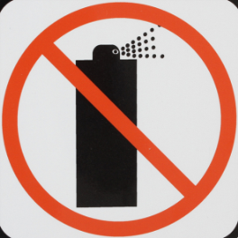
ENVIRONMENTAL SAFETY
Due to concern for the safety of students and staff with specific allergies, students are not permitted to bring Aerosol Dispensers (i.e. spray cans, body sprays, etc.) on campus, or to use such products in excess during school hours.
Reference : Administrative Regulation 3514-Business and Non-instructional Operations -Environmental Safety
If a student is found with these products, parent/guardian will be contacted to address the concern.

Student Discipline/Suspension

Education Code 48900

A pupil may not be suspended from school or recommended for expulsion unless the superintendent or the principal of the school in which the pupil is enrolled determines that the pupil has committed an act as defined pursuant to one or more of EC 48900 subdivisions (a) to (t), inclusive:

  - (1) Caused, attempted to cause, or threatened to cause physical injury to another person.
(2) Willfully used force or violence upon the person of another, except in self-defense.
  - Possessed, sold, or otherwise furnished a firearm, knife, explosive, or other dangerous object, unless, in the case of possession of an object of this type, the pupil had obtained written permission to possess the item from a certificated school employee, which is concurred in by the principal or the designee of the principal. Please note that with the passage of AB 424 no one has the authority to grant permission to possess a firearm on school grounds.
  - Unlawfully possessed, used, sold, or otherwise furnished, or been under the influence of, a controlled substance listed in Chapter 2 (commencing with Section 11053) of Division 10 of the Health and Safety Code, an alcoholic beverage, or an intoxicant of any kind.
  - Unlawfully offered, arranged, or negotiated to sell a controlled substance listed in Chapter 2 (commencing with Section 11053) of Division 10 of the Health and Safety Code, an alcoholic beverage, or an intoxicant of any kind, and either sold, delivered, or otherwise furnished to a person another liquid, substance, or material and represented the liquid, substance, or material as a controlled substance, alcoholic beverage, or intoxicant.
  - Committed or attempted to commit robbery or extortion.
  - Caused or attempted to cause damage to school property or private property.
  - Stolen or attempted to steal school property or private property.
  - Possessed or used tobacco, or products containing tobacco or nicotine products, including, but not limited to, cigarettes, cigars, miniature cigars, clove cigarettes, smokeless tobacco, snuff, chew packets, and betel. However, this section does not prohibit use or possession by a pupil of his or her own prescription products.
  - Committed an obscene act or engaged in habitual profanity or vulgarity.
  - Unlawfully possessed or unlawfully offered, arranged, or negotiated to sell drug paraphernalia, as defined in Section 11014.5 of the Health and Safety Code.
  - (1) Disrupted school activities or otherwise willfully defied the valid authority of supervisors, teachers, administrators, school officials, or other school personnel engaged in the performance of their duties.
(2) Except as provided in Section 48910, a pupil enrolled in kindergarten or any of grades 1 to 8, inclusive, shall not be suspended for any of the acts enumerated in this subdivision, and this subdivision shall not constitute grounds for a pupil enrolled in kindergarten or any of grades 1 to 12, inclusive, to be recommended for expulsion.
  - Knowingly received stolen school property or private property.
  - Possessed an imitation firearm. As used in this section, "imitation firearm" means a replica of a firearm that is so substantially similar in physical properties to an existing firearm as to lead a reasonable person to conclude that the replica is a firearm.
  - Committed or attempted to commit a sexual assault as defined in Section 261, 266c, 286, 288, 288a, or 289 of the Penal Code or committed a sexual battery as defined in Section 243.4 of the Penal Code.
  - Harassed, threatened, or intimidated a pupil who is a complaining witness or a witness in a school disciplinary proceeding for the purpose of either preventing that pupil from being a witness or retaliating against that pupil for being a witness, or both.
  - Unlawfully offered, arranged to sell, negotiated to sell, or sold the prescription drug Soma.
  - Engaged in, or attempted to engage in, hazing. For purposes of this subdivision, “hazing” means a method of initiation or preinitiation into a pupil organization or body, whether or not the organization or body is officially recognized by an educational institution, which is likely to cause serious bodily injury or personal degradation or disgrace resulting in physical or mental harm to a former, current, or prospective pupil. For purposes of this subdivision, “hazing” does not include athletic events or school- sanctioned events.
(r) Engaged in an act of bullying. For purposes of this subdivision, the following terms have the following meanings:
(1) “Bullying” means any severe or pervasive physical or verbal act or conduct, including communications made in writing or by means of an electronic act, and including one or more acts committed by a pupil or group of pupils as defined in Section 48900.2, 48900.3, or 48900.4, directed toward one or more pupils that has or can be reasonably predicted to have the effect of one or more of the following:
(A) Placing a reasonable pupil or pupils in fear of harm to that pupil’s or those pupils’ person or property.
(B) Causing a reasonable pupil to experience a substantially detrimental effect on the pupil’s physical or mental health.
(C) Causing a reasonable pupil to experience substantial interference with the pupil’s academic performance.
(D) Causing a reasonable pupil to experience substantial interference with the pupil’s ability to participate in or benefit from the services, activities, or privileges provided by a school.
(2) (A) “Electronic act” means the creation or transmission originated on or off the school site, by means of an electronic device, including, but not limited to, a telephone, wireless telephone, or other wireless communication device, computer, or pager, of a communication, including, but not limited to, any of the following:
(i) A message, text, sound, video, or image.
(ii) A post on a social network internet website, including, but not limited to:
(I) Posting to or creating a burn page. “Burn page” means an internet website created for the purpose of having one or more of the effects listed in paragraph (1).
(II) Creating a credible impersonation of another actual pupil for the purpose of having one or more of the effects listed in paragraph (1). “Credible impersonation” means to knowingly and without consent impersonate a pupil for the purpose of bullying the pupil and such that another pupil would reasonably believe, or has reasonably believed, that the pupil was or is the pupil who was impersonated.
(III) Creating a false profile for the purpose of having one or more of the effects listed in paragraph (1). “False profile” means a profile of a fictitious pupil or a profile using the likeness or attributes of an actual pupil other than the pupil who created the false profile.
(iii) (I) An act of cyber sexual bullying.
(II) For purposes of this clause, “cyber sexual bullying” means the dissemination of, or the solicitation or incitement to disseminate, a photograph or other visual recording by a pupil to another pupil or to school personnel by means of an electronic act that has or can be reasonably predicted to have one or more of the effects described in subparagraphs (A) to (D), inclusive, of paragraph (1). A photograph or other visual recording, as described in this subclause, shall include the depiction of a nude, semi-nude, or sexually explicit photograph or other visual recording of a minor where the minor is identifiable from the photograph, visual recording, or other electronic act.
(III) For purposes of this clause, “cyber sexual bullying” does not include a depiction, portrayal, or image that has any serious literary, artistic, educational, political, or scientific value or that involves athletic events or school-sanctioned activities.
(B) Notwithstanding paragraph (1) and subparagraph (A), an electronic act shall not constitute pervasive conduct solely on the basis that it has been transmitted on the internet or is currently posted on the internet.
(3) “Reasonable pupil” means a pupil, including, but not limited to, a pupil with exceptional needs, who exercises average care, skill, and judgment in conduct for a person of that age, or for a person of that age with the pupil’s exceptional needs.
(s) A pupil shall not be suspended or expelled for any of the acts enumerated in this section, unless that act is related to school activity or school attendance occurring within a school under the jurisdiction of the superintendent of the school district or principal or occurring within any other school district. A pupil may be suspended or expelled for acts that are enumerated in this section and related to school activity or attendance that occur at any time, including, but not limited to, any of the following:
- While on school grounds.
- While going to or coming from school.
- During the lunch period whether on or off the campus.
- During, or while going to or coming from, a school-sponsored activity.

(t) A pupil who aids or abets, as defined in Section 31 of the Penal Code, the infliction or attempted infliction of physical injury to another person may be subject to suspension, but not expulsion, pursuant to this section, except that a pupil who has been adjudged by a juvenile court to have committed, as an aider and abettor, a crime of physical violence in which the victim suffered great bodily injury or serious bodily injury shall be subject to discipline pursuant to subdivision (a).
(u) As used in this section, “school property” includes, but is not limited to, electronic files and databases.
(v) For a pupil subject to discipline under this section, a superintendent of the school district or principal is encouraged to provide alternatives to suspension or expulsion, using a research-based framework with strategies that improve behavioral and academic outcomes that are age appropriate and designed to address and correct the pupil’s specific misbehavior as specified in Section 48900.5.
(w) (1) It is the intent of the Legislature that alternatives to suspension or expulsion be imposed against a pupil who is truant, tardy, or otherwise absent from school activities.
(2) It is further the intent of the Legislature that the Multi-Tiered System of Supports, which includes restorative justice practices, trauma-informed practices, social and emotional learning, and schoolwide positive behavior interventions and support, may be used to help pupils gain critical social and emotional skills, receive support to help transform trauma-related responses, understand the impact of their actions, and develop meaningful methods for repairing harm to the school community.

Sexual Harassment EDC 48900.2
In addition to the reasons specified in Section 48900, a pupil may be suspended from school or recommended for expulsion if the superintendent or the principal of the school in which the pupil is enrolled determines that the pupil has committed sexual harassment as defined in Section 212.5. For the purposes of this chapter, the conduct described in Section 212.5 must be considered by a reasonable person of the same gender as the victim to be sufficiently severe or pervasive to have a negative impact upon the individual's academic performance or to create an intimidating, hostile, or offensive educational environment. This section shall not apply to pupils enrolled in kindergarten and grades 1 to 3, inclusive.

Hate Violence EDC 48900.3
In addition to the reasons set forth in Sections 48900 and 48900.2, a pupil in any of grades 4 to 12, inclusive, may be suspended from school or recommended for expulsion if the superintendent or the principal of the school in which the pupil is enrolled determines that the pupil has caused, attempted to cause, threatened to cause, or participated in an act of, hate violence, as defined in subdivision (e) of Section 233.

Harassment EDC 48900.4
In addition to the grounds specified in Sections 48900 and 48900.2, a pupil enrolled in any of grades 4 to 12, inclusive, may be suspended from school or recommended for expulsion if the superintendent or the principal of the school in which the pupil is enrolled determines that the pupil has intentionally engaged in harassment, threats, or intimidation, directed against school district personnel or pupils, that is sufficiently severe or pervasive to have the actual and reasonably expected effect of materially disrupting classwork, creating substantial disorder, and invading the rights of either school personnel or pupils by creating an intimidating or hostile educational environment.

Terroristic Threat EDC 48900.7
- In addition to the reasons specified in Sections 48900, 48900.2, 48900.3, and 48900.4, a pupil may be suspended from school or recommended for expulsion if the superintendent or the principal of the school in which the pupil is enrolled determines that the pupil has made terroristic threats against school officials or school property, or both.
- For the purposes of this section, "terroristic threat" shall include any statement, whether written or oral, by a person who willfully threatens to commit a crime which will result in death, great bodily injury to another person, or property damage in excess of one thousand dollars ($1,000), with the specific intent that the statement is to be taken as a threat, even if there is no intent of actually carrying it out, which, on its face and under the circumstances in which it is made, is so unequivocal, unconditional, immediate, and specific as to convey to the person threatened, a gravity of purpose and an immediate prospect of execution of the threat, and thereby causes that person reasonably to be in sustained fear for his or her own safety or for his or her immediate family's safety, or for the protection of school district property, or the personal property of the person threatened or his or her immediate family.

Recommendation for Expulsion: Education Code 48915

- (1) Except as provided in subdivisions (c) and (e), the principal or the superintendent of schools shall recommend the expulsion of a pupil for any of the following acts committed at school or at a school activity off school grounds, unless the principal or superintendent finds that expulsion is inappropriate, due to the particular circumstance:
  - Causing serious physical injury to another person, except in self-defense.
  - Possession of any knife or other dangerous object of no reasonable use to the pupil.
  - Unlawful possession of any controlled substance listed in Chapter 2 (commencing with Section 11053) of Division 10 of the Health and Safety Code, except for either of the following:
    - The first offense for the possession of not more than one avoirdupois ounce of marijuana, other than concentrated cannabis.
    - The possession of over-the-counter medication for use by the pupil for medical purposes or medication prescribed for the pupil by a physician.
  - Robbery or extortion.
  - Assault or battery, as defined in Sections 240 and 242 of the Penal Code, upon any school employee.
- Upon recommendation by the principal, superintendent of schools or by a hearing officer or administrative panel appointed pursuant to subdivision (d) of Section 48918, the governing board may order a pupil expelled upon finding that the pupil committed an act listed in subdivision (a) or in subdivision (a), (b), (c), (d), or (e) of Section 48900. A decision to expel shall be based on a finding of one or both of the following:
- Other means of correction are not feasible or have repeatedly failed to bring about proper conduct.
- Due to the nature of the act, the presence of the pupil causes a continuing danger to the physical safety of the pupil or others.
- The principal or superintendent of schools shall immediately suspend, pursuant to Section 48911, and shall recommend expulsion of a pupil that he or she determines has committed any of the following acts at school or at a school activity off school grounds:
- Possessing, selling, or otherwise furnishing a firearm. This subdivision does not apply to an act of possessing a firearm if the pupil had obtained prior written permission to possess the firearm from a certificated school employee, which is concurred in by the principal or the designee of the principal. This subdivision applies to an act of possessing a firearm only if the possession is verified by an employee of a school district.
- Brandishing a knife at another person.
- Unlawfully selling a controlled substance listed in Chapter 2 (commencing with Section 11053) of Division 10 of the Health and Safety Code.
- Committing or attempting to commit a sexual assault as defined in subdivision (n) of Section 48900 or committing a sexual battery as defined in subdivision (n) of Section 48900.
- Possession of an explosive.
- The governing board shall order a pupil expelled upon finding that the pupil committed an act listed in subdivision (c), and shall refer that pupil to a program of study that meets all of the following conditions:
- Is appropriately prepared to accommodate pupils who exhibit discipline problems.
- Is not provided at a comprehensive middle, junior, or senior high school, or at any elementary school.
- Is not housed at the school site attended by the pupil at the time of suspension.
- Upon recommendation by the principal, superintendent of schools, or by a hearing officer or administrative panel appointed pursuant to subdivision (d) of Section 48918, the governing board may order a pupil expelled upon finding that the pupil, at school or at a school activity off of school grounds violated subdivision (f), (g), (h), (i), (j), (k), (l), or (m) of Section 48900, or Section 48900.2, 48900.3, or 48900.4, and either of the following:
- That other means of correction are not feasible or have repeatedly failed to bring about proper conduct.
- That due to the nature of the violation, the presence of the pupil causes a continuing danger to the physical safety of the pupil or others.
- The governing board shall refer a pupil who has been expelled pursuant to subdivision (b) or (e) to a program of study which meets all of the conditions specified in subdivision (d). Notwithstanding this subdivision, with respect to a pupil expelled pursuant to subdivision (e), if the county superintendent of schools certifies that an alternative program of study is not available at a site away from a comprehensive middle, junior, or senior high school, or an elementary school, and that the only option for placement is at another comprehensive middle, junior, or senior high school, or another elementary school, the pupil may be referred to a program of study that is provided at a comprehensive middle, junior, or senior high school, or at an elementary school.
- As used in this section, "knife" means any dirk, dagger, or other weapon with a fixed, sharpened blade fitted primarily for stabbing, a weapon with a blade fitted primarily for stabbing, a weapon with a blade longer than 3 ½ inches, a folding knife with a blade that locks into place, or a razor with an unguarded blade.
- As used in this section, the term "explosive" means "destructive device" as described in Section 921 of Title 18 of the United States Code.

Board Policy Manual
Rialto Unified School District
Policy 5132: Dress And Grooming ^{Status: ADOPTED} Original Adopted Date: 08/25/1999 | Last Revised Date: 10/09/2019 | Last Reviewed Date: 10/09/2019
The Board of Education believes that appropriate dress and grooming contribute to a productive learning environment. The Board expects students to wear clothing that is suitable for the school activities in which they participate. Students shall not wear clothing that present a health or safety hazard or is likely to cause a substantial disruption to the educational program .
(cf. 4119.22/4219.22/4319.22- Dress and Grooming)
District and school rules pertaining to student attire shall be included in student handbooks, may be posted in school offices and classrooms, and may be periodically reviewed with all students as necessary. Students shall not be prohibited from dressing in a manner consistent with their gender identity or gender expression or with their religious or cultural observance.
(cf. 5145.3 – Nondiscrimination/Harassment)
(cf. 5145.7 – Sexual Harassment)
The principal or designee is authorized to enforce this policy and shall inform any student who does not reasonably conform to the dress code. The dress code shall not be enforced in a manner that discriminates against a particular viewpoint or results in a disproportionate application of the dress code based on students’ gender, sexual orientation, race, ethnicity, household income, or body type or size.
(cf. 0410 – Nondiscrimination in District Programs and Activities)
(cf. 0415 – Equity)
(cf. 5145.2 – Freedom of Speech/Expression)
School administrators, teachers, and other staff shall be notified of appropriate and equitable enforcement of the dress code.
(cf. 4131 – Staff Development)
(cf. 4231 – Staff Development)
(cf. 4331 – Staff Development)
When practical, students shall not be directed to correct a dress code violation during instructional time or in front of other students.
Repeated violations or refusal to comply with the district’s dress code may result in disciplinary action. (cf. 5144 - Discipline)
Gang-Related Apparel
The principal, staff, and parents/guardians at a school may establish a reasonable dress code that prohibits students from wearing gang-related apparel when there is evidence of a gang presence that disrupts or threatens to disrupt the school's activities. Such a proposed dress code shall be presented to the Board, which shall approve the plan upon determining that it is necessary to protect the health and safety of the school environment. The dress code policy may be included in the school’s comprehensive safety plan. (Education Code 35183)
(cf. 0450 - Comprehensive Safety Plan)
(cf. 5136 - Gangs)
When determining specific items of clothing that may be defined as gang apparel, the school shall ensure that the determination is free from bias based on race, ethnicity, national origin, immigration status, or other protected characteristics.
Uniforms
The Board may approve a school-initiated dress code requiring students at the school to wear a school uniform whenever the Board determines that such a dress code will promote student achievement, a positive school climate,
and/or student safety.
The Superintendent or designee shall establish procedures whereby parents/guardians may choose to have their children exempted from the school uniform policy. Students shall not be penalized academically, otherwise discriminated against, or denied attendance to school if their parents/guardians so decide. (Education Code 35183)
The Superintendent or designee shall ensure that resources are identified to assist economically disadvantaged students in obtaining uniforms. (Education Code 35183)

Rialto Unified School District
DRESS CODE
The mission of the Rialto Unified School District (RUSD), the bridge that connects students to their future aspirations, is to ensure each student achieves personal and career fulfillment within a global society.
RUSD believes that high expectations for students and a safe and engaging learning environment prepares students for academic success and their future. The student dress code should serve to support all students in developing a body-positive self-image. All students are expected to adhere to RUSD Student Dress and Grooming Board Policy 5132, which includes, but is not limited to, the three expectations.
“Big Three”
- Clothing must cover and conceal undergarments; no private parts, including midriff, should be visible.
- Appropriate shoes must be worn at all times.
- Clothing, backpacks, and accessories must be free of images and content that are sexually suggestive, depict drugs, alcohol, or tobacco use, firearms, gang-related images, or other illegal activities.

- All RUSD staff will support students by reinforcing Dress and Grooming Board Policy 5132.
- Students who do not comply with the dress code expectations, may be subject to progressive discipline.
- Any student in need of appropriate clothing, will be referred to the RUSD Kindness Connection.

Non-Discrimination Policy
The Rialto Unified School District does not discriminate on the basis of the actual or perceived race ethnicity, religion, color, age, national origin, political affiliation, gender, gender identity, gender expression, sexual orientation, mental or physical disability, parental or marital status, or any other basis protected by the federal, state or local law, ordinance, or regulation in its educational programs or employment.

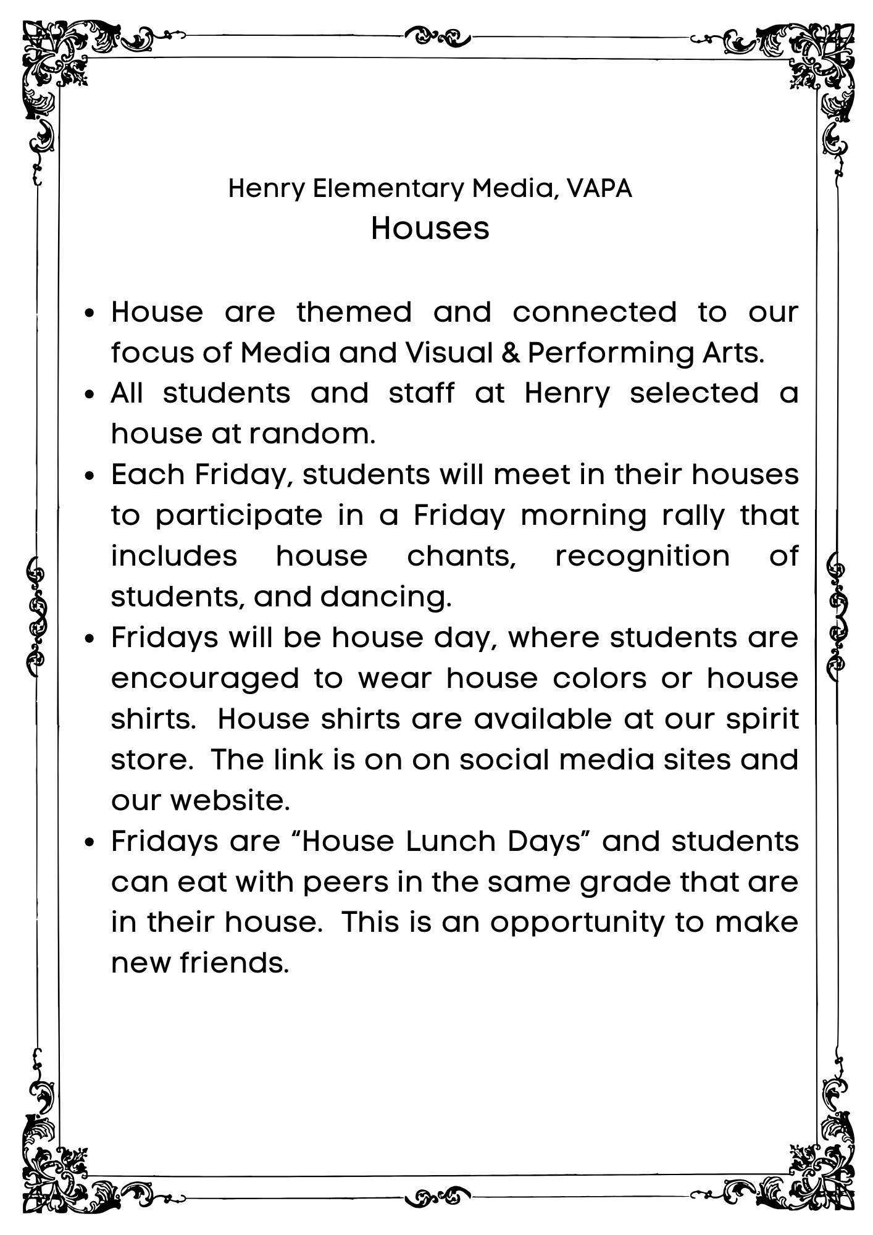
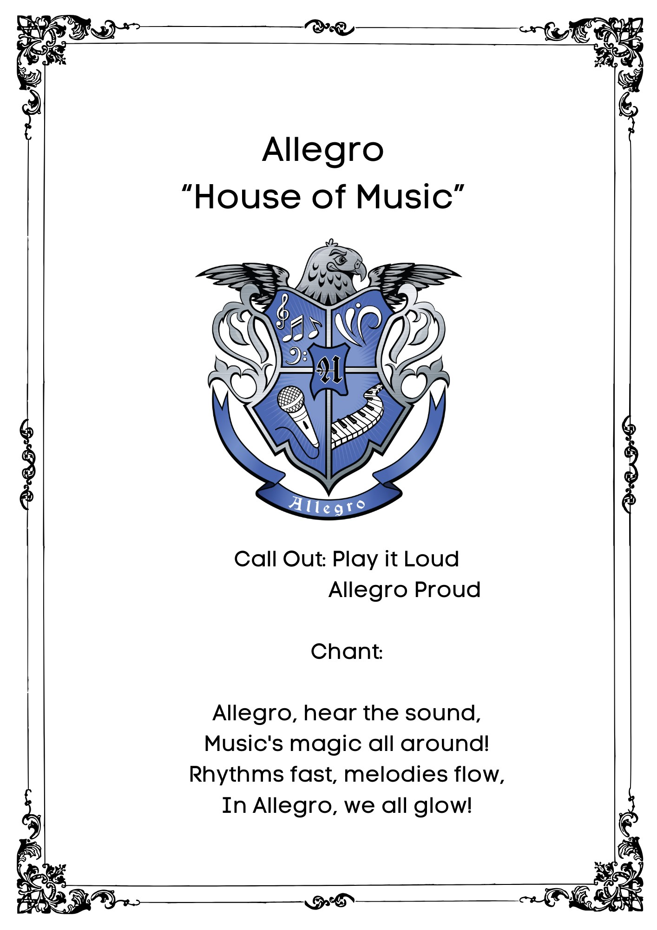

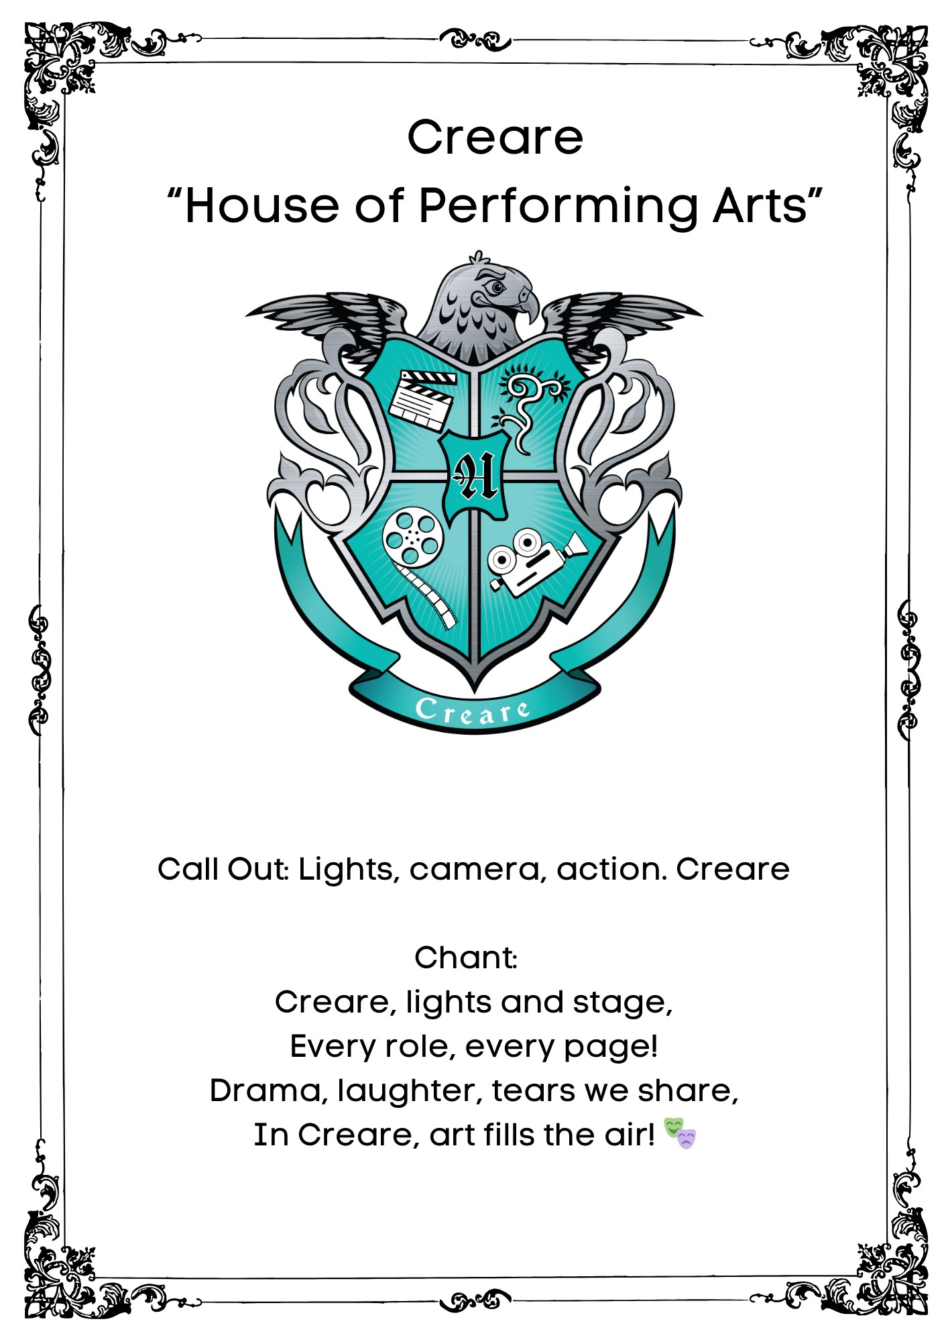

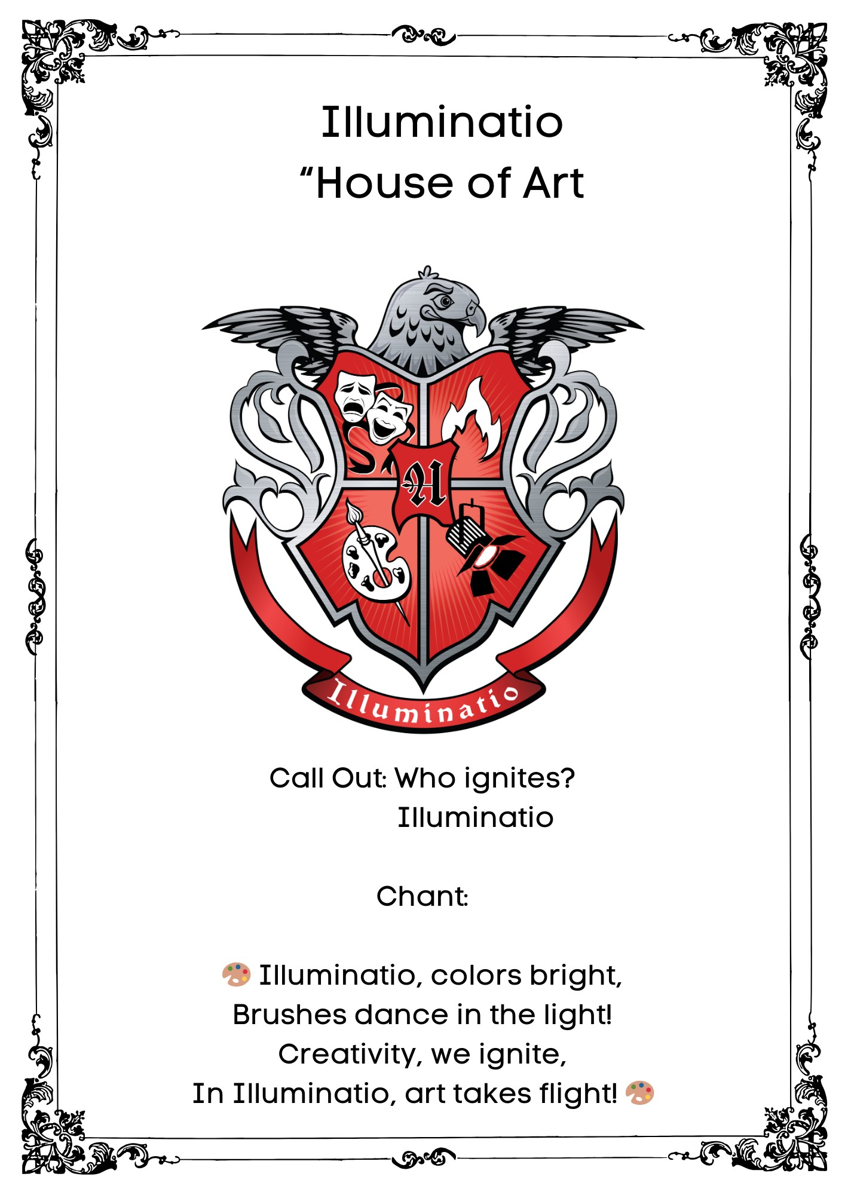

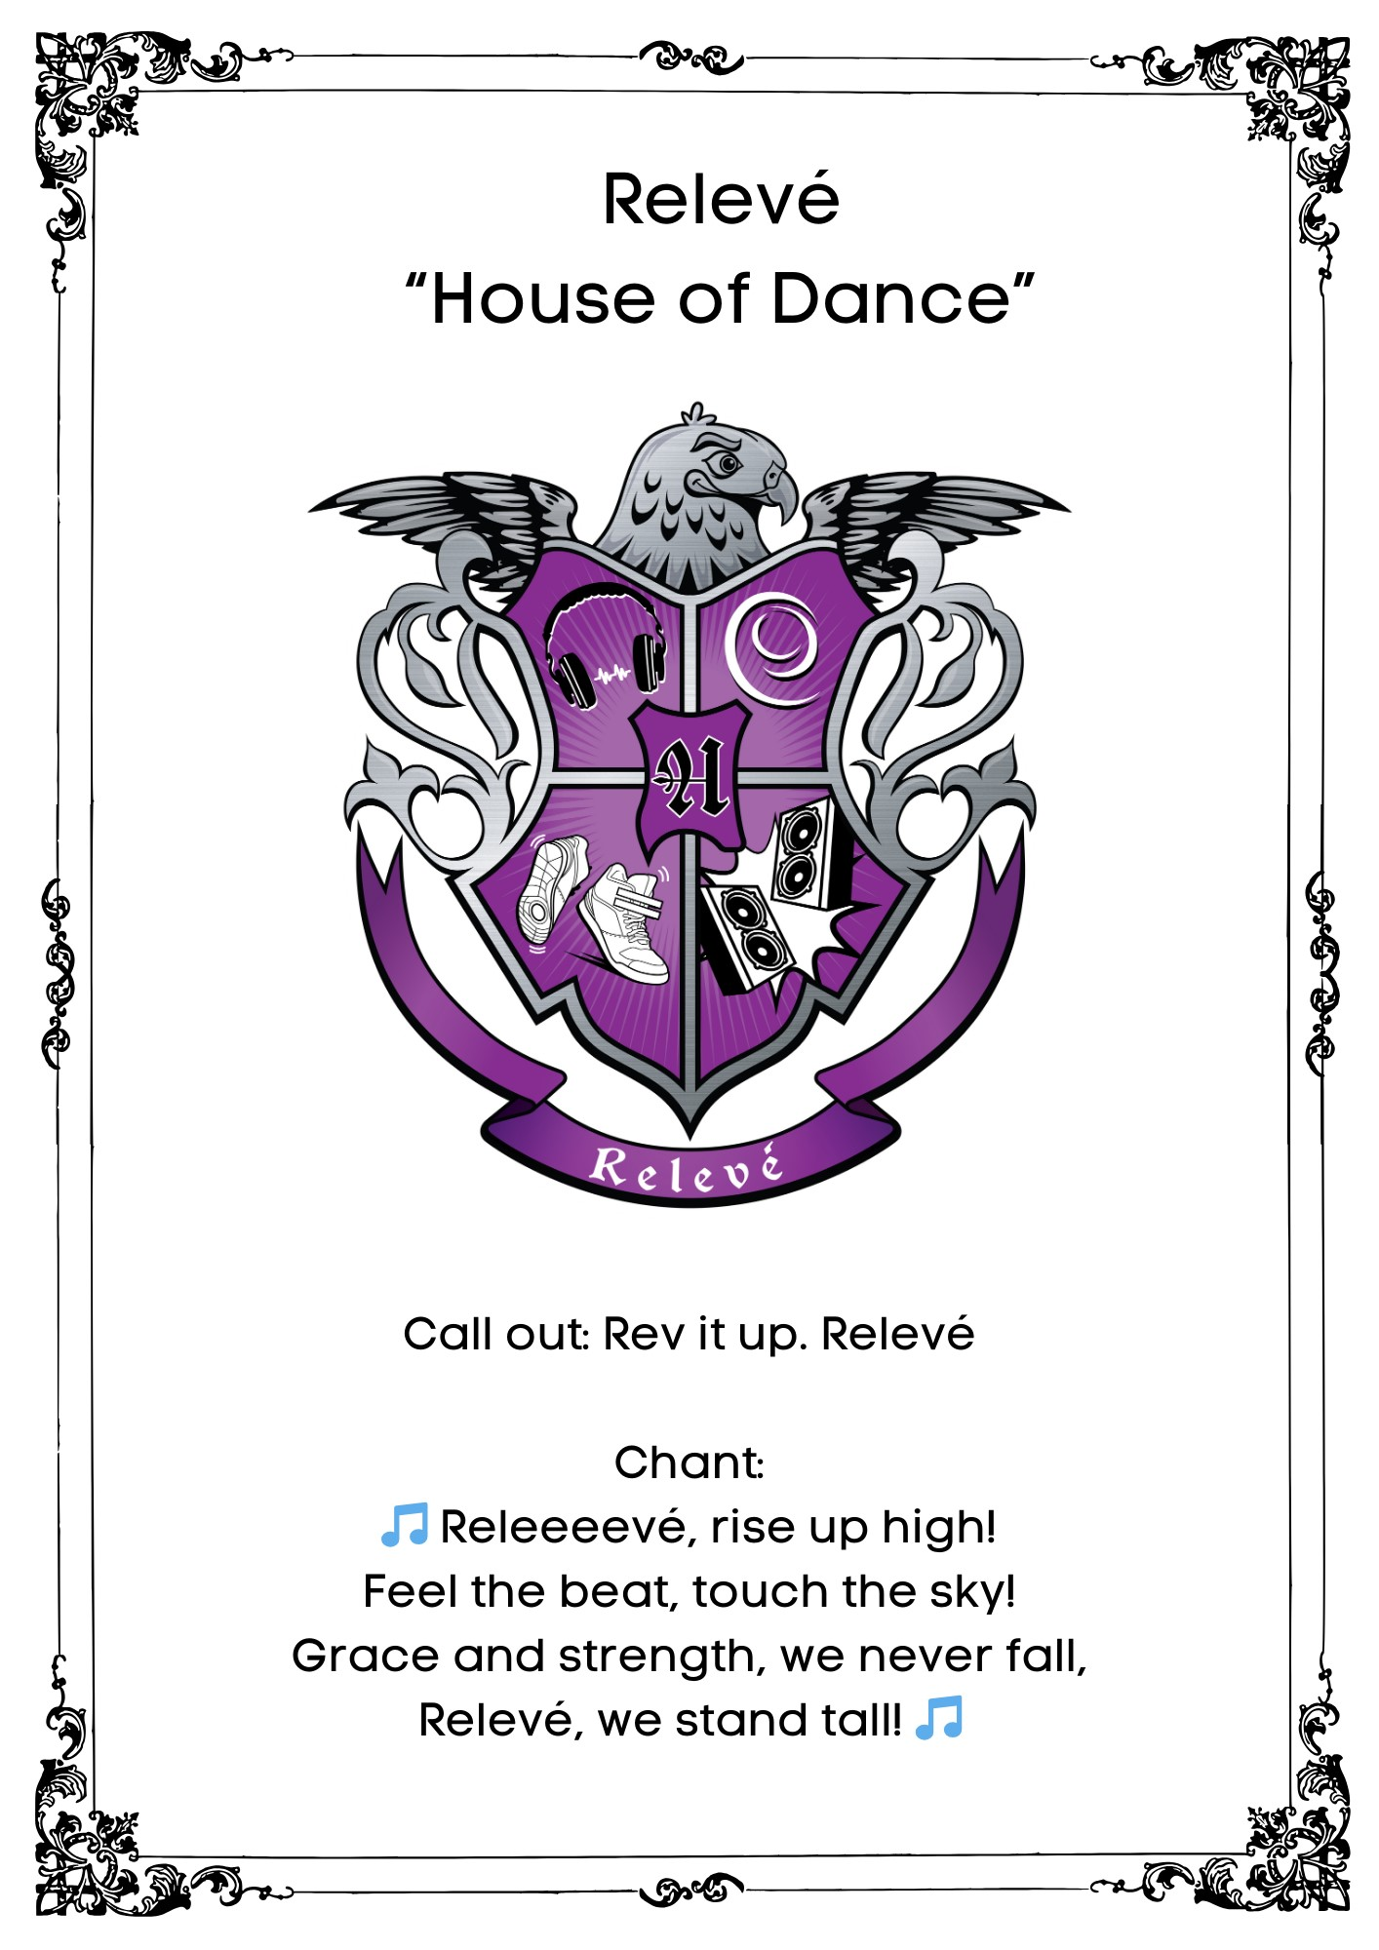

Transitional Kindergarten Expectations and Routines
2024-2025

 | Be Safe | Be Respectful | Be Responsible
Beginning of the day | Walk quietly when entering the room and watch for others. Leave space for classmates. | Eat only your breakfast and allow others to do the same. Write only on your own paper. | Place backpack and other belongings in designated areas.  Complete your job. (seatwork or activity)
Large Group  (Whole class) | Walk/Exercise safely. Keep hands, feet, and objects to yourself.  Sit properly.  Use tools safely. | Listen when others are talking and take turns. Use kind words and be friendly.  Use inside voices. | Pay attention and follow directions. Sit so others can see and hear.
Small Group  (Centers) | Sit properly and use tools/materials safely. | Share. Use eyes and ears properly. | Follow directions. Try your best. Clean up your area when done.
Asking  for Help | Stay seated where working. | Raise your hand to get the teacher’s attention. | Ask a neighbor if they can help.
Lining Up  for Dismissal | Stay in your assigned area until told to move. Push in your chair when leaving your seat and walk to the line. | Respect personal space by keeping hands and feet to yourself. | Collect your belongings (water bottle, lunch pail, sweater/jacket)

Kindergarten Classroom Expectations and Routines
2024-2025

 | Be Safe | Be Respectful | Be Responsible
Starting the  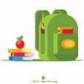  Day | Walk quietly when entering the classroom. | Sit quietly and properly on the rug or on the chair. | Place backpack in designated area. Take folder and water bottle out of backpack.
General   | Keep hands, feet, and objects to yourself. Use classroom tools appropriately. | Follow directions. Listen when others are talking. Take turns when talking. Use kind words and be friendly to others. | Use appropriate voices. Be honest and truthful. Bring folder daily. Write your name on paper.
Transitions   | Walk in the classroom. Stay in your assigned area until told to move. Push in your chair when leaving your seat | Respect personal space (leave space between you and others). | Clean your area before leaving.
Computers   | Stay on sites your teacher allows | Keep hands on your own computer. Use two hands to carry computer. | Treat computer and headphones with care.
Carpet   | Walk to the carpet. Keep hands and feet inside your circle. | Use indoor voices when we are on the carpet. Raise your hand for permission to speak. | Sit on individual circle with legs crossed.

First Grade Classroom Expectations
2024-2025

 | Be Safe | Be Respectful | Be Responsible
Starting the Day  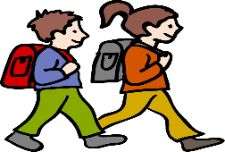 | -Walk quietly when entering the classroom.  -Eat quietly during breakfast | -Sit quietly and eat breakfast.  -Use appropriate table manners. | -Place backpacks and water bottles in the designated area.  -Follow breakfast procedures.
Working Independently   | -Sit quietly and properly on your chair (four legs down).  -Follow classroom procedures | -Use a whisper voice.  -Move quietly around the room when necessary. | -Complete all assignments.  -Double check your work.  -Put all materials away when finished.  -Stay on task.
Asking for Help   | -Let the teacher know immediately about an emergency (bleeding, vomiting, etc.) | -Raise your hand quietly and wait to be called on. | -Always try by yourself first.  -Ask a partner quietly for help.  -Use the bathroom signal when needed.
Transitions  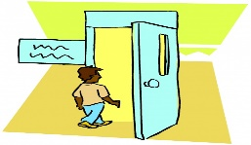 | -Walk in the classroom.  -Stay in your assigned area until told to move.  -Push your chair when leaving your seat. | -Respect personal space (leave space between you and others). | -Clean your area before leaving.  -Listen and follow all directions.
General   | -Keep hands, feet, and objects to yourself. | -Follow directions from the teacher and staff.  -Listen and take turns when others are talking.  -Use kind words and be friendly. | -Use appropriate voices  -Be honest and truthful.  -Return homework packets at the end of the week.

2nd Grade Classroom Expectations & Routines
2024-2025

Expectation | Beginning of the Day | General | Whole Class Activities | Small Group Activities | Transitions
Be Safe | - Walk quietly to work seat  - Be aware of personal space | - Keep your chair flat on the floor  - Walk at all times  - Keep hands, feet and objects to yourself | - Be aware of your personal space  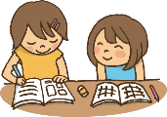 | - Sit quietly and correctly in your chair  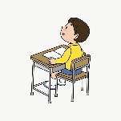 | - Push in your chair  - Be quick and quiet  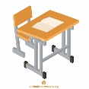
Be Respectful | - Sit quietly and do your work   | - Raise your hand quietly and wait to be called on  - Follow directions the first time | - Listen when others are talking  - Wait for your turn | - Share and use materials properly  - Talk quietly  - Keep interruptions to a minimum | - Be prepared to listen for directions  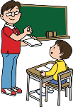
Be Responsible | - Have homework completed | - Stay on task  - Use your inside voice | - Pay attention   | - Complete all work  - Everyone participates | - Clean your area before leaving

Third Grade Classroom Expectations and Routines

2024-2025
Routines  Expectations | Entering Classroom   | Working At Desks  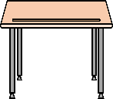 | Asking for Help   | When You Finish Work   | Lining Up  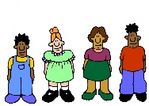
Be Responsible | - Use restroom and water fountain during recess breaks  - Be prepared with all materials | - Be on task during work time  - Share materials  - Be a good role model for others | - Wait patiently for the teacher to call on you.  - Be a good listener  - Always try by yourself first | - Finish additional work quietly  - If finished, read a book quietly or complete other assigned tasks. | - Wait for your table to be called  - Push in chairs
Be Respectful | - Wait at the door until invited in.  - Wait quietly for instructions  - Raise your hand and wait to be called on | - Raise your hand and wait to be called on  - Be respectful of others’ work and feelings  - Use quiet voices while working | - Raise your hand and wait to be called on.  - Respectfully stay on topic. | - Return materials  - Let others finish their work  - Follow clean up procedures | - Stand quietly  - Listen for directions
Be Safe | - Keep hands, feet, and objects to yourself | - Keep all chair legs on floor  - Keep hands, feet, and objects to yourself  - Stay in seat  - Use materials as intended | - Let the teacher know immediately about an emergency (bleeding, vomiting, etc.) | - Walk when returning materials  - Return to seat | - Hands & feet to yourself  - Face forward in line  - Walk to get in line.


Fourth Grade Classroom Expectations
2024-2025

Classroom Expectations | Starting Class | Teaching Time | Group Work | Independent Work
Be Safe | Sit on your chair properly.  Keep your body parts and belongings in your personal space. | Stay in your seat unless directed to do otherwise.  When having to move, walk. | Use materials properly to avoid accidents.  Walk if needing to move to a different section of the room. | Use materials properly to avoid accidents.  Walk if needing to move to a different section of the room.
Be Respectful | Let students eat breakfast peacefully. | Give the teacher your attention.  Remain quiet unless participating in class. | Listen to your peers point of view.  Let your peers share without interrupting them.  Use constructive criticism. | Maintain silence.  Leave other students alone, even when done with your work.
Be Responsible | Get to school on time.  Have your computer charged.  Have homework completed.  Have your utensils ready.  Use the restroom before school starts. | Focus on the lesson.  Listen and observe what is happening in the lesson.  Raise your hand when needed. | Work together.  Clean your area if you used materials.  Stay focused on your task. | Stay on your task.  Complete your task to the best of your ability.  Turn in your work on time.

Fifth Grade Classroom Expectation and Routines
2024-2025

Expectations  Routines | Entering the  Classroom   | Instruction/  Independent  Work   | Group  Work   | Computer  Use  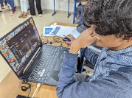 | Exiting  Classroom  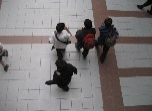
Be  Safe | - Walk calmly to your destination.  - Place backpacks and belongings in designated area.  - Sit in your chair with all chair legs on the floor.  - Keep chair pushed in when not seated. | - Use materials and equipment for its intended purposes.  - Keep workspaces organized.  - Stay seated.  - Keep all chair legs on the floor. | - Walk when moving around the classroom.  - Use materials for what they are intended for.  - Arrange desks, chairs and materials carefully. | - Keep food and drinks away from computers.  - Use computers gently. | - Push in chairs.  - Wait your turn to exit.  - Keep hands, feet and belonging to yourself.
Be  Respectful | - Use kind words (plea, thank you, excuse me).  - Eat breakfast quietly.  - Chew with your mouth closed. | - Listen attentively by looking at the teacher.  - Raise your hand and wait to be called on.  - Keep materials in your work area.  - Offer to help others if they don’t understand. | - Listen to other group members’ opinions without interrupting.  - Speak politely even when disagreeing.  - Encourage everyone to participate. | - Use headphones when there is audio.  - Respect others’ privacy by looking at your own screen unless invited to look. | - Say good-bye to classmates/teachers.  - Hold door open for students who have not exited.
Be  Responsible | - Be on time for class.  - Finish breakfast promptly (15 minutes).  - Clean up your area (throw trash away clean up spills). | - Complete task in allotted time.  - Ask for help if you don’t understand.  - Check your work for accuracy.  - Return materials to the proper place. | - Keep each other focused on assigned task.  - Complete assignment in allotted time.  - Clean up your workspace.  - Use indoor voices. | - Bring computer fully charged.  - Log into your own account.  - Report technical issues to the teacher immediately.  - Go to assigned websites only. | - Make sure materials are put away.  - Take necessary material with you to complete homework.  - Proceed promptly to your next destination (Step Up, tutoring, ride home).

Major
Administrator Managed

Aggression/Threats

Bullying/Harrassing
Repeated instance of profanity/vulgarity

Possession of dangerous objects

Vandalism/destruction of property

Theft

On- going Defiance/Disrespect
Minor
Teacher Managed

- Disruption

- Defiance

- Disrespect

- Profanity

- Profanity/Vulgarity

- Physical Contact (Minor)
Henry Elementary 3 Expectations - Be Safe, Be Respectful, Be Responsible

PBIS Behavior Management Flow Chart

Complete PBIS referral
Continue behavior support

Referral to Student Study Team if needed
Admin provides feedback to classroom teacher

Administration will investigate and contact parents

Complete referral and send with student office.
Teacher classroom intervention
& Parent Contact
Teacher documents behaviors and results of support.
- If behavior occurs again, consult administration for intervention support.
- Parent conference to discuss additional supports

BULLYING/HARASSMENT COMPLAINT FORM
(Students May Report Anonymously)

Date Filed: _______________ Name: ____________________________________

Address: _________________________________________ Phone #: ________________

Please identify yourself as a:
Student _____ Parent/Guardian _____ Employee _____ Volunteer _____ Other _____

Please check the type of bullying that has occurred (more than one can be checked):

Verbal Abuse Physical
(name-calling, racial remarks, belittling, etc. (hitting, kicking, shoving, twisting limbs, spitting,
Can be done over the phone, in writing, or destroying personal belongings)
in person, over the phone, text, email)

Extortion Hazing
(verbal or physical bullying for money (Having to participate in an act of physical or emotional
or personal items) harm to be part of a group, or are a victim of a group)

Indirect Bullying Cyberbullying
(Rejection, exclusion, ignoring, alienating, or (Using technology to harass, threaten, or target another
isolating to purposely cause emotional distress) person – text, IMs, email, Facebook, videos, MySpace,
Twitter, etc.)

Bullying/ Harassment on the basis of: Race, color or nationality Gender Disability Other

Dates of alleged bullying or harassment(s): ______________________________________________________________________________
Person(s) alleged to have committed the bullying or harassment:
______________________________________________________________________________
Description of the incident: If possible, use specific dates, times, locations, names, etc. Use the backside of the form or additional sheets if necessary.
___________________________________________________________________________________________________________________________________________________________________________________________________________________________________________________

Names of Witnesses: ________________________________________________________________
_________________________________________________________________________________
Have you reported this to anyone else: Yes ___ No ___ If so, who? ___________________________

Signature of Reporting Person _____________________________ Date ___________________

Note: Completion of this form will initiate an investigation of the alleged incident of bullying or harassment outlined in this form. All information will be confidential except for that which must be shared as part of the investigation. Submission of a good faith complaint or report of bullying or harassment will not affect the complainant or reporter’s future employment, grades, learning, or working environment or work assignment. By signing above, you are verifying that your statements are true and exact to the best of your knowledge.
Revised 6/12/2013

Rialto Unified School District
Legal Notices for Pupils and Parents/Guardians
Bullying and Harassment

The Rialto Unified School District prohibits discrimination, harassment, intimidation, or bullying of students or staff, including sexual harassment, hate-motivated behavior, cyber bullying, hazing or initiation activity, extortion, or any other verbal, written, or physical conduct that causes or threatens to cause violence, bodily harm, or substantial disruption. This policy applies while on school grounds, going to or coming from school, at school activities, or using district transportation.
Board Policy 5131

Bullying is defined as any severe or pervasive physical or verbal act or conduct, including communications made in writing or by means of an electronic act, and including one or more acts committed by a pupil or group of pupils directed toward one or more pupils that has or can be reasonably predicted to have the effect of causing a reasonable pupil to experience a substantially detrimental effect on the pupil’s physical or mental health, academic performance, or ability to participate in school activities.

REPORT IT
Any person that has been a victim of, or witnessed bullying or harassment on school grounds, during school activities, or going to and coming from school is highly encouraged to report the incident immediately to a counselor, administrator, or other adult personnel on campus. Students have an option of reporting the incident anonymously through the Bullying/Harassment Complaint form located at the school.

INVESTIGATION
The principal or designee shall promptly investigate all complaints of bullying or sexual harassment. The person who filed the complaint shall have an opportunity to describe the incident, present witnesses and other evidence of the bullying or harassment, and put his/her complaint in writing. Within 10 school days of the reported incident, the principal or designee shall present a written report to the person who filed the complaint and the accused individual. The report shall include his/her findings, decision, and reason for the decision. If the person is in disagreement with the outcome of the investigation, an appeal can be filed at the Department of Student Services located at 260 S. Willow Ave., Rialto, CA 92376.

TRANSFER REQUEST
A student that has been reported as the victim of a violent offense as defined by state law is entitled to transfer to another school within or outside the District, under California Education Code 46600 § (b). Placement at a requested school is contingent upon space availability. Transfer requests can be obtained at Henry Elementary School.

DISTRICT LIAISON
Department of Student Services
Lead Agent, Students Services or
Agent, Child Welfare & Attendance
260 S. Willow Ave., Rialto, CA 92376
(909) 873-4336

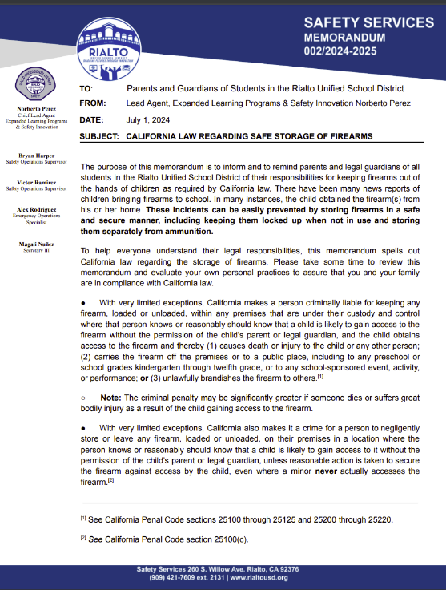
Cell Phone Policy (Mobile Communication Devices)
Rialto Unified School District

Elementary and Middle School
Students may use cell phones, smart watches, pagers, or other mobile communication devices before school begins and after the regular school day ends. Devices must be turned off and not visible during the school day which includes passing periods, recesses, and lunch.

When a student uses a mobile communication device in an unauthorized manner, the student shall be subject to progressive consequences and a restorative process.

- Early Intervention includes conducting restorative conversations with the student.
- If a student does not follow the expectation of the policy after the restorative conversations, the consequence shall include confiscation of the phone by a school official in accordance with law.
  - The employee shall store the device securely until it is returned to the student or turned over to the principal or designee, as appropriate. When a device is confiscated, the student shall have it returned at the end of the period or school day.
- A parental pick-up of the device at the end of the school day shall be required for students who have not followed the expectations of the policy on multiple occasions.
- If a student continues to not meet expectations of the policy, the student shall have his/her cell phone privileges revoked for the remainder of the quarter/semester/trimester.
- In cases of severe incidents, such as distribution of pornography, severe cyber bullying, or terroristic threats; the student shall be prohibited from possessing cell phones, smart watches, or pagers while on school grounds for the remainder of the current school year.

**A student shall not be prohibited from possessing or using a mobile communication device under any of the following circumstances:

- In the case of an emergency, or in response to a perceived threat of danger
- When a teacher or administrator grants permission to the student to possess or use a mobile communication device, subject to any reasonable limitation imposed by that teacher or administrator
- When a licensed physician or surgeon determines that the possession or use is necessary for the student's health and well-being
- When the possession or use is required by the student's individualized education program

Henry Elementary Media, Visual & Performing Arts School Elementary

Title I School Parent and Family Engagement Policy

Henry Elementary School has developed, with input from parents, a Title I parent involvement and engagement policy. It was jointly agreed upon during the school site council meeting as evidenced by school site council agenda and meeting minutes. The policy is included in the Parent/student handbook, as well as available on the school website.

Involvement of Parents in the Title I Program

Title I Presentation
Henry Elementary conducts an annual meeting to inform parents about Title I requirements and about the parent rights to be involved in the Title I program.

Amendments
In the event that amendments need to be made, parents may make requests for amendments to be voted on during the next School Site Council meeting, or a special meeting may be called to address the amendments sooner.
If parents find that the engagement policy is not satisfactory, they submit parent comments to be reviewed and changes can be made during a school site council meeting.

Meetings and Participation
Parents are polled to determine the best time and mode(type of meeting, ex. Virtual or in-person) of meetings in order to get the most parent involvement and attendance. Virtual meetings will be recorded so that parents can view them if they are unable to attend. Meeting times and modes may be changed if need be to accommodate our families.

Monitoring
During each School Site council and ELAC meeting, progress of Title I programs are monitored and discussed to evaluate the implementation and effectiveness of the programs at Henry Elementary through progress monitoring of the actions in the School Plan. Changes and amendments may be made throughout the year if needed. If more than 10% of the plan needs correction, then a vote through the School Site council must be made in order to approve the changes.

Henry Elementary Media, Visual & Performing Arts School

Rialto Unified School District

Family School Compact
2024 - 2025

Henry Elementary Media VAPA School ensures a positive and safe learning environment through community partnerships and a commitment to excellence.

TEACHER PLEDGE:
We understand the importance of the school experience to every student and our roles as educators and models. Therefore, we agree to carry out the following responsibilities to the best of our ability:

- Provide a safe, positive and healthy learning environment for your student
- Teach grade level content standards and support the individuals needs of your child
- Regularly communicate with you regarding your student’s progress
- Communicate classwork and homework expectations
- Encourage parent participation and volunteering in school activities
- _______________________________________________________________________________

Teacher’s Signature:_________________________________ Date:____________________

STUDENT PLEDGE:
I realize that my education is very important. I also understand that my family and teacher want to help me to do my best in school. I know I am the one responsible for my own success, and that I must work hard to achieve it. Therefore, I agree to carry out the following responsibilities to the best of my ability:

- Be responsible for my actions
- Follow school and classroom rules
- Be a cooperative learner
- Read at least 20 minutes a night
- Ask for help when I need it
- Show pride in myself and my school
- Complete and return my homework on time
- _______________________________________________________________________________

Student’s Signature: _____________________________________ Date:___________________

PARENT PLEDGE:
I realize that my child’s education is very important, and I understand that my participation in my child’s education will help his or her achievement and attitude. Therefore, I agree to carry out the following responsibilities to the best of my ability:

- Make sure my child gets an adequate night’s sleep and has a healthy diet
- Make sure that my child arrives to school on time everyday
- Support my child with school with school expectations
- Provide a quiet place as well as necessary materials needed for my child to study at home
- Make sure my child reads 20 – 30 minutes each day
- Emphasize to my child the importance of learning and doing his or her best work
- Regularly communicate with my child’s teacher
- Participate in school activities such as Back to School Night, Parent-Teacher-Student Conferences, Open House, and PTA events
- _______________________________________________________________________________

Parent’s Signature: ___________________________________ Date:______________________

