SSC Meeting Agenda
Thursday, 8/23/24
Time | Action | Agenda Item Directed By:
8:15am | Call to order/Roll Call  Quorom met (see sign in) 8:26/8:51  Reyes calls meeting to order  Ito seconds the motion  Comenzar junta/Tomar lista | Principal – Mayra C. Reyes
8:20am | Approval of Agenda  Jones motions to approve agenda  Jackson seconds the motion  Aprobar agenda | SSC Members
8:20am-8:45am | 2023-2024 Community Schools Application  What are Community Schools?  -brings services to schools for all stake-holders  -shared decision-making with the community, what do we need in our community?  -expanding before/after school opportunities  Four Pillars:  Student Supports  -Site Coordinator  -Medical, Dental, Vision (ex: mobile eye clinic, free glasses)”Vision to Learn”  -Food Needs  -Referrals for housing and outiside resources  Expanded Learning  -enrichment activities  -academic supports (supplemental tutoring)  -extended learning time  Community Engagement  - schools become a hub for resources  -ed opportunities for parents  Shared Leadership  - all stakeholders build a culture of learning  -focus on student learning  -make decisions together  Collab Leadership on Site  -full-time coord  -Focus Groups: Students, families, staff, public meetings, town halls  If we become a CS, what are the financial benefits?  -based on school population ($150,000-$500,000 for 5 years w/a possible 2 year extension grant)  -District will provide extra ELOP funding  Letter of Intent due: 8/24/2023  If selected in quarter 2, site-based work will begin quarter 3 officially a CS in July 2024!  Application Process  -Letter of Intent (August)  -Narrative (due October)  -Site Visit and Interviews (November)  -Interviews (all stakeholders)  -70% stakeholder input in order to become a CS  -input through various methods acceptable  Timeline:  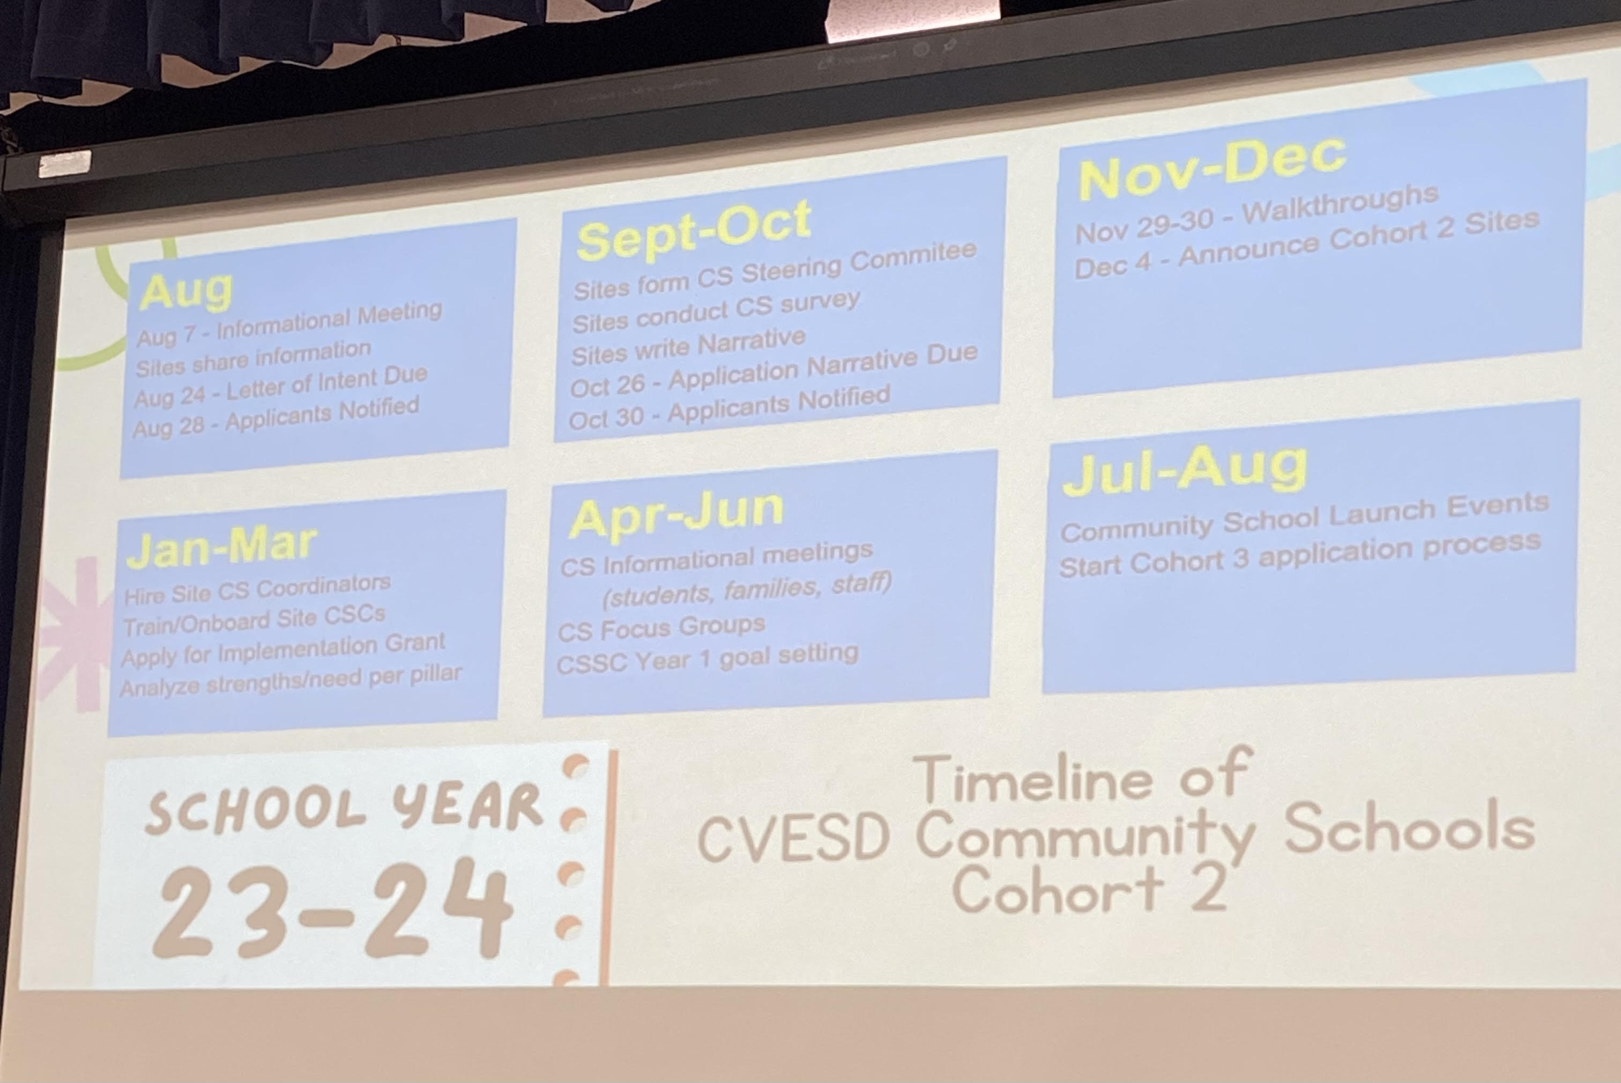*8-10 schools intended to be selected for phase 2  2023-2023 Aplicación de escuela comunitaria | Principal – Mayra C. Reyes
8:45am-9:15am | 2022-2023 Goal Progress  2022-2023 Progreso de metas  Single Plan for Student Achievement (SPSA)  Goal 1: ELA  Goal 2: Math  Goal 3: Multilingual English Learners (MELs)  Goal 4: Chronic Absenteeism  Goal 5: Suspension
9:15am-9:25am | 2023-2024 Budget Allocation & Proposed Amendments  2023-2024 Presupesto y enmiendas propuestras  Goal 1: ELA (Nearly Met)  K-2 Smarty Ants – improve from 15%-40% (+25%)  Actual met: 30% (+15)  2-6 Achieve3000 – improve from 9%-26% (+17)  Actual met: 21% (+12)  CAASPP – improve from 46%-50% (+4)  Actual met: 48% (+2)  Goal 2: Math (Nearly Met)  K-6 iReady – improve from 2%-26% (+24)  Actual met: 21% (+19)  CAASPP – improve 32%-40% (+8)  Actual met: 35% (+3)  Goal 3: Multi-Lingual Learners (Nearly Met)  42% Rohr students = MEL  ELPAC Assessment: Level 4 – 13% RFEP  Goal: grow at least 1 level: 56%  Level Results: 1 (19%), 2 (30%), 3 (41%), 4 (10%)  Goal 4: Chronic Absenteeism  Defined as: missing 10% of the school year (1-2 absences/month)  Goal: decrease from 26%-13%  PROPOSAL:  Increase noon-duty support by 1 hour/day (10am-1pm)  Current cost: $25,000 (title 1 and LCAP)  Additional Hour: $16,000 (title 1 – left over from beh. Interventionist)  Reyes set a motion  Ito seconds motion  LCAP Carryover ($30,000)  -reallocate carryover to pay for School Counselor  -formerly used for beh. Interventionist  Martin set a motion  Chambers Seconds motion  **amend SEL Behavior Reminders, amended to add activities $1000  Chambers set a motion  De La Torre seconds motion  SEL Tools $250  Ito set a motion  Chamber seconds motion  Teacher Release $1,000  Ito set a motion  De La Torre seconds motion  Library $750  Jones set a motion  Martin seconds motion  Childcare $1,000  Jackson set a motion  Damaris seconds motion  Buses/Field Trips $2,000  De La Torre set a motion  Jones seconds motion  Goal 5: Suspension  Budget for 2023-2024 (carry over not incuded)  -Total Allocation: $183,059  -Site Control: $22,575  -flexible spending  -contingent upon enrollment  -population: 315 (including preschool)  -LCAP: $74, 825  -state funding aligned to student needs  -Title I: $85, 659  -funding from the federal govt.  -fill out the free and reduced lunch applications  LCAP Carryover for 2023-2024  $59,098 | Principal – Mayra C. Reyes  SSC Members
9:25am-9:30am | Oral Communications  Comunicaciones orales | Principal – Mayra C. Reyes
9:30am | Adjournment (9:32)  Terminar junta  Next Meeting 9/05/2023 8:15am

