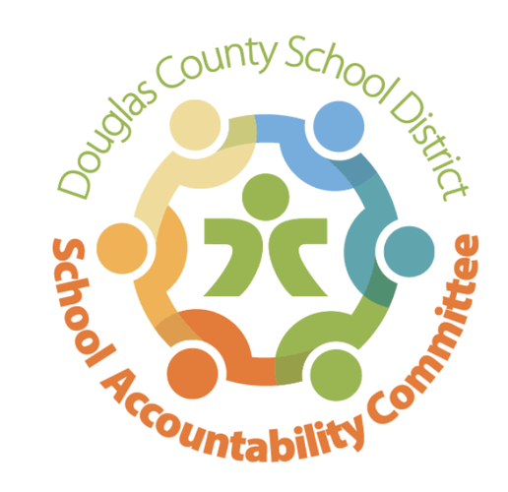2024-2025

Ranch View Middle School

School Accountability Committee (SAC)

**Meeting minutes 5/12/25:**

Location: RVMS Library

Time: 4:17 Meeting called to order

* Introductions & Quorum (in attendance: Erin Kyllo, Erin Turley, Lucas Kruse, Jenny Parks, Nancy Irvin, Sonya Illg, Alicia Stemmerman)

**Celebrations & School-Wide Past Happenings:** Erin Kyllo

* John Irwin Award, School of Excellence was received it last week at the district celebration at the Legacy Center
* Art awards and yearbook awards, track: new school record set!
* RVMS won Battle of the books
* 5/13 RVMS has 2 nominations at the field festival at the Legacy Center
* Recap of the 1st Annual RVMS Career Day
  + Big success, keynote speakers, wide variety of careers, ended with a closing from a Broncos player
* Recap of Grizzly Gives Week
  + Over $10,000 raised!!
* Recap of CMAS Testing (opt out numbers, etc.)
  + Opt out #s:

Reading 7th: 39 students opt out 8th: 53 student opt out

Math 7th: 35 students opt out 8th: 44 opt out

Science 8th: 47 opt out

* + Exploring barriers as to why students are opted out by their parents, Mrs. Kyllo attempts to contact parents who opt their student out to help support them/provide information to help remove barriers
* Recap of iReady Testing
  + Math proficiency 63%
  + Reading proficiency 73%
  + This is the first year there was an issue with AI cheating with students who used their own computers
* Pod Wars update
  + 7th Artic is in the lead!
* Staff Appreciation (May 5-9)
  + Theme based off the Battle of the Pods, mocktails were fun, thank you to Pit Crew for loving the staff so well!
* Choir performed our National Anthem at the Rockies game on May 10
* 8th Grade Moving Up Ceremony was May 9, the soon to be freshman enjoyed learning TRHS school spirit chants

**New Business:** Erin Kyllo

* Parent survey - coming
  + Going out to parents tomorrow, 5/13
  + Less than 30 questions
  + Last year 120 parents filled out the survey
* SAC Elections Vice Chair & Secretary
* Updates on the upcoming 2025/2026 School Year
  + Staffing Update: Open: 2 special Ed and 2 EAs and night custodian
    - Daytime custodian recently hired
  + 6th grade transition ideas
    - Hosting a virtual night for current 4th graders on 5/19
* School-wide Happenings:
  + Honor Roll Assembly: May 7 & 8
    - Largely attended by parents
  + Choir, Band, Orchestra Concert tomorrow, May 13
  + 8th Grade Science Fair coming up this week, on May 14
  + Yearbook Distribution on May 15, students can’t wait
  + Park Day: May 21
    - Permission forms past due! Will send out another reminder to parents
  + Battle to the Pods on May 22
  + Last day of School & 8th grade Color Run on May 23
  + NY/DC Trip: May 25-30
  + International Trip to Greece: June 3-11

**Standing Reports:**

* Teacher Report: Nancy Irvin here in place of Craig Moody
* DAC (District Accountability Committee): No representative present
* PIT Crew (Parent Teacher Organization) Report: Alicia
  + Sonya & Lyndsi ‘graduating’ out of RVMS, Alicia will be taking a lead position next year & they have 4 committed PIT Crew members for next year 2025/2026
* Community Report: Jenny Parks
* Principal’s Wrap-Up: Erin Kyllo

**Open forum for guests:**  (5 minutes)

* Community Members (3 min. max)
  + Mr. Grant talked to SAC and handed out a sheet with statistics on the # of documented counseling visits for this school year, classroom lessons that were given this year by the counselors (signs of suicide, how to identify their strengths, stress & coping skills), statistics on student engagement in the recent Career Fair (that was hosted by the counselors), and info on the Anxiety Group that was conducted by the counselors this year.

Meeting adjourned at 5:16

**Next SAC Meeting: 2025/2026 SAC Meeting Dates TBA**