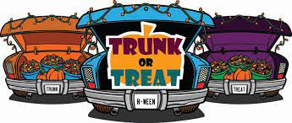

**TOWNSHIP OF SADDLE BROOK   
 TRUNK OR TREAT**

**OCTOBER 26th**

**RAIN OR SHINE**

**12-2 PM**



This Photo by Unknown Author is licensed under CC BY-NC

**55 Mayhill Street**

**DJ MUSIC & PRIZES**

**SADDLE BROOK RESIDENTS ONLY!**

**Non-perishable food and toiletries will be collected for the Saddle Brook Food Pantry**

**This event is not sponsored by the Saddle Brook Board of Education**

If you wish to enter your vehicle, please go to this link for more information and to sign up:

**https://volunteersignup.org/44JEM**