St Joseph School Pizza Order Form
2024-2025
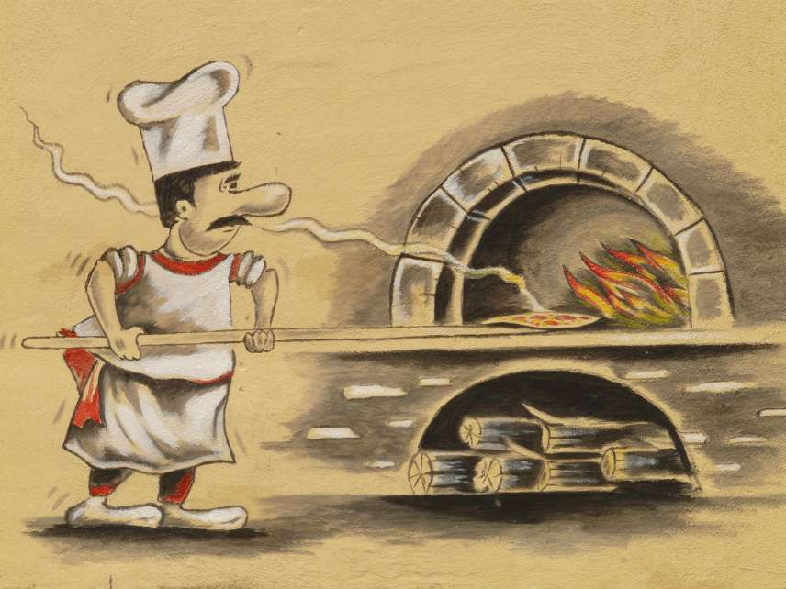
Parents who wish to purchase pizza for their children, there will be one pizza payment for the 2024-2025 school year. Pizza distribution will begin, Friday, September 20, 2024.
1 slice $ 55.00 per child/year
2 slices $ 105.00 per child/year
3 slices $160.00 per child/year



*** PIZZA FORMS ARE DUE BY FRIDAY, September 13,2024***

Family Name: __________________________________________

Email Contact: __________________________________________

Payment:

_____ Payment will be made via FACTS Management

_____ Payment attached: check payable to Saint Joseph School

Child 1: ____________________ Grade ________ # of slices ________Gluten-Free __________Total: $ _____________
Child 2: ____________________ Grade ________ # of slices ________Gluten-Free __________Total: $ _____________
Child 3: ____________________ Grade ________ # of slices ________Gluten-Free __________Total: $ _____________
Child 4: ____________________ Grade ________ # of slices ________Gluten-Free __________Total: $ _____________
Child 5:_____________________Grade ________ # of slices ________Gluten-Free __________Total: $ _____________

Grand Total: $ _____________

For any questions, please email: Assunta C. Eramo at Sue2621@yahoo.com

