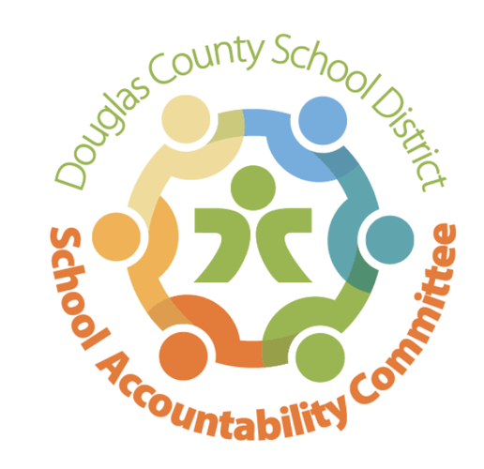2024-2025

Ranch View Middle School

School Accountability Committee (SAC)

**Meeting Minutes 1/27/25:**

Location: RVMS Library

Time: 4:17 Meeting called to order

* Introductions & Quorum (Present: Erin Kyllo, Erin Turley, Kate Welsh, Craig Moody, Jenny Parks, Alicia Stemmerman, Lyndsi Kocher, Lucas Kruse)
* Prior Meeting Minutes from 11/11/24 were approved in November and posted to the SAC Website

**Celebrations & School-Wide Past Happenings: (**Erin Kyllo)

* 2nd Semester off to a great start, nice to have students back
* Update on funds raised from the (caramel) Fundraiser: plans for staff ice-maker, white boards for PE, Science rooms are replacing chairs, art stools, FAC stools, stage curtain, wall mats in the gym, new wrestling mats, hand driers & water fountains. Wish list: Golf cart for security use, new marquee sign
* Pod Wars, just starting up the semester, further update next meeting
* Winter Play “The Greek Mythology Olympiaganza”, Winter Instrumental and Choir Concert were fantastic performances, students had worked hard & it paid off
* Turkey Trot school event for students
* RVMS Spelling Bee was on 1/9, the winners were: Logan Fogel, Cristian Torres Khotsyphom, and Jonah Klukowski, and runner up Amelia Brock
  + District Spelling Bee coming up on 2/1
* Passport to Excellence on 1/23 went smoothly and had approximately 300 participants

**New Business: (**Erin Kyllo)

* Updates on the upcoming 2025/2026 School Year
  + Open Enrollment Numbers: District predicts 850, Mrs. Kyllo predicts 820
  + Coffee Talk for incoming families changed from 2/6 @1:30 to 2/5 @1:30 due to schedule conflict
  + 6th Grade Registration is happening & Elementary School Visits are being made
  + Pod Visits by RVMS Administration focusing on harassment & discrimination
  + Mrs. Kyllo is inquiring about vape detectors in which the sensitivity can be set to THC only
* School-wide Happenings:
  + Parent-Teacher Conferences coming up on February 11 will have select times for invite only and select times for open house/student led
  + Valentine’s Day Dance coming up on February 13 @ 5:30 pm
  + Very excited for the 1st Annual RVMS Career Day coming up on February 28, plans to have 55 booths!
  + Grizzly Gives Week will be March 3-11 filled with Spirit Week/theme days, Penny Wars, T-shirt sales (and a donation link), Stop the Clock, Dodgeball, Homework passes
  + Spring Musical is Annie Jr. and will be on March 6-8
  + Band and Orchestra Concert will be on March 10
  + Last day of 3rd Quarter is March 14
  + Spring Break is March 17-21
  + CMAS Testing is April 7-18

**Standing Reports:**

* Teacher Report (Craig Moody) 8th grade boys basketball finished 2nd
* DAC (District Accountability Committee, Kate Thorne) there has been discussion on educator effectiveness, school consolidations will be in effect for the 2026-2027 school year
* PIT Crew (Parent Teacher Organization, Lyndsi Kocher) cookie exchange was fun & appreciated by staff, the Gift Crowds for staff were a hit, also did a CFA breakfast for staff. Coming up on 1/29 will be a Mod Market restaurant night fundraiser, on 2/11 will be crockpot meals for staff, on 2/26 will be a restaurant fundraiser from 4-8 at Freddies, in March PIT Crew will be gathering a ‘Rainbow of Snacks’ for CMAS
* Principal’s Wrap-Up (Erin Kyllo) students have proposed longer passing periods, late start on Fridays, and to have feminine products in the bathrooms.

**Open forum for guests:**

* None

**Next SAC Meeting: May 12th @ 4:15 in the RVMS Library**