Going to school is like being a princess. You go to school each day, and a princess has to go to work in her castle.

**Work Like A**

**Princess!**



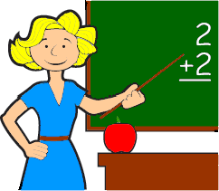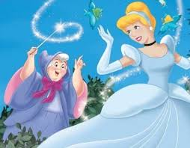When you get to school you have to **follow your schedule**. Your teachers have different things they need to teach you. When a princess gets to her castle she needs to follow a schedule too, and listen to the King and Queen. Or, listen to her Fairy Godmother!

Most of the time you need to **do work** that the teacher has prepared for their students. Princesses have to do work also. They have princess lessons that the King and Queen give them to practice, so, that she will be ready to be Queen someday. And sometimes, she has to clean the castle!

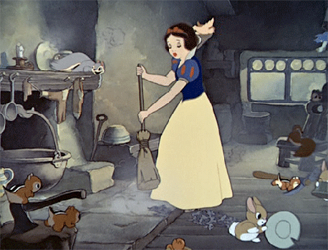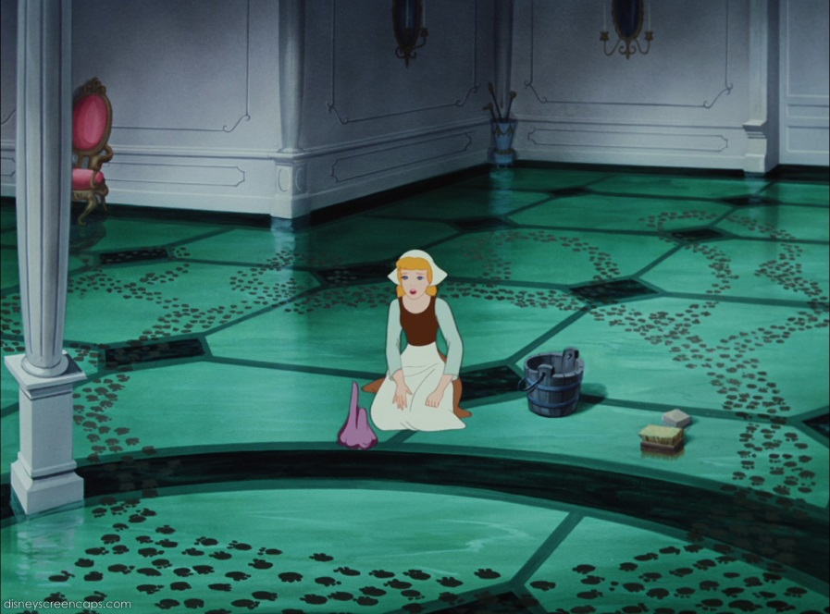

If you work hard, do your best and get all your **work done** you might have **choice time**! You can **take a break** from work, and do something fun!

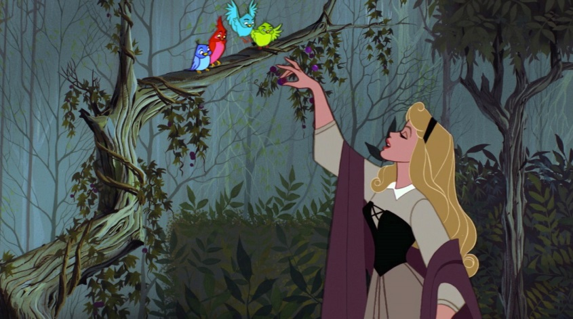Some princesses build a snowman.

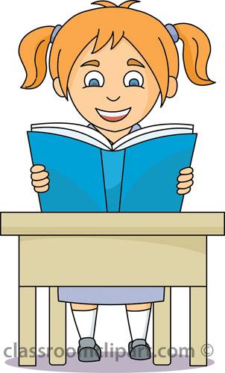

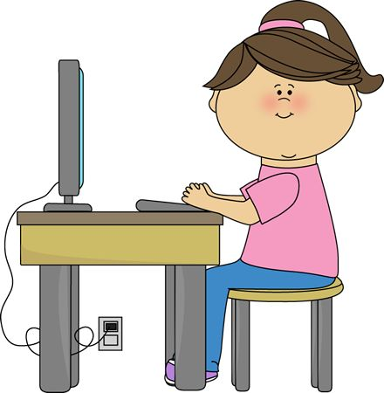After working hard at school, practicing and making positive choices, it is **choice time**! You can choose something fun to do like playing a game, coloring or u sing the computer.

After choice time it is **back to school work** and practice. Princesses need to be ready to do their royal duties and students need to be ready to do assignments and take tests.

Try to remember that going to school is like trying to be a good princess. You **work hard** and **do your best** each day trying to be the best student you can. Just like a princess works hard and practices to be the best Queen she can.

**Always work hard and do your best!**

**If you get frustrated, try to just, Let It Go!**