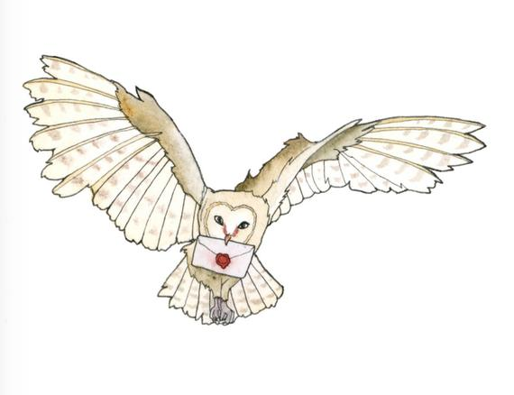

Work Like
Harry Potter

Going to school is like going to school at Hogwarts to become a wizard. You go to Grant Elementary each day and the wizards go to Hogwarts School of Witchcraft.

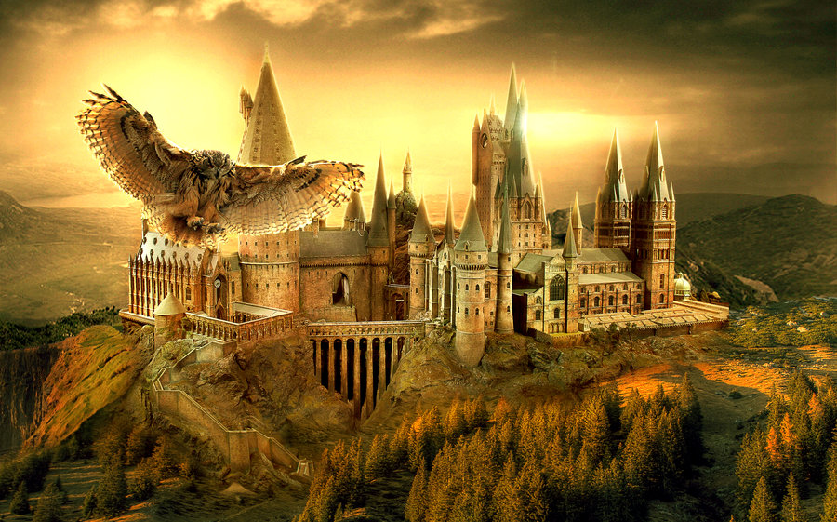


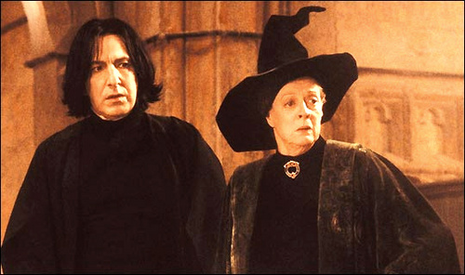
When you get to school you have to follow your schedule. Your teacher has different things she needs to teach you. When the wizards get to their class, they need to follow a schedule too and listen to what Serverus Snape, Professor Minerva McGonagall and Head Master Albus Dumbleore must teach them.


At school it is important to do your best. Most of the time you need to do work that the teacher has prepared for her students.

Harry Potter and Ron Weasley must practice too. They must work on the spells and potions with their professors, so they make sure to do it correctly and with success.
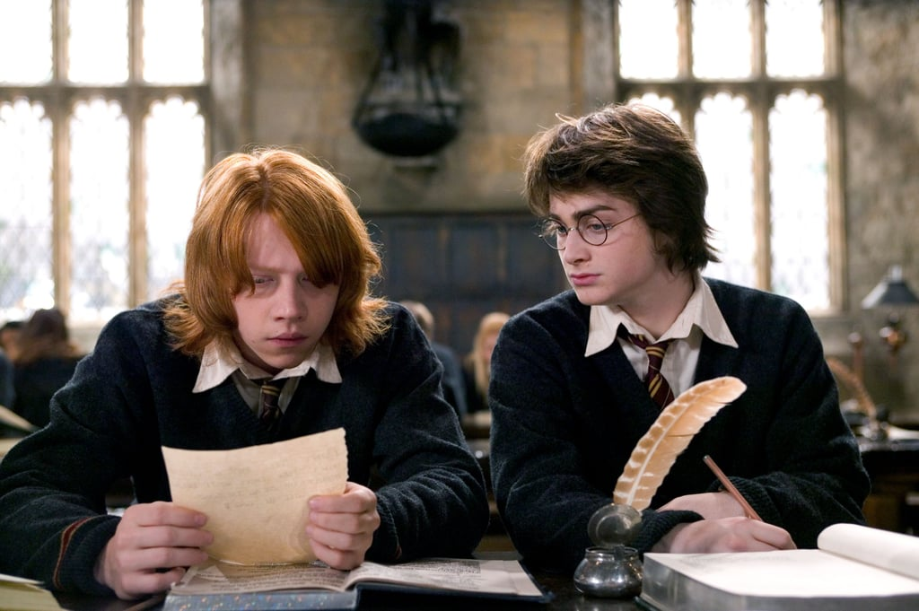
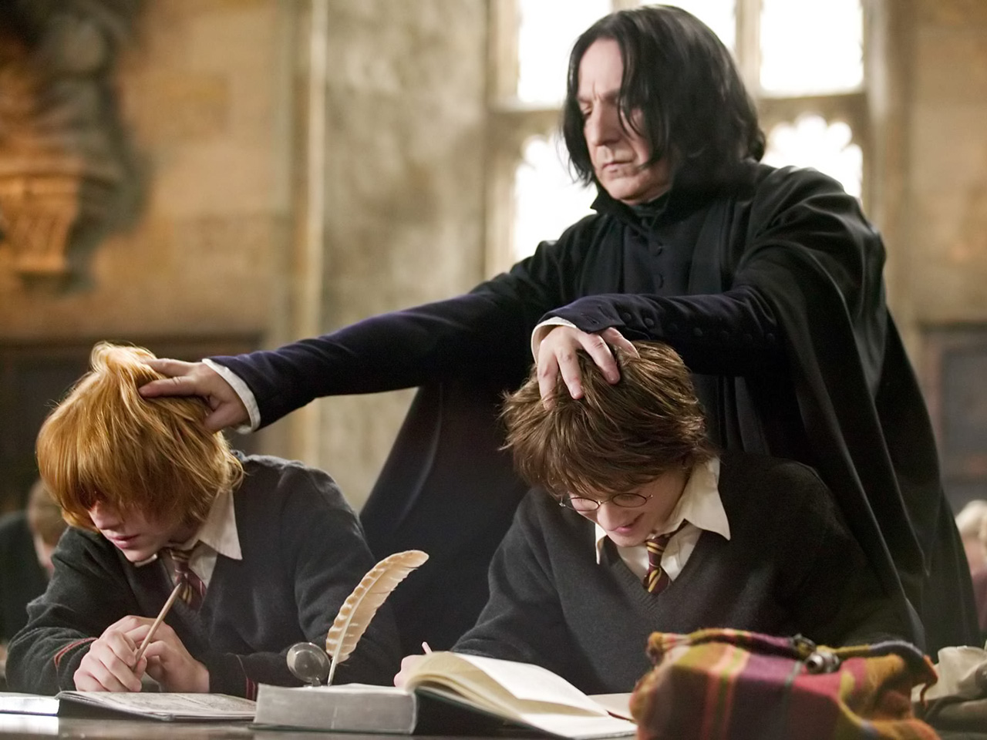

After Harry and Ron finish a long day of lessons and casting spells, they take breaks. If you work hard and get your work done you might have choice time. This means you can take a brain break from work and do something fun!
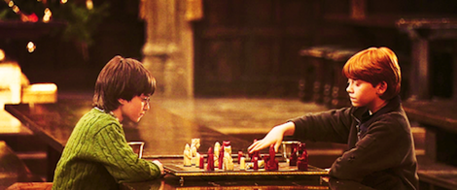



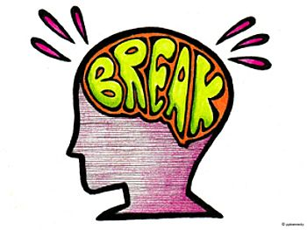
Once you have completed all your work at your desk, you too can choose something fun to do like using the iPad, reading a book, quietly visit with a friend or another teacher approved activity.

After choice time it is back to your school lessons. Harry, Ron and Hermonie need to be ready for their classes and you as a student, must be ready to follow lessons and take tests as well.


Try to remember that going to school is like being a wizard at Hogwarts, you work hard and do your best each day just like Harry Potter!
"It is our choices, Harry, that show what we truly are, far more than our abilities.”
To all you students;
work hard and
do your best!



