I’ll Remember to Use Words

It’s fun to go to school.

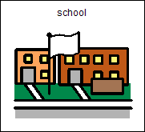

I can read books and draw when I’m at school.

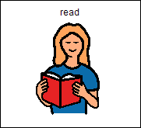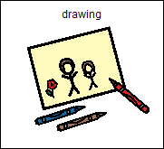

I can follow my schedule.

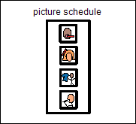

Sometimes, my teacher asks me to do something that I don’t want to do.

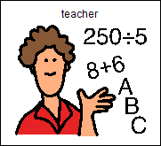

I will try to remember to use my words.
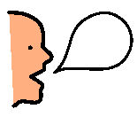
I can say, “I don’t want to”.
Or, I can say, “Can I do something else?”

When I must do something that I don’t want to do, I feel angry. I feel like screaming.

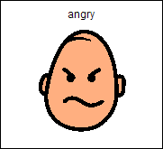

I will try not to yell or cry.

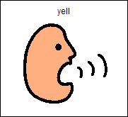

I can take deep breaths to calm down.

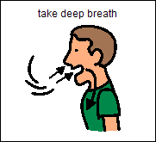 1 2 3 4 5

I will try to remember to:

Use My Words!

