All About Hugging and Touching

Hugging is a nice way to tell someone you really care about them.

Sometimes kids hug their Moms, Dads, Grandmas, Grandads or brothers and sisters.
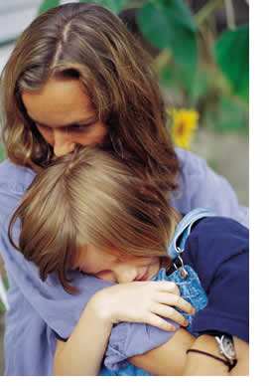
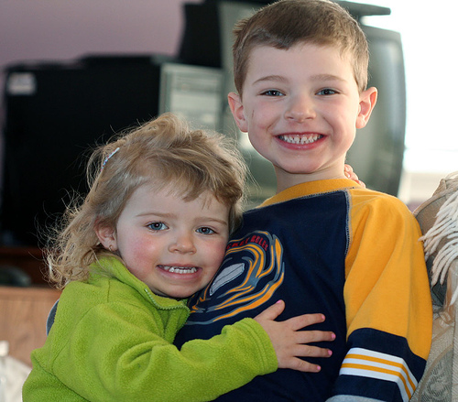

Sometimes kids hug their cats or dogs….or even teddy bears!

Little children sometimes hug each other, too.

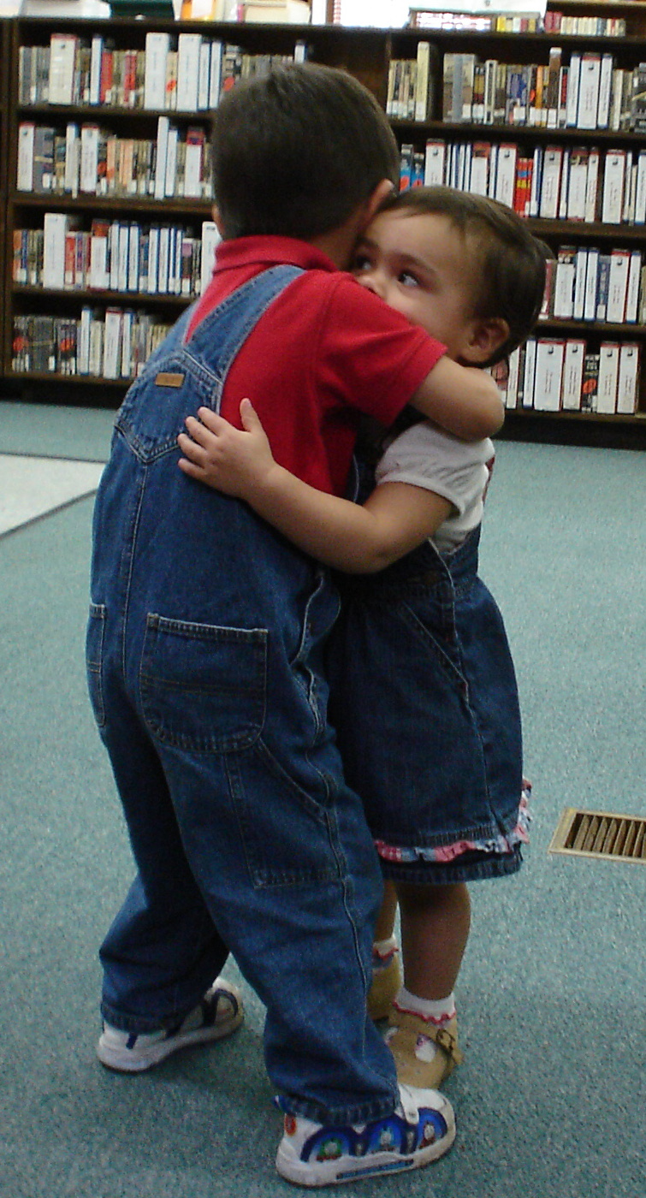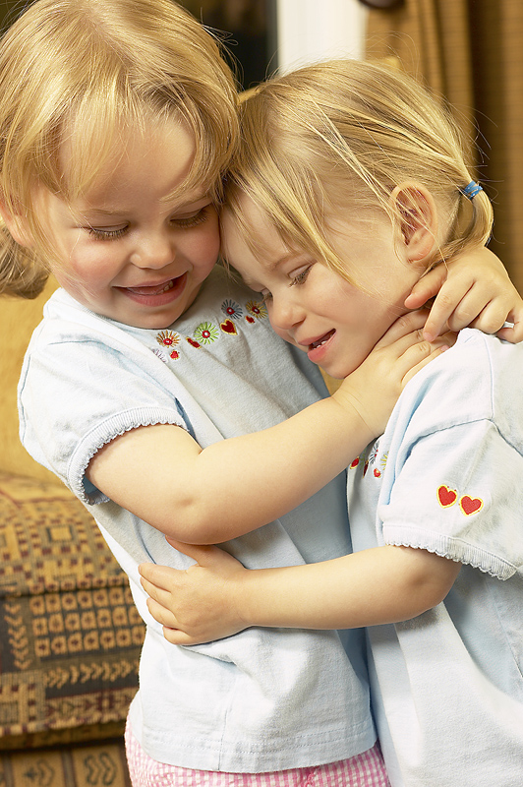

But, when kids get a little older, they aren’t so comfortable about hugging and touching.

When kids are in 2nd grade (and older), they usually keep a little more space between them when they are playing, talking or sitting.

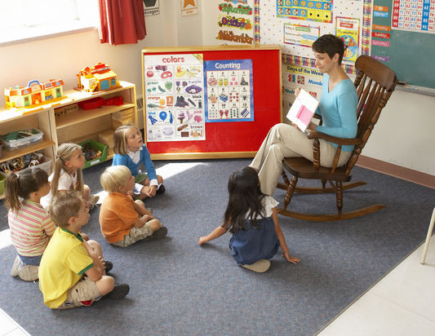
Here are kids sitting in class. They sit with space between them so they aren’t touching each other. They are trying not to bother others. They are not leaning on each other, either.


These two girls are friends. They are sitting together on the bus. There is a little space between them and they are not touching each other or leaning on each other.

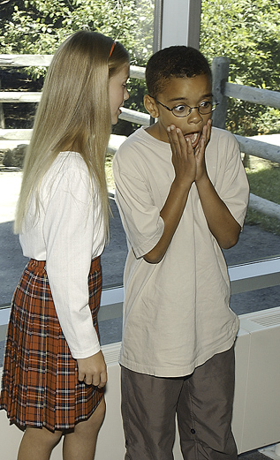
This girl is telling the boy a secret. But, she still leaves a little space between them. She is not touching him or leaning on him.

Sometimes it’s hard to understand when it’s OK to touch or hug someone and when it is not OK. Here are some hints:

When you are playing together, sometimes your knees or shoulders or arms touch each other – That’s OK!

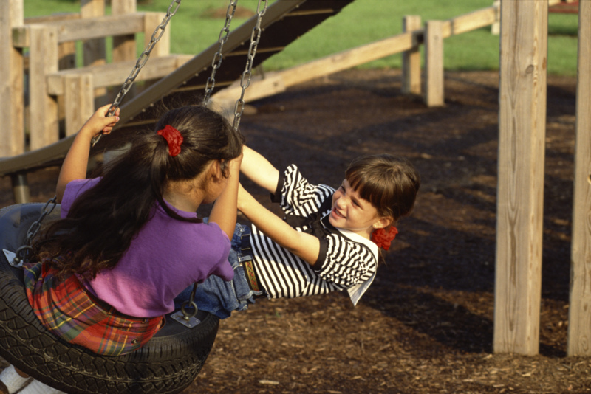

Sometimes friends put their arms around each other for a quick hug when they are getting their picture taken or when they just see each other for the first time that day. These are called sideways hugs – just one of your arms on your friends shoulder. These are also quick hugs – only about 5 seconds. Usually girls give each other these quick sideways hugs, but not boys.



When you get older, it’s usually better to just say Hi or wave instead of hugging or touching your friends.

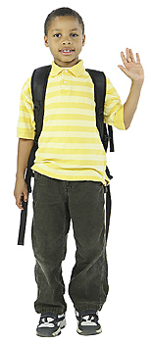

You can tell when someone isn’t very comfortable with touching or hugging. Do you know how you can tell?

When someone isn’t comfortable with touching or hugging, they step back or pull away from you. When this happens, it’s a good idea if you step back also. That shows that you understand.

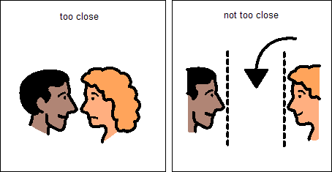

So, now you know about touching and hugging when kids get older. Here are some things to remember:

It’s OK to touch or hug members of your own family
Some kids are uncomfortable when you are too close
Quick sideways hugs are OK with good friends (usually girls)
If kids pull away or step back, it’s a good idea for you to step back, too. That will make both of you more comfortable.


