|  |  |  |
| --- | --- | --- |
| 8:00 | Unpacked and got ready for the day | 😊 ☹ |
| 9:00 | Stayed in class and was safe | 😊 ☹ |
| 10:40 | Stayed in class and was safe | 😊 ☹ |
| 11:45 | Safe at lunch and recess | 😊 ☹ |
| 1:00 | Stayed in class and was safe | 😊 ☹ |
| 2:30 | Stayed in class and was safe | 😊 ☹ |
| Specials Class | Stayed in class and was safe | 😊 ☹ |

After I earn 2 smiley faces, I want to earn:

Key for Key Ring 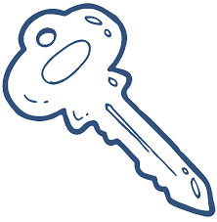

Video of Dogs

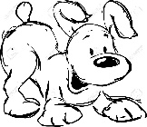

Picture of Dogs

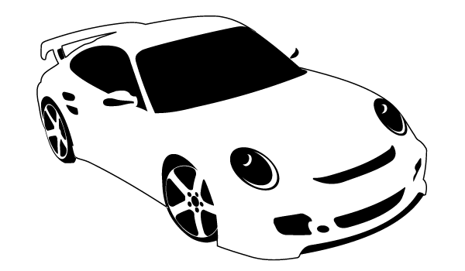Picture of Car

Do a job 