**TODAY IS:** _________________________

**Today I Felt:** Happy Sad Cranky Confused Excited Tired

**My Choices Were:** Awesome Okay Not Good

**Things To Remember To Tell My Adult:** _____________________________________________________________________________________

_____________________________________________________________________________________

_____________________________________________________________________________________

_____________________________________________________________________________________

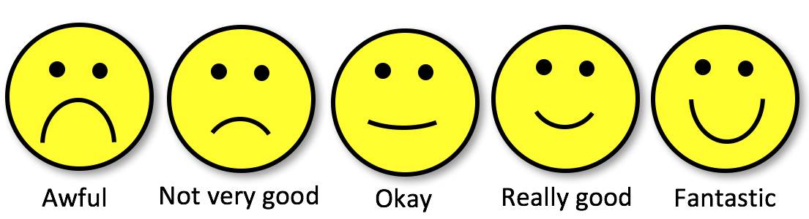**I got along with others while behaving in a friendly and appropriate way.**

**I completed class assignments on time, applying my best effort.**



**I spoke respectfully to adults and followed their requests without arguing or complaining.**



**I paid attention to my teacher or the assignment during class or work periods.**



**I bet tomorrow will be:** Another Great Day A Little Better Than Today **A LOT** Better Than Today

**Tomorrow will be better because:**

_____________________________________________________________________________________

_____________________________________________________________________________________