­­­ 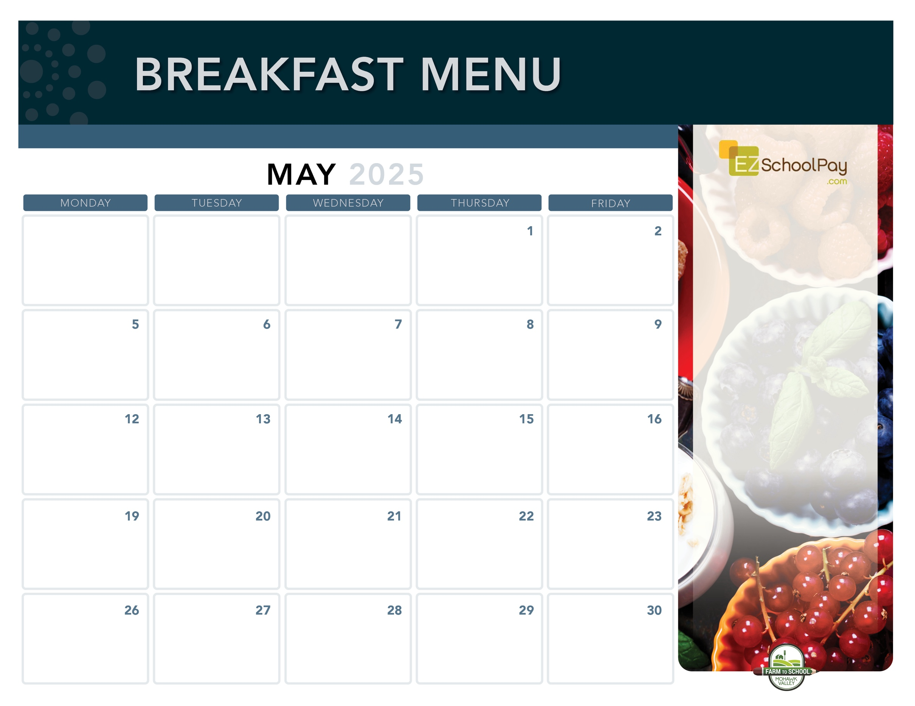

**New!**

Yogurt

Parfait

Berry

Smoothie

**Sauquoit Valley Elementary School**

Assorted Whole

Grain Muffins

& Yogurt

Cinnamon   
Bun

Homemade Banana

Chocolate Chip Muffin or Muffin Bar

& Yogurt

**School Lunch**

**Hero Day!**

Scrambled Eggs

& Whole Grain Toast

**Available Daily**

-Yogurt

-Assorted Whole

Grain Cereals

-Fresh Fruit

-Chilled Fruit Juice

-Ice-Cold New

York State Milk

Plain or Chocolate

OHM BOCES Food Service is an Equal Opportunity Employer.

Assorted Whole

Grain Muffins

& Yogurt

**Memorial Day –**

**No School**

Snackin’

Waffle

Pancake

Sausage Stick

Whole Grain

Pancakes

Whole Grain

Pancakes

***1:00 Dismissal***

**No School**

Fruit

Frudel

Mini

Cinni

Good

Morning Wrap

Breakfast

Pizza

Nature Valley

Oatmeal Round

Breakfast

Sandwich

Mini

Cinni

Snackin’

Waffle

Whole Grain Bagel

with Cream Cheese

Breakfast is Free | Menu is subject to change | For more information, contact hdussault@oneida-boces.org