­­­ 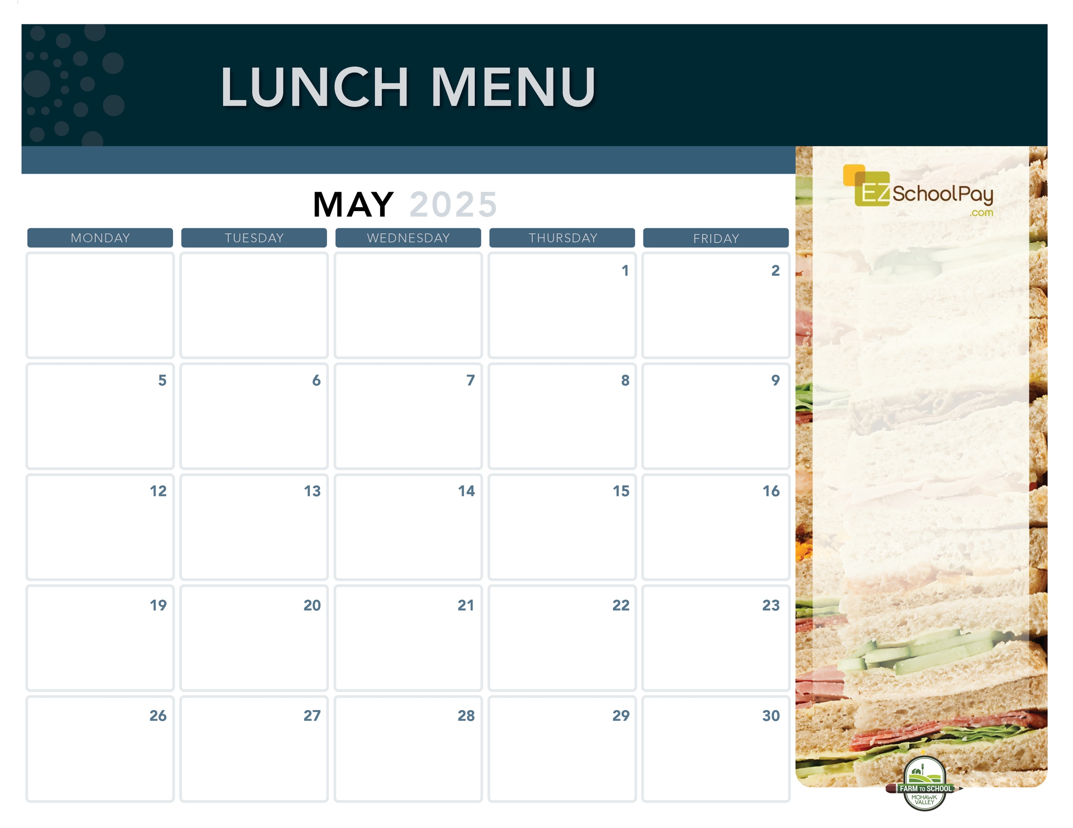

**Dip N’ Sip**

**Grilled Cheese**

**& Tomato Soup**

Mixed Deli Sandwich

Maple Glazed Carrots

Jello

**Mozzarella Sticks**

**with Dipping Sauce**

Deli Ham Sandwich

Green Beans

**Pizza Party!**

Cheesy Cheese or

Sausage Pizza

Fresh Green Salad

***1:00 Dismissal***

**Memorial Day**

**No School**

**Pizza Party!**

Cheesy Cheese or

Garlic Pizza

Caesar Salad

**Homestyle**

**Chicken Tenders**

Steamy Rice

Tuna Salad Sandwich

Broccoli

**Chicken & Cheese**

**Quesadilla**

Cilantro Lime Rice

Deli Turkey Sandwich

Corn

**Crispy Chicken or**

**Chicken Parm Sandwich**

Tuna Salad Sandwich

Broccoli

**Pizza Party!**

Cheesy Cheese or

Buffalo Chicken Pizza

Caesar Salad

**Sauquoit Valley Elementary School**

**New!**

**Boneless**

**Chicken Bites**

**Plain or BBQ**

Tuna Salad Sandwich

Broccoli

**Pulled Pork Sandwich**

**with Macaroni & Cheese**

Honey Lime Slaw

Deli Ham Sandwich

**Boneless**

**Chicken Bites**

**Plain or Teriyaki**

Deli Turkey Sandwich

Broccoli

**School Lunch**

**Hero Day!**

**Pizza Party!**

Cheesy Cheese or

Pepperoni Pizza

Fresh Green Salad

**Brunch for Lunch!**

French Toast Sticks

Breakfast Sausage

Mixed Deli Sandwich

Golden Hashbrown

**Italian Dunkers**

**with Dipping Sauce**

Deli Ham Sandwich

Green Beans

Miss Mila’s Chocolate Chip Cookie

Turkey Gravy Dinner Roll Mixed Deli Sandwich Whipped Potatoes Veggie Choice

**Dino’s Own**

**Meatball Sub**

Mixed Deli Sandwich

Green Peas

**Italian Dunkers**

**with Dipping Sauce**

Deli Ham Sandwich

Green Beans

Grape Slushie

**Brunch for Lunch!**

French Toast Sticks

Breakfast Sausage

Mixed Deli Sandwich

Golden Hashbrown

**Taco Tuesday**

Beef Tacos

Lettuce, Tomato & Cheese Cup

Deli Turkey Sandwich

Street Corn Salad

**New!**

**Pizza Party!**

Cheesy Cheese or

Pepperoni Pizza

Fresh Green Salad

**No School**

**Available Daily**

Fresh Entree Salads

Party Plates

Peanut Butter & Jelly Sandwich

Fresh Sandwiches

Assorted Fresh Fruit

Vegetable Cruncher Cups

Variety of Fresh Fruit & Juice

Ice Cold New York State Milk

Plain or Chocolate

**Local Items this Month**

Milk, Yogurt, Corn, Carrots, Green Beans, Miss Mila’s Cookie,

Grape Slushie

Local items are indicated with a star on the menu

OHM BOCES Food Service is an Equal Opportunity Employer.

Lunch is Free | Menu is subject to change | For more information, contact hdussault@oneida-boces.org