
2024-2025 Weekly Lesson Planning Document
Template for the following:
Science, Social Studies, CTE, World Languages,
HPELW, Fine Arts, JROTC
Week of Monday, November 18 through Friday, November 22

EDUCATOR’S NAME: ___ Ms. Burton, Ms. Daughrity, Ms. Mitchell ____________________________________ SUBJECT: ______Chemistry I______________________________________
 | MONDAY | TUESDAY | WEDNESDAY |  | THURSDAY | FRIDAY
Lesson Title:  Unit:  Chapter:  Page Number(s):  (It is suggested that you use your curriculum map.) | Unit 4  Chapter 8:  Chemical Equations & Reactions  pp. 253-279 | Unit 5  Chapter 2:  Measurements & Calculations  pp. 37-38 |  | Unit 5  Chapter 2:  Measurements & Calculations  pp. 38-39 | Unit 5  Chapter 2:  Measurements & Calculations  pp. 39-40 |  | Unit 5  Chapter 2:  Measurements & Calculations  pp. 40-42
TN Standard(s):  Grade level standard (include standard notation and language).  Which State Standard is your lesson addressing? This should also be on your Whiteboard Protocol. | CHEM1.PS1.2 Demonstrate that atoms, and therefore mass, are conserved during a chemical reaction by balancing chemical reactions.  CHEM1.PS1.4 Use the reactants in a chemical reaction to predict the products and identify reaction classes (synthesis, decomposition, combustion, single replacement, double replacement).  CHEM1.PS1.1 Understand and be prepared to use values specific to chemical processes: the mole, molar mass, molarity, and percent composition.
Objective (s):  What specifically should students be able to do at the end of the lesson? The objective is standards-based.  Write the objective in student friendly terms. For example, I can multiply binomials.  This is should also be on your Whiteboard Protocol.  What do you want students to know, understand and be able to do as a result of this lesson?  The objective should be written using the stem…  I CAN…. | I Can…  Recall and apply all previous knowledge concerning chemical equations and reactions. | I Can…  Define SI base units for time, length, mass, and temperature. |  | I Can…  Explain how adding a prefix changes a unit. | I Can…  Perform metric prefix conversions. |  | I Can…  Explain the concept of a derived unit and give examples that are used in chemistry.

Possible Misconception (s):  What misconception(s) are you anticipating during this lesson? | Students often think they can balance the elements on each side of an equation by changing the subscripts rather than changing the coefficient.  Draw models of cubes on the board or display some three-dimensional models of cubes to help students with spatial relationships. Students often make errors in comparing related cubic units. For example, students know that there are 1000 mm in 1 m. They may then incorrectly assume that there are 1000 mm³ (103 mm³) in 1 m³ instead of the 109 mm³ that are actually present (103 mm × 103 mm × 103 mm = 109 mm³). Draw a model for this cube so students can see why a cube with lengths of 1000 mm per side has a volume of 1 × 109 mm³. Both the numerical value and the unit must be cubed.
Literacy-Based DO NOW:  This literacy-based activity should be ready for students to begin working on upon entering class. Students should have an opportunity to read, write, and/or speak. | Prepare for the Chapter 8 Test. | Why is it important for ALL scientists to use the same standards for measuring matter? |  | Why is the Kelvin scale the preferred temperature scale for performing calculations in science? |  | What prefix would be the best to use (with the base unit meter) if you are measuring the length of the sink at your lab table? Explain your reasoning! |  | Use the metric stairstep (on p. 3 of your notes) to convert…  a. 0.00573 cm ? → μm  b. 8924 mL ? hL  c. 32 GB ? daB
Agenda for the Day  Simple outline of lesson segments or activities that is time stamped.  Teacher/class should take 2 minutes or less to review. | - Do Now (8 minutes)  - Test (42 minutes) | - Do Now (8 minutes)  - Review Learning Objective (2 minutes)  - I Do (12 minutes)  - We Do (12 minutes)  - You Do (13 minutes)  - Exit Ticket (5 minutes) |  | - Do Now (8 minutes)  - Review Learning Objective (2 minutes)  - I Do (12 minutes)  - We Do (12 minutes)  - You Do (13 minutes)  - Exit Ticket (5 minutes) |  | - Do Now (8 minutes)  - Review Learning Objective (2 minutes)  - I Do (12 minutes)  - We Do (12 minutes)  - You Do (13 minutes)  - Exit Ticket (5 minutes) |  | - Do Now (8 minutes)  - Review Learning Objective (2 minutes)  - I Do (12 minutes)  - We Do (12 minutes)  - You Do (13 minutes)  - Exit Ticket (5 minutes)
Beginning of Lesson  I Do  Science: Engage & Explore | I will distribute the Chapter 8 Test to the class. | I will provide information concerning the fundamental SI units used by the scientific community. |  | I will explain the need for metric prefixes in order to adjust a base unit to the proper “size” required by a measurement. |  | I will model how to use the stairstep method to convert measurements between metric prefixes. |  | I will introduce the concept of derived units and provide examples of commonly used derived units in chemistry.
Middle of the lesson  We Do  Science: Explain and Elaborate |  | Respond to CFUs embedded in the guided notes to indicate mastery of the concepts covered in class today. |  | Respond to CFUs embedded in the guided notes to indicate mastery of the concepts covered in class today. |  | Respond to CFUs embedded in the guided notes to indicate mastery of the concepts covered in class today. |  | Respond to CFUs embedded in the guided notes to indicate mastery of the concepts covered in class today.
End of the lesson  You Do  Science: Evaluate | Complete the Chapter 8 Test to demonstrate mastery of concepts concerning chemical equations and reactions. | Respond to CFUs embedded in the guided notes to indicate mastery of the concepts covered in class today.  Ask any questions I have concerning using the fundamental SI units used by scientists. |  | Respond to CFUs embedded in the guided notes to indicate mastery of the concepts covered in class today.  Ask any questions I have concerning metric prefixes and their meanings. |  | Respond to CFUs embedded in the guided notes to indicate mastery of the concepts covered in class today.  Ask any questions I have concerning converting measurements between metric prefixes. |  | Respond to CFUs embedded in the guided notes to indicate mastery of the concepts covered in class today.  Ask any questions I have concerning derived units and how they are obtained.
(05 MINUTES MAX)  Literacy Based closing activity:  Engage students in reading and writing tasks that assess their understanding of the lesson. Students are drawn back to the objective for the day. |  | Complete literacy-based Exit Ticket question on paper or in Microsoft Forums. Will be based on what was discussed in lesson for the day. |  | Complete literacy-based Exit Ticket question on paper or in Microsoft Forums. Will be based on what was discussed in lesson for the day. |  | Complete literacy-based Exit Ticket question on paper or in Microsoft Forums. Will be based on what was discussed in lesson for the day. |  | Complete literacy-based Exit Ticket question on paper or in Microsoft Forums. Will be based on what was discussed in lesson for the day.
SPED Modification (s):  What modifications are being made to accommodate the students receiving special services? | Extended time on assignments; ability to correct assignments; reduced number of problems  Planned/preferential seating  Allow breaks during class  Extended time for testing; reduced choices on multiple choice tests  Repeating directions verbatim
ESL Modification (s):  What modifications are being made to accommodate the students receiving special services? | Small group instruction  Read aloud for assessments  Interactive reader for computer assignments  Extended time on assignments and tests  Opportunity to redo assignments and correct tests based on teacher feedback  Bilingual support provided by translated copies, peers, and dictionaries
Assessment (s):  How will you know that students have reached the objective?  Assessments may include:  Pre-assessment, formative assessments, summative assessment, post-assessment, discussions, performance, demonstration, etc. | Formative assessments from the CFUs embedded in the guided notes and the exit ticket. |  | Formative assessments from the CFUs embedded in the guided notes and the exit ticket. |  | Formative assessments from the CFUs embedded in the guided notes and the exit ticket. |  | Formative assessments from the CFUs embedded in the guided notes and the exit ticket. |  | Formative assessments from the CFUs embedded in the guided notes and the exit ticket.
Corrective Activity (s):  What will I do if the student doesn’t understand the lesson? | -Weekly tutoring sessions  -Peer tutoring partners.  -Opportunity for corrections. |  | -Weekly tutoring sessions  -Peer tutoring partners.  -Opportunity for corrections. |  | -Weekly tutoring sessions  -Peer tutoring partners.  -Opportunity for corrections. |  | -Weekly tutoring sessions  -Peer tutoring partners.  -Opportunity for corrections. |  | -Weekly tutoring sessions  -Peer tutoring partners.  -Opportunity for test corrections.
Extension/Enrichment Activity (s):  What will I do with students who understand quicker than others? | - Have each student imagine that he or she, along with other passengers, has become shipwrecked on an island. With no chance of rescue, the castaways decide to start a new country and elect him or her president. One of the first tasks of the president is to divide up the land among the people in a way that is fair to all. But the president realizes he or she has nothing to use for taking measurements and so has to come up with a new measuring system. On a sheet of paper, have students answer the following questions: 1) What will you call your unit of measurement? 2) Why would it be important to use a consistent standard of measurement? 3) What factors would be important as a basis for your measurement?  - Have students select five liquids from Figure 2.8. Ask them to imagine that the five liquids are mixed in a large container and then poured into a graduated cylinder, such as the one shown in Figure 2.7. Have students predict what will happen as time passes  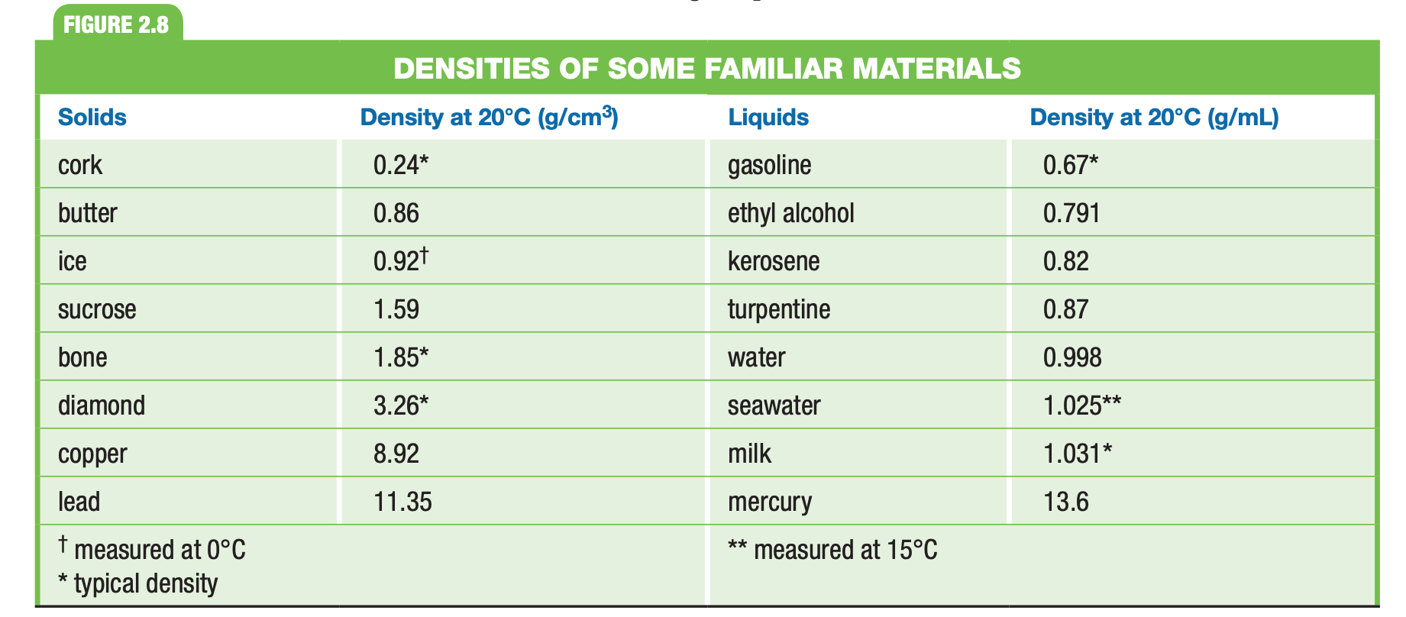
Technology Integration:  How will the students use technology to help them master the objective. | - Use district-issued electronic device to complete online assignments, formative assessments (exit tickets), and summative assessments.

IN THE FOLLOWING PAGES:
ONLY COMPLETE SECTION(S) BELOW IF YOUR SUBJECT IS IDENTIFIED/LISTED
ALL SCIENCE (S):  What is your resource plan for each of the 5 Es of inquiry-based science instruction?  - Engage  - Explore  - Explain  - Elaborate  - Evaluate | Engage  - Ch. 2 Section 2 Classroom Catalyst, TE p. 37  - Ch. 2 Section 3 Classroom Catalyst, TE p. 48  - Differentiated Instruction TE pp. 38-42; 48; 52; 57; 59-60.  Interactive Video  - Chapter 2: Why It Matters: Measurements and Calculations  https://my.hrw.com/content/hmof/science/hss2017/tn/gr9-12/hmd_chem_9781328833594_/dlo/whyitmatters/index.html?vid=1  Explore  Laboratory Activities/Investigations/Animations & Simulations  - Virtual Lab: Using Units and Measurements  https://my.hrw.com/content/hmof/science/hss2017/tn/gr9-12/hmd_chem_9781328833594_/dlo/virtuallab/c02_00vl16/index.html  - PhET Simulation: “Density”  http://phet.colorado.edu/en/simulation/density  - Uncertainty in Measurements  http://antoine.frostburg.edu/cgi-bin/senese/tutorials/sigfig/index.cgi  - Precision and Accuracy  http://www.learner.org/courses/learningmath/measurement/session2/part_c/accuracy.html  - “Rags to Riches” Game (Scientific Notation and the Metric System)  http://www.quia.com/rr/83587.html  Explain  Textbook  - Units of Measurement, pp. 37-46  - Using Scientific Measurements, pp. 48-61  - Interactive Reader: Section 2.2 and 2.3  Elaborate  - Cross-Disciplinary Connection: Classical Ideas About Matter (SE)  (HRW RESOURCE)  - Differentiated Instruction (TE wrap) (HRW RESOURCE)  - WebLinks (HRW RESOURCE)  Evaluate  - Ch. 2 Section 2 Formative Assessment, TE/SE p. 46  - Ch. 2 Section 3 Formative Assessment, TE/SE p. 61
ALL SCIENCE (S):  (Multiple opportunities to engage in science, Makes since of science content)  What is your plan to incorporate technology while incorporating the 5E instructional model? | SUGGESTED OPPORTUNITIES FOR TECHNOLOGY  1. PhET Simulations  2. Microsoft Forms  3. Virtual Lab

