Kindergarten Supply List

Full size backpack
Two (2) boxes of CRAYOLA crayons
1 package of pencils
2 bottles of glue
6 glue sticks
2 boxes of Kleenex tissue
2 rolls of paper towels
1 tub of Lysol wipes
1 pair of FISKAR scissors (kid size)
2 reams of copy paper
Ziplock bags (gallon & quart size)


Thank you for coming prepared to school! We are looking forward to a successful year with you.
Sincerely,
First Grade Teachers
  - 1 backpack (no rollers)
  - 3 packs of dry erase markers
  - 5 packs of pencils
  - 2 packs of cap erasers
  - 2 packs of pink rectangular erasers
  - 1 inch 3 ring binder with/ clear pocket
  - 1 pencil box
  - 2 boxes of crayons
  - 1 pack of washable markers
  - 1 pack of colored pencils
  - 2 primary composition books for writing

  - 1 ride rule composition book for math
  - Plug in headphones
  - 2 two pocket folders
  - 3 containers of Clorox wipes
  - 2 bottle of hand sanitizer
  - 2 rolls of paper towels
  - 3 pack of glue sticks
  - 1 pack of band aids
  - 2 anti-bacterial liquid soaps
  - 1 reap of colored
  - 1 box of gallon zip lock backs
  - 2 primary composition books for writing
  - 1 ride rule composition book for math
  - Plug in headphones
  - 2 two pocket folders

  - 1 box of sandwich zip lock bags
  - 2 rolls of paper towels

Dear Bulldog Families,
Welcome to 1st grade! Below is a list of supplies you will need for the school year.

Bruce Elementary School

Second Grade Supply List 2023-2024
2 spiral notebooks
2 packs of notebook paper
4 packs of pencils (supply all year)
2 packs of Crayola crayons (24 pack)
1 pair of scissors
Headphones
2 glue sticks
(2) Blue 3 prong folders
(2) Yellow 3 prong folders
1 pencil pouch (please no pencil boxes)
1 whiteboard
Dry Erase Markers
1 pack of copy paper
2 bottles of hand sanitizer (supply all year)
1 can of Disinfectant Spray
2 containers of Clorox Wipes (supply all year)
1 quart size box of Ziploc Bags
1 gallon size Ziploc Bags

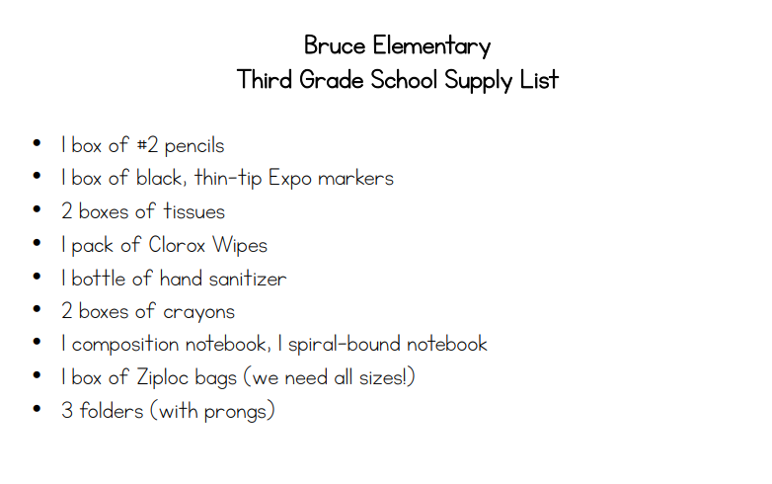

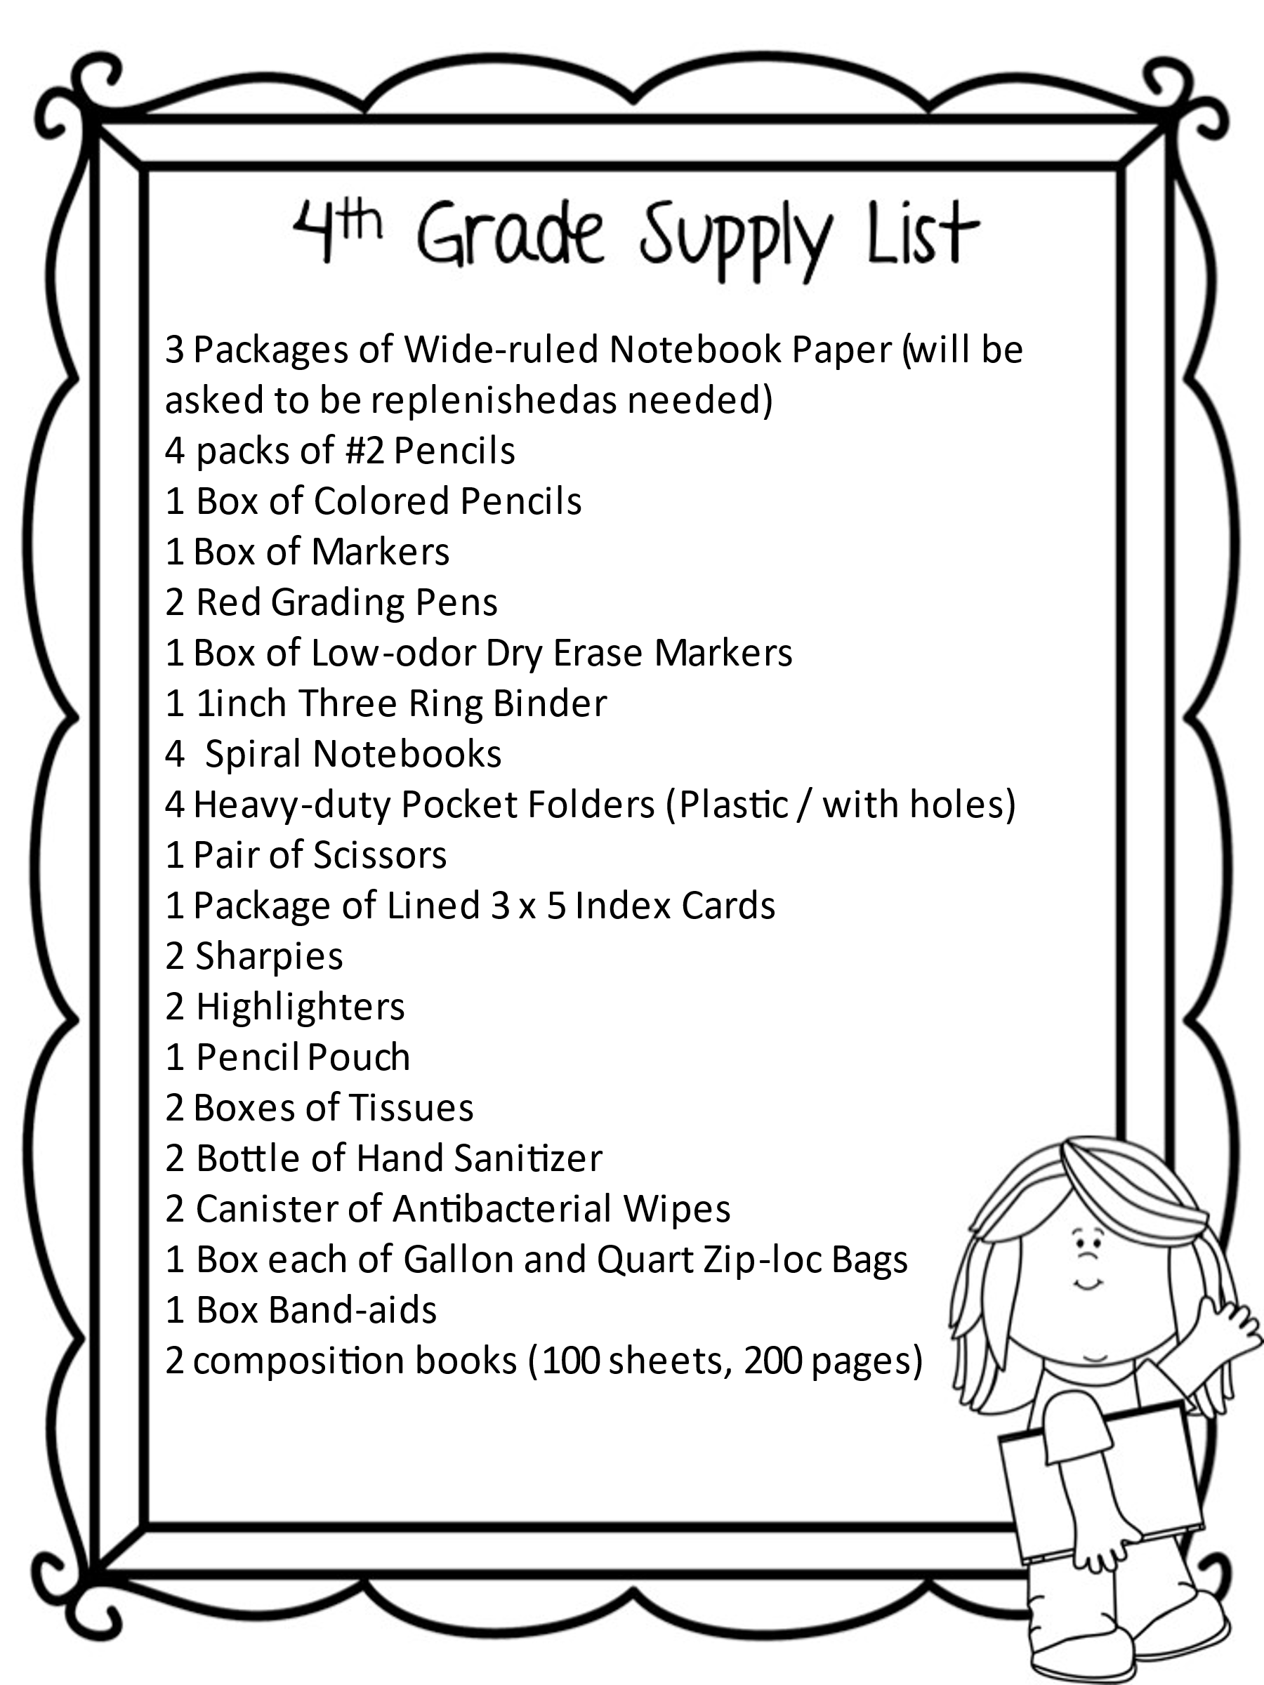

Bruce Elementary School
Fifth Grade Supply List
4- packs of wide-ruled, loose-leaf paper
4- packs of 24 count #2 pencils (NO MECHANICAL PENCIL)
2- pack color highlights
1-pack color pencils or markers
1-pack erasers
1-pack of index cards
1-ream of copy paper
4- 3-hole poly pocket folders (yellow- science, black-social studies, blue-reading, red-math)
1-3in binder
1-school pencil pouch w/3 holes for supplies (No plastic bag)
1-composition notebook
Headphones for Computer Intervention/Programs
1-pack of dry erase markers (thin black tip)

Homeroom Supplies:
3- boxes of larger Kleenex tissue
2- container of Clorox wipes
1-box of gallon zip-lock bags
1-box of quart zip-lock bags
1-bottle of hand sanitizer


