RTI²-Behavior Implementation Manual
Barret’s Chapel School
Shelby County Schools

DATE CREATED: 03-22-2019
DATE LAST MODIFIED:09-23-2020
2019-2020 TEAM MEMBERS: Lawanda Womack, Chris Stallings, Destin DeMarco, Kathy Knight, Coach Jim Harbin, Cassie Turner




TABLE OF CONTENTS

RTI²-B Overview…………………………………………………………………………………………….
Purpose Statement……………………………………………………………………………………….
Team Composition and Norms……………………………………………………………………..
School -wide Behavioral Expectations…………………………………………………………..
School-wide Behavioral Expectations Matrix………………………………………………..
Lesson Plans………………………………………………………………………………………………….
Teaching the Plan………………………………………………………………………………………….
Acknowledgement System……………………………………………………………………………
Operational Definitions with examples and non-examples……………………………
Minor vs. Major Offenses……………………………………………………………………………..
Minor Incident Report Form………………………………………………………………………….
Discipline Process Flowchart………………………………………………………………………….
Classroom Checklist………………………………………………………………………………………
Calendar of Events………………………………………………………………………………………..
Planning for Stakeholder Input……………………………………………………………………..
RTI²-B Evaluations…………………………………………………………………………………………
Appendix………………………………………………………………………………………………………

RTI²-B Overview
Response to Instruction and Intervention-Behavior (RTI²-B) is a Multi-Tiered System of Supports (MTSS) that offers a powerful, evidence-based approach for meeting the behavioral and social needs of students in Tennessee schools.
RTI²-B is a promising framework for prevention and intervention within an integrated, three-tiered approach. Each tier of the framework involves careful reflection on the needs of students, the design of interventions matching those needs, and the collection of data to evaluate progress (individually for students and collectively as a school). These efforts require a shared school-wide commitment to teach and reinforce positive behavior. It also involves adopting an optimistic view that all students can learn appropriate behavior if sufficient and supportive opportunities to learn are provided. When using positive behavior supports in all three tiers (e.g., focusing on teaching students the behaviors we want to see, as opposed to punishing the behaviors we don’t want to see, and developing relationships between students and school staff), schools create a culture where all students and teachers are respected and included in their community. Furthermore, student and staff contributions to the school create a positive and proactive way to acknowledge, engage, and respect all stakeholders.
The purpose of RTI²-B is to empower educators to equip all students with the opportunity to meet high expectations regarding behavior and the support to reach every student. Also, students, families, and educators can work together to develop and contribute to a shared school vision. Tennessee Behavior Supports Project can help schools meet that goal.
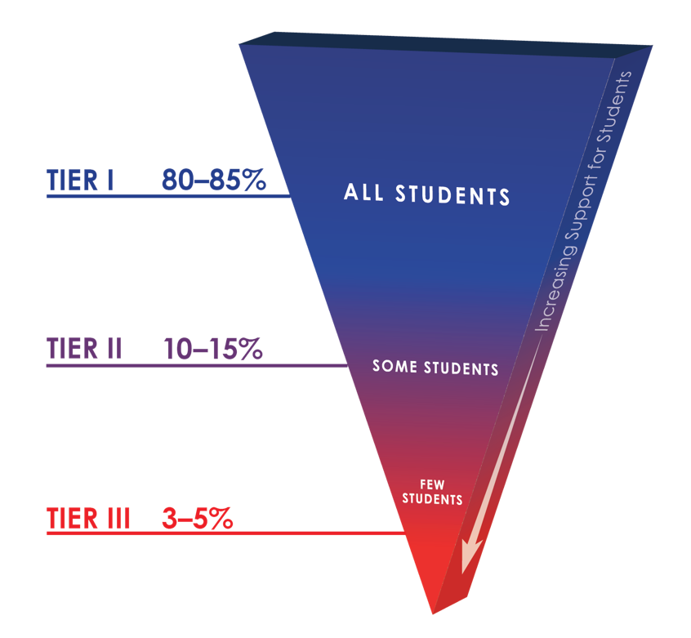

Within the multi-tiered framework of RTI²-B, each tier increases the intensity of intervention and supports so students can be best supported within their school.
Tier I: Tier I focuses on the behavioral and social needs of all students across the school environment. Approximately 80% of students typically respond to this level of support. Tier I includes establishing school-wide expectations to support a sense of safety and inclusion among students and staff, teaching and modeling those expectations within different settings throughout the school, positively acknowledging students and staff who follow these expectations, having a formal system for responding to inappropriate behavior, and maintaining a school-wide system where all stakeholders’ opinions are valued.
Tier II: Tier II involves delivering more targeted interventions for approximately 10-15% of students who do not respond to Tier I supports. Tier II interventions are provided in addition to Tier I supports in place for all students in the school. Interventions at Tier II are typically systematic, evidence-based interventions that are delivered to groups of students at a time. For example, Tier II interventions typically include small-group social skills instruction, behavior contracts, self-monitoring plans, and check-in/check-out.

Tier III: Tier III includes individualized interventions for approximately 3-5% of students who do not respond to Tier I or Tier II interventions and supports. Tier III interventions involve the implementation of specialized, one-on-one systems for students. Examples of Tier III supports include individualized counseling and function-based interventions.

PURPOSE
The Barret’s Chapel RTI²-Behavior Leadership Team is committed to the development and support of the social and behavioral climate of our school. The purpose for implementing RTI²-B at our school is to establish and maintain a safe and effective school environment that maximizes the academic achievement and social-emotional behavioral competences of all stakeholders.
TEAM COMPOSITION AND NORMS The school leadership team for 2019 is listed below. The team will meet monthly to review school data and report findings to the faculty. Faculty and staff are encouraged to contact a team member at any time if there are questions or concerns that need to be addressed at team meetings. Each year up to 50% of team members may roll off as members of the team and new members may be instated. Team member expectations are listed below.
RTI²-B School Team Composition
NAME | School Role | E-mail Address | Phone No.
Lawanda Womack* | School Counselor | womackla@scsk12.org | 416-0325
Cassandra Turner | Asst Principal | turnerca@scsk12.org | 416-0325
Jim Harbin | P.E Teacher | Harbinj@scsk12.org | 416-0325
Destin DeMarco | Stem Teacher | demarcoda@scsk12.org
Kathy Knight | School Counselor | knightkl@scsk12.org | 416-0325
Day to meet: 2nd Wednesday each month |  | Time: 3:30 – 4:30
Location: Conference Room
Dates to present to faculty: Faculty meeting following second Wednesday (Monday)
Reminders:
- Place a * next to the name of the team coach
- Teams meet monthly and information is shared with faculty at least quarterly (preferably monthly in order to keep faculty abreast of information).

EXPECTATIONS (norms) OF LEADERSHIP TEAM MEMBERS:
- Stay on task
- Keep side conversations to a minimum
- Arrive on-time
- Limit screen time (cell phones)
- Participate
- Complete designated job

STUDENT BEHAVIORAL EXPECTATIONS
Our school’s agreed-upon school-wide behavioral expectations are operationally defined. This will improve clarity and consistency of what is expected throughout the school.

Barret’s Chapel School Behavioral Expectations are called
Wildcat Expectations
School – Wide Expectations:
Be Ready, Be Respectful, and Be Responsible

Our school designed and created posters to reflect expected behaviors in the school. Posters are displayed throughout the school to prompt students and remind them to follow the expectations. A picture of the school-wide behavioral expectation poster is located in the appendix of this implementation manual.
SCHOOL-WIDE BEHAVIORAL EXPECTATIONS TEACHING MATRIX
The RTI²-B School-wide matrix anchors expected social skills, in all locations of the school, to the school-wide expectations listed above. Students will no longer guess what is expected of them in each location but will, instead, be taught what is expected and positively acknowledged for following the school-wide expectations and social skills. Posters of the matrix with expectations and social skills will be displayed in designated locations in the building to remind and prompt students to follow the expectations/social skills listed on the matrix. Faculty will have a copy of the matrix follow and to remind students of expectations as they transition from one location to the next. A copy of the matrix is located in the appendix of this implementation manual.
To further prompt and remind students and teachers of expectations and social skills, posters (for designated locations) will be displayed highlighting the social skills anchored to the expectation for the specific area. Pictures of these posters are located in the appendix of this manual.
LESSON PLANS
In order to consistently teach the behavioral expectations with social skills in all locations throughout the school, lesson plans have been developed. There is a scripted lesson plan for each location listed on the matrix. Faculty members will be given a schedule at the beginning of each school year that will list when groups of students will be taught the expectations and social skills in each location listed on the matrix. Once lesson plans have been initially taught in each location, teachers will continue to use lesson plans to re-teach and make corrections. Completed lesson plans are located in the appendix of this implementation manual.
TEACHING THE PLAN
Our School-wide Leadership Team worked through the logistics of teaching the plan and putting it into place. Details are listed below on how our school will prepare for implementation each year for students, faculty, and family/community. The team has created charts for each group that will be followed each year.

Teaching the Plan to Students
What will be done? | How will it be done? | When will it be done?
RTI²-B Booster training for faculty beginning of each new school year.  (e.g., training on all components of the manual) | Faculty will be given a booster training on all the components listed in the implementation manual. Each faculty member will be given a digital or hard copy of the manual for reference. | During in-service, first of new school year.
Introduce the plan to students  (e.g., describe steps for first introducing the school-wide plan to all students) | Students will be gathered in an assembly and introduced to the expectations and reward system. Faculty and students will model correct and incorrect behaviors. Presentation of the reward system will be delivered. | First or second day of school.
Create and display posters for each setting before students arrive. (Expectation posters/ Expectations with Social Skills Posters) Where will posters be displayed? How will they be attached to walls? Where will posters be stored for summer months? | A Team member will be asked to hang all posters in designated locations. The matrix will be hung at the entrance of the school and in the office of the person in charge of discipline. Each teacher will be responsible for hanging the classroom poster in their classrooms. Expectation posters will also be hung in the cafeteria, hallways, bathroom areas, exit areas to buses and playgrounds. | This will be completed before students arrive the first day of school.
Use lesson plans to teach expected behaviors in all settings. Who will initially teach in each location? How will groups go to locations for lesson plans? How will faculty be trained on how to follow-up with lesson plans? | Each team member will be assigned a location to teach the lesson plan in that location. A schedule will be developed to identify when small groups, with teacher, will go to each location to hear the lesson plan. Teachers will follow up the lesson plan with planned activities to reinforce the lesson plan. | During the first week of school. Teachers follow-up will be ongoing.
Review the plan and reteach lessons throughout the year.  (e.g., after each break (fall, Christmas, Spring break) | After each break in school (fall, Christmas, Spring), the lesson plans will be re-taught to small groups in each locations. Teachers will be responsible for completing this activity. | After each break/quarter in the school year
Teach the plan to new students throughout the year.(Consider using student leadership team) | A member of the student leadership team will be assigned to a new student. The team member will mentor the new student on the process. | Upon arrival of a new student to the building.
Establish a STUDENT LEADERSHIP TEAM. (How will students be picked for the team? How many on team? What will their responsibilities be? Who will be in charge?) | A student leadership team will be picked by the faculty. It will consist of a diverse group of students. There will be 4 students chosen from 4th and 5th grades. A leadership team member will facilitate the student team. | 4th grade members will remain on team during their 5th grade year and new members from 4th grade will be added in the spring before the new year begins.

Teaching the Plan to Staff
Who will be trained on the plan?
custodians, cafeteria workers, bus drivers, office staff, paraprofessionals, teachers
How:  All support staff will be trained during an in-service. They will also provide all materials needed to faculty. | When: August 6, 2019
How will you train staff to teach expectations and deliver acknowledgements?
How: We will have an RTI²-B Workshop during in-service. During that time, the leadership team will review the plan with the faculty and ask for feedback and consensus on components. They will also provide all materials needed to faculty.  Staff will practice using behavior-specific praise with each other and be given an opportunity to spend their rewards points. | When: August 6, 2019
How will you teach the components of the discipline process to all staff?
(e.g., behavior definitions, office-managed vs. staff-managed, discipline process flowchart)
How:  We will have a RTI²-B Workshop during in-service. During that time, the leadership team will review the plan with the faculty and ask for feedback and consensus on components. They will also provide all materials needed to faculty | When:  August 6, 2019
How will you teach core features of the plan to substitute teachers?
(e.g., expectations, acknowledgements, discipline)
How:  Substitutes will have a 1-page handout that reviews the important features of the RTI²-B plan with copies of the Office Discipline Referral forms and Behavior definitions in their substitute folders. | When: Ongoing
What important dates will you share?
How:  All dates of celebrations, the teaching plan for students and when screeners will be administered will be reviewed and provided to faculty and staff during the workshop. | When: August 6, 2019

Teaching the Plan to Family and Community
How will core features of the plan be shared with family/community members at the beginning of the school year? (e.g. expectations, acknowledgements, discipline)
During “Meet the Teacher” night, the school administrators will start the open house with an overview of the RTI²-B plan and its benefits to the school. Each classroom teacher will review specifics of the plan in their classroom during their time with parents.
How often will information about the plan be shared with family/community members?
Parents will be given monthly updates in the school newsletter, along with updates on the website. There will be opportunities during the school year during PTO meetings to learn more about the plan as well, from the parent representative.
How can families incorporate RTI²-B in the home?
(e.g., home matrix, home acknowledgement system)
School behavior expectations will be provided to parents during parent training along with the school behavior matrix to be discussed with the students at home.
What additional resources can family/community members access for more RTI²-B information and support? (e.g., online resources, resources within the district)
Tennessee Behavior Supports Project website (wwwTbspmemphis.com), parent trainings provided at school each semester, family engagement specialist will put together family resources to share on school website.
Who will be the liaison between the school and family/community?
The school will have a PTO representative (family engagement specialist) that will act as the liaison between the school team and the family/community.
How can family/community members get involved with RTI²-B at your school?
Through the PTO there will be opportunities to help create materials, support celebration or raffles, participate in acknowledging staff during appreciation breakfasts, and help share information about the plan with other parents.
Does your school have an established parent organization? If so, who will communicate with the parent organization? Family Engagement Specialist

ACKNOWLEDGEMENT SYSTEM
Our RTI²-B Leadership Team investigated several options for positively acknowledging students and faculty; and, family and community. The purpose of the acknowledgement system for students is to promote a positive culture within the building and to encourage and motivate students to be the best they can be. The purpose of the acknowledgement system for faculty, family and community is to show appreciation for their support. The acknowledgement system matrix for each group is below.
As a team, we determined that our school will use the point system as a part of the acknowledgement system. A copy of the point tiers and incentive list is located in the appendix.

 | School-wide Acknowledgment System Matrix
 | Name | Description | When (frequency) | Where (location) | Who (distributors)
Students | Dojo Points | Dojo points will be given to students daily for following our three expectations. Points will be used to select Classroom and schoolwide rewards. Students can earn up to 5 Dojo points daily. | Every week students will accumulate points. They can choose to spend them that week or “bank” them to save up for a higher-level reward. (Monthly limit) | Points are given in all settings. | All staff are able to give dojo points. Daily points will be given by classroom teacher.
Students | Cats Party | The Cats Party will include dancing, face painting, and popcorn. | Quarterly | Gym | School Admin
Staff | Caught Ya! | Teachers recognize other staff members for going above and beyond. | Weekly | All Settings; drawings at staff meetings | Administrator and RTI²-B Leadership Team
Staff | Warm-Fuzzies | Teachers will put notes of kindness and praise in colleagues’ boxes. | Daily | All Settings | All staff
Staff | Wildcat Breakfast | The PTO and RTI²-B Leadership Team will host a quarterly appreciation breakfast for all staff members. The breakfast is a way to say “thank you” for participating in RTI²-B at the school. | Quarterly | Teacher’s Lounge | PTO & RTI²-B Leadership Team
Staff | Grade-level Team Lunch | Grade-level team with the highest attendance rate will be able to go out to lunch and receive class coverage. | Quarterly | School-Wide | Administration
Family/Community | Eagle Gram | Eagle Gram will be sent to community partners to show appreciation for their support of Barret’s Chapel. | Sporadic | Community | Office Staff & RTI²-B Leadership Team
Family/Community | School Website | There will be a running banner on the school website highlighting participation from the community and families. | Ongoing (changed out monthly or quarterly) | Website | RTI²-B Leadership Team and tech person
Family/Community | Volunteer Appreciation Program | This will be an annual celebratory event to thank family and community members who have been involved with RTI²-B over the course of the year. The event could involve students performing for the guests, making cards/pictures to give to the guests, food, etc. | One time per year (at end of school year) | TBD | RTI²-B Leadership Team, Office Staff, Administrator; all teachers and students to assist (e.g., making cards or pictures, performances, etc.)

DEALING WITH PROBLEM BEHAVIORS Our RTI²-B Leadership Team prepared a chart containing operational definitions of problem behaviors showing examples and non-examples to clarify what is considered a minor misbehavior and a major misbehavior. Faculty will refer to this chart to help assist in making decisions regarding the school’s discipline process. The operational definitions of problem behaviors are located in the appendix of this manual.
To further clarify what is to be handled in the classroom (minor offense) and what is to be handled in the principal’s office (major offense), the RTI²⁻B Leadership Team created a chart that lists offenses that may be seen in the classroom, handled by the classroom teacher, and offenses that require an immediate trip to the principal’s office. Please note that the teacher managed offenses are not all inclusive. There are minor offenses that may not be listed. It is expected that teachers will use discretion and be consistent. This chart is located in the appendix of this manual.
In order to give guidance to teachers on handling minor problem behaviors, guiding steps to follow are located in the appendix of this manual along with possible interventions.
MINOR INCIDENT REPORT FORM
Though using the guiding steps to change problem behaviors into good behaviors, it does not always work for all students. With this in mind, the team determined that once a student has reached 3 similar minors with one teacher, the minor then becomes a major and the student is sent to the principal’s office for further discipline. In order to document the minors, the team created a Minor Incident Report form (MIR) so that teachers can track minor behaviors and the principal can document what the teacher has done to try to eliminate the problem. When sending a student with minors to the office, the teacher will include the MIR form along with an office discipline report form (ODR). The MIR and ODR forms are located in the appendix of this manual.
DISCIPLINE PROCESS FLOWCHART
Together as a team, a discipline process flowchart has been created. The flowchart is designed to show steps faculty will take when dealing with behavioral issues and for the major offenses that are sent immediately to principal’s office. It is deemed important that all faculty follow the flowchart to promote consistency in the school environment. The flowchart is located in the appendix of this manual.
OFFICE DISCIPLINE REFERRAL FORM
The Office Discipline Referral form will be completed for major offenses. A copy of the ODR is located I the appendix of this manual.
CLASSROOM CHECKLIST
Together as a team, in order to ensure that all teachers are consistent, a classroom checklist has been created. The checklist will be used to check classrooms to determine how the RTI²-B components are being implemented and if with fidelity. Teachers are encouraged to do self-checks to make sure all components are in place throughout the year. The classroom checklist is located in the appendix of this manual.
CALENDAR OF EVENTS
Together as a team, RTI²-B calendar components are listed with approximate dates for the school year. At the beginning of each year, the team will add confirmed dates to the school calendar. The approximate dates with components are listed below.
RTI²-B Calendar Components | Date(s)
RTI²-B School Team Meetings | 2nd Wednesday of each Month
Initial Session to Teach Core Components to Staff | In-service week August 2019
Booster Sessions to Teach Core Components to Staff | Quarterly
Begin School-wide Implementation  (e.g., Kick-off Celebration) | August 12
Teaching Expectation Lesson Plans to Students in All Settings | August 12
Re-teaching Expectation Lesson Plans to Students in All Settings | As needed
Celebrations/Assemblies | Quarterly
Family Nights | Quarterly

PLANNING FOR STAKEHOLDER INPUT
Because it is important that our school receive feedback and input from all stakeholders, possible ways were discussed to involve our school community (students, faculty, family/community) in developing the RTI²-B framework. By planning ways to involve them, it is hoped to receive continued input and feedback from them on the components of the RTI²-B framework. The following chart suggests ideas on how our school may receive feedback and input.

 | Behavioral Expectations | Teaching and  Re-teaching of Expectations | Acknowledgement System | Discipline  Process
Students | Student Leadership team will review and provide feedback | Different classes will be responsible at quarterly assemblies to review Behavior Expectations via a power point presentation and perform a skit for the “Expectation of the Quarter.” | Student Leadership team will meet once a month to discuss the incentives and ideas for future rewards. | Have student be part of the discipline process using restorative circles, student leaders will provide input on how to create student ownership at the school
Staff | A draft of the RTI²-B handbook will be sent to faculty and staff for feedback through grade-level reps on the RTI2-B team | Lessons will be sent to each grade level chair to be reviewed and suggestions offered before RTI²-B workshop day | A draft of the RTI2-B handbook will be sent to faculty and staff for feedback through grade level team members. | All behaviors will be sorted with the staff into office vs. classroom managed during the RTI²-B workshop, team will create definitions, faculty and staff will provide examples and non-examples to ensure cohesiveness and consistency.
Family/  Community | All parts of the plan will be reviewed with family and community during back to school night.  Administrators will ask for feedback from PTO  representative | Community and family representative/Family engagement specialist will gather community input on current incentives and receive feedback. | Community/Family Rep and Family engagement specialist will collaborate and provide information on community members that will be able to contribute to the school’s reward system. | Team members will have input on the discipline process in the RTI2-B systems.

EVALUATION PLAN
Data will be collected and reviewed monthly to identify any weak areas and to make important decisions regarding student behavior. A collection of data will also be used to determine fidelity of the process and teacher satisfaction. The chart below will identify evaluation tools that will be used and when the evaluations will be completed.
Data | Evaluation Tool | Date to be Completed
System to collect, organize, and summarize Discipline Data  (e.g., SWIS, PowerSchool, Infinite Campus) | Our school uses:  PowerSchool will be used to summarize referral data along with class dojo. | Our plan: Discipline data will be evaluated weekly by teachers for conduct and every 20 days by RTI2-B team to discuss trends and incentives
Fidelity Data | Tiered Fidelity Inventory (TFI) | Our plan: Two times per year.
Social Validity | Primary Intervention Rating Scale (PIRS)  (Also called the “Staff Input Survey”) | Our plan: Staff input survey will given quarterly.

APPENDIX
TABLE OF CONTENTS
Posters
Expectation Poster
Matrix
Posters by location
Lesson Plans by Location
Acknowledgement Ticket
Operational Definitions
Teacher managed (minors) / Office managed (majors)
Steps for Correction
Possible Interventions
Minor Incident Report Form (MIR)
Office Discipline Report Form (ODR)
Flowchart
Classroom Checklist
POSTERS

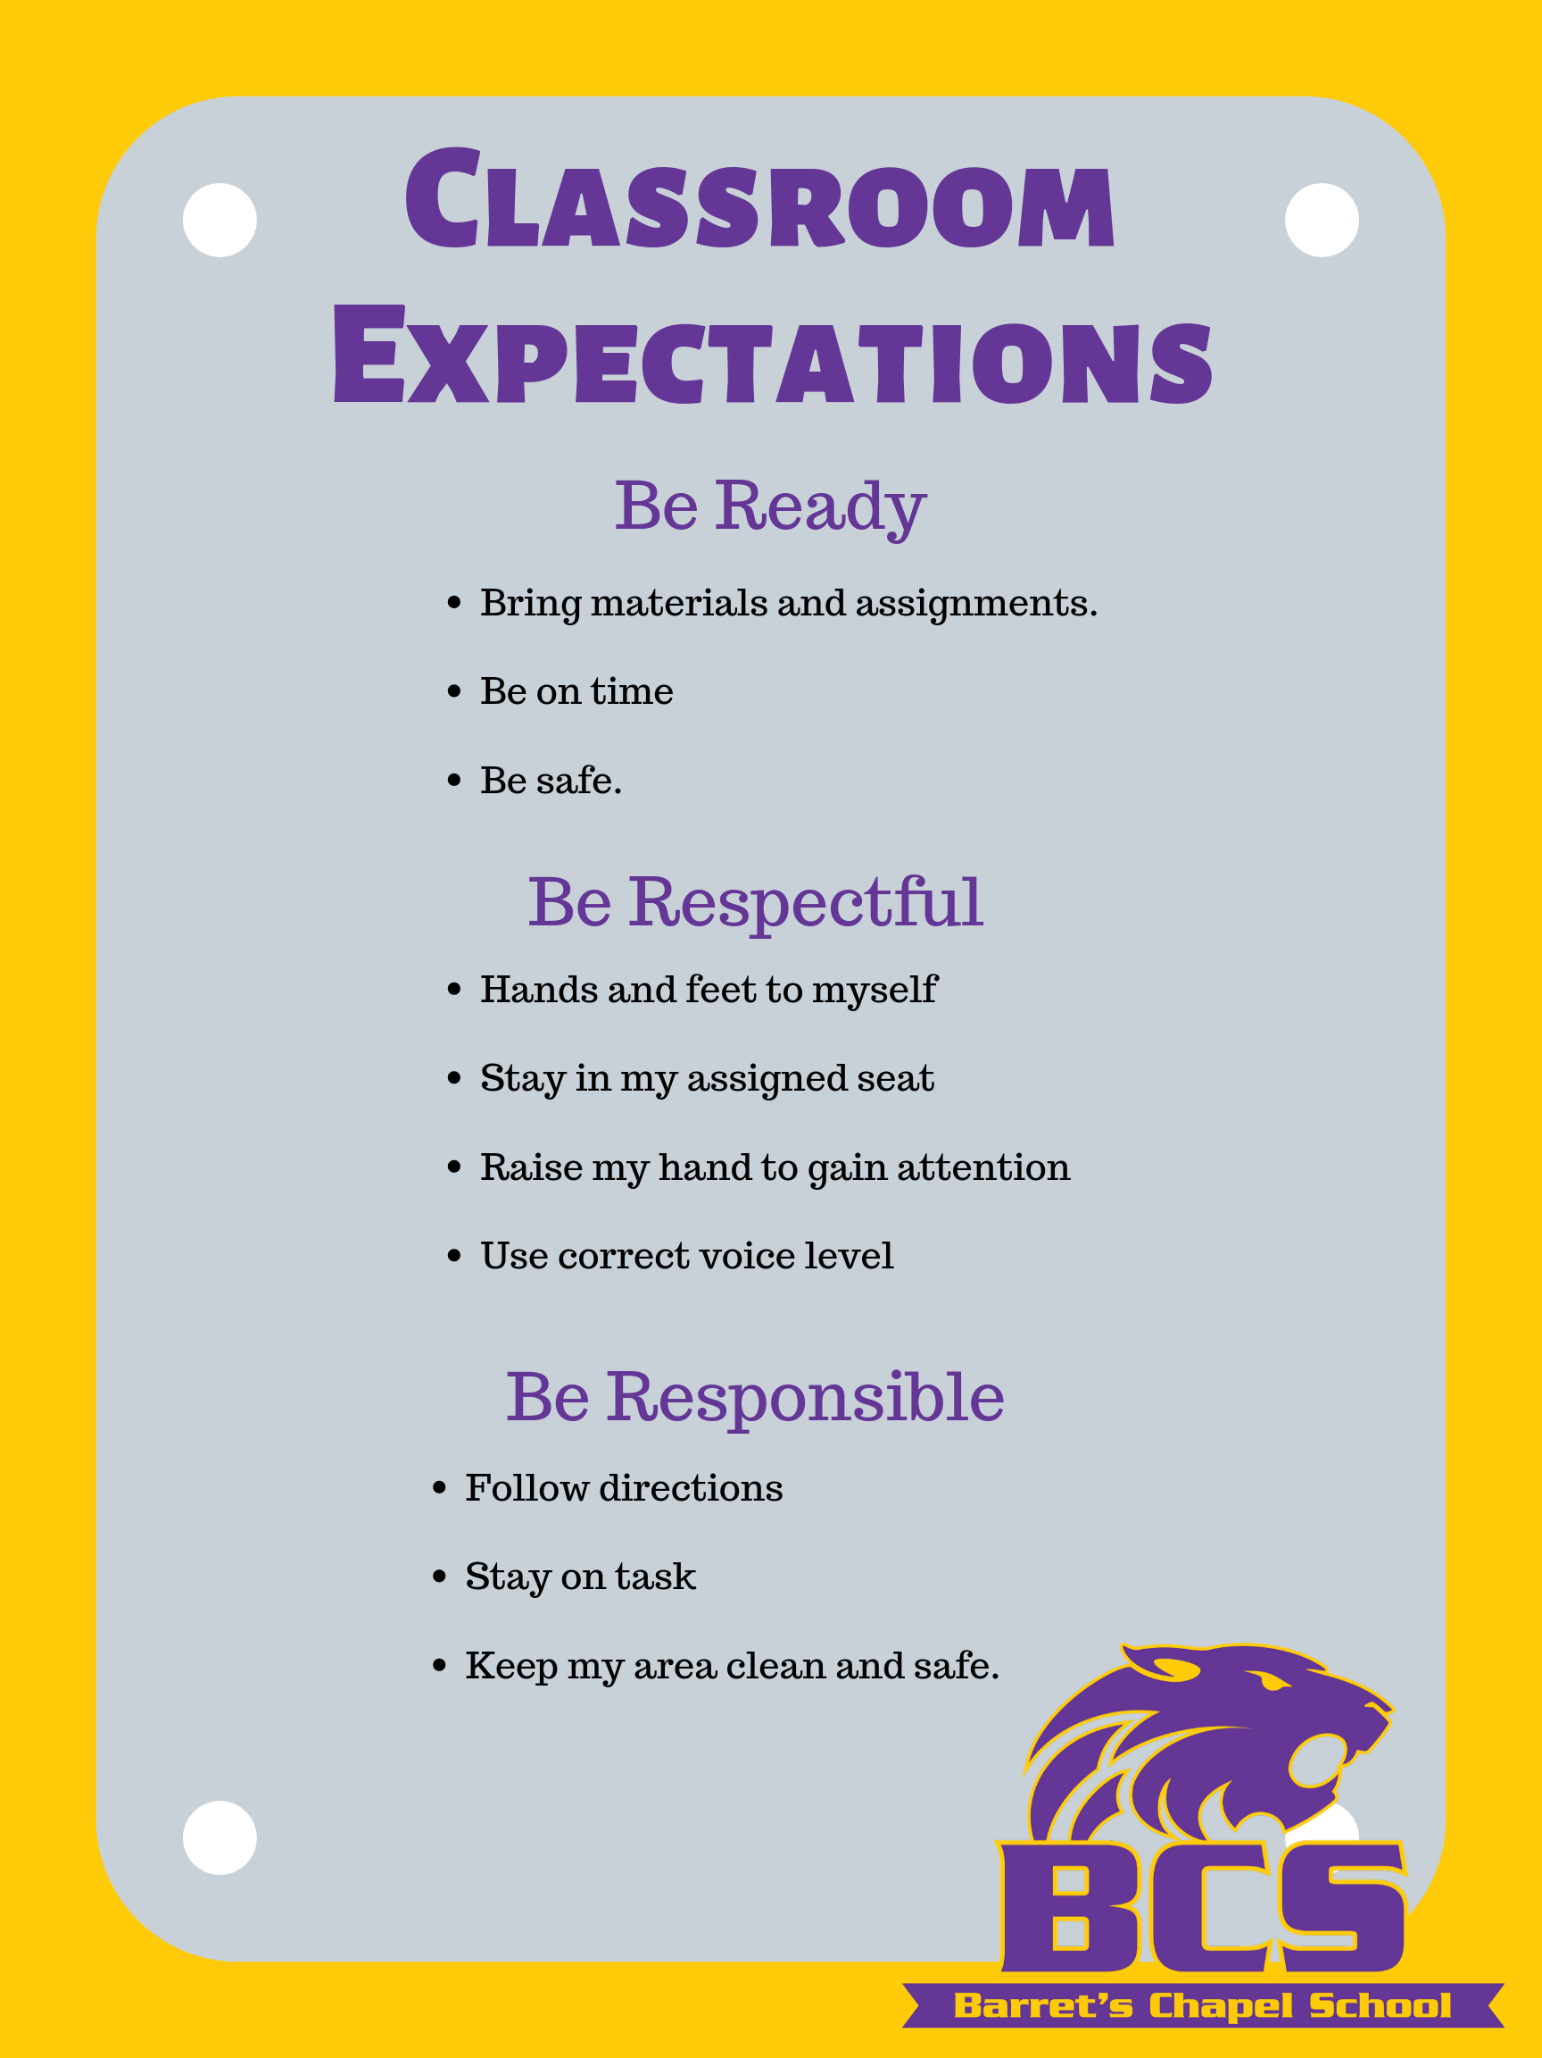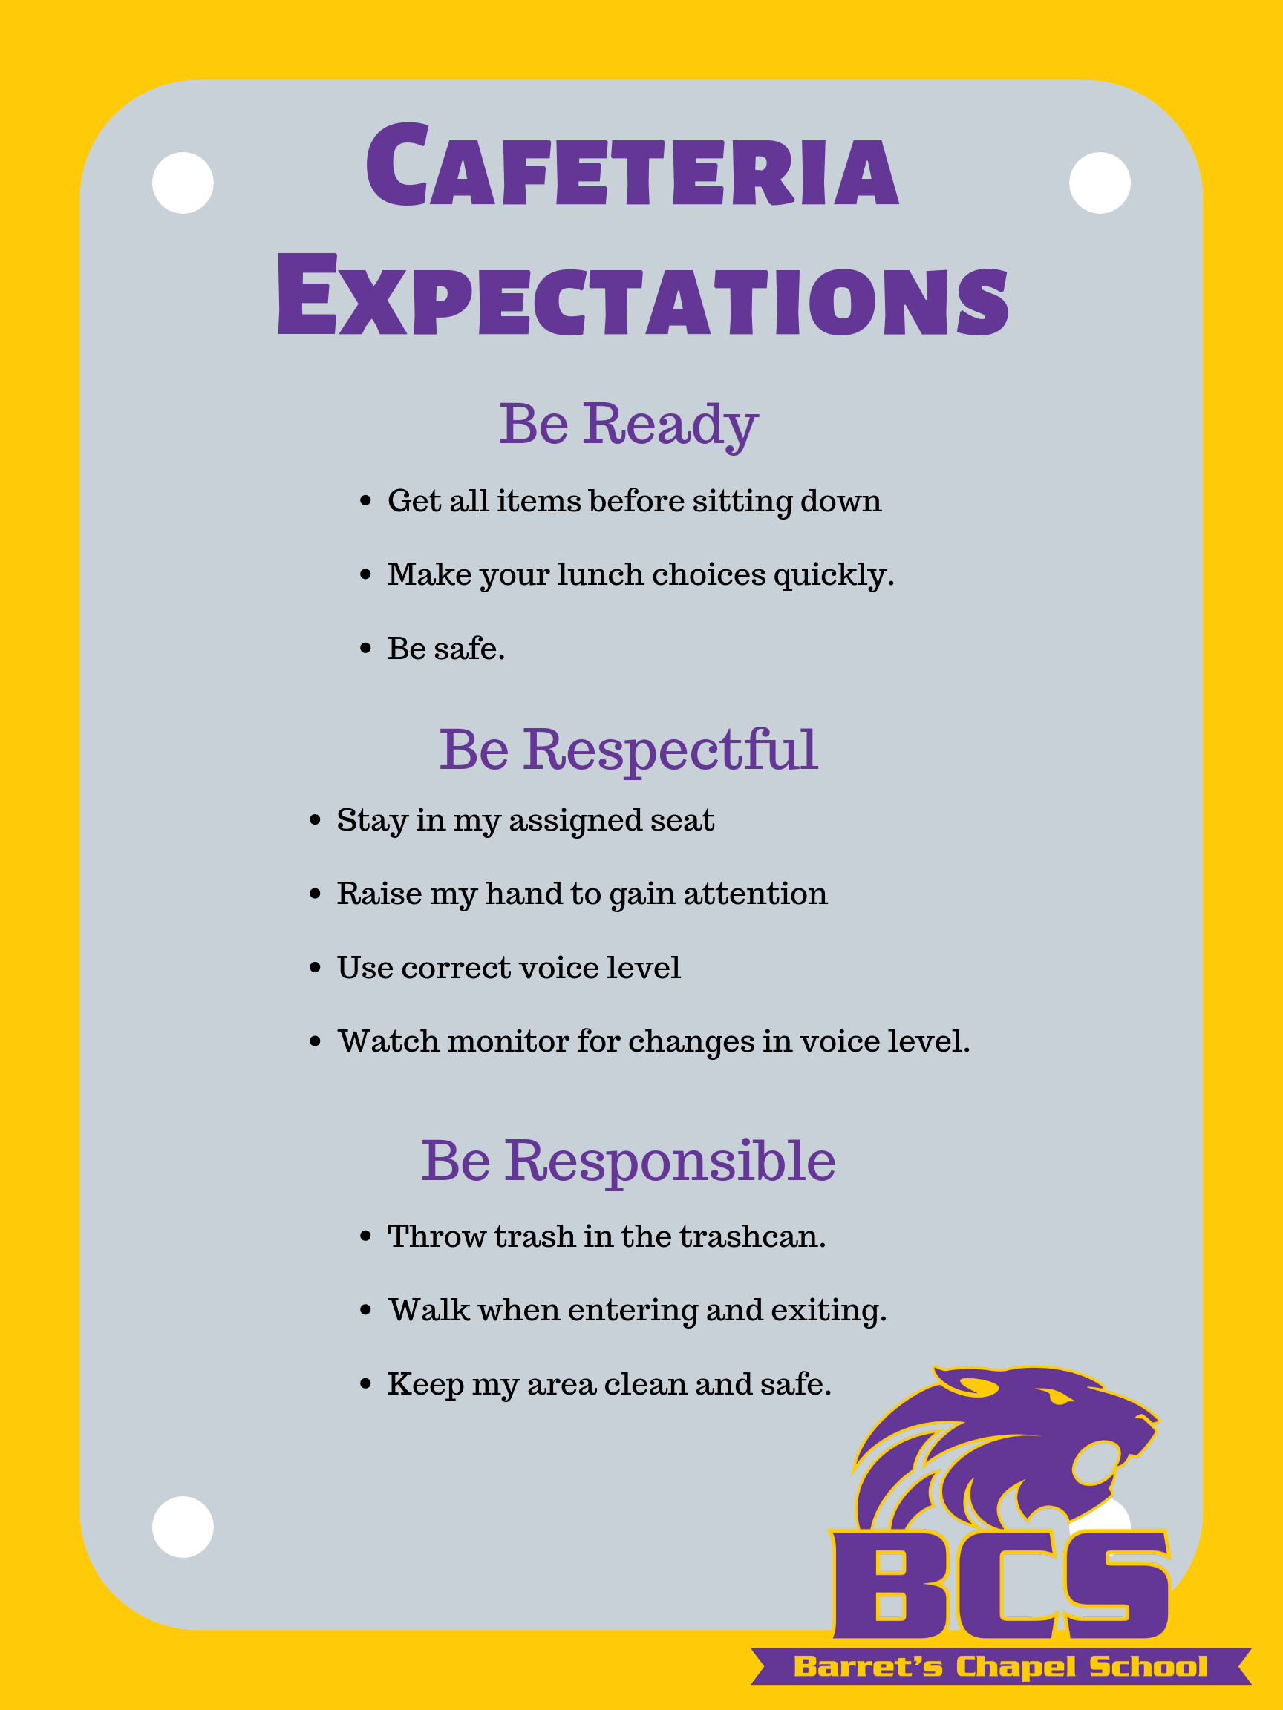
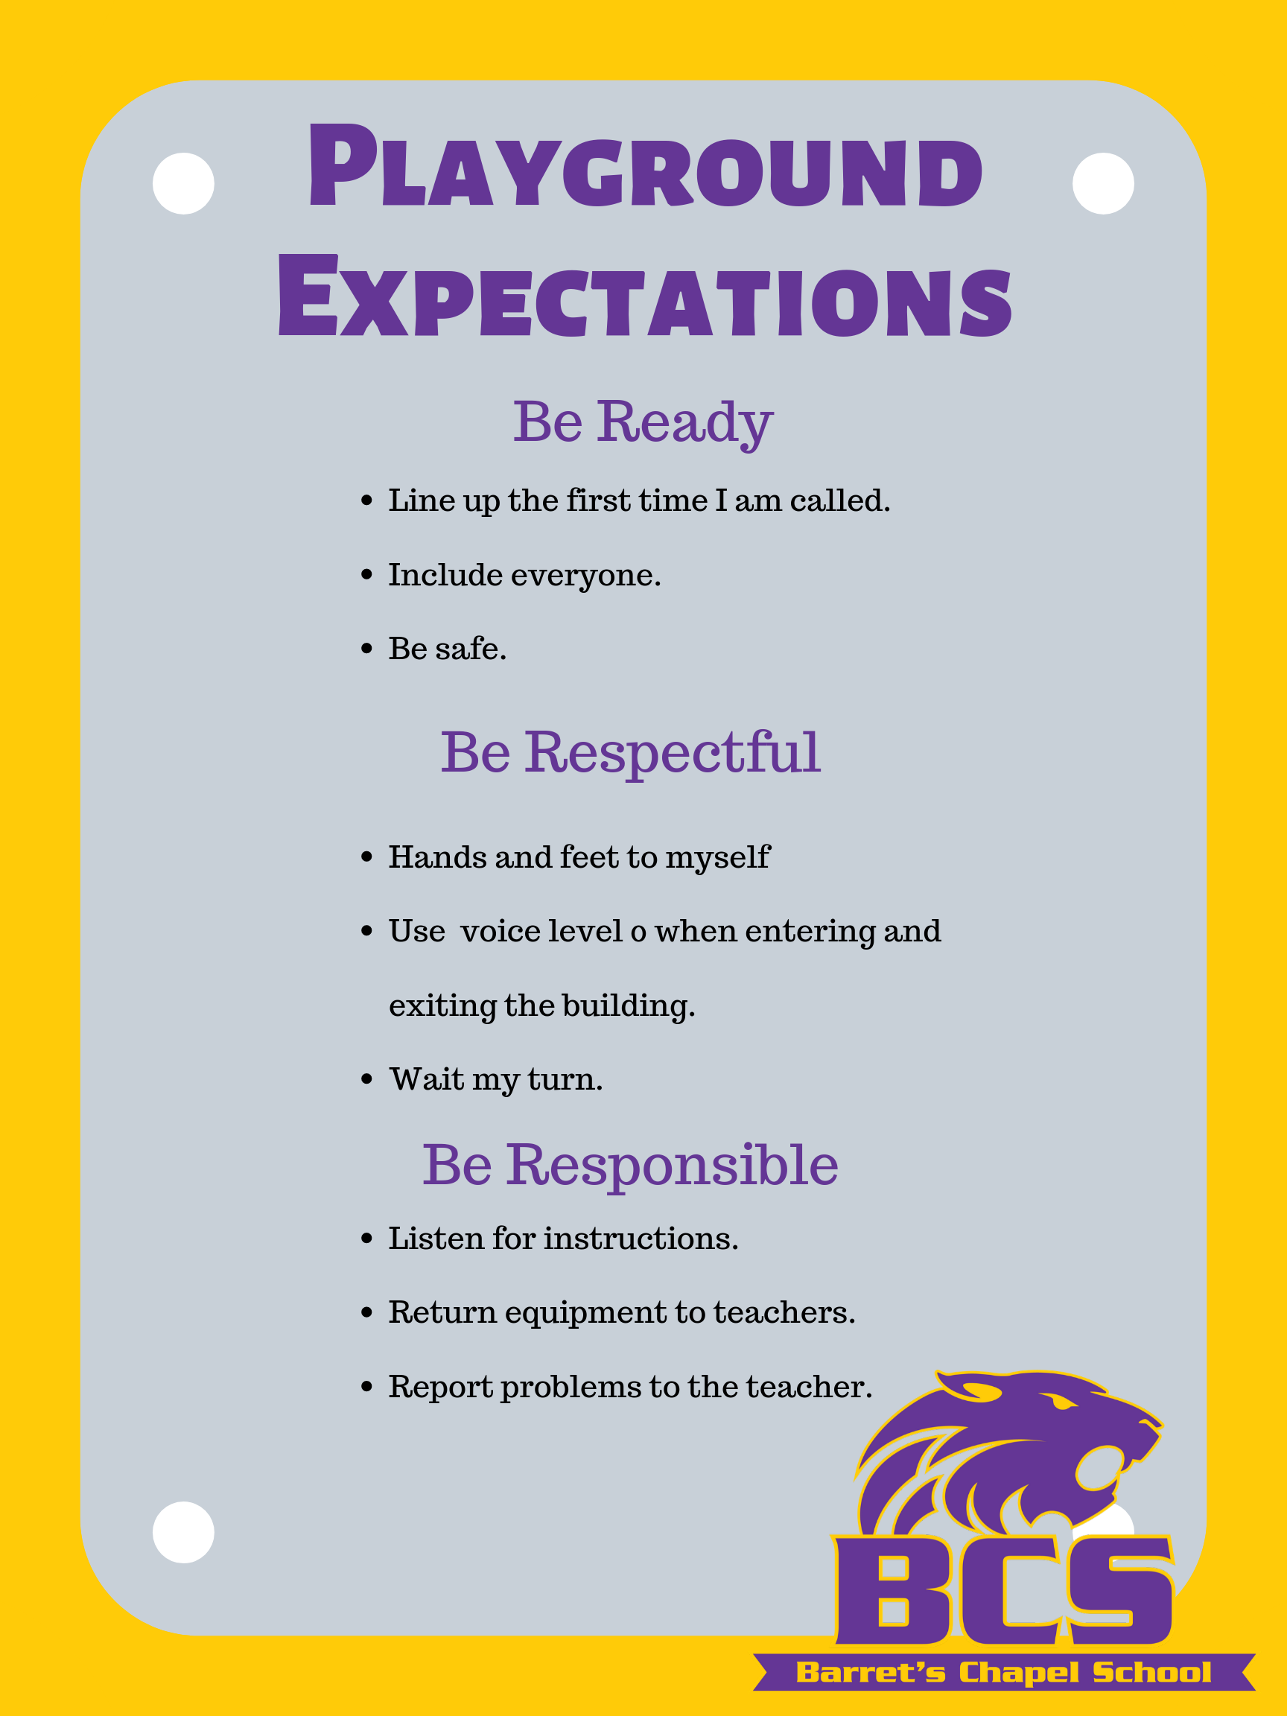
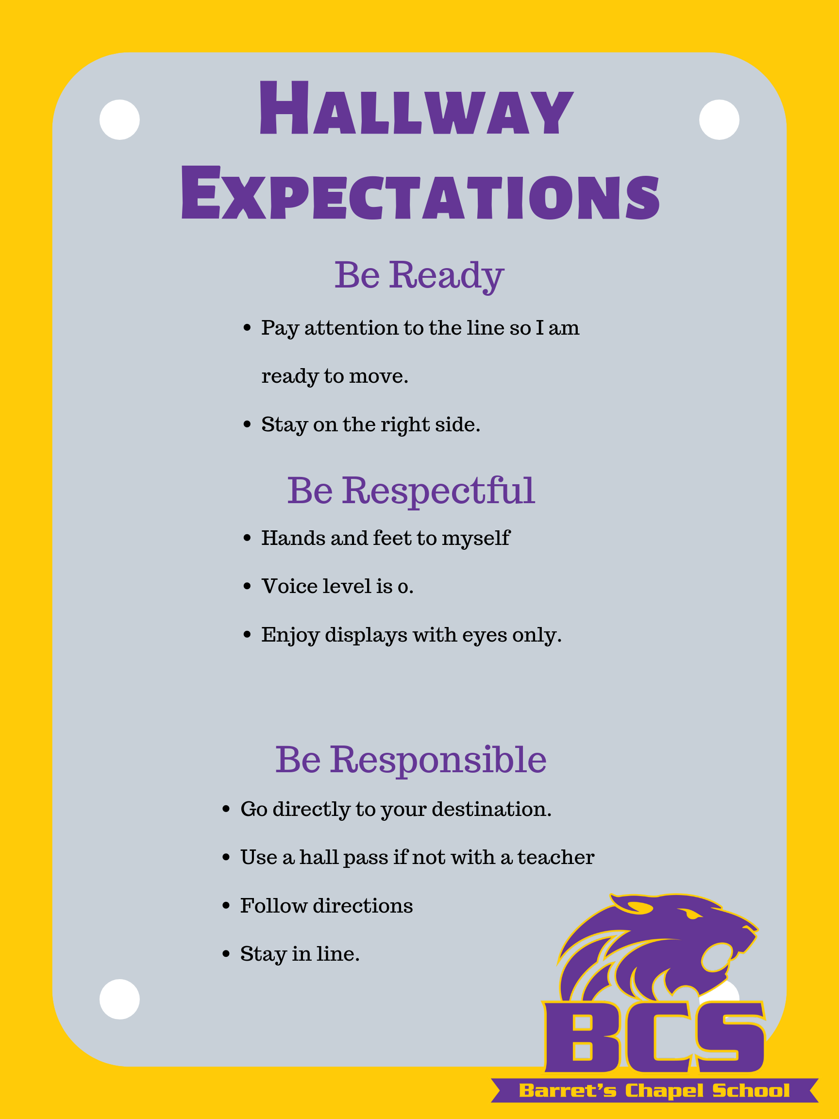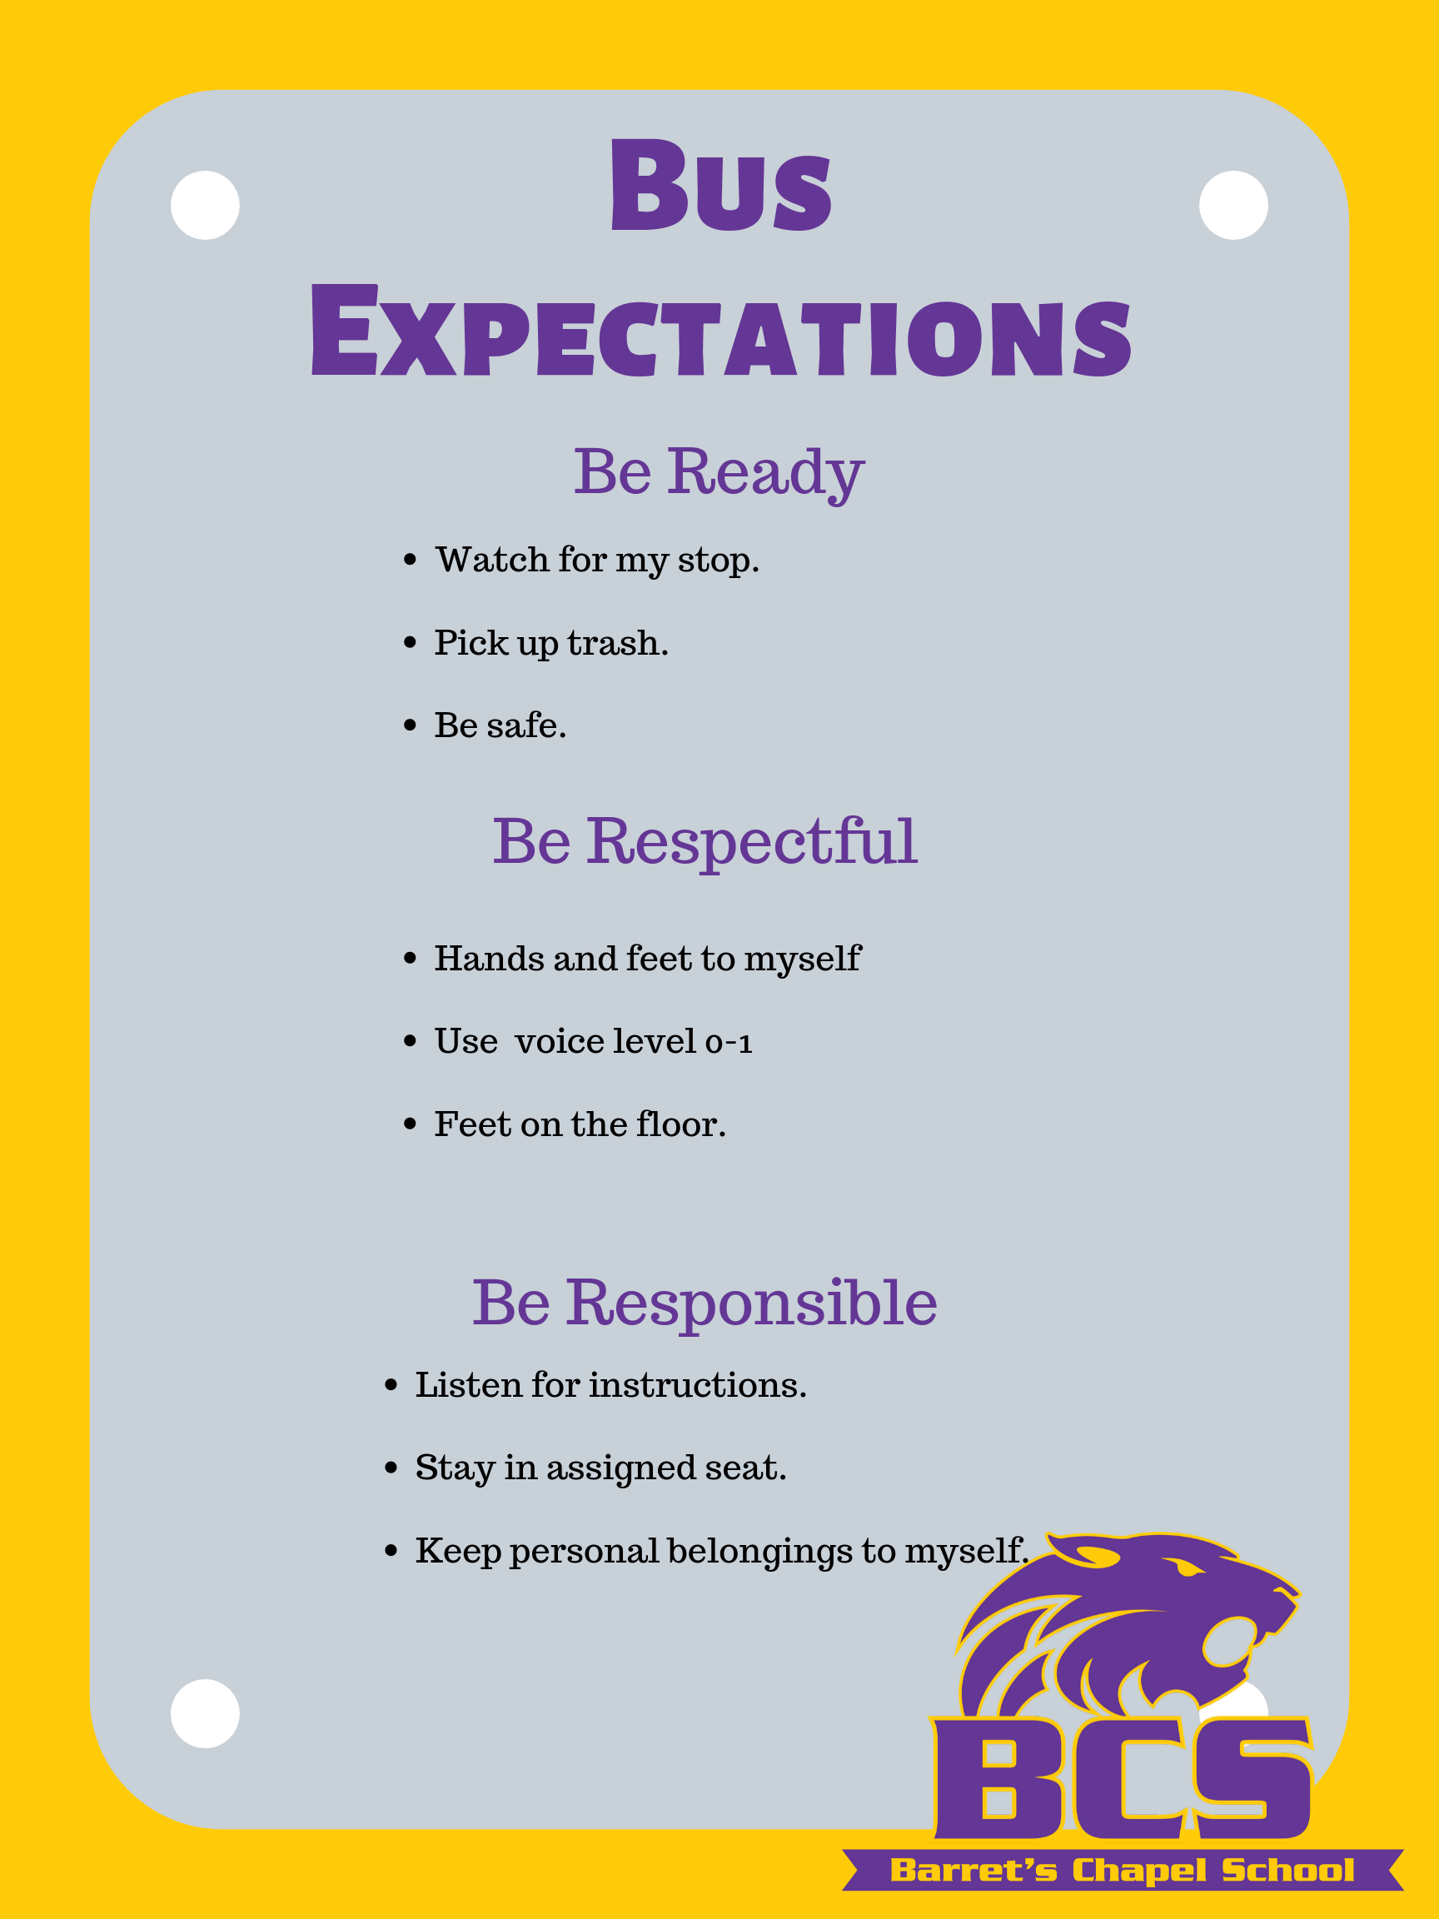
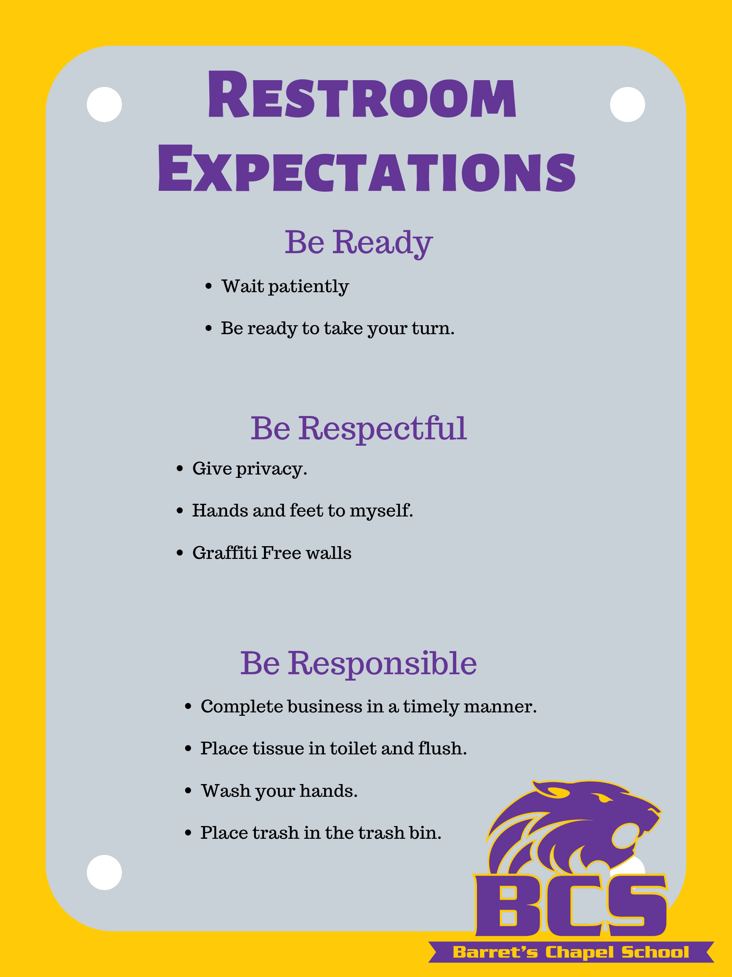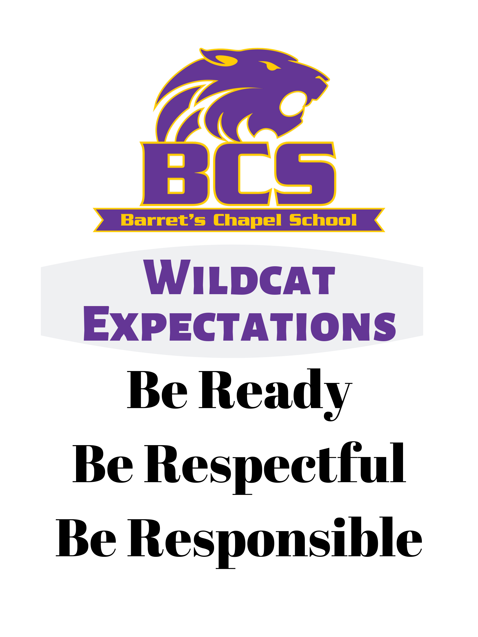

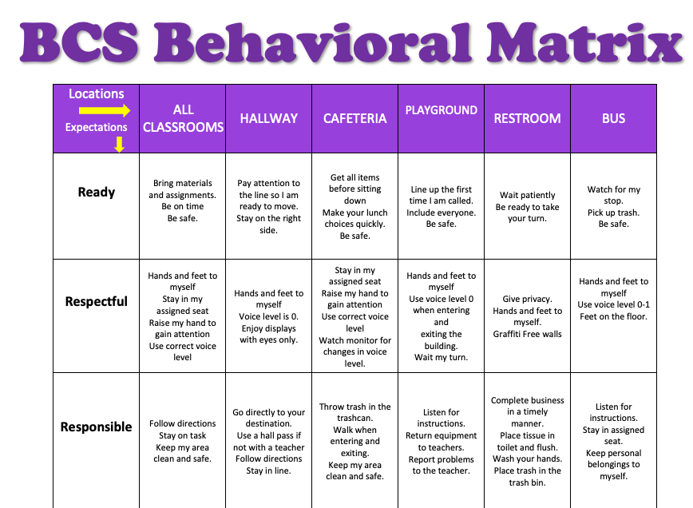

Acknowledgement Point Items
Points Level  *Students will receive 4 daily points for attendance, respectfulness, responsibility, and readiness | Rewards  *Teachers will be able to award extra points for positive “above and beyond” behavior.
20 Points | Healthcare Items (shampoo, lotion, toothbrush, deodorant, etc.)
30 Points | Show and Tell, Stinky Feet, Super Supplies, Teacher Time, Water bottle to class, Fuzzy Friend or Favorite Toy,
40 Points | 15 min. Computer time, Homework Pass, Specialty Seating, 15 min. “Me Time” or “Lazy Time,” Homework Pass (1 Class/1 assignment)
50 Points | Switch Seats in Class, Wear a Hat, Lunch Buddy at special table in Café.
75 Points | Shadow admin or counselor for an hour, Lunch with buddy in classroom.
100 Points | Lunch and a movie with a buddy in classroom.  *100 point club will be entered into a raffle for a special prize

Barret’s Chapel School
School-wide Expectations Lesson Plan: Classroom
Lesson plans should be taught in the area and take 10-15 minutes
Special Notes: | This lesson plan can and should be used to teach all classroom routines (e.g., sharpening pencils, lining up to leave classroom, transitioning between centers, turning papers in, asking for help, working with a partner, etc.)
Objective | The students will use respectful, responsible, and safe behaviors when in the classroom setting and during all classroom routines.
Setting | All Classrooms
Expectations | (Refer to Behavioral Expectations Matrix)  Respectful: Greet teacher. Hands and feet to self. Stay in assigned seat. Raise hand to gain attention. Use teacher assigned voice level.  Responsible: Be on time. Turn in homework. Follow directions. Complete assignments. Stay on task. Watch for voice level cue. Leave personal items at home.  Ready: Store supplies in designated locations. Chair legs on floor. Feet on floor. Keep floor free of objects/trash. When leaving desk push chair under desk/table. Keep doors locked.
Examples:  Teach using “I Do, we do, you do” | Students enter room saying, “good morning.”  Students proceed to assigned seat while keeping hands and feet to themselves.  Teacher describes and imitates the differences between the voice levels on the voice level chart. Discuss reasons why it is important and safety issues surrounding keeping our voices on the intended level.  Soliciting teacher assistance by raising hand without talking and waiting for teacher.  Students will stand up, check their area for mess on the floor, push in their chair, and line up at the door.  Teacher will review with students through questions.
Non-Examples: Model Only  Do NOT have students model non-examples. | Running in the classroom  Interrupting teacher while teacher is talking  Pushing peers while standing in line.  Throwing stuff on the floor
Follow Through and Practice | Teacher gives a hand signal to indicate it’s time for voice level 0 and listening ears. Students practice turning their voices off when the teacher gives the hand signal. Teacher provides feedback and behavior-specific praise.  Students brainstorm what respectful, responsible, and safe behaviors look like in the classroom. They role-play those behaviors and provide feedback to each other. Teacher models non-examples.  Teacher refers to social skills matrix posted in classroom as needed. Review and reinforce after each break and quarter.  *Practice signals to use: Hand signals, timer/visual signals
Reinforcement: How will behaviors be reinforced in this setting | Teachers can consider using a class-wide acknowledgement system (e.g., Mystery Behavior of the Day, Behavior BINGO, etc. to help reinforce appropriate behaviors.)

Barret’s Chapel School
School-wide Expectations Lesson Plan: Hallways
Lesson plans should be taught in the area and take 10-15 minutes
Objective | The students will use respectful, responsible, and safe behaviors when in the classroom setting and during all classroom routines.
Setting | Hallways
Expectations | (Refer to Behavioral Expectations Matrix)  Respectful: Hands and feet to self. Walk one square length from the person in front of you. Voice level zero. Enjoy displays with eyes only.  Responsible: Listen for directions. Stay in line. Use a hall pass. Go directly to class in the morning.  Safe: Walk on right side.
Examples:  Teach using “I Do, we do, you do” | 3-squares from the wall  2-feet in a block  1-space between students  0-Voice on level 0
Non-Examples: Model Only | Hands on people or on walls  Looking to the side or head turned to look backwards  Talking, whistling, humming  Walking too slowly (i.e., not staying with the group), walking too quickly (i.e., getting ahead of the group), running, creating a gap, walking backwards  Walking beside someone
Follow Through and Practice | - Repeated practice of walking and waiting in the hallways  *Practice signals to use: Gesture given by teacher for silent voice; sign with pictures/sign language (if needed)
Reinforcement: How will behaviors be reinforced in this setting | - Teacher distributes points with behavior specific praise.

Barret’s Chapel School
School-wide Expectations Lesson Plan: Playground
Lesson plans should be taught in the area and take 10-15 minutes
Objective | The students will use respectful, responsible, and safe behaviors when in the classroom setting and during all classroom routines.
Setting | Playground
Expectations | (Refer to Behavioral Expectations Matrix)  Respectful: Wait your turn. Hands and feet to self. Voice level 0 when entering and exiting.  Responsible: Return equipment to designated locations. Line up the first time called. Share. Include others.  Safe: Listen for instruction. Stay in line on entry and exiting. Only use slide and snake on rear playground. Leave nature’s objects on the ground. Report problems to teacher. Stay in designated area. Leave debris where it lies.
Examples:  Teach using “I Do, we do, you do” | Use equipment safely  Keep hands, feet, and bodies to self  Take turns, share, play fairly  Enter and exit the building on 0 voice.
Non-Examples: Model Only | Using equipment inappropriately (e.g., throwing balls over fences, climbing up slides instead of sliding down, etc.)  Body contact/rough play (e.g., pushing, shoving, hitting, kicking, tackling, etc.)  Unsportsmanlike conduct (e.g., calling peers names)  Actions or talk that disrespects others (e.g., cursing, making fun of others, etc.)
Follow Through and Practice | Show videos of students using playground equipment appropriately and interacting positively with each other while playing at recess  Review and reteach expectations once a month with your class during recess  *Practice signals to use: Freeze when the whistle blows three times.
Reinforcement: How will behaviors be reinforced in this setting | - Teacher distributes points with behavior specific praise.

Barret’s Chapel School
School-wide Expectations Lesson Plan: Cafeteria
Lesson plans should be taught in the area and take 10-15 minutes
Objective | The students will use respectful, responsible, and safe behaviors when in the classroom setting and during all classroom routines.
Setting | Cafeteria
Expectations | Respectful: Eat only your food. Keep food in your tray. Hands and feet to self. Leave area free of trash. Voice level 2 after eating. Watch monitor for change in voice level. Enter and exit in line at level 0. Raise hand for attention.  Responsible: Listen for directions. Get all items before sitting. Talk after eating. Place trash in trash bin. Know your lunch choice. Be on time when arriving and departing.  Safe: Wash hands before eating. Stay in line. Wait your turn. Hold tray with both hands. Stay seated. Sit at assigned table. Stay in the cafeteria.
Examples:  Teach using “I Do, we do, you do” | One student holds a tray to go to the table using voice level 0 and demonstrates how to dump tray.  Student stands in the food line correctly (space between bodies, facing forward).  Using polite table manners.  Clean up after self.  Raise hand to leave assigned area.
Non-Examples: Model Only | Pushing in line  Making a mess (e.g., food and trash on floor or table, and not on tray) and not cleaning up after self  Not using polite manners (e.g., loud talking, playing with food, shoving food in mouth, eating and talking at the same time, etc.)
Follow Through and Practice | Video of positive cafeteria behavior  Put weekly cafeteria objective on white board in the cafeteria.  *Practice signals to use: Follow signal of cafeteria supervisor; Follow signal for dismissal
Reinforcement: How will behaviors be reinforced in this setting | Teacher distributes points with behavior specific praise.  Classes that do the best job meeting the cafeteria objective for the week will earn extra points.

Barret’s Chapel School
School-wide Expectations Lesson Plan: Restroom
Lesson plans should be taught in the area and take 10-15 minutes
Objective | The students will use respectful, responsible, and safe behaviors when in the classroom setting and during all classroom routines.
Setting | Restrooms
Expectations | (Refer to Behavioral Expectations Matrix)  Respectful: Give privacy. Wait your turn. Hands and feet to self. Graffiti free walls. Voice level 0.  Responsible: Complete business in toilet or urinal in a timely manner. Place tissue in toilet. Flush. Wash hands. 2 pumps soap. 3 pumps for paper towels. Turn off water. Place trash in bin.  Safe: One person per stall. Only 3 students at a time. Report water on floor.
Examples:  Teach using “I Do, we do, you do” | Joe uses the restroom and washes his hands.  Abby walks in the restroom and sees someone throwing paper towels around. She walks away and reports it to an adult.
Non-Examples: Model Only | Two students are in the restroom singing in a loud voice.  Student is splashing water onto the floor from the sink.
Follow Through and Practice | Videos of proper restroom usage to show to class for discussion/review.  Videos of non-examples. Classrooms watch, and students are instructed to raise hands when they notice someone NOT following expectations.
Reinforcement: How will behaviors be reinforced in this setting | Teacher distributes Class Dojo points with behavior specific praise.  All adults committed to monitoring restrooms and providing positive reinforcement for appropriate behavior or giving corrective feedback as necessary.

Major Problem Behaviors
Major Problem Behavior | Definition | EXAMPLE  IMMEDIATE OFFICE REFERRAL | NON-EXAMPLE
Abusive Language/ Inappropriate Language/ Profanity  (Inapp Lan) | Student delivers verbal messages that include swearing, name calling or use of words in an inappropriate way. | Cursing, slandering another person, hostile threats either written, spoken, or non-verbal | Put downs, taunts, or slurs of a non-offensive nature, saying stupid, ugly, shut up, etc., mild oaths not directed at an individual. Offensive communications targeting race, gender, faith, etc. of others.
Arson  (Arson) | Student plans and/or participates in malicious burning of property. | Setting fires to or on school property. Possession of combustible items | Student is carrying a lighter
Bomb Threat/  False Alarm  (Bomb) | Student delivers a message of possible explosive materials being on-campus, near campus, and/or pending explosion. | Written or verbal bomb threat, deliberately pulling fire alarm when not warranted, planting an explosive device on school grounds/property, making or attempting to construct a bomb at school
Defiance/Disrespect/ Insubordination/  Non-Compliance  (Disrespect) | Student engages in refusal to follow directions, talks back and/or delivers socially rude interactions. | Refusing to comply with rules/expectations, leaving class without permission, verbal defiance/ argumentative | Mildly talking back, not following directions, sleeping, ignoring teacher, refusal to complete assignment
Disruption  (Disruption) | Student engages in behavior causing an interruption in a class or activity. Disruption includes sustained loud talk, yelling, or screaming; noise with materials; horseplay or roughhousing; and/or sustained out-of-seat behavior. | Screaming, loud talk, fighting. Any behavior more than nagging that impedes the educational environment | Intentional distractions, noises, pranks, annoying statements/questions, breaking line, making messes, throwing paper wads, tapping pencil, out or seat, passing gas
Dress Code Violation  (Dress) | Student wears clothing that does not fit within the dress code guidelines practiced by the school/district. | Wearing something other than what dress code dictates | Shirt untucked, no belt
Fighting  (Fight) | Student is involved in mutual participation in an incident involving physical violence. | Hitting with intent to hurt, punching, kicking, hair pulling, scratching, choking | Horse play, playful grabbing, pinching, non-aggressive punching or slapping, chasing, shoving. “not keeping hands and feet to self.”
Forgery/ Theft  (Forge/Theft) | Student is in possession of, having passed on, or being responsible for removing someone else's property or has signed a person’s name without that person’s permission. | Forged notes from parents, doctors, teacher, etc.  Stealing, hiding/purchasing stolen property, aiding someone in stealing
Gang Affiliation Display  (Gang Display) | Student uses gesture, dress, and/or speech to display affiliation with a gang.
Harassment/Bullying  (Harass) | Student delivers disrespectful messages* (verbal or gestural) to another person that includes threats and intimidation, obscene gestures, pictures, or written notes.  *Disrespectful messages include negative comments based on race, religion, gender, age, and/or national origin; sustained or intense verbal attacks based on ethnic origin, disabilities or other personal matters. | Repeated verbal harassment or abuse, inappropriate touching, gesturing, notes or pictures
Inappropriate Display of Affection  (Inapp affection) | Student engages in inappropriate, consensual (as defined by school) verbal and/or physical gestures/contact, of a sexual nature to another student/adult. | Inappropriate contact with another student or adult | Students give a brief hug of friendship
Inappropriate Location/ Out of Bounds Area  (Out Bounds) | Student is in an area that is outside of school boundaries (as defined by school). | Caught in inappropriate area of school property | Student in restroom without a pass
Lying/Cheating  (Lying) | Student delivers message that is untrue and/or deliberately violates rules. | Forged notes from parents, doctors, teachers. Takes someone else’s work and claims it to be their own | Student makes up story regarding homework or not have appropriate materials
Other Behavior  (Other) | Student engages in problem behavior not listed.
Physical Aggression  (PAgg) | Student engages in actions involving serious physical contact where injury may occur (e.g., hitting, punching, hitting with an object, kicking, hair pulling, scratching, etc.). | Fighting with the intent to hurt | horseplay
Property Damage/Vandalism  (Prop dam) | Student participates in an activity that results in destruction or disfigurement of property. | Purposely breaking classroom materials, throwing desks, chairs, computers, destruction of any school property
Skip class  (Skip) | Student leaves or misses class without permission.
Truancy  (Truan) | Student receives an ‘unexcused absence’ for ½ day or more.
Tardy  (Tardy) | Student is late (as defined by the school) to class or the startup of the school day (and Tardy is not considered a minor problem behavior in the school). | Student enters class after bell | Student is in the door when the bell rings
Technology Violation  (Tech) | Student engages in inappropriate (as defined by school) use of cell phone, pager, music/video players, camera, and/or computer. | Has cell phone or another inappropriate device visible | Devices are properly stored, but not turned to silence
Use/Possession of Alcohol  (Alcohol) | Student is in possession of or is using alcohol. | Smelling of alcohol, possession of alcohol
Use/Possession of Combustibles  (Combust) | Student is in possession of substances/objects readily capable of causing bodily harm and/or property damage (matches, lighters, firecrackers, gasoline, lighter fluid). | Has possession of
Use/Possession of Drugs  (Drugs) | Student is in possession of or is using illegal drugs/substances or imitations. | Has possession of
Use/Possession of Tobacco  (Tobacco) | Student is in possession of or is using tobacco. | Has possession of
Use/Possession of Weapons  (Weapons) | Student is in possession of knives or guns (real or look alike), or other objects readily capable of causing bodily harm. | Has possession of

Minor Problem Behavior | Definition | EXAMPLE  Handled by teacher | NON-EXAMPLE
Defiance/Disrespect/ Non-compliance  (M-Disrespect) | Student engages in brief or low-intensity failure to respond to adult requests. | Talking back, not following directions, sleeping, ignoring teacher, refusal to complete assignment
Disruption  (M-Disruption) | Student engages in low-intensity, but inappropriate disruption. | Intentional distractions, noises, pranks, annoying statements/questions, breaking line, making messes, throwing paper wads, tapping pencil, out of seat, passing gas
Dress Code  Violation  (M-Dress) | Student wears clothing that is near, but not within, the dress code guidelines defined by the school/district. | Jackets put in locker, hats off, outerwear is put away
Inappropriate Language  (M-Inapp Lan) | Student engages in low-intensity instance of inappropriate language. | Put downs, taunts, or slurs of a non-offensive nature, saying stupid, ugly, shut up, etc.,
Other  (M-Other) | Student engages in any other minor problem behaviors that do not fall within the above categories.
Physical Contact/ Physical Aggression  (M-Contact) | Student engages in non-serious, but inappropriate physical contact. | Horse play, playful grabbing, pinching, non-aggressive punching or slapping, chasing, shoving. “not keeping hands and feet to self.”
Property Misuse  (M-Prpty Misuse) | Student engages in low-intensity misuse of property. | Breaking pencils/crayons, kicking furniture, mishandling textbooks/library books/tearing up paper/assignments, handouts, slamming locker
Tardy  (M-Tardy) | Student arrives at class after the bell (or signal that class has started). | Students enters classroom after bell rings without excuse or an admit slip
Technology Violation  (M-Tech) | Student engages in non-serious but inappropriate (as defined by school) use of cell phone, pager, music/video players, camera, and/or computer. | Using computer time inappropriately, possessing electronic devices without permission

The following clarifies behaviors that will be handled by the school office and by the teacher.

Teacher Managed | Office Managed
Defiance/Disrespect (minor) | Defiance/disrespect (Refusing to comply after intervention)
Disruption (minor) | Disruption  (Fighting, Throwing furniture)
Noncompliance | Leaving Class w/o Permission  Argumentative
Class Disruption | Impeding learning of others
Dress code violation (minor) | Wearing something other than required dress code
Excessive talking out | Screaming, yelling
Inappropriate Physical contact | Fighting, Hitting with intent to hurt
Inappropriate language (minor) | Profanity, slandering, threats, written, spoken or nonverbal
Incomplete class work | Repeated incomplete class work
Tardy | Refusal to return to classroom, wandering hallways
Technology Violation | Inappropriate websites, chatting online, inappropriate device visible.
Off tasks | Threats
Other | Vandalism
Running in halls | Weapons
Unprepared for class
Vandalism/misuse of property/forgery | Third minor with intervention documentation

STEPS TO FOLLOW WHEN ADDRESSING PROBLEM BEHAVIORS:
RESPONSES TO INAPPROPRIATE BEHAVIORS ARE ALWAYS:
- Calm
- Consistent
- Brief
- Immediate
- Respectful

STEPS TO SPECIFIC ERROR CORRECTION:
- Respectfully address the student
- Describe inappropriate behavior
- Describe expected behavior/expectation
- Anchor to expectation on Matrix
- Redirect back to appropriate behavior

PREVENTIVE STRATEGIES TO DISCOURAGE PROBLEM BEHAVIOR
- Active supervision
- Pre-corrects
- Increased praise

 | ACTIVE SUPERVISION | PRE-CORRECTS
What is it? | Moving, scanning, and positively interacting with students | A general reminder preceding the context in which the behavior is expected
Why? | Sets students up for success and reminds teacher to watch for desired behaviors | Provides students with a reminder to increase the probability of their success

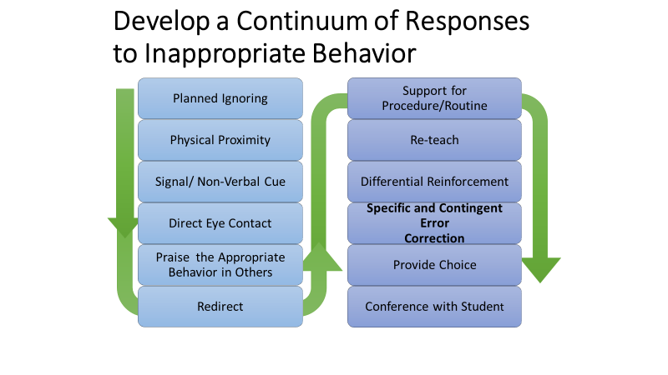
Continuum of Responses to Inappropriate Behavior

Minor Incident Report Form
1st Incident | Date | Time
Location | Problem Behavior | Staff Intervention/Action Taken
☐Classroom  ☐Cafeteria  ☐Hallway  ☐Bus  ☐Outside Building/Playground  ☐Restroom  ☐Other: ______________ | Respectful, Responsible, and Safe  ☐Respectful-Disruption: Excessive talking, argumentative.  ☐Responsible-Dress Code Violation  ☐Safety-Horseplay  ☐Respectful-Profanity/Inappropriate Language  ☐Respectful/Responsible/Safety-Non-Compliance: Class rules, cheating, running in building, off task  Student Signature: _______________________________________ | ☐Warning  ☐Reteach Expectation  ☐Teach Replacement Behavior  ☐Conference with Student  Teacher Initials: ______________
2nd Incident (Same Behavior) | Date | Time
Location | Problem Behavior | Staff Intervention/Action Taken
☐Classroom  ☐Cafeteria  ☐Hallway  ☐Bus  ☐Outside Building/Playground  ☐Restroom  ☐Other: ______________ | Respectful, Responsible, and Safe  ☐Respectful-Disruption: Excessive talking, argumentative.  ☐Responsible-Dress Code Violation  ☐Safety-Horseplay  ☐Respectful-Profanity/Inappropriate Language  ☐Respectful/Responsible/Safety-Non-Compliance: Class rules, cheating, running in building, off task  Student Signature: _______________________________________ | ☐Begin Documentation  ☐Conference with student  ☐Intervention (30 day cycle)  ☐List interventions: _________________________  ☐Referred to Counselor  ☐Lunch Detention: __________________  ☐Seat Change/Student Conference  ☐Reteach Expectation  Teacher Initials: ______________
3rd Incident (Same behavior) | Date
Location | Problem Behavior | Staff Intervention/Action Taken
☐Classroom  ☐Cafeteria  ☐Hallway  ☐Bus  ☐Outside Building/Playground  ☐Restroom  ☐Other: ______________ | Respectful, Responsible, and Safe  ☐Respectful-Disruption: Excessive talking, argumentative.  ☐Responsible-Dress Code Violation  ☐Safety-Horseplay  ☐Respectful-Profanity/Inappropriate Language  ☐Respectful/Responsible/Safety-Non-Compliance: Class rules, cheating, running in building, off task  Student Signature: _______________________________________ | ☐Office Referral  ☐Contact Parent via  ☐Email: _______________  ☐Phone: ______________  ☐Note Home Date: ________  ☐Parent Conf Date: _________  ☐Detention: __________________  ☐Intervention: _______________________  ☐Other: ____________________________  Teacher Initials: ______________
After the 3rd Minor Infraction, this completed form should be sent to the office along with the Office Discipline Referral Form

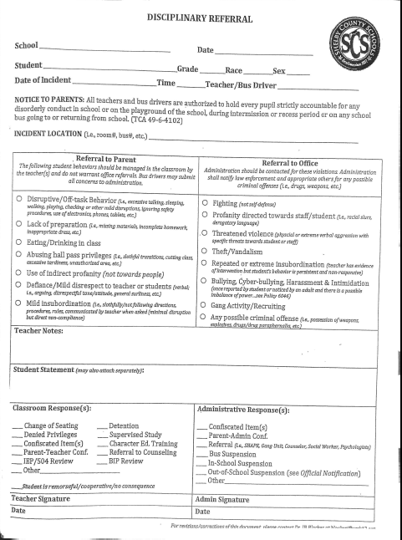

Barret’s Chapel School School
Give warning/state the expectation
Observe Problem Behavior

Is the behavior a teacher or office managed situation?

TEACHER MANAGED OFFICE MANAGED

First Offense:
Verbal Warning
Reteach, role-play correct behavior
Conference with student

Ensure safety

Second Offense: (Of same behavior)
Document
Submit report to Assistant Principal.
Conference with student
Apply classroom intervention for 30 days
(Role-Play, Reflection, Reset Time, Behavior Plan)
Change intervention if first intervention does not correct behavior and apply for 30 days.
Refer to School Counselor
Contact parent and log discussion

Referring teacher completes ODR as a major and sends the form and student to administration immediately

Teacher Managed | Office Managed
Defiance/Disrespect (minor) | Defiance/disrespect (Refusing to comply after intervention)
Disruption (minor) | Disruption  (Fighting, Throwing furniture)
Noncompliance | Leaving Class w/o Permission  Argumentative
Class Disruption | Impeding learning of others
Dress code violation (minor) | Wearing something other than required dress code
Excessive talking out | Screaming, yelling
Inappropriate Physical contact | Fighting, Hitting with intent to hurt
Inappropriate language (minor) | Profanity, slandering, threats, written, spoken or nonverbal
Incomplete class work | Repeated incomplete class work
Tardy | Refusal to return to classroom, wandering hallways
Technology Violation | Inappropriate websites, chatting online, inappropriate device visible.
Off tasks | Threats
Other | Vandalism
Running in halls | Weapons
Unprepared for class
Vandalism/misuse of property/forgery | Third minor with intervention documentation

Administrator determines appropriate action, follows through on consequence, documents action in Powerschool.

3rd offense (of same behavior)
Document
Complete Referral to Admin.
Continue intervention
Contact parent with evidence of interventions

Administrator follows up with referring teacher and makes parent contact.
Send to Office with completed ODR as a Major.
3 Minors = 1 Major

TIPS ON MINOR BEHAVIOR DOCUMENTING
- Document behavior when student has not responded to classroom strategies (pre-correction, redirection, stating expectations and verbal warning).
- Take concrete action to correct behavior
- Parent contact is warranted with continued classroom managed behaviors
- Be consistent and patient…behavior change takes time.
- Provide an intervention after each offense

CLASSROOM CHECKLIST
RTI²-B Core Components | Features in the Classroom
Behavioral Expectations | - I have the school-wide behavioral expectations posted in my  classroom.  - My classroom expectations align with the school-wide behavioral  expectations.  - 80% of my students can state the school-wide behavioral  expectations.
Teaching Behavioral Expectations | - I have taught the school-wide behavioral expectations in my  classroom.  - I have retaught the school-wide behavioral expectations  throughout the year in my classroom.  - I refer to the school-wide behavioral expectations regularly.  - My substitute plans include RTI²-B core components.
Acknowledgement System | - I use a variety of strategies to give specific positive feedback in  my classroom.  - My students can tell how they receive acknowledgement for  expected behavior.  - I give out acknowledgements that are tied to the school-wide  behavioral expectations in my classroom.  - My students are able to participate in the school-wide  acknowledgement system.
Discipline Process | - I consider behavioral definitions when determining if problem  behaviors are office-managed or staff-managed.  - I use the Office Discipline Referral form when students engage in  office-managed problem behavior.  - I refer to the school-wide discipline process flowchart when  students engage in problem behavior.  - I provide students an opportunity to get back on track after  engaging in problem behavior.

