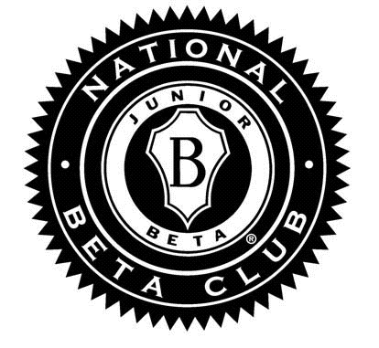

National Junior Beta Club
White Station Middle School

The National Junior Beta Club is intended for current 6th grade students of White Station Middle School. Inductions will be held during the Spring semester of the students’ 6th grade school year. Membership in the National Junior Beta Club is both an honor and a privilege. Students selected into this organization are expected to uphold the following principles: Achievement, Character, Leadership, and Service. Students must have been enrolled the 1st semester of their 6th grade year at White Station Middle in order to be inducted into the National Junior Beta Club. To be considered, students must meet the following criteria:

Achievement: Recognizing and honoring high academic achievement. (The National Beta Club Handbook)
- To be considered for membership:
  - Students enrolled in the Optional program must earn 89 or above for each subject/class (including exploratory) for the 1st, 2nd and 3rd nine week grading period.
  - Students enrolled in the Traditional program must earn ALL A’s and B’s for the 1st, 2nd, and 3rd nine week grading period with no more than one C (with at least a 75 average) for all three grading periods.

Character: Preparing young people for life and empowering them to be successful. (The National Beta Club Handbook) Prospective Junior Beta Club members are expected to exhibit appropriate behavior by following classroom and school rules. The following conduct criteria are used to determine selection and to remain a Beta Club member in good standing:

- No U’s or “N’s in Conduct.
- No In-School or Home Suspensions.
- No incidents of cheating/plagiarism.
- No disciplinary referrals.

Leadership: Developing the leaders of tomorrow. (The National Beta Club Handbook) After Beta Club inductions, officers will be selected. The officers will lead the organization in community service opportunities. Other leadership opportunities will also be offered throughout the student’s 7th grade year.

Service: Demonstrating the motto “Let Us Lead By Serving Others” (National Beta Club Handbook). Students will be invited to participate in community service projects.

Invitations to the National Junior Beta Club will be distributed in the Spring and inductions will take place the following April or May.

If you have any questions please see Ms. Jones-Richardson, Beta Club Sponsor.

