Math News

Essential Question: How can you define shapes and compose new shapes?
Use Attributes to define (2-D) Shapes: 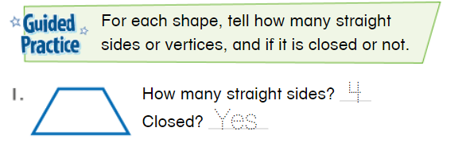

Defining and Non-Defining Attributes of 2-D Shapes: 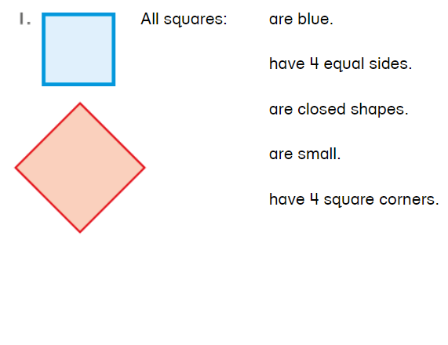

Build and Draw 2-D Shapes by Attributes:
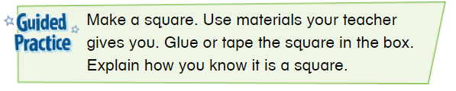

Vocabulary: 2-D Shape
3-D Shape attributes cone cube
cylinder edge face flat surface square
rectanglerectangular prismside sphere
triangle vertex/vertices

Standards:
1.G.A.1

1.G.A.2

Compose 2-D Shapes:
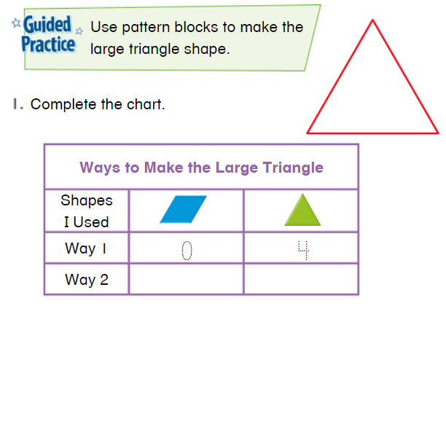

Use Attributes to Define 3-D Shapes
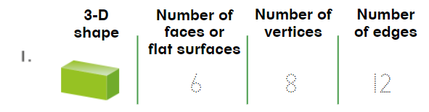

Defining and Non-Defining Attributes 3-D Shapes: 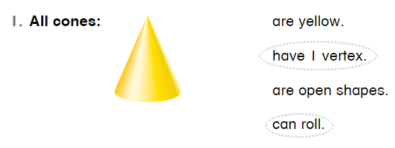
Problem Solving: 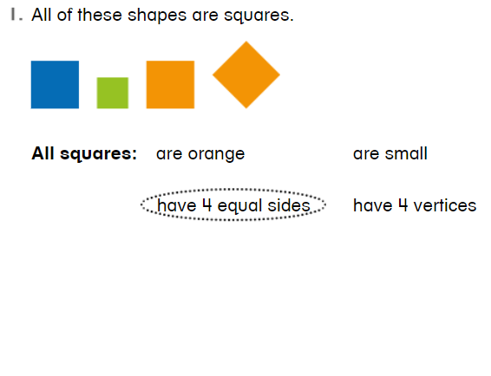
Compose With 3-D Shapes: 