CLUE Supply List
Ms. Rauch
rauchce@scsk12.org

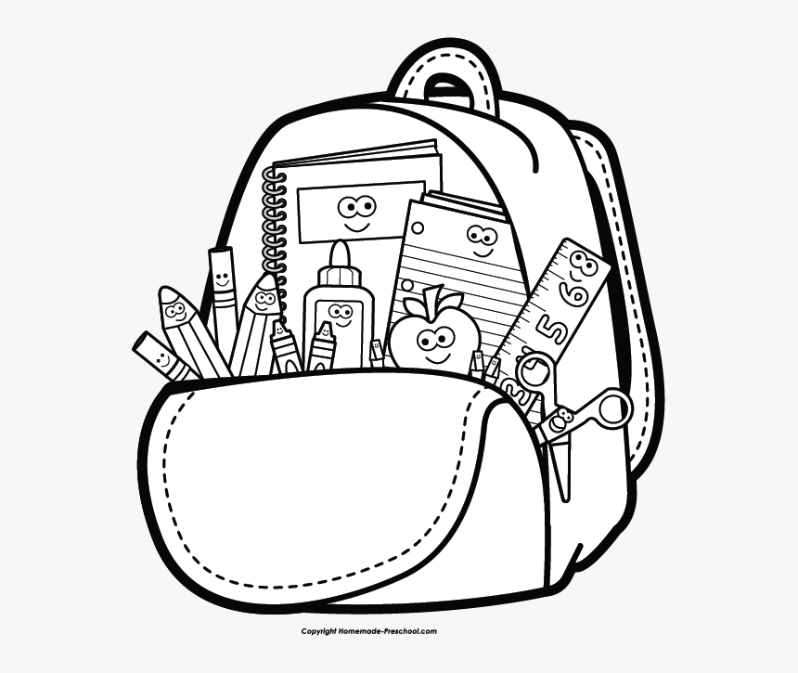

- 1 Ream of White Copy Paper
- A bag of individually wrapped candy (dealer’s choice)
- A gift card (any amount will help!) from one of the following places: Target, Wal-Mart or Amazon

