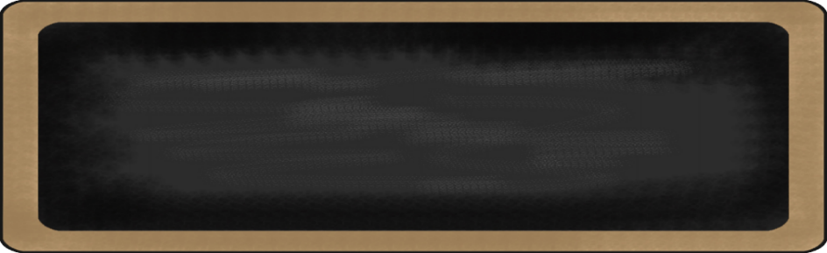
Mrs. Jones’Class
2-01 Mrs. A. Jones
jonesa16@scsk12.org

2nd Grade News

April 7-11th

Dear Parent/Guardian,

Please continue to discuss the importance of following classroom and school rules with your child. Also, please be mindful of the following school and classroom updates:
-Homework is assigned on Monday and should be returned on Friday.
-Please ensure teachers have current contact information on file. Check PowerSchool for accurate information.
-Inform your child’s teacher in writing (note, email, or Remind) regarding dismissal changes.
-Visit Richland Elementary / Homepage for school news and updates.
-Students are dismissed at 3:15.

- ‘https://schools.scsk12.org/germanshire-es

Spelling Words
(REVIEW)
- Seen
- Pay
- Thankful
- Gym
- Unkind
- Mean
- Base
- Joyful
- Untrue
- Cry


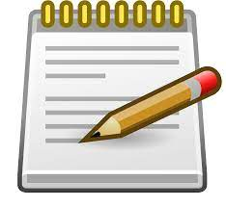

h

Important Dates

TCAP TESTING BEGINS NEXT WEEK! Proctors Needed
April 15-17th -2nd grade reading test
April 18th- No School
April 22-23rd- 2nd grade math test
Please make sure that your child is on time for the TCAP test. If your child has an appointment, please try to schedule it after 11:oo.
INSTRUCTIONAL WEBSITES FOR 2rd GRADE
www.ixl.com
www.schoolexpress.com
www.khanacademy.org

What we are learning this week:
ELA | Math | Science | Social Studies
TCAP Review | Graphing- TCAP Review |  | Producer & Consumer

