Overton High School

2023-24—Quarter 1 Syllabus

Course: Computer Science Foundations

Instructor: Dr. R. Walker
Email: Walkerrr@scsk12.org Telephone: 901.416-2136 Ext. 84226

**THIS SYLLABUS IS SUBJECT TO CHANGE**

Course Description
Computer Science Foundations (CSF) is a course intended to provide students with exposure to
various information technology occupations and pathways such as Networking Systems, Coding,
Web Design, and Cybersecurity. As a result, students will complete all core standards, as well as
standards in two of four focus areas. Upon completion of this course, proficient students will be able
to describe various information technology (IT) occupations and professional organizations.
Moreover, they will be able to demonstrate logical thought processes and discuss the social, legal,
and ethical issues encountered in the IT profession. Depending on the focus area, proficient
students will also demonstrate an understanding of electronics and basic digital theory; project
management and teamwork; client relations; causes and prevention of Internet security breaches;
and writing styles appropriate for web publication. Upon completion of the CSF course, students will
be prepared to make an informed decision about which Information Technology program of study
to pursue

Core standards: 1, 2, 3, 7, 8, 9, 23 Focus Area- Coding: 17, 27, 28, 29, 30

Course Standards (Quarter 1)
Safety
1) Accurately read, interpret, and demonstrate adherence to safety rules, including (1) rules
published by the National Science Teachers Association (NSTA), (2) rules pertaining to
electrical safety, (3) Internet safety, (4) Occupational Safety and Health Administration
(OSHA) guidelines, and (5) state and national code requirements. Be able to distinguish
between rules and explain why certain rules apply.

2) Identify and explain the intended use of safety equipment available in the classroom. For
example, demonstrate how to properly inspect, use, and maintain safe operating
procedures with tools and equipment.

Electronics and Basic Digital Theory
3) Demonstrate understanding of electrical circuits and devices, and relate to the physical laws
(such as Ohm’s Law and power laws) that govern behaviors of electrical circuits and devices.
Accurately apply these physical laws to solve problems. For example, calculate the resistance
of a DC circuit with a given DC voltage and current.

Career Exploration
7) Research various occupations in information technology industries, such as programmers,
web designers, webmasters, networking administrators, computer systems administrators,
telecommunications line installers, and informational security analysts. Compose an
informative table or chart that includes the following: work activities typically performed,
tools and technology used, nature of work environment, and the knowledge and skills
needed for success.
8) Explore various professional societies related to information technology and identify the
services and benefits provided by each member. Create a table that lists their purposes,
benefits to membership, and any certifications affiliated with the organization. For example,
investigate the Institute for Electrical and Electronics Engineers (IEEE), Computing Technology
Industry Association (CompTIA), and the Association for Computing Machinery (ACM).
Overview of the Internet
9) Drawing on multiple sources (i.e., internet, textbooks, videos, and journals), research the
history of the Internet. Create a timeline or infographic, illustrating the Internet’s historical
evolution from its inception to the present time. Discuss the needs that led to the creation of
the Internet; discuss both the benefits and disadvantages of the Internet to society, as well
as potential implications for the future. Provide examples drawn from the research to
support claims.

Social, Legal, and Ethical Issues
23) Drawing on multiple sources (i.e., internet, textbooks, videos, and journals), research the
various social, legal, and ethical issues encountered by IT professionals. Using these findings,
identify the roles and responsibilities one must consider while developing a prospective
project or addressing an IT problem. For example, web developers and programmers must
apply copyright laws and understand uses of open source software
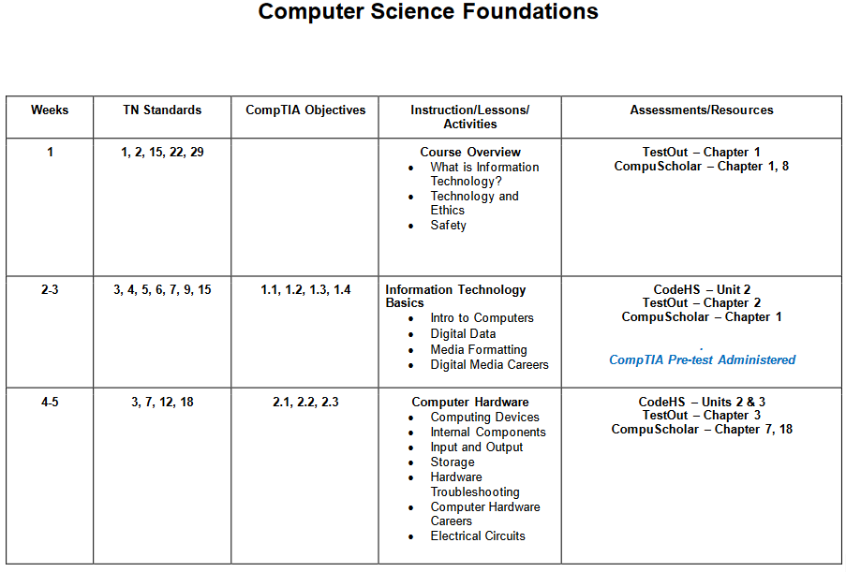

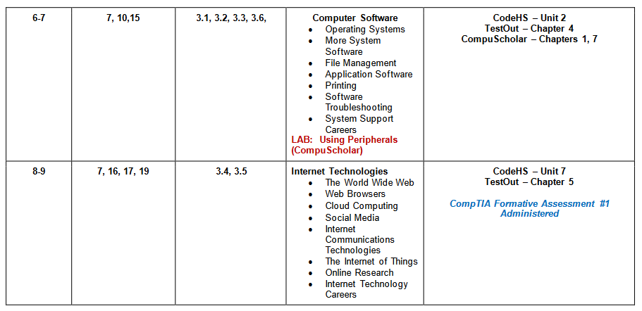
Course Schedule (Quarter 1)

Course Format

Students will develop skills through a variety of methodologies including lectures, simulations, demonstrations, and hands-on practice.

Supplies/Materials
Students will need a binder/pocket folder for handouts, pen/pencil, and writing paper. A flash drive is recommended to save work/projects. The binder/pocket folder and flash/thumb drive should be brought to class daily.
Classroom Procedures:
- Enter class quietly and quickly and have a seat. Do not hang at the door or horse play in class.
- Check board/computer and begin bell work assignment.
- If you are late, please enter the classroom quietly, sign in, place your late note/tardy slip on the clipboard, and be seated immediately.
- Please pay attention during class lecture/instructions and presentations.
- Log off all workstations before leaving class.
- If you are absent, check with your elbow partner/classmate for makeup work (see me for any handouts)
- Always remain quiet and continue working. If you need assistance, check with your elbow partner to the left and right before asking me.
- Raise your hand if you have questions; please get permission before getting on the floor or approaching my desk.

Conduct (Expectations and Consequences)
- Come to class prepared to work, participate, and pay attention every day (folder/notebook, pencil/pen, USB storage device).

CONSEQUENCE: Failure to do so will result in lower grades and possibly a “U” in conduct.
- Be on time*. Students should be seated before the tardy bell rings and should begin the assignment listed on the board as soon as the bell rings or before the bell rings. They should continue working until told to shut down. The first and second tardy will be recorded as a warning, the third tardy will result in a referral.

CONSEQUENCE: For the first and second tardy the student will be warned. Parents will be notified after the third tardy. A referral will be written after the third tardy and the student will be sent to the grade level administrator.

- Any student caught cheating will receive a zero. Cheating involves both supplying answers and receiving them.

- In addition, students are expected to abide by ALL Memphis-Shelby County and Overton High School rules (including correct computer rules and procedures) as printed in the student handbook.

CONSEQUENCE: Violations will be handled according to Memphis Shelby County Policy relating to the specific violation.
- No food, drinks, gum, water bottles/cups, etc. allowed near the computer workstations. Please do not bring food or drinks to this class.
- No cell phones

Grade Scale
A | 90 - 100
B | 80 – 89
C | 70 – 79
D | 60 – 69
F | 59 or below

Late Work/Make Up Work Policy
Late Work Policy
- Students are expected to complete all daily work, class work, and homework.
- If a student fails to complete daily work, class work, or homework, the teacher will contact the parent for assistance in implementing interventions to assist the student in completing the assignments.
- Students may submit late work with 10% deducted for each day after the due date. After the third school day, the highest grade will be 70%.
Make Up Work Following an Absence
Students are expected to make up work missed while they were absent, or in ISS. They will be given full credit for work done when they present a note from a parent or guardian within two (2) days of an absence. No makeup work will be accepted for students who are caught skipping class, or who receive an OSS assignment.

ACCEPTABLE COMPUTER AND NETWORK USE CONTRACT

All provisions of the MSCS Acceptable Use of Computers and Networks Policy apply at all times when using a computer. The policy can be found on the MSCS webpage.

The following guidelines regarding the acceptable use of computers and networks, including the Internet in my classroom, shall apply to all students:

- All technology equipment shall be used only with permission of and under supervision of the classroom teacher·
- Do not erase, rename, or make unusable anyone else's files, programs, or disks.
- Do not let other persons use your name, log-on password, or files for any reason.
- Do not use or try to discover another user's password.
- Do not use computers or networks for any non-instructional purpose (e.g., social media, games, music, activities for personal profit, chat lines, sources of viruses [hacker boards]) without instructor’s permission.
- Do not write, produce, generate, copy, propagate, or attempt to introduce any computer code destined to self-replicate, damage, or otherwise hinder the performance of any computer's memory, file system, or software. Such software is often called a bug, virus, worm, Trojan horse, or similar name.
- Do not deliberately use the computer to annoy or harass others with language, images, or threats.
- Do not deliberately access, create, or transmit any obscene or objectionable information, language, or images, including swearing, vulgarity, and ethnic or racial slurs.
- Do not intentionally damage the system, damage information belonging to others, misuse system resources, or allow others to misuse system resources.
- Do not tamper with computers, networks, printers, or other associated equipment except as directed by the teacher.
- Do not swap computers, peripheral devices, battery chargers, supplies, etc.

Rules for Using the Internet
Due to the nature of materials that are available through the Internet, students will be expected to adhere to the following rules when using classroom computers to access the Internet:
- Do not access the Internet without the permission of the teacher.
- Do not use or try to discover another user's password.
- If you encounter a problem using the computer or accessing a site on the Internet, stop and ask for assistance.
- Immediately notify the instructor, if you inadvertently access obscene, pornographic, objectionable, or otherwise questionable material.

Examples of Prohibited Use of Networks/Internet
- Using swearing, vulgarity, ethnic or racial slurs, and any other inflammatory language.
- Transmitting obscene messages or pictures (i.e. pictures of individuals wearing apparel that is prohibited by dress policy). Using the network in such a way that would disrupt the use of the network by other users.
- Using the network in such a way that would disrupt the use of the network by other users.
- Playing unauthorized games or videos on the Internet or deliberately accessing unauthorized sites.

Vandalism Prohibited
Any malicious attempt to harm or destroy MSCS equipment or materials, data of another user, or attempts to degrade or disrupt system performance will be viewed as violation of MSCS policy and, possibly, as criminal activity under applicable state and federal laws. This includes, but is not limited to, the uploading or creating of computer viruses.

