Class: Biology Student: _________________________ Period: ______
Teacher: Mr. Jarvis
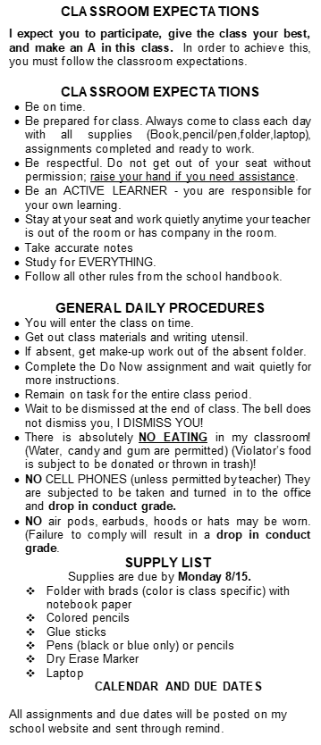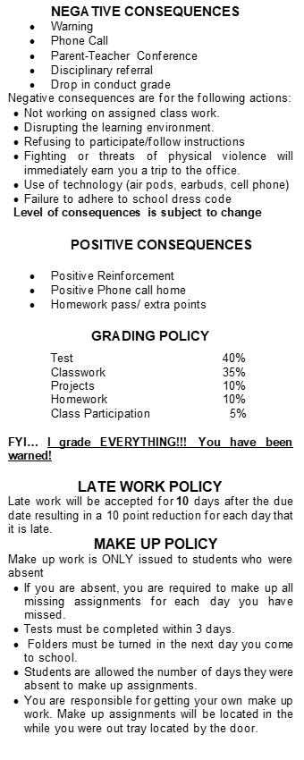

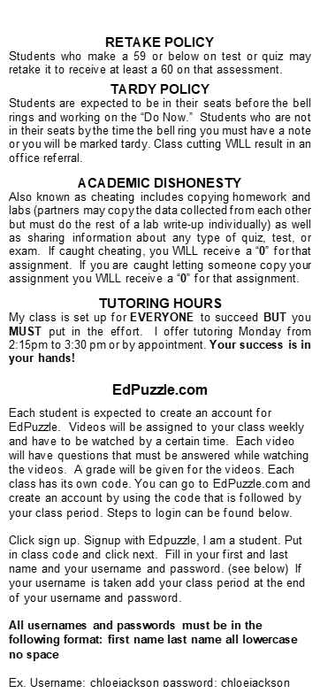  Grading Scale  A (90-100)  B (80-99)  C (70-79)  D (60-69)  E (0-59) | Technology  As the semester progresses, we will be relying more on technology to work on assignments. Please be sure to bring your laptop chargers to ensure your participation.  Cellphones  With 200 students to look over, I know phones will be used in class. They are prohibited unless instructed to do so. The phone will be confiscated, and this will not be a request. It will be given back ONCE after class. If another incident occurs, I will be handing the device into the office where it is held until the end of day.  Additional communication  You can reach me through the following:  Call or text at 901-501-5576 or  Email at jarvisw@scs.k12.org  I will typically read and respond within 24 hours. Please keep in mind that these classrooms have large numbers of students, and I will address all communication in the order it is received.  Bathroom  Each student can go twice a quarter and will be tracked. If the student needs accommodations on this class rule, parents please sign the line below.  Finally, this syllabus, like anything else, is subject to change. I will give the class an advanced notice in this event.  The syllabus is to be signed by both Student and parent then returned to class by Wednesday.  Parent: _____________________  Preferred contact: _____________  Email: ______________  Phone: ______________  Student: _______________

