
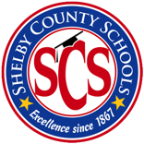
The Wolverine Way- One Team, One Goal!

Teacher: Marshon Harris Week of: December 2-6, 2024
Subject: Functional Skills

Lesson Topic: Community Resources
Text: Brigance TSI

Lesson Objective: SWBAT identify recreational facilities, defines those facilities, and demonstrate how to utilize and behave at recreational facilities IOT live independently as possible.
Activity:
- Teacher will introduce and model the lesson
- Students will analyze the lesson.
- Students will cite information about content understanding.
- Students will demonstrate evidence of skill mastery.

Independent Work:
- SWBAT understand and explain key vocabulary words.
- SWBAT share how recreation facilities benefit them and the community.
.
.

Wrap up/Conclusion:
- Students will explain what is a community resource v. what is not.

