
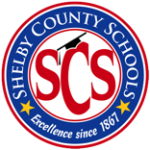
The Wolverine Way- One Team, One Goal!

Teacher: Marshon Harris Week of: Oct. 14-18, 2024
Subject: Functional Skills

Lesson Topic: JOB-RELATED KNOWLEDGE & SKILLS
Text: Brigance TSI

Lesson Objective: Students will be able to read and comprehend pre-employment vocabulary.
Activity:
- Teacher will introduce and model the lesson
- Students will analyze the lesson.
- Students will cite information of understanding.
- Students will demonstrate evidence of mastery.

Independent Work:
- Students will complete remaining problems in the lesson.
.
.

Wrap up/Conclusion:
- Students will expound on how this these skills will benefit them as they transition from high school to post-school.

