Semester Course

1.3 Loss Aversion

Student Activity Packet

UNIT: BEHAVIORAL ECONOMICS

Name: _____________________________ Period ___________

Students will be able to:
- Discuss the cognitive bias of loss aversion and how it can influence our decisions
- Make decisions that involve risk and the possibility of loss
- Analyze how loss aversion can impact us as consumers
- Learn how to overcome loss aversion

 | INTRO

PROMPT:
Use the space below to answer the prompt.

- For each scenario, circle or highlight the number that indicates how you would feel on a scale of 1-10:

  - You are walking along the sidewalk and find a $20 bill on the ground.
Very Bad Neutral Very Good
<1-------2-------3-------4-------5-------6-------7-------8-------9------10>

  - You are walking along the sidewalk and realize you’ve lost a $20 bill from your pocket.
Very Bad Neutral Very Good
<1-------2-------3-------4-------5-------6-------7-------8-------9------10>

- How did your answers compare? Did you feel the same level of emotion for both scenarios or did you find that you felt stronger emotions for one over the other? Explain.

 | DO IT (1)

ACTIVITY: ECON: Risk and Loss Aversion (See Below)
The exercise you did in the Intro showed how we can sometimes feel losses more than we feel gains of the same amount. Let’s explore this bias, known as loss aversion, by playing a game to see how you make decisions when faced with varying levels of risk and possible loss. Follow the directions on the worksheet to complete this activity.

 | LEARN IT (2)

VIDEO: The Psychology Behind Irrational Decisions
As you saw through the previous activity, our decisions can be strongly influenced by our fear of experiencing loss. Watch this video to learn more about loss aversion. Then, answer the questions.

- According to the video, people tend to feel losses _____x more than gains of the same value.

- Review the screenshot from the video below. Why do you think people tend to choose the guaranteed outcome of $1,500 in scenario one, but not in scenario two?

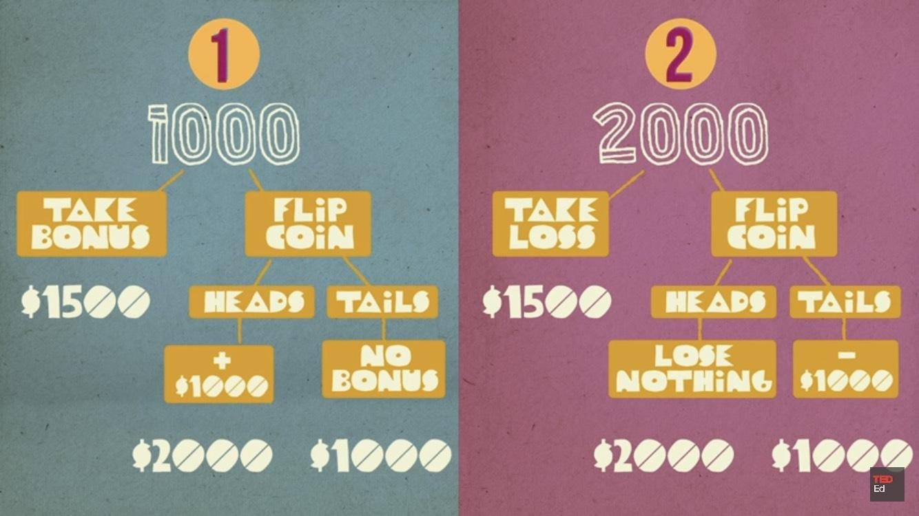

- Think back to a time in your life when you experienced a gain that made you feel good, but, if it had been a loss, would have felt disproportionately worse.

- Why might it be important to intentionally focus on the gains you have in life?

REFERENCE: When Do Consumers Deal With Loss Aversion? (3)
As consumers, we are bombarded with strategies that try to get us to spend money based on our loss aversion. Review the strategies presented in the resource slides. Then, answer the questions.

- Which of these strategies have you encountered in your daily life? Choose one and describe how you reacted to it.

- Do you think you should always avoid making a purchase when you’re targeted by a loss aversion strategy? Explain.

- Create an ad or coupon that uses one of the loss aversion strategies in the slides for a product of your choice. You can draw it below or, if done digitally, share a screenshot or link to the finished ad or coupon.

REFERENCE: Overcoming Loss Aversion
Loss aversion is a completely natural bias for human beings to have as it helps us avoid losses. However, it can get in the way when we’re faced with a decision that has potential gains as well! Read through this reference to learn what you can do to overcome loss aversion. Then, read through the scenario below. Finally, answer the questions.

Scenario:
Sam is a high school senior and has gotten into several colleges and universities. He’s narrowed it down to two choices. Sam feels like College A, which is across the country, is a better fit for him than College B, which is 45 minutes from home. However, he’s nervous about moving so far away from home and being away from his family and some of his friends. He’s also not sure if he wants to pay for airfare and other travel expenses each time he wants to come home.

- Clearly, Sam is focusing on some of the potential losses of attending School A even if it might be a better fit for him. Write 1-3 questions that would encourage Sam to overcome loss aversion and make a decision.

- What might be a worst case scenario for Sam? What is a possible solution if this happens?

- How do you think thinking through this worst case scenario might help Sam make a decision?

ECON: Risk and Loss Aversion (from above) (1)
Decisions we make that involve risk are often affected by our willingness or unwillingness to lose something. Our tendency to prefer to avoid losses is a cognitive bias called loss aversion. In this game you will make decisions that involve the possibility of gaining points paired with different levels of risk to lose points.

How the Game Works
- Your objective is to end the game with more points than your classmates, but you won’t know your classmates scores until everyone has completed the game
- Keep your results secret so you don’t influence the decisions of others

Playing the Game
- You start the game with 100 points
- For each round, indicate whether you choose to play or sit out by marking an X in the box of your choice
- If you choose to play, flip a coin
- If you choose to sit out, proceed to the next round
- If the coin lands on heads, highlight the amount you gain
- If it lands on tails, highlight the amount you lose
- After each round, add or subtract the amount you gained/lost and update your point total in the far right column
- Once you’ve completed all ten rounds, calculate and enter your final score at the bottom of the chart
- Report your score to your teacher so they can determine the winner
Round | Play | Sit Out | Heads | Tails | Points
 |  |  |  |  | 100
1 |  |  | Gain 60 | Lose 10
2 |  |  | Gain 60 | Lose 20
3 |  |  | Gain 60 | Lose 30
4 |  |  | Gain 60 | Lose 40
5 |  |  | Gain 60 | Lose 50
6 |  |  | Gain 60 | Lose 60
7 |  |  | Gain 60 | Lose 70
8 |  |  | Gain 60 | Lose 80
9 |  |  | Gain 60 | Lose 90
10 |  |  | Gain 60 | Lose 100
Final Score: |  |  |  |  | --

Reflection Questions
- If a person lost points in the first round, does that mean they made a bad decision to play that round? Why or why not?

- In this game, the reward is always constant no matter how much risk you take on (gain 60 points). Now think of your personal finances and of the points as being money. What would have to be different in order for you to take on more risk of losing your money as the rounds progress?

- Imagine a person played the game and chose to sit out every round, ending with the same 100 points they started with. Do you think that’s a good strategy? Why or why not?

- Nora wanted to invest in the stock market for the first time. She didn’t want to do anything too risky so she chose to invest in a low-risk index fund (a safe investment that generally increases in value over time). After a few months she was disappointed to see the value of her investment had gone down. Today she told you she sold her investment to avoid losing anymore money and she’s no longer interested in investing in the stock market. What would be your advice for Nora? Why?

