Middle College High School Student Handbook

2023-2024
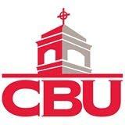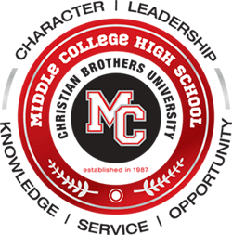

“We are Middle College”

Step Up, Get in the Game!
Step Up, Get in the Game!
Step Up, Get in the Game!
Step Up, Get in the Game! Step Up, Get in the Game!
Step Up, Get in the Game!
Step Up, Get in the Game!
Step Up, Get in the Game!
Step Up, Get in the Game!
Step Up, Get in the Game!
Step Up, Get in the Game!

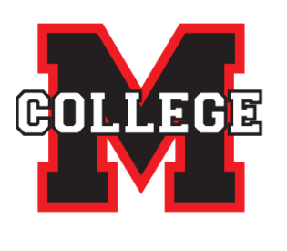
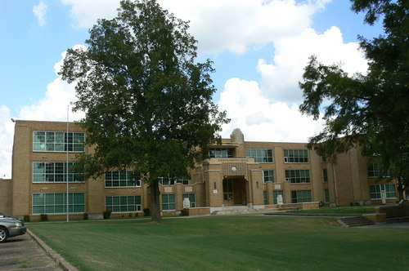

TABLE OF CONTENTS

Page | Information
2-4 | History, Alma Mater, and 5 Pillars
5 | Shelby County Schools’ 2023-2024 Calendars
6 | Enrollment Contract
7-8 | MCHS College Readiness Expectations/Discipline Procedures
9-10 | Discipline Guidelines outlined and revised by SCS for Categories A-E
11-12 | Guidelines for rescinding a transfer for choice schools
13-15 | Uniform Guidelines, Updates and Policies
16 | Attendance Policy
17 | Community Service Requirement
18-26 | ACT/SAT/Dual Enrollment/AP Course Enrollment
27 | Virtual School Courses
28-31 | Graduation and Grading
32 | Plagiarism
33-34 | Parent’s Rights to Know and Compact
35-40 | Signature Required Pages (FOR RECORDS ONLY, additional signature  pages will be sent along with the handbook)

MIDDLE COLLEGE ALMA MATER
By Ray McGarity and E. L. Pender

Proudly point us to our records, high in deeds and thoughts.
And we thank you Middle College, for the things you’ve taught.
Always do your best, at all times; hear the lesson’s call.
Use life’s standards that we’ve learned here;
And you will stand tall.
Achieve your goals; learn from your hardships;
Never be denied,
So here’s to thee our ALMA MATER,
MIDDLE COLLEGE HIGH.

Years of work have made this moment, so for all you do,
We proudly thank our staff and teachers, and even CBU.
Now life’s challenge lies before us; each must pass the test;
Using knowledge and compassion, strive to be your best.
Achieve your goal; learn from your hardships; never be denied.
So, here’s to thee our
ALMA MATER, MIDDLE COLLEGE HIGH.

MIDDLE COLLEGE HIGH SCHOOL MISSION

Our mission is to immerse students in a safe collegiate and academically challenging learning environment that prepare them to communicate effectively, think and reason critically, value diversity, and engage in service to others on and beyond high school.

MIDDLE COLLEGE HIGH SCHOOL VISION

Middle College High School will foster a safe and nurturing atmosphere of academic innovation. Enthusiastic teachers, supportive parents, and involved community partners will unite as the driving force to prepare students to become self-motivated, self-disciplined, and socially responsible individuals.

MIDDLE COLLEGE FIVE PILLARS

Character

Character is the force within each individual, which distinguishes that person from others. It gives each one individuality. It is that without which no one can respect oneself, nor hope to attain the respect of others. It is this force of character, which guides one through life and, when once developed, grows steadily. Character is achieved and not received. It is the product of constant action, daily striving to make the right choice. The problem of character is the problem of self-control. We must be in reality what we wish to appear to others. By demonstrating such qualities as respect, responsibility, trustworthiness, fairness, caring, and citizenship, we may hope to prove by example that we value character. Attitude---Respect---Effort
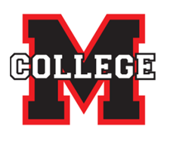
Leadership

Leadership should exert a wholesome influence on the school. In taking the initiative in class and school activities, the real leader strives to train and aid others to attain the same objective. The price of leadership is sacrifice - the willingness to yield one’s personal interests for the interest of others. A leader has self-confidence and will go forward when others hesitate. No matter what power and resources may exist, they are ineffectual without the guidance of a wise leader. Leadership is always needed; thus, to lead is a substantive charge to everyone in our community.

Knowledge

Knowledge is one great element in life, which leads to the highest success, and it can be acquired in only one way - through diligence and effort. Learning furnishes the lamp by which we read the past, and the light, which illuminates the future. Our community members have the charge to continually expand their world through the opportunities inherent in scholarship.

Scholarship means a commitment to learning. A student is willing to spend hours in reading and study, knowing the lasting benefits of a cultivated mind. We should continue to learn even when formal education has ended, for education ends only with the end of life.

Service

Service can be described in various ways. In the routine of the day’s work, many opportunities arise to help others. Willingness to work for the benefit of those in need, without monetary compensation or without recognition, is the quality we seek in our membership. We are committed to the idea of volunteering our time and abilities to the creation of a better tomorrow.

We demonstrate service by helping those inside and outside of our school. Our community invests in us and we invest in it through our community service commitment.

Opportunity

Being prepared to take advantage of and seeking out a set of circumstances that makes it possible to succeed. Opportunities exist inside and outside of an effective school. Successful schools create opportunities for all students to take advantage of their individual gifts, as well as master a rigorous set of academic and social standards. We prepare for opportunities through our demonstration of Knowledge, Service, Character, and Leadership.

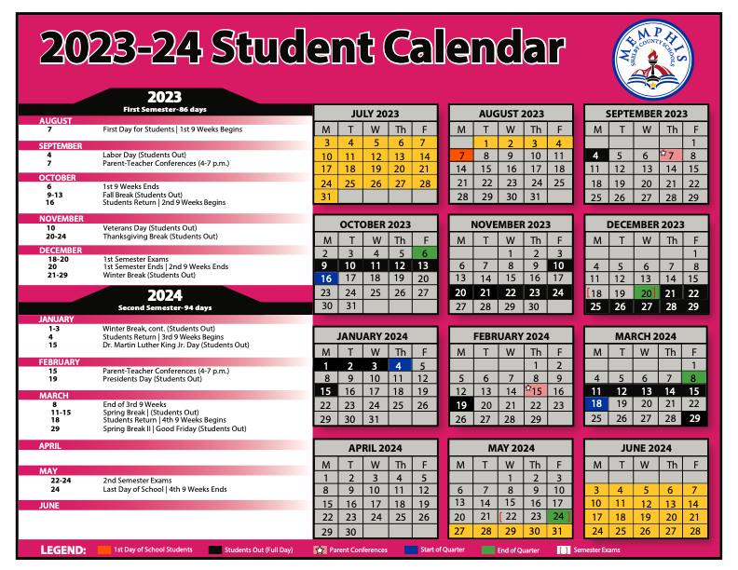

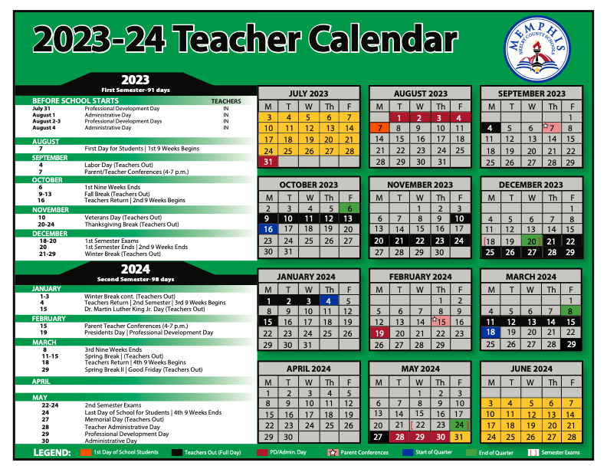

Middle College 2023-2024 Enrollment Contract

Middle College High School is committed to academic excellence. The board, faculty, staff, parents and students are also committed to our mission to prepare each student for success in college, a career, and life through a challenging curriculum in a student-centered environment. Therefore, we ask that before you enroll at MCHS, you read this behavior and academic contract. Continued violations of our college readiness expectations will lead to detention and/or administrative actions including dismissal from the Middle College High School program.

ACADEMIC STANDARDS: (Student should initial by each line)
____I have read, and I agree with our mission statement. MCHS will offer me a rigorous and challenging curriculum to prepare me for success out of high school.
____I recognize that the faculty at Middle College High School will challenge me academically.
____I understand that MCHS staff will have the final approval for all scheduling decisions, and I will not be able to drop or opt out of courses due to rigor or difficulty.
____I agree to fulfill ALL academic requirements at Middle College High School including afterschool and Saturday intervention and supports as requested by MCHS.
____I agree to turn in ALL homework and classwork assignments on time and of high quality and participate fully in all classes.
____I understand and agree that no late work will be accepted by any of my teachers.
____I agree to abstain from cheating and plagiarism in all classes.

DISCIPLINARY EXPECTATIONS: (Student should initial by each line)
I agree to conduct myself in an appropriate manner and follow the code of conduct, be in uniform every day, and abide by all MCHS, SCS and CBU policies and procedures.
I will attend school daily (Monday-Friday) and will be on time for school and each of my classes every day.
___I will remain in each class the full duration of scheduled time, and I will not be absent from any of my classes without permission.
___I will treat staff and students in a respectful manner, and I will follow staff directives respectfully at all times.
___I will not interfere with other students’ right to learn.
___I will demonstrate appropriate behavior and language at school, away from school, online, or any school function.
___I will only eat, chew gum, or drink in the designated areas of the school. (Cafeteria only)
___I will adhere to lounge and vending machine expectations.
___I will adhere to the dress code and understand the consequences.
___I will accept all disciplinary actions as spelled out in the code of conduct and determined by MCHS administration.
___I understand that I must participate in community service annually and agree to do so.

PARENT EXPECTATIONS (Parent should initial by each line)
____I will support my child’s learning by providing a study area at home to complete assignments and study.
____I understand that MCHS staff will have the final approval for all scheduling decisions.
____I agree for my child to participate in the program at MCHS, and I will support all the MCHS and SCS policy guidelines and all administrative decisions.
____I will attend all requested meetings by MCHS staff and administration.
____I understand that it is my responsibility to provide transportation by 3:30 and/or 15 minutes after any event, including tutoring, games, and other school events.
____I understand I am expected to participate in 15 hours of parent service to MCHS yearly. This includes volunteering at games, chaperoning, parking duty, etc.
____I understand that written notifications will be sent home and it is my child’s responsibility to communicate these notifications to parents and return them signed to designated locations.
____I understand and agree that no late work will be accepted by my child’s teachers, and that it is my responsibility to contact my child’s teachers whenever he/she scores less than a 75% on an assignment or assessment in order for a reassessment or makeup to be provided.

Failure to comply with the terms on this contract may result in a discipline hearing and possible dismissal from MCHS.

Sign all below

I, _____________________________(Student) and _____________________________(Parent) freely agree to the above expectations and guidelines as explained and will work hard to meet all expectations and enforce those expectations daily.

I _________________________________(Student) and _________________________________(Parent) have visited and reviewed the MCHS uniform guidelines, college readiness expectations and discipline policy at www.middlecollegeatcbu.org and understand that I must abide by and uphold all rules and expectations set forth at Middle College High School.

ALL STUDENTS AND PARENTS WILL SIGN AN UPDATED CONTRACT PRIOR TO ENROLLMENT
Middle College Discipline Policy
- Purpose:
To ensure a safe and academically rich environment allowing positive interaction between peers, teachers, and staff during academic hours of school operations.
- Scope
This policy applies to all students registered and enrolled at Middle College High School. Exceptions are allowed for Individual Education Plans and specific behavior intervention plans for those students qualifying for these services.
- Policy Statement
MCHS School staff and faculty will provide an environment rich with academic instruction and student success. Every student attending school will follow the school rules and meet the high expectations set for a free and appropriate public education. If violations of our college readiness expectations occur, students are reprimanded and responsible for completing assigned consequences. It is the responsibility of the student to bring back all parent notifications and communications related to our discipline policies. All rules and behaviors not mentioned or violated in excess are addressed in the Shelby County Schools Student Code of Conduct Policy 6022.
Rewards and recognition will be given for students with no infractions and to those who have demonstrated a good attitude, respect for others and self, and academic effort.
MCHS Level I College Readiness Expectations
- All students are expected to keep a positive attitude, always be respectful, and put forth 100% effort in all tasks, assignments, and duties.
- Violations of MCHS College Readiness Expectations include:
- Being unprepared or not having materials ready for class daily (i.e., device, books, paper, pens. etc…).
- Tardiness to school or to any class during the school day (unexcused).
- Late or missing class work or homework.
- Missing assigned interventions after school, before school, or on Saturdays.
- Uniform violations such as shirttail, sagging, no belt, ill-fitting apparel, (too loose or too tight), hats, headphones, etc.
- Excessive noise in frequency, duration, or severity. These include any noises created that interrupt academic or respectful social interaction in classrooms, hallways, auditorium, or lunchroom.
- Unauthorized access and/or use of DE and AP lounges.
- Unauthorized use of vending machines.
- On campus unsupervised 30 minutes after school or school event.
- Trespassing after school hours or in unauthorized areas before or after school. All students who leave campus and return will be considered trespassing. This includes parking lots adjacent to the school.
- Visible cell phones throughout the school day (classroom, hallways, stairwells, cafeteria and restrooms). This includes after school activities inside the school (tutorial sessions, practice, etc.). This does not include sporting events in the gym (basketball, volleyball, etc.) or performances in the auditorium (plays, orchestra, etc.).
- Unauthorized use of student/school devices (websites, games, social media, and recording during school hours).
- Food, candy, drinks, or gum in hallways, classrooms, or any areas not designated for eating.
- Chain or fast-food containers in the cafeteria and in classrooms.
- Unauthorized sale and distribution of food, candy, and beverages.

All expectations include on and off campus behaviors and any digital representation of self and the school community.

MCHS Level II-Violations See: SCS STUDENT CODE OF CONDUCT
Responsibilities
- Teachers must document all infractions in the designated system.
- Administrators/PBIS TEAM must monitor and ensure that students and teachers are fulfilling their responsibilities.
- Parents must attend requested meetings and ensure rules, values, and expectations are being met at all times.

Middle College Behavior Support and Discipline Measures

Middle College is a rigorous, accelerated college readiness program. Our students do a great job in exercising self-discipline, behaving responsibly, and obeying the rules. These rules apply on school property, at school-sponsored events, on district-issued technological devices, and on buses. However, some students are not always considerate of others or the school’s rules. When this happens the school district must take action to fulfill one of its major responsibilities – keeping the school environment safe and productive for all students and individualizing supports and interventions for students. To do this, SCS and MCHS advocate student behavior programs that teach, model, encourage and reward positive behaviors in students. Most of the students’ misbehavior is handled individually through classroom and school-wide intervention strategies. Disciplinary measures designed to correct negative behaviors are used when these strategies, used alone are not effective. For every five (5) level one violations, students will be assigned ISS and a parent conference will be scheduled to review and diagnose causes of misbehavior and discuss steps to avoid further disciplinary action. Additional consequences include, but are not limited to:
- Confiscation of items and/or loss of privileges
- After-school detention
- Overnight suspensions or mandatory parent conferences in lieu of suspensions
- Home suspensions
- Reassignment to home school (transfer revoked- See guidelines for a transfer to home school)
- School expulsion and assignment to an alternative school

Middle College High School Progressive Discipline Protocols
Level I Violations | Consequences
1 Infraction | Verbal Warning
2 Infractions | Parent Phone Call and Referral to Administration
3 Infractions | After-School Detention/Letter (Notification Letter 1)
5 Infractions | In-School Suspension /Letter (Notification 2) + Mandatory Parent Conference
>10 Infractions | Mandatory Parent Conference/Letter (Notification 3) +In-School Suspension +Probationary Status
>15 Infractions | Transfer Revocation Meeting with administrators, faculty, parents, and student (Notification 5)
Any excessive or repeated Level 1 offences and ALL level 2, 3, 4, and 5 offenses will be written up as an office referral and will be handled on an individual basis by MCHS administration and are subject to all disciplinary actions including immediate transfer revocation and referral to the Transfer Renewal Committee.
Unexcused absences from detention will result in parent conference and automatically assigned to two detentions. Detention must be served in lieu of participation in any extracurricular activity (Sports, afterschool academy, clubs, etc.).

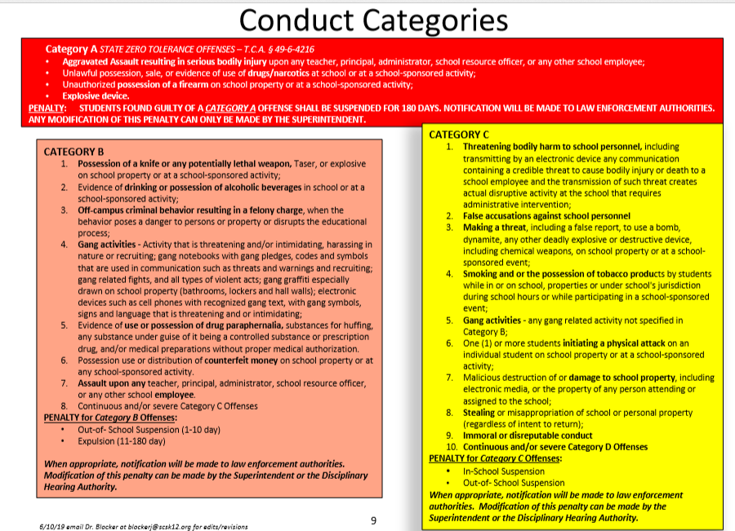
Discipline Guidelines outlined and revised by SCS

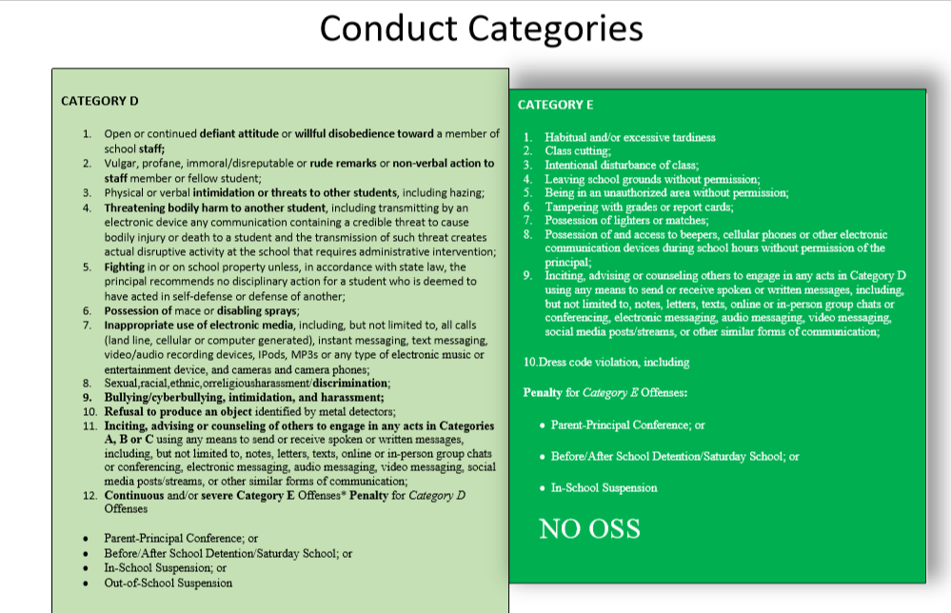

SCS Criteria for Rescinding a General Choice Transfer

- The student has accumulated any combination of 10 or more unexcused tardies and/or unexcused absences to school or class, early dismissals from school or class, or late pickups.

- The student has been referred to the District Attorney’s Office for Truancy (SARB).

- Student is not maintaining acceptable academic progress (2 or more D’s and/or at least one F at the end of a grading period).

- The student has received any combination of:
  - 3 office referrals and In-School Suspensions (ISS), or Short Term Out-Of-School Suspensions (OSS)(1-3 days)
  - 2 (or more) Short Term Out-Of-School Suspensions (OSS) of 4-10 days for any reason
  - Any Long-Term Out-Of-School Suspension/Expulsion

- A statement from Student Services that the student is being returned to the school on probation and has not met the terms of the probation.

- Evidence that the parent/guardian has falsified or provided fraudulent supporting documents when applying for the transfer; not being forthcoming with any change in address; or other status pertinent to the transfer after receiving it.

- The school location has become overcrowded or exceeded the State’s maximum class-size (extreme cases).

When a student is at risk of violating any of the aforementioned criteria (other than the student committing an offense that results in a long-term suspension/expulsion or the parent falsifying documents to obtain the transfer), an administrator must meet with the parent/guardian to warn them that their child’s transfer is in jeopardy of being rescinded, reason why, and what they must do to keep the rescission from happening.

This must be given to the parent in writing during the meeting.

***REASON (S) FOR RESCINDS MUST BE VERIFIABLE IN POWERSCHOOL***

Middle College Uniform Policy

The basic uniform shall be red Middle College Polo shirt and khaki bottoms (skirt, skorts, shorts and pants). Students who have TN Ready graduate status DO NOT have to wear the basic uniform (See included guidelines*).

Pants:
- Pants must be straight-legged or boot cut. Full-length pants, cropped pants, cargo pants and straight-legged capri pants are permitted. Denim jeans, leggings, tights, jeggings, pedal pushers, and bell-bottoms are not permitted.
- Walking shorts are permitted for high school students. (Walking shorts are straight-legged shorts that are at the knee.)
- Pants must fit at the waist and not be oversized or undersized (e.g., baggy pants, sagging pants, tights, or pants made of spandex or denim are prohibited.). Belts are encouraged and if worn, they must be fitted and put through belt loops. Sweatpants (or pants made of stretchable material) are not permitted.
- Skirts must be at or below the knee.
- No denim material may be worn as uniform clothing.

Shirts/Tops/Jackets:
- Shirts must be tucked on the inside unless they are made to be worn over pants or skirts.
- T-shirts may be worn as undergarments. They must be solid white.
- All shirts must have sleeves and a collar.
- No portions of the uniform may be made of sheer or see-through material, including lace.
- Light jackets, vests, shirts, sweaters, sweatshirts, and cardigans are permitted as items that may be worn over the uniform top. They must be solid red or black and may not have large logos, stripes, or other designs. Jackets purchased and approved by MCHS are permitted during the school day.
- Middle College APPROVED HOODIES PURCHASED FROM MCHS are allowed to be worn over the Basic Uniform. Students must adhere to all uniform guidelines underneath any jacket, hoodie, or other outerwear.
- No sweatshirts may be worn inside out to hide designs or large logos.
- Heavy coats, heavy jackets and raincoats are not covered by these regulations and are not to be worn or carried during the school day. *Violations of this policy will result in collection of the jacket and will have to be picked up by a parent.

Head and Foot Apparel
- Headbands larger than two inches, headgear, hats, caps, wraps, sunglasses, headphones, and other items are not to be worn inside the facilities or on campus.
- Shoes can have heels no higher than one and one-half inches. Shoes with rollers/wheels are prohibited. Athletic shoes, sandals with straps on the heel, and boots are permitted.

Other Guidelines:
- The district prohibits K-12 students from wearing any type of clothing, apparel or accessory that denotes their membership in or affiliation with a gang associated with criminal activities. Therefore, principals shall have the authority to place restrictions on the Basic Uniform for safety reasons including gang-related activity.
- Students may wear the uniforms of nationally recognized student organizations at their schools on days specified by the organization (e.g., Girl Scouts and Boy Scouts).
- Blankets are not allowed in the building.
- Violation of the school uniform policy shall not affect a student's academic grade.
- Parent complaints about the school uniform policy and the school dress code shall be reported to the principal or a designee.
- The school uniform policy shall be in effect during both the school year and the Summer Program.

Friday Exception: Middle College allows students to wear an official Middle College t-shirt, team jerseys, college t-shirts and MCHS club organization shirts with uniform bottoms/jeans on Fridays.

Middle College @ Christian Brothers’ University
TN Ready Graduate Status
Students with documented TN Ready Graduate Status in grades 9th-12th may wear the following:

- MCHS Dual Enrollment issued lanyard/arm band to identify Dual Enrollment status.
- Jeans and Casual pants are acceptable. (Ripped jeans, baggy pants, sagging pants, tights, or pants made of spandex are prohibited.)
- Collared shirts of any color- Shirts must have sleeves and may not be made of see-through material. All collared shirts/blouses must be buttoned properly; at no time should your shirt/blouse be opened. MCHS and college t-shirts may only be worn on designated day{s} assigned by MCHS administrator.
- Only Middle College approved hoodies purchased from MCHS are allowed.
- Skirts or dresses must be to the knee in front and back.
- Shoes can have heels no higher than one and a half inches. Athletic shoes, sandals with straps on the heel, and boots are permitted.
- You can have your cell phones at CBU campus only. Phones are prohibited in MCHS building.
- You must adhere to SCS uniform policy when you are out on break at CBU.
- CRE’s will be given for failure to adhere to the policy.
- Please note that multiple CRE’s will lead to an overnight suspension.
***Consequences for not adhering to the dress code policy are in accordance with the SCS and MCHS uniform policy and SCS student code of conduct***

Middle College Attendance Policy

Purpose:
To ensure all students and families are held to high standards of attendance, timeliness, and honor MCHS college readiness s expectations.

Scope
This policy applies to all students registered and enrolled at Middle College High School.

Policy Statement
It is vital for students to be on time, at school, and meet all attendance requirements in order to be college and career ready. All district Attendance and Excuses Policies stated in SCS Policy 6014 will be enforced.
All students are expected to attend school all day. All students are also expected to be on time for school and on time for every class, every day. All attendance violations will be documented in our school level College Readiness Tracking system and in our district’s student information management system. All attendance violations, including excused and unexcused tardiness and absenteeism will be monitored and documented. Excessive tardiness and absenteeism will lead to School Attendance and Review Team (SART) and/or Transfer Renewal Meetings (TRM). Students who accumulate 3 excused or unexcused absences will receive a warning letter, while those with 5 absences will be sent a notification for a School Attendance and Review Team (SART) meeting. For students who accumulate 10 excused or unexcused absences, a Transfer Renewal Meeting (TRM) will take place and the student’s transfer may be revoked. When a student is absent, in order to excuse the absence, a written statement within two (2) school days of the student’s return to school explaining the reason for the absence is required from the parent or guardian. A written statement from the parent or guardian will be accepted and may excuse up to ten (10) absences or tardies. After ten excused absences or tardies, all future absenteeism and tardiness (excused or unexcused) will be marked as violations of our College Readiness Expectations.
Unexcused Tardiness: Middle College values timeliness and attendance. All unexcused tardiness will be marked as a violation of our College Readiness Expectations and can lead to disciplinary action. All other SCS policies addressing tardiness and attendance will be upheld in our student management systems.
Make-up Work: In the event of an excused absence, students are expected to make up work missed within a reasonable time (e.g., at least one or more days or makeup for each day of excused absence).
In the event of an unexcused absence, one day of makeup time shall be allowed for each day of unexcused absence, if the following conditions are met. The parent of a student or a student with an unexcused absence must submit a written request to the teacher to makeup the work and must participate in an appropriate intervention (e.g., student or parent conference with the teacher, Saturday school, online tutorial, other appropriate intervention determined and scheduled by the teacher). For absences due to long-term suspension (over 10 days)/expulsion, the program of making up work shall be in accordance with state law.
Before and After School: School begins at 8:15 and the cafeteria will be open starting at 7:30 for breakfast. Exceptions will be made for library access. Students are to be picked up by 3:30 daily. Students who are unsupervised after 3:30 are in violation of our attendance policy subject to disciplinary action.
Rewards and recognition will be given for students with no infractions and to those who have demonstrated a good attitude, respect for others and self, and academic efforts.

MCHS Attendance Expectations:

- All students will be at school on time every day.
- All students will be on time for all classes daily.
- SCS Policy 6014 will be adhered to by all Students.

Stakeholder and student Responsibilities:

- Teachers must document all attendance violations including excused and unexcused tardiness and absenteeism in the district’s student information management system.
- Attendance Designee will document all attendance violations in MCHS’s local College Readiness system.
- Administrators/PBIS TEAM must monitor and ensure that students and teachers are fulfilling their responsibilities.
- Parents must ensure students are at school daily and on time.
- Students must be on time to every class, every day.

Middle College Community Service Requirement

Middle College at Christian Brothers University requires each student to complete a minimum of 25 hours each year. The community service hours consist of the following: ten hours that are specific to Middle College (House activities), ten hours of school service (Open House, Date with Data, peer tutoring, etc.), and five hours of elective service that is the student’s choice. A minimum of 12.5 hours MUST BE completed by the end of the first semester.

To receive credit for volunteer hours, students must submit hours for approval using the documents located in the main office or create an account with United Way of the Mid-South which not only tracks service hours but also lists current community service opportunities in and around Memphis. To receive credit for the current month, the hours must be submitted by the fifth of the following month. The form must be filled out completely, including all the highlighted areas, to receive credit. If using a United Way account, simply print out a transcript and turn in to the main office. Volunteer opportunities are sometimes provided by Middle College, but students should utilize community agencies to fulfill the community service requirement.

Failure to complete the community service requirement will result in a student being ineligible to participate in dual credit or dual enrolment courses and could result in revoke of Middle College transfer.

“The best way to find yourself, is to lose yourself in the service of others.” - Gandhi

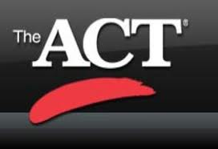
Middle College ACT Information

Benchmarks determine the probability of students’ success in college and are the minimum scores to prevent remedial placement.

ACT College Readiness Benchmarks:
English Composition = 18, Reading=22, Math=23, and Science= 23.

2023-2024 Test Dates (National)
Test Date | Regular Registration Deadline  Late Fee Applies After This Date | Late Registration Deadline | Photo Upload and Standby Deadline
September 9, 2023 | August 4 | August 18 | September 1
October 28, 2023 | September 22 | October 6 | October 20
December 9, 2023 | November 3 | November 17 | December 1
February 10, 2024 | January 5 | January 19 | February 2
April 13, 2024 | March 8 | March 22 | April 5
June 8, 2024 | May 3 | May 17 | May 31
July 13, 2024* | June 7 | June 21 | July 5
*No test centers are scheduled in New York for the July test date.
Test Information Release for the 2023-2024 testing year will occur in September, April, and June. See www.act.org/the-act/tir for more information.

ACT Test Registration Information
How to register for the ACT
- Visit www.studentact.org
- Create an ACT Web account. Email yourself the username and password for your records. The same information will be used throughout your high school career. All of your ACT scores will be listed under your account.
- During your first registration, you will be asked questions about your high school, your high school classes, your background, and your family, and your interests. In addition, you will also be asked for identifying information such as your name, address, phone number, email, and social security number. Upon completing this information, you can proceed to register for the ACT itself.
- The registration process will ask you to select your preferred test date, select whether you will take the ACT (No Writing) or the ACT Plus Writing, and will apprise you of any applicable fees. You will also have the opportunity to order items such as ACT Test Information Release and official ACT test preparation materials. During the registration process, you will also be able to designate schools which you would like to receive your ACT test scores (although you do not have to select any schools if you prefer not to). You will choose where you’d like to take the ACT (but be sure to sign up early, since testing centers can fill up fast!), and then you will be asked to confirm all the information you have provided and then provide a method of payment (credit cards are the only payment method accepted when registering online).
- Note: As per the ACT website, once you register for the ACT, your order cannot be cancelled, and most fees are non-refundable. Students registering online will have the ability to print out their ACT score report from their ACT Web Account as soon as scores are available, and the report is ready. If you are unable to test on Saturdays (the usual day the ACT is administered) due to religious beliefs, if you are homebound or confined, or if you need to receive testing accommodations due to a disability, you will have to complete additional documentation outside of your ACT Web Account in order to have the test administered to you.

ACT Fees

ACT (no writing): $46.00
Includes reports for you, your high school, and up to four colleges (if codes are provided when you register).

ACT with writing: $62.50
Includes reports for you, your high school, and up to four colleges (if codes are provided when you register). The $16.50 writing test fee is refundable on written request if you are absent on test day or switch to ACT (no writing) before testing begins.

Fee Waivers
If you are testing on a national test date and can't afford the registration fee for the ACT or ACT with writing, you may be eligible for an ACT Fee Waiver. Fee Waivers must be requested by Ms. Jones or Mrs. McDowell-Brown.
You must meet all of the following requirements:
- Currently enrolled in high school in the 11th or 12th grade.
- Either a United States citizen or testing in the US, US territories, or Puerto Rico.
- Qualify for free or reduced lunch or meet one or more indicators of economic need listed on the ACT Fee Waiver form.

If you are eligible, you may use a maximum of two separate fee waivers total. The waiver is used once you register, even if you do not test on the requested test date. IMPORTANT: To take full advantage of the waiver, you must follow through and test on your registered test date.
Fee waivers cover only the basic registration fee for your test option on a national test date, including up to four college choices (if you provide valid codes when you register). Waivers do not cover the late registration fee, test date or test center changes, standby fee, additional score reports, or any other services.
You cannot request a fee waiver directly from ACT; you must contact your high school counselor. If you receive an ACT Fee Waiver Form, follow the "Student Directions" on it for your registration method (or if requesting Special Testing). Note: If you register online, and register during the late period or request any additional services, you must enter a credit card to pay those fees before submitting your registration.
- Take acceptable photo identification. You will not be admitted to test if your ID does not meet ACT requirements.
  - State ID or Drivers License
  - ACT Identification Form (Must be requested and completed by Counselor-Ms. Jones or Mrs. McDowell-Brown. All requests must be made within 3 days before the test day.
- Take sharpened, soft lead No. 2 pencils with good erasers (no mechanical pencils or ink pens). Do not bring any other writing instruments; you will not be allowed to use them. If you are registered for the ACT with writing, your essay must also be completed in pencil.
- Take a permitted calculator to be used on the mathematics test only. It is your responsibility to know whether your calculator is permitted. Please refer to the ACT Calculator Policy (PDF).

Test Day
- Take a printed copy of your ticket to the test center. You will not be admitted to test if you do not have a printed copy of your ticket. If you have lost your ticket, you can print another through your ACT web account.

2023 – 2024 SAT Test Information
SAT Score Structure
- Total score: 400–1600
- Evidence-Based Reading and Writing Section: 200–800
- Math Section: 200–800
How to register for the SAT
Students can register online at the College Board website or my postal mail. To register by mail, ask your guidance counselor for the SAT Paper Registration Guide.
When registering online, registration fees must be paid via credit card. If you prefer to write a check, you must register by postal mail.
Regular registration deadlines are typically about three to four weeks before a test date. Late registration deadlines are typically about two to three weeks before a test date.

SAT Fees

SAT (no essay): $46.00

SAT with Essay: $57

Late registration fee: Additional $28
SAT registration fee includes up to four score reports (if selected during the registration period). You can visit the SAT website to find out why StudyPoint recommends sending score reports after viewing your SAT scores.

Fee Waivers
If you are testing on a national test date and can't afford the registration fee for the SAT or SAT with Essay, you may be eligible for an ACT Fee Waiver. Fee Waivers must be requested by Ms. Jones or Mrs. McDowell.
You must meet all of the following requirements:
- Currently enrolled in high school in the 11th or 12th grade.
- Either a United States citizen or testing in the US, US territories, or Puerto Rico.
- Qualify for free or reduced lunch or meet one or more indicators of economic need listed on the SAT Fee Waiver form.
If you are eligible, you may use a maximum of two separate fee waivers total. The waiver is used once you register, even if you do not test on the requested test date. IMPORTANT: To take full advantage of the waiver, you must follow through and test on your registered test date.

Dual Enrollment Requirements
Middle College High School is a program that offers students the opportunity to attend and earn college and high school credits simultaneously. By collaborating with Christian Brothers University, we are able to offer high school students the opportunity to earn college credits by taking courses on the CBU and Middle College campuses. By engaging students in rigorous instruction and challenging life tasks, we prepare all students to be successful in life, college, and their careers. Our goal is for every student to graduate high school with over 60 hours of college credit.
Requirements to have access to dual credit classes for MCHS Campus:
- A cumulative GPA of 2.75 or higher
- A minimum score of 19 on the ACT or 990 on the SAT
- Satisfactory conduct
- Satisfactory completion of the MCHS community service requirement
- Administrative approval
Requirements to have access to dual enrollments classes for CBU Campus:
- 11th or 12th Grade
- A cumulative GPA of 3.0 or higher in high school course work
- A minimum score of 21 on the ACT or 990 on the SAT
- Satisfactory conduct
- Satisfactory completion of the MCHS community service requirement
- Administrative approval
Specific ACT sub scores required to take dual enrollment courses at CBU:
- English – 20
- Math
  - Finite – 23
  - Pre-Calculus – 26
  - Calculus- 27
- Science
  - Intro to College Chemistry – ACT math sub-score 20
  - Principles of Chemistry – ACT math sub-score 25 and ACT composite 25
  - Biology – ACT math sub-score 20 and ACT composite 22
For continuation in the program, a student must:
- Maintain a cumulative GPA of 3.0 in all dual enrollment coursework.
- Have no outstanding debts to the university.

Dual Enrollment Courses: Student Expectations
- Must attend DE New Student Orientation
- Enrollment in a DE course if final. Students may not ask to be dropped after the course has started.
- Must attend classes daily and punctually. Must attend CBU classes even when SCS is not in session.
- Must have required materials for each class.
- Must read all materials distributed. Prepare all class assignments and submit ALL homework on or before the deadline.
- Must always exhibit the behavior of a collegiate student.
- Must dress according to the uniform policy established by Middle College.
- Must walk with a peer instead of driving to CBU.
- Must avoid stopping at Dollar General, Subway, etc. (These areas are considered off campus without permission). Only travel to CBU &MCHS campuses.
- Do NOT go into any dormitories on CBU campus
- Be sure to study in an open area in the library. You are NOT to go on the 3rd floor.
- Must avoid PLAIGARISM
- Bullying/Cyber bullying is prohibited
- Must take full advantage of opportunities to develop and implement career plans.
- Must be a self-advocate and learn how to locate and utilize available campus resources and student support services, including IT center, writing lab, math lab, etc.
- Must learn how to log on to Banner Web, Moodle, etc. as it is a necessity.
- Must maintain an A or B average in ALL classes. A student will be placed on probation for obtaining multiple grades of “D” or “F” on their college transcripts or falling below a 2.75 GPA and will be put on academic probation.
- If a student is removed from CBU courses or considered ineligible to enroll in courses on the CBU campus, he/she is no longer considered eligible to attend MCHS.
- Special Note: Parents are NOT to contact CBU professors or Administration Staff
For specific questions please contact --- at 901-416-4551 or ---.

AP Courses: Student Expectations
Middle College High School is pleased to offer students the opportunity to take Advanced Placement (AP) courses that is equivalent in rigor to college-level courses. These demanding courses require higher levels of effort, time, and commitment than honors-level classes and are recommended for highly motivated and determined students. Students enrolled in these courses take National AP Exams offered by The College Board in May of each year. The AP Exams dates are established by the College Board. College credit is often awarded for passing scores on AP Exams; however, students must research individual institutions on policies regarding the issuance of college credit.
Advanced Placement courses are taught at a college-level and students are expected to be responsible for their educational experiences. If concerns arise, parents are welcome to confer with AP teachers, but it is recommended that students use this opportunity to foster the independence needed for future educational success. The goal of all AP courses is to give students the opportunity to develop the academic and personal skills that are integral parts of postsecondary education.
- Students will remain in the AP course(s) for the duration of the year.
- Student will complete independent work outside of class and know that the pace of learning will be faster than in Non-Honors and Honors classes. Students understand a high level of independent study is required on their part.
- Students will meet deadlines for assignments.
- Students will complete summer assignments.
- Students will seek extra help when needed.
- All students enrolled in AP classes will take the AP Exam (no exceptions)
- Students will prepare diligently for the AP exam by participating in AP Saturday Study Sessions sponsored by SCS.
- Students will be assessed frequently with AP release test items and timed tests.
- Students will approach coursework with open minds and positive attitude.
- Students enrolled in AP Courses will receive five extra points added to their quarter grade.
- Students earning a final grade lower than a C may not be considered for another AP course.
- Students will maintain a A/B in all AP Courses.
- Enrollment in an AP course is final. Students and parents may not ask to be dropped after the course has started.

Virtual School (Online) Courses: Student Expectations

Students enrolled in a Virtual School (Online) course will be scheduled to a study hall class. During study hall, students will actively complete their online assignments. Although Virtual School allows students to work at their own pace, MCHS’ Virtual School Monitor, along with other Study Hall Teachers, will provide students with benchmarks (time frame) for assignments to be completed. All students are required to meet these benchmarks. Students who do not meet the benchmarks will be assigned to after school lab and will receive an infraction.
All Virtual School courses will be listed on students’ report cards and calculated into their grade point averages. All courses should be taken seriously and completed by the benchmark deadlines. At the beginning of the year, all students and parents will be required to participate in Virtual School’s mandatory orientation. Orientation dates will be shared with students and parents. During the orientation, parents will receive information on how to monitor their child’s online progress.
Students may not take more than two online courses per semester without Administration approval. All courses are broken into modules that include ongoing online discussions, research, project work, readings, collaboration activities, and multi-mode assessments. Online instructors are available to assist students during their posted office hours. However, students can progress throughout the course without being online simultaneous as their instructor. Within the Blackboard Learn system, a student has the ability to send messages or inquires to the online instructor. All correspondence is answered within a 24-hour window. If student a experiences difficulties with their online course, he/she should inform the MCHS Virtual School Monitor immediately. Students should contact their Online Instructor regarding assignments and grades.

Graduation Requirements

To earn a regular high school diploma, students must earn the specified 22 units of credit, complete a capstone experience, and have satisfactory records of attendance and conduct.

CURRICULUM REQUIREMENTS:
The following 22 units are required for graduation:
• English ………………..4 units
• Mathematics……...........4 units
(4 units of high school Math)
• Science……………...…3 units
(3 units of high school Science)
• Social Studies……….....3 units
• Wellness……………….1 unit
• Physical Education…….0.5 unit
• Personal Finance …...…0.5 unit
• Electives……………….3 units
• Foreign Language……. 2 units
(2 units of high school Foreign Language)
• Fine Arts …………...…1 unit
22 Total Units
(with an elective focus, three credits in the same content area such as Career and Technical Education, science, fine arts, etc.)

SELECTION OF VALEDICTORIAN AND SALUTATORIAN:
The selection of valedictorian and salutatorian at each school is based on the following criteria:
  - Candidates must have completed all graduation requirements at the scheduled time of graduation for the class.
  - Candidates must be designated as seniors at the beginning of the fall term of the year of intended graduation.
  - Candidates must have completed four (4) units of credit at the school of intended graduation by the end of the seventh (7th) semester in their high school program.
  - The student with the highest grade point average will be designated valedictorian for the graduating class. The student with the next highest grade point average will be designated salutatorian. Grade point average will be determined at the end of the first semester of the senior year. (See Computing Grade Point Average and Class Rank.)

GRADUATION WITH HONORS OR DISTINCTION:

- Students who score at or above all of the subject area readiness benchmarks on the ACT or equivalent score on the SAT will graduate with honors.
- Students will be recognized as graduating with “distinction” by attaining a B average and completing at least one of the following:
• earn a nationally recognized industry certification
• participate in at least one of the Governor’s Schools
• participate in one of the state’s All State musical organizations
• be selected as a National Merit Finalist of Semi-Finalist
• attain a score of 31 or higher composite score on the ACT
• attain a score of 3 or higher on at least two advanced placement exams
• Successfully complete the International Baccalaureate Diploma Program
• Earn 12 or more semester hours of transcript postsecondary credits.

COMMUNITY SERVICE GRADUATION RECOGNITION:
Any student who accumulates 25 or more community service hours each year of their enrollment at Middle College (9th-12th) will receive a special designation in the graduation program and a medallion to be worn on their robe during the graduation ceremony.

CAREER READY GRADUATION RECOGNITION:
Any student who completes three or more courses within a single CTE (career and technical education) program of study will receive a special designation in the graduation program for being a CTE concentrator.

EARLY GRADUATION REQUIREMENTS:
A public school student may complete an early high school graduation program and be eligible for unconditional entry into a public two-year institution of higher education or conditional entry into a public four-year institution of higher education, if the student meets the requirements below:
- Each student desiring to complete an early graduation program shall indicate to the high school principal the student's intent prior to the beginning of grade nine (9) or as soon thereafter as the intent is known. The intent shall be indicated on a form provided by the department of education and signed by the parent.
- For early graduation and unconditional entry into a public two-year institution or conditional entry into a public four-year institution, a student shall:
(1) Achieve a benchmark score as determined by the state board of education for each subject area in which end-of-course examinations are administered;
(2) Successfully complete eighteen (18) credits to include: (A) English I, II, III, and IV; (B) Algebra I and II; (C))Geometry; (D) United States history; (E) Two (2) courses in the same foreign language; (F) One (1) course selected from the following: (i) Economics; (ii) Government; (iii) World Civilization; or (iv) World geography; (G) One (1) course selected from the following: (i) History and appreciation of visual and performing arts; or (ii) A standards-based arts course, which may include studio art, band, chorus, dance, or other performing arts; (H) Health; (I) Physical Education; (J) Biology; (K) Chemistry;
(3) Have a cumulative grade point average of at least 3.2 on a 4-point scale;
(4) Score on either the ACT or the SAT at or above benchmarks set by the Tennessee higher education commission for mathematics and English;
(5) Obtain a qualifying benchmark score as determined by the state board of education on a world language proficiency assessment approved by the board; and
(6) Complete at least two (2) courses from the following types of courses:
(A) AP, (B) IB, (C) Dual Enrollment,(D) Dual Credit.

The courses specified in the 18 credits may be dual enrollment or dual credit courses, AP or IB courses, or standard courses for which high school credit is granted. Selected courses, as determined by the state board of education, may be completed at the middle school level.
A student in the early graduation program may take two (2) high school English courses in an academic year. A student who completes the early graduation program in accordance with these requirements qualifies for unconditional admittance to all public two-year institutions of higher education.
A public four-year institution may accept a student who completes the early graduation program. A student pursuing early graduation in accordance with these requirements is exempt from additional graduation requirements established by the state board of education.
A student who completes the early graduation program shall be awarded a high school diploma.
The state board of education and the Tennessee higher education commission shall set the required benchmarks at scores that demonstrate exemplary high school performance and are indicative of an ability to perform college-level work.
The state board of education or a local board of education shall not impose graduation requirements that would prohibit a student who is pursuing an early graduation program as outlined above from completing high school in less than four (4) years.
Any fees incurred to satisfy early graduation requirements will be the responsibility of the students and parents.
Secondary Honor Rolls:
It is the policy of Shelby County Schools to recognize student academic excellence through uniform honor rolls for all schools in the district. Students will be selected for honor rolls based on grades earned during each reporting period with the following criteria using the Quality Point Scale.
Principal’s List
The numerical equivalent of all A’s in all courses (A = 93-100)
Conduct - All “E’s in conduct

Distinguished Honor Roll
Grade point average of 3.6 or above with no grade below 75 (C) Conduct - E (Excellent) or S (Satisfactory)
Honor Roll
Grade point average of at least 3.0 but less than 3.6 with no grade below 75 (C)
Conduct - E (Excellent) or (Satisfactory)

Citizenship Honors
All “E’s” in conduct

Grading and Assessment:
Academic Grading Legend

Conduct Grading Legend
Excellent E
Satisfactory S
Needs Improvement N
Unsatisfactory U

Plagiarism Policy:
Plagiarism is a ZERO TOLERANCE offense (turning another’s homework as your own, failing to punctuate direct quotes, copying words/ideas from someone without giving credit, giving incorrect information about the source of a quotation, changing words but copying the sentence structure of a source without giving credit). Assignments that are copied will be given a zero and the student will be placed on Out-of-school suspension (OSS) for two days. There shall be a mandatory parent-administrator meeting on the readmission date, and the student will be placed on probationary status at Middle College High School for the rest of the school year. Additionally, if the student is a senior, he or she may lose access to ALL Senior Week activities and the privilege to walk at graduation.

Cheating: Students caught cheating during assessments (talking; mouthing words to another student; sign language to another student; looking at another student’s paper; looking into a backpack, book, or notebook/folder; looking at notes; writing answers on cheat sheets, body parts, or clothing; wandering eyes) will be given a grade of zero.

As it relates to out-of-class essays, students are prohibited from using Google Classroom, Microsoft Online, or any software with built-in sharing capabilities. Since all student-issued devices are equipped with Microsoft Office, students must use Microsoft Word. Students are allowed to save drafts on their devices and/or on a flash drive. Students must follow their instructor’s submission guidelines, e.g., e-mailing, printing, submitting in an online drop box, etc.

Falsification: Falsification consists of deliberately changing results, statistics, or any other kind of factual information to make it suit your needs. It also consists of deliberately changing a source’s intent by misquoting or taking out of context. Assignments that are falsified will be given a zero, and the student will be given an office referral.

Multiple submission: If you wish to turn in the same work, in whole or in part, for more than one course, you must obtain permission to do so from all instructors involved in the form of an email. Failure to obtain this permission constitutes academic dishonesty and will result in a zero for the assignment; the student will also receive an office referral.

Parent Concern Process

The following procedure will be followed whenever a parent/guardian has a concern or complaint:
STEP 1: The parent/guardian is to set an appointment to meet with the teacher or staff member involved in the complaint. The teacher and/or the parent/guardian may request that the principal or his/her designee be present.
STEP 2: If the issue is not resolved, the parent/guardian may complete a Parental Concern Form (located online and in the main office) to request a meeting with the Assistant Principal.
STEP 3: If the issue remains unresolved, the parent/guardian may call the main office or send an e-mail to the principal requesting a meeting with all parties involved in the concern.

"Coming together is a beginning, staying together is progress, and working together is success." – Henry Ford

Elementary and Secondary Education Act (ESEA)
Parents’ Right-To-Know
All parents have the right to request the following:
- A teacher’s professional qualifications, which includes: state qualifications, licensure, grade/s certification, waivers
- A teacher’s baccalaureate and /or graduate degree, fields of endorsement, previous teaching experience
- A paraprofessional’s qualifications
- An assurance that their child’s name, address, and telephone listing not be released to military recruiters

All parents will receive information on the following:
- Their child’s level of achievement in each of the state academic assessments
- Their option to request a transfer to another school within the district if their child is the victim of a violent crime at school
- Their right to timely notification that their child has been assigned, or has been taught for four or more consecutive weeks by, a teacher who is not highly qualified

NINGUN NINO SE QUEDA ATRAS
Derecho De los Padres de Familia a saber
Todos los padres tienen derecho a solicitar lo siguiente:
- Las calificaciones profesionales de un maestro, que incluye: Calificaciones del Estado, Licenciatura, graos de la certificación, Renuncia a derecho
- El Bachillerato a Titulo de graduación del maestro, campos de especialidad, experiencia previa
- La calificaciones del profesional
- Garantía que los datos de su hijo como nombre, dirección, numero de teléfono, no se entregan a los reclutadores militares

Todos los padres recibirán información sobre lo siguiente:
- El nivel de rendimiento de su hijo en cada una de las evaluaciones académicas del estado
- Su opción de solicitar un traslado a otra escuela del distrito si su hijo/a es victima de un crimen violento en la escuela
- Su derecho a aviso con tiempo anticipado que su hijo/a ha sido asignado o ha estado bajo la enseñanza durante cuatro semanas consecutivas o más, de un maestro que no está altamente cualificado

FOR YOUR RECORDS ONLY
Middle College High School 2023-2024 School Compact
Middle College High School has jointly developed with parents a school parent compact that will be reviewed during parent conferences. This compact has outlined how parents will share the responsibility for improving student academic achievement and how the school and parents will develop a partnership to help children achieve the State’s high standards. The compact has described the Title I school’s responsibility to provide high-quality curriculum and instruction in a supportive environment. It has also described how each parent will be responsible for supporting their children’s learning. Middle College High School has given parents reasonable access to staff, to volunteer, participate, and observe their child’s class. It also addresses the importance of communication between the teachers and parents on an ongoing basis. The school has given frequent progress reports to parents and has held parent and teacher conferences at the school.
Parent’s Agreement
It is important that I take a responsible role in helping my child. Therefore, I shall strive to do the following:
- Get my child to school on time with his/her materials for learning and pick him/her up before 3:30 pm.
- Review and support Middle College High School’s effort in adhering to
  - The Positive Behavior Intervention and Support (PBIS) Plan.
- Establish a quiet place and time for homework and monitor my child’s homework regularly.
- Encourage and support my child’s academic and extra-curricular efforts that teach social skills to promote positive interactions with all.
- Communicate with each of my child’s teachers by phone or email, at least once per week, to assess his/her progress.
- Communicate with my child’s teachers promptly if he or she receives less than 75% on any assignments/assessments for makeup or reassessment to be given.
- Attend quarterly conferences.
- Ensure my child has a library card and visits the library regularly.
- Check with my child for information sent home, promptly read and sign it. See communications sent home as opportunities to become involved in the child’s school.
- Check e-mail for correspondence that may be sent to parents by teachers and administrators/ Ensure that teachers and administrators have a correct e-mail address.
- Volunteer for a minimum of three (3) hours per school year and support MCHS events, performances, and initiatives in any way that I am able, including physical appearance, financial support or community outreach.
Parent’s Signature _____________________________

Students’ Agreement
It is important that I work to the best of my ability. Therefore, I shall strive to do the following:
- Attend school and class daily and on time with all necessary materials for learning.
- Complete and return all class work and homework assignments on time.
- Conform to the rules of the students’ code of conduct as prescribed in the student handbook.
- Strive for excellence and support other students to build a meaningful community.
- Take responsibility for my learning by taking advantage of school support activities (i.e. tutorials and Saturday Academy.) Ask for help; seek knowledge.
- Support school events that are designed to solidify MCHS culture, uplift the school and celebrate our successes.
- I will take advantage of opportunities when they arise as it pertains to college readiness, work skills, college exploration, culture exposure and opportunities to extend my current levels of performance.
- Make sure that all correspondence/communication that is sent home for parents is given to the parent.

Student’s Signature _____________________________________________

Teacher’s Agreement
It is important that I work to the best of my ability. Therefore, I shall strive to do the following:
- Provide necessary assistance to parents so they can help their children at school and at home with assignments via Parent portal, e-mail and written documents.
- Review Family Engagement Compacts
- Discuss the school-parent compact as it relates to student achievement.
- Increase students’ and parents’ awareness of student progress by providing frequent student progress reports to parents and updating grades and assessments in a timely fashion.
- Use a variety of engaging activities in the classroom to make learning enjoyable and conducive for all learners.
- Ensure a safe and respectful environment for all.
  - Inspire students to achieve and recognize their full potential and self-worth by assessing the students’ educational needs and adjusting the instruction to accommodate those needs.
  - Understand the importance of communication between teachers and parents.
  - Update grades promptly and consistently.
  - Demonstrate to students how to study for their class.

Principal’s Agreement
As the administrator of Middle College High School, I support this form of parental involvement. Therefore, I shall strive to do the following:
- Provide a supportive and effective environment that allows for positive communication between the teacher, parent, and student.
- Encourage teachers to provide academic and social activities that will promote learning for all learning types.
- Provide high-quality curriculum and instruction in a safe learning environment that enables children to exceed the State’s student academic achievement standards (Gateway, TCAP Writing and End of Course Exams) and excel on PLAN, ACT and SAT tests.
- Encourage volunteers to assist in enhancing the educational process for students and promoting community involvement in education.
- Give parents reasonable access to staff; and allow them to volunteer, participate and observe in their child’s class.
- Have high expectations of myself, teachers, students, and other staff.
- Hold parent teacher conferences throughout the year to keep parents informed of their child’s progress.
- Provide a safe place for social and emotional support.
- Facilitate the utilization of our five pillars in order to build the capacity of all of our students academically, socially and emotionally.
- Encourage and orchestrate college readiness exercises and college readiness exploratory visits in order to prepare our students for post-secondary options.

FOR YOUR RECORDS ONLY


2023-2024 CBU and KROC Field Trip Permission Form
Dear Parents,
Students at Middle College High School engage in many instructional activities, tasks and curriculum events at Kroc Memphis and Christian Brothers University. By completing the form below you are allowing you child to attend instructional events, curriculum tasks, and classes at the Kroc Center and Christian Bothers University as scheduled throughout the 2019-2020 school year.
Parent Name | Student Name
Parent Email | Student Email
Parent Phone | Student Phone
Emergency Contact | Emergency Contact Phone#

Date | Daily, Weekly, Monthly for the 2022-2023 School Year
Location | CBU and KROC Center
Method of Transportation | Walking
Notes | Ongoing permission to attend CBU and KROC Memphis Special Programs Curriculum.

I _________________________give my child________________________permission to attend school curriculum events, classes, programs and activities at CBU and Kroc Memphis as they are scheduled and needed for academic, social, or college readiness purposes. I understand that these events will support my child in being prepared for college and all SCS and MCHS behavioral, academic, and social polies, expectation, and rules will be enforced.
Parent/Guardian Signature_____________________Date_________

Student Signature _____________________________Date_________

FOR YOUR RECORDS ONLY
2023-2024
CBU and KROC Hold Harmless Agreement
Hold Harmless Statement
Student ___________________________
Students at Middle College High School engage in many instructional activities, tasks and curriculum events at Kroc Memphis and Christian Brothers University. By completing the form below, you are allowing you child to attend instructional events, curriculum tasks, and classes at the Kroc Center and Christian Bothers University as scheduled throughout the 2017-2018 school year.
I consent to this/these fieldtrips with the understanding that my child (the above-named student) can be relied on to follow instructions and that my child will not require continuous observation by any of the supervisors or chaperones.
I further understand that the Board of Education does not or may not carry insurance relative to this field trip for injuries to the students/ I maintain that my child has insurance, either through the Boards’ Student Insurance or through my own insurance carrier.
I fully recognize that this field trip involved an element of risk and I assume all risks an hazards incidental to my child’s participation. I do hereby release, absolve, indemnify and agree to hold harmless the Board of Education, its agents, employees and officers and the field supervisor/chaperones from any loss, liability, damage, or costs, including court costs and attorney’s fees, resulting from my child’s participation in this field trip.
I consent to the conditions stated above. I request that my child be allowed to participate in this field trip planned and I specifically consent to his or her participation. If any emergency medical procedures or treatment are required during this field trip, I consent to the field trip supervisors/chaperones taking, arranging for or consenting to the procedure or treatment at their discretion.

Parent: | Emergency Contact:
Address: | Address:
Cell Phone: | Cell Phone:
Other Phone | Other Phone

Parent Signature ________________________________________Date_________________________

FOR YOUR RECORDS ONLY

Student Handbook Agreement Page

Middle College High School at Christian Brothers University is a 9-12 high school in the heart of Shelby County. Our students come from all over our district and region. Students who apply to and attend Middle College must have the desire to attend college, work hard to reach their potential, and fully participate in a highly accelerated and rigorous program of study. Our college readiness values, high expectations, and support systems drive our mission for every student to graduate high school being college and career ready.
We believe that to be college and career ready all students must have a set of skills, values, and mindset that allows for success in any career or college. Basic institutional values like timeliness, meeting deadlines, being prepared, and dressing professionally are part of being college ready, but soft skills of body language, attending to details, collecting data/taking notes, questioning, and working in teams are just as important and must be learned and lived to be successful. We value humility, respect, service, leadership, teamwork, and work to instill these values in all students. Embodying these traits and practicing these skills continually creates adults who are ready to be independent and successful in their careers. All systems, policies, and protocols are designed to teach and uphold these values and skills.
I have reviewed and read all the documents, policies, and expectations included in the Middle College Student Handbook. I understand that my child is responsible for participating in an accelerated and rigorous program that requires time, effort, and dedication to improvement and growth. I understand and agree to abide by and to uphold the values and expectations of Middle College high school.

Student Signature
__________________________________________________________Date_____________

Parent Signature __________________________________________________________Date_____________

