
T-STEM Academy at East High School

CLUE 9 English I Syllabus

- Teacher Name: Amanda Thompson

- Teacher Email: thompsona8@scsk12.org

- Tutoring Days: Tuesday 3:30-4:30 and by appointment

- District Grading Scale

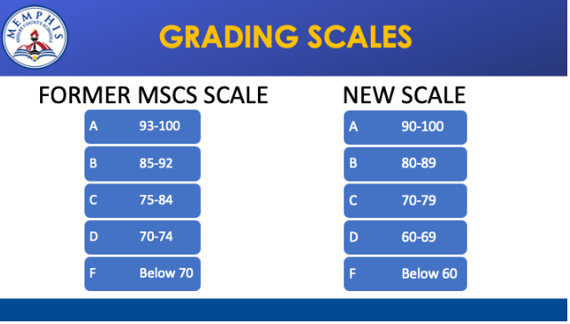

- District Late Work Policy
Make-up work occurs during a nine-week period. Students should make every effort and be afforded the opportunity to make up work missed due to excused and unexcused absences. In the event of an excused absence, students are expected to make-up work missed within a reasonable time (e.g., at least one or more days of makeup for each day of excused absence).

In the event of an unexcused absence (including short-term suspensions), one day of makeup shall be allowed for each day of unexcused absence (unless otherwise extended by the school or extended based on law or policy), beginning the day after the student’s return to class.

For example, if a student misses Thursday and Friday of a week and returns to school on Monday, the student has Tuesday and Wednesday to complete make-up work and work is due on Thursday. Teachers must provide the make-up work and determine the grade during a nine-week period.

Ms. Thompson’s Late Work Policy
If absences have occurred, district late work polices will be applied to makeup work submissions.

If no absence has occurred, late work will not be penalized if it is submitted on the due date by the end of the school day. Late work received after the initial due date will receive no higher than 70/D. It will also be graded and scored according to the rubric aligned to the assignment.

*Extensions can be granted on a case-by-case basis*

Assessment Re-takes
As a continuous learner, I want to give you opportunities to demonstrate mastery of a topic, not just completion. After an assessment, you will have the option to re-take the assessment after you have received a grade and/or feedback from Ms. Thompson. The re-take must be completed during Ms. Thompson’s tutoring hours within a week of receiving feedback. The highest grade will be recorded in the gradebook.

- Rules/Expectations
1. Respect yourself, the teacher, and others.
2. Be prepared for class each day and preserve a positive learning environment
3. Pay attention, participate, and ask questions
4. Take responsibility for your actions.
5. Turn off your cell phones and electronic devices.

- Required Texts/Supplies
Computer
USB Flash Drive
Copy of Outliers by Malcolm Gladwell (a downloadable pdf copy and other resources are available using the following link http://www.clue901.com/cluebooks.html)
Paper, pencil, highlighters, etc. if needed

Units of Study

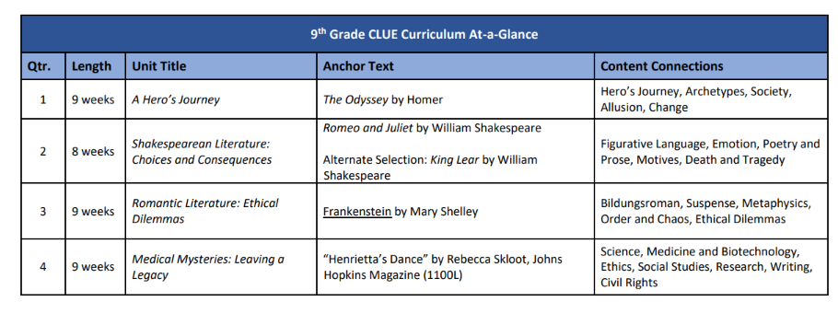
- Academic Integrity:
  - Students at East High School are expected to adhere to the highest standards of academic integrity. Plagiarism, whether intentional or unintentional, violates the established expectations for East High School students and is subject to disciplinary actions that could include dismissal from the Optional Schools program.

    - While collaboration is encouraged and even expected in many courses, collaborative work must be completed collectively and with the expressed permission of the teacher.

Book Report Project Based Learning:
Over the course of the year, you will be required to read an additional text (s) of your choice from the master list provided. The book report will consist of a written essay and will also include a creative presentation. You may choose to work with another student using the same novel however, each of you will be responsible for own individual submissions. Book lists, project instructions, examples, and other resources will be provided in person and via email.

