Logging into i-Ready

Admins must login at: https://login.i-ready.com
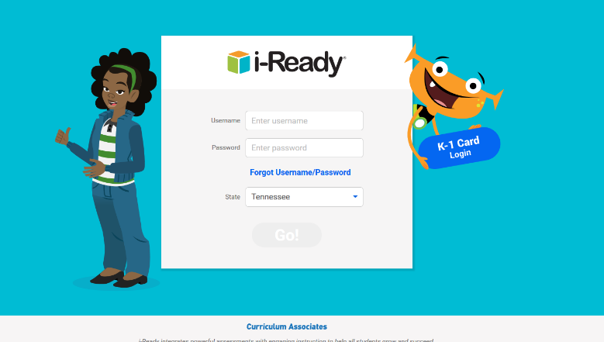
- Need help resetting username or password? Click the “Forgot Username/Password” link on the login screen)

Teachers and Students must login via Clever at: https://clever.com/in/scs
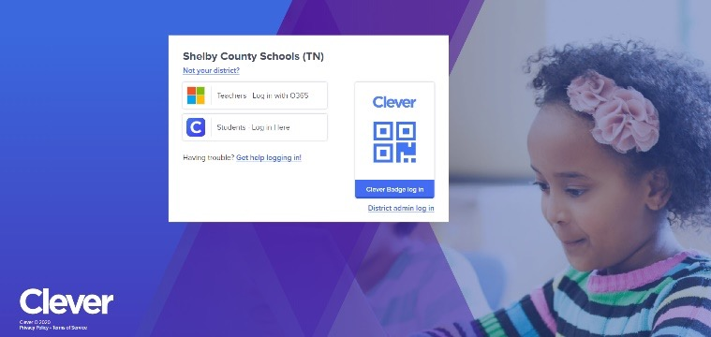

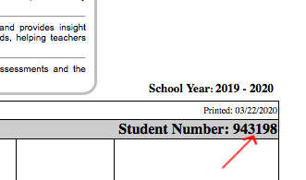
- The student will login to Clever using their Student# as their username (this is also their cafeteria number, and the # from their report card/progress report) and their 8-digit Date of Birth (without dashes or slashes) as their password. For example, if a student was born 3/22/2010 their password would be 03222010

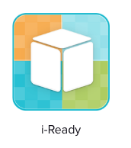

- Once logged into Clever, they will select the i-Ready icon and go from there! The icon will look like the one pictured at right (it can typically be found under “Curriculum” or “Favorite Resources”)

- For additional help retrieving student#: You can also get your login credentials, or view the student’s Student#, from the student/parent portal by logging into the portal (you will have to set up a parent or student account, or already have one, to login to the portal) and select the “Online Education” link from the left hand menu. The parent/student portal can be found at: https://scstn.powerschool.com/public/

