
Parent Handbook
2021-2022

Mr. Marvin Townsend, Principal
Mr. Blake Waddell, Vice Principal

Mr. Damion Longino 9th Grade AP
Ms. Nelba Thomas 10th Grade AP
Dr. Trevor Gore 11th Grade AP
Ms. Vickie Fayne 12th Grade AP

Professional School Counselors
Rose Clemmensen 9th Grade
Sherri Lee 10th Grade
Keely Webb 11th Grade
Fran Odom 12th Grade
Wendy Willingham Pre IB/IB
LaShonda Norman College and Career

https://schools.scsk12.org/Page/2603

Germantown High School’s Family Engagement Plan
2021-2022
Germantown High School encourages parental involvement in the educational process and has established an expectation for parental involvement at our school. In order to promote student success, our parents will work with the school by acting as advisors, resource persons, and coordinators in the following ways:
1. Become school advocates and offer support.
2. Utilize their talents and /or resources to enhance the instructional programs at our school.
3. Serve on the Germantown High School Based Decision-Making Council, become active members of the PTSA, and join booster clubs when appropriate.
4. Respond to questionnaires, surveys, and memos expressing thoughts, suggestions, and concerns.
5. Attend school events and serve as advisors to various organizations.
Title I Involvement
The administrators, faculty, and staff will provide a strategic plan and implement Title I requirements according to the guidelines set forth in the law, which include the following:
- Inform parents of Title I requirements and our school’s participation at the annual Title I Meeting on Tuesday, September 15th, 5:00 PM or at the alternate meeting on Wednesday, September 16th at 8:00 AM. LINK BELOW.
https://teams.microsoft.com/l/meetup-join/19%3ameeting_ZDc0MGQ4MmYtYzVjNC00YjJhLTgwNzAtZWUwOTUxMGRjMmMw%40thread.v2/0?context=%7b%22Tid%22%3a%222b291c94-5eb0-44b7-89ea-4baf16ecc4a9%22%2c%22Oid%22%3a%2201ccef12-3787-492e-936b-e12d754d817a%22%7d

2. Allow parents to observe the school’s programs and visit classrooms, therefore supporting classroom instruction.
3. Provide parents with student information and send home progress reports in the middle of each nine weeks.
4. Provide two-way communication between parents and the school.
5. Provide information in a language that parents can understand.
6. Provide parents with assessment results.
7. Provide parents with a copy of the Family Engagement Plan, Student Code of Conduct, Parents’ Right-To-Know, and RTI2-B Plan.
8. Provide parents with a description and explanation of the curriculum used at Central High, forms of academic assessment used to measure student progress, and the proficiency levels students are expected to meet.
To ensure that our parents participate in the development and implementation of our school’s program, we will do the following:
1. Inform parents of their rights to be involved in their child’s education.
2. Encourage parental involvement in an organized, on-going, and timely way in the planning, reviewing, and improvement of programs for family engagement and GHS Family Engagement Plan.
3. Provide flexible times for our parents to attend parent meetings, with opportunities to attend regular meetings at night and alternate meetings in the morning of that same week.
4. Provide parents training that will support our students’ education.
5. Jointly develop with parents a school/parent compact showing how parents, schools, and students have shared responsibilities, by distributing and acquire appropriate signatures of all stakeholders (parents, students, and teachers).
6. Encourage parents to visit our school regularly and to take an active role in school planning by serving on the School Improvement Plan committee.
7. Support our Parent/Teacher/Student Association as they conduct regular meetings each month.
8. Parents will serve on the Family Engagement Plan Committee, and the document created will be presented to parents for input and approval before distribution to GHS families and the community
9. Provide access to community and support services.
10. Develop programs that enable parents to actively participate in their child’s education.
11. Provide training to staff to promote parental involvement.
12. Provide timely information about programs under family engagement through Power Teacher, flyers, Teacher websites, PTSA Website, and GHS Website.
Note: Parent can also mean a guardian or person who has custody of the child, or it may refer to an individual who has care giving authority.

Germantown High School is a federally funded school. Shelby County Schools does not discriminate in its programs or employment on the basis of race, color, religion, national origin, handicap/disability, sex or age. For more information, please contact the Office of Equity Compliance at (901) 416-6670.
PARENT’S RIGHT TO KNOW
All parents have the right to request the following:
- A teacher’s professional qualifications, which includes: state qualifications, licensure, grade/s certification, waivers
- A teacher’s baccalaureate and /or graduate degree, fields of endorsement, previous teaching experience
- A paraprofessional’s qualifications
- An assurance that their child’s name, address, and telephone listing not be released to military recruiters
All parents will receive information on the following:
- Their child’s level of achievement in each of the state academic assessments
- Their option to request a transfer to another school within the district if their child is the victim of a violent crime at school
- Their right to timely notification that their child has been assigned, or has been taught for four or more consecutive weeks by, a teacher who is not highly qualified
Derecho De los Padres a saber
Todos los padres tienen derecho a solicitar lo siguiente:
- ·Las calificaciones profesionales de un maestro, que incluye: Calificaciones del Estado, Licenciatura, graos de la certificación, Renuncia a derech
- El Bachillerato a Titulo de graduación del maestro, campos de especialidad, experiencia previa
- La calificación del professional
- Garantía que los datos de su hijo como nombre, dirección, numero de teléfono, no se entregan a los reclutadores militares
·
Todos los padres recibirán información sobre lo siguiente:
- El nivel de rendimiento de su hijo en cada una de las evaluaciones académicas del estado
- Su opción de solicitar un traslado a otra escuela del distrito si su hijo/a es víctima de un crimen violento en la escuela
- Su derecho a aviso con tiempo anticipado que su hijo/a ha sido asignado o ha estado bajo la enseñanza durante cuatro semanas consecutivas o más, de un maestro que no está altamente cualificado
Para información adicional visita el sitio de web del Departamento de Educación de TN en http://www.state.tn.us/education/reportcard/index.shtml

Germantown High School is a federally funded school. Shelby County Schools does not discriminate in its programs or employment on the basis of race, color, religion, national origin, handicap/disability, sex or age. For more information, please contact the Office of Equity Compliance at (901) 416-6670.

TITLE I PARENTAL INVOLVEMENT
Shelby County Board of Education
5010
Issued Date: 08/26/10 Revised: 08/22/17
SCS Title I Parental Involvement
The Shelby County Board of Education recognizes and encourages the involvement of parents at the school and district level. As a school district, we recognize that parents are key stakeholders and serve as partners in the academic achievement of all students to meet or exceed the Every Student Succeeds Act proficiency standards.
The SCS parental involvement policy includes input from parents, community members, school and district personnel. The purpose of this policy is to comply with all pertinent mandates of state and federal regulatory standards which require that all parents have access to various levels and types of parental involvement activities with no person excluded based on race, religion, creed, gender, socio-economic status, physical impairment or age.
Each SCS school that is served by Title I of the Every Student Succeeds Act shall:
§ Offer opportunities for parents to provide input and participate in meaningful consultation in the planning, design and implementation of the Title I Program.
§ Offer district level administrators, local school administrators and teachers formal training to increase knowledge and skills in working with families of children receiving Title I services.
§ Conduct an annual meeting at flexible times with parents to discuss the school's participation in Title I programs such as Free and Reduced Lunch, Migrant Education, SES, Public School Choice, and other offerings.
§ Provide parents of participating children with explanation of district curriculum, students' assessments and reports, and accurate explanations of their child's progress.
§ Provide multiple opportunities for parents to provide input for developing and revising policies relating to parent involvement, including the use of school and district level Parent Involvement funds, and on policies at the school level. Parents will also be asked to share suggestions for improving target participation in student learning. Formal parent complaints concerning school plans will be submitted to the school district when the school makes the plan available publicly.
§ Develop a school-parent compact that outlines how parents, the entire school staff and students will share the responsibility for improved student achievement and the means by which the school and parents will build and develop a partnership to help children achieve high standards.
§ Conduct, with the involvement of parents and community members, an annual evaluation of the content and effectiveness of the school parent involvement policy, including
identification of barriers to greater participation by parents of diverse backgrounds. Findings will be utilized to design additional effective strategies for parental involvement.
§ Allow parents of students receiving Title I service to participate in deciding how Title I funds for family engagement activities are allotted.
§ Provide information such as parent letters, newsletters, and website documentation concerning programs or activities in a language that all parents understand.
§ Provide parents, community members, and school stakeholders a copy of this Parental Involvement Policy in a timely manner.
Building Capacity for Parental Involvement
To ensure effective involvement of parents and to support a partnership among the school involved, parents, and the community to improve student academic achievement, each SCS school that is served by Title I of the Every Student Succeeds Act and SCS as a whole -
1. shall provide assistance to parents of children served by the school or local education agency, as appropriate, in understanding such topics as the State's academic content standards and State student academic achievement standards, State and local academic assessments, the requirements of 20 U.S.C.A., § 6318, and how to monitor a child's progress and work with educations to improve the achievement of their children:
2. shall provide materials and training to help parents to work with their children to improve their children's achievement, such as literacy training and using technology, as appropriate, to foster parental involvement;
3. shall educate teachers, pupil services personnel, principals, and other staff, with the assistance of parents, in the value and utility of contributions of parents, and in how to reach out to, communicate with, and work with parents as equal partners, implement and coordinate parent programs, and build ties between parents and the school;
4. shall, to the extent feasible and appropriate, coordinate and integrate parent involvement programs and activities with Head Start, Reading First, Early Reading First, Even Start, the Home Instruction Programs for Preschool Youngsters, the Parents as Teachers Program, and public preschool and other programs, and conduct other activities, such as parent resource centers, that encourage and support parents in more fully participating in the education of their children;
5. shall ensure that information related to school and parent programs, meetings, and other activities is sent to the parents of participating children in a format and, to the extent practicable, in a language the parents can understand;
6. shall involve parents in the development of training for teachers, principals and other educators to improve the effectiveness of such training;
7. shall involve parents in developing, implementing and evaluating the District-wide Parental Involvement Plan. Strategies and activities of the District-wide Parental Involvement Plan shall be incorporated into the Tennessee Comprehensive System-wide Planning Process;
8. shall encourage and support the development and experience of active PTA/PTSA organizations to attend parent school meetings each month to discuss school accomplishments, concerns and needs; and
9. shall offer parents opportunities to participate in training sessions addressing state academic and content standards, state/local assessments, monitoring students' progress, literacy program opportunities, home learning activities to strengthen their child's reading and math skills, use of the internet to access information about their child's progress, parental rights under the Every Student Succeeds Act, understanding child development, effective volunteer participation, parent leadership, parent organization involvement, High School Redesign, public school choice options, community services, pre-school/ Head Start programs, adult education programs and community education programs.
Shared Responsibilities for Supporting Student Success for Every Child
SCS will continue to support and be responsible for successful student achievement in Title I schools by:
· Jointly developing, with parents and other school stakeholders, a school- parent compact that outlines expectations and responsibilities of all stakeholders. The compact will identify the shared responsibility to improve student academic achievement. School-parent compact shall:
1. describe the school's responsibility to provide high-quality curriculum and instruction in a supportive and effective learning environment that enables the children served by Title I of the Every Student Succeeds Act to meet the State's student academic achievement standards, and the ways in which each parent will be responsible for supporting their children's learning, such as monitoring attendance, homework completion and television watching; volunteering in their child's classroom; and participating, as appropriate, in decisions relating to the education of their children and positive use of extracurricular time; and
2. address the importance of communication between teachers and parents on an ongoing basis through, at a minimum --parent-teacher conferences in elementary schools, at least annually, during which the compact shall be discussed as the compact relates to the individual child's achievement;
a. frequent reports to parents on their children's progress; and
b. reasonable access to staff, opportunities to volunteer and participate in their child's class, and observation of classroom activities.
3. provide that parents are invited and encouraged to participate in developing the Tennessee Comprehensive System-wide Planning Process.
Accessibility to All Families
SCS will continue to be accessible for all families being served Title I schools by:
§ Providing opportunities for the participation of parents with limited English proficiency, parents with disabilities and parents of migratory children.
§ Providing school environments that are welcoming, informative and providing schools reports and/or displays in a language that parents can understand.
§ Providing invitations to parent meetings and/or workshops that are presented in an understandable language. Such meetings and workshops shall be conducted at varied times and dates throughout the school year, and notification will be sent in a timely manner.
§ Providing transportation, childcare and translators for parent involvement activities where applicable and where/if funds permit. 20 U.S.C.A. § 6318

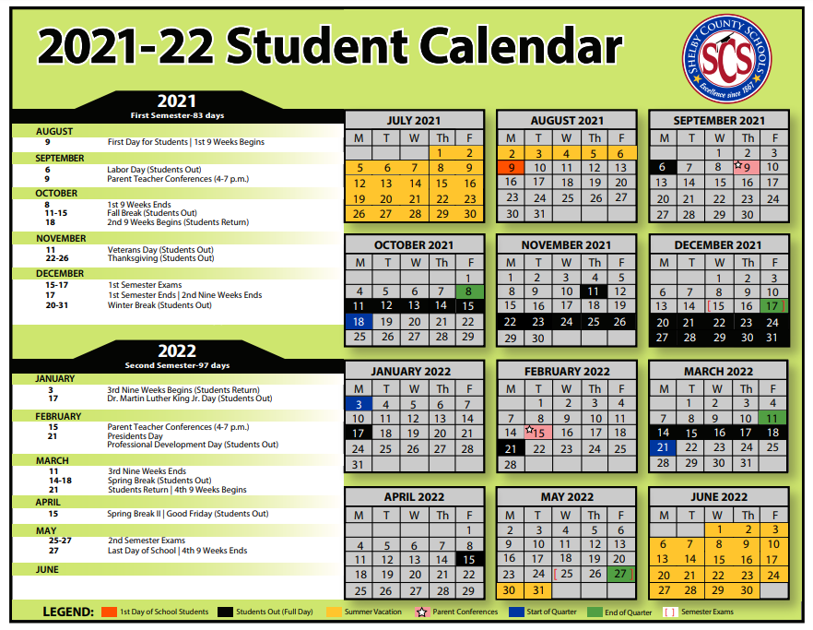

GERMANTOWN HIGH SCHOOL TUTORING SCHEDULE WILL BE RELEASED SOON.
GHS Family Engagement Opportunity Schedule will be released soon.
PLEASE VISIT THE GHS WEBSITE FOR UPDATES.

Germantown High School’s Home-School Compact
2021-2022
Germantown High School has jointly developed with parents a home-school compact that will be reviewed during parent conferences. This compact outlines how parents, the entire school staff, and students will share the responsibility for improving student academic achievement and how parents will develop a partnership to help children achieve the State’s high standards.

PARENT’S AGREEMENT
It is important that I take a more responsible role in supporting my child’s learning. Therefore, I shall strive to do the following:
- See that my child is punctual and attends school regularly
- Support the school in its efforts to maintain proper discipline
- Establish a time for homework and review it for completion
- Provide a quiet, well-lit place for studying, and limited television time
- Volunteer to work at my child’s school in various capacities
- Make certain that my child wears school appropriate clothing
- Participate in decisions related to education, parent meetings, conferences, and workshops
- Communicate with the teachers frequently to discuss my child’s progress and behavior
- Encourage my child to be respectful
- Develop a partnership with the school to help my child achieve the state’s high standards
Parent’s Signature
_______________________________________________________

STUDENT’S AGREEMENT
It is important that I work to the best of my ability. Therefore, I shall strive to do the following:
- ·Attend school regularly
- Arrive at school on time and attend all classes daily
- Come to school each day with a pen, pencil, paper and other necessary tools for learning
- Perform at my highest level of learning each day
- Complete and return homework assignments on time
- Observe regular study hours
- Respect others
- Follow all rules that govern student conduct at my school
- Observe and follow classroom policies and procedures
- Take responsibility for my actions, grades, and cooperate with others in order to receive a quality education
Student’s Signature _______________________________________________________
________________________________________________________

TEACHERS’ AGREEMENT
It is important that students achieve. Therefore, I shall strive to do the following:
- Provide instructions that foster high academic expectations and provide challenging and exciting class assignments
- Encourage and maintain ongoing communication with parents by providing information about student progress (phone calls, emails, texts, conferences, parent meetings, parent visitations)
- Determine the student’s educational needs and adjust the instruction to accommodate those needs
- Provide meaningful homework assignments for students
- Inform parents of homework, classroom policies, and procedures

Teachers’ Signatures:

Period 1 Teacher ___________________________________________________
Period 2 Teacher ___________________________________________________
Period 3 Teacher ___________________________________________________
Period 4 Teacher ___________________________________________________
Period 5 Teacher ___________________________________________________
Period 6 Teacher ___________________________________________________
Period 7 Teacher ___________________________________________________

SCHOOL’S RESPONSIBILITY
I support this form of parental involvement. Therefore, I shall strive to the following:

- Provide a supportive, safe, and effective learning environment that allows for positive communication between the teacher, parent, and student
- Provide time to listen to students and parents’ concerns
- Provide high quality curriculum and instruction in a supportive and effective learning environment that enables children to meet Tennessee’s academic achievement standards
- Encourage teachers and students to have high expectations academically, socially, emotionally, and physical
- Make expectations widely known to all stakeholders
- Maintain open communication with parents (phone calls, emails, texts, conferences, parent meetings, parent visitations)
- Provide multiple/flexible opportunities for parent-teacher conferences and reasonable access to staff, to volunteer, participate, and observe in their child’s class.

Principal’s Signature _________________________________________________



La escuela secundaria Germantown es una escuela federal financiada por Título I “school-wide”. El Título I es parte de la ley Cada Estudiante Triunfa. El Título I requiere que las escuelas crean un ambiente de aprender positivo y comprensivo que resulta en altos niveles del logro para todos los estudiantes. Los fondos están disponibles para los programas y las estrategias académicas, los profesores y otras personas adicionales, desarrollo de la facultad, materiales, tecnología y el entrenamiento de los padres.
Esperamos a trabajar con usted y su niño para tener un año exitoso.
ESCUELAS DEL CONDADO DE SHELBY 2021 ~ 2022 TÍTULO I DE PADRES / MAESTROS / ESTUDIANTES / CONVENIO DE LA ESCUELA
Este compacto ha sido desarrollado conjuntamente y aprobado por el personal Germantown High School, los padres y los estudiantes para delinear cómo todos compartirán la responsabilidad de mejorar el logro académico de los estudiantes y se desarrollarán una asociación para ayudar a los niños a alcanzar los altos estándares del estado.
Padre / Guardián Acuerdo Quiero que mi hijo de lograr. Por lo tanto, voy a ser responsable de apoyar el aprendizaje de mi hijo, comprometiéndose a lo siguiente:
* Ver que mi hijo sea puntual y asista regularmente a la escuela con los materiales necesarios. * Apoyar a la escuela en sus esfuerzos por mantener la disciplina apropiada. * Establezca un horario para hacer la tarea y revisar con regularidad. * Proporcionar un lugar tranquilo y bien iluminado para estudiar. * Fomentar esfuerzos de mi hijo y estar disponible para preguntas y apoyo. * Manténgase al tanto de lo que mi hijo está aprendiendo, haciendo visitas periódicas y el voluntariado en la escuela de mi hijo. * Asistir a las conferencias de padres y maestros. * Proporcionar una tarjeta de biblioteca para mi hijo. * Fomentar una asociación con la escuela para ayudar a mi hijo a alcanzar un alto nivel del Estado. * Proveer un ambiente seguro y amoroso y ser un modelo positivo. * A mi hijo a ser un buen oyente. * A mi hijo a verbalizar sus / sus problemas y malentendidos. * Proporcionar una hora fija para acostarse que le da a mi niño duerma suficiente para funcionar en la escuela. Firma del Padre / Tutor: ________________________________________
Acuerdo del Estudiante Es importante que yo trabajo con lo mejor de mi capacidad. Por lo tanto, voy a tratar de hacer lo siguiente: * Venir a la escuela a tiempo todos los días con los suministros necesarios para el trabajo en el aula. * Escucha, seguir instrucciones, completar y entregar las tareas, completar todos los proyectos, ensayos y otras tareas de trabajo en clase. * Llevar uniforme y usarlo correctamente cada día.
* Dar mi celular y todos los dispositivos electrónicos en mi armario durante el horario escolar .
* Respetar a los demás y seguir las reglas de conducta y normas de Germantown alta de toda la escuela para estudiantes. * Problemas de ataque, no personas. * Asumir la responsabilidad de mis actos y grados y cooperar con los demás en todas las situaciones de aprendizaje. Firma del Estudiante: __________________________________________
Responsabilidad de la Escuela Secundaria Germantown
Acuerdo Maestro Es importante que los estudiantes alcancen. Por lo tanto, voy a tratar de hacer lo siguiente: Proporcionar un ambiente acogedor y apropiado para el desarrollo que favorezca a todos los estilos de aprendizaje. * Proporcionar una educación de alta calidad y plan de estudios que fomenta altos académicos y expectativas, y las asignaciones que sean significativos, interesante, estimulante, pertinentes, ya un ritmo adecuado para mis estudiantes. * Proporcionar tareas para los estudiantes, en su caso. * Anime a los estudiantes y padres de familia, proporcionando información frecuente sobre el progreso de los estudiantes. * Proporcionar asistencia necesaria a los padres para que puedan ayudar con las tareas. * Realizar conferencias de padres y maestros para discutir Compacto de Padres de la Escuela. * Dedique tiempo a recibir formación profesional para adquirir conocimientos que asegure el logro del estudiante.
Firmas de los Maestros:
Homeroom__________________________________
Primera clase________________________________
Segunda clase_________________________________
Tercera clase_________________________________
Cuarta clase__________________________________
Quinta clase_________________________________
Sexta clase___________________________________
Septimaclase_______________________________

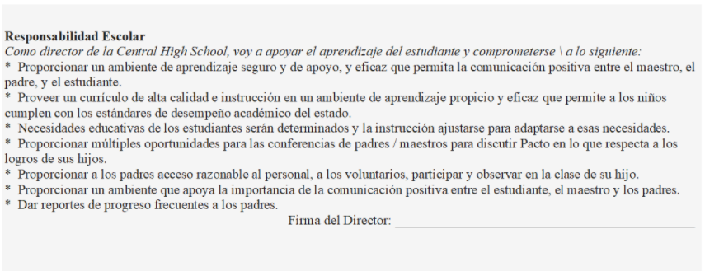
Germantown HSnHS

