The Theatre Program at Central High School

Please visit our website. http://memphiscentraltheatre.weebly.com/

Mrs. Jenn Wood-Bowien

The Band Program at Central High School

Please visit our website https://www.centralwarriorbands.com/

Dr. Ollie Liddell
Mr. Jeremy Thompson

The Visual Arts Program of Central High School

This high school visual arts program continues its strong tradition of producing quality, award winning work. Students annually receive awards for their work entered in regional and national competitions. Over the last several years, students have been consistent winners in the regional ACT-SO competition, the Mid-South Fair, the Delta Fair, The West Tennessee Regional Student Art Exhibition, Cooper Young Student Art, and the prestigious regional and national Scholastic competitions. Annually, our students have shown their paintings in the Memphis International Airport as winners of the Airport Authority Visual Arts Contest. Additionally, our students have won awards in national competitions such as the Youth Art Month Flag Design Competition, as well as top honors in other local competitions such as the Regions Bank/Commercial Appeal Academic All-Stars program.
The classes at this high school prepare our students to be successful in the fine arts/design. Students develop their knowledge, passion, and skills through working with three visual arts instructors at this school in classes that include: Art I, Pre-AP, Art II, Art II Honors, Art III Honors, Art IV, A.P. 2-Dimensional Design, A.P. 3-Dimensional Design and A.P. Drawing Portfolio courses. All classes encourage and promote a rigorous program in which students grow in their skill and interest level. Our graduating students often receive scholarships for the visual arts.
In addition to their regular coursework, students participate in programs with guest artists and arts organizations from the community. Students have partnered with the Urban Arts Commission working with a nationally renowned artist to arts program demonstrates why it is traditionally regarded as a top high school for the visual arts.
Mrs. Sonya Forbes Gomez, Mr. James Dycus, and Mr. Raymond K Bowers
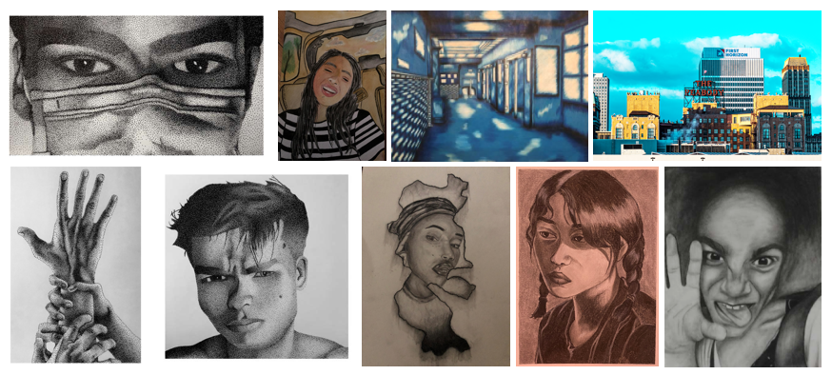
The Orchestra Program at Central High School

Central High School has 3 orchestras:

Camerata Orchestra – open to any student with previous string instrument experience-grades 9-12
Honors Concert Orchestra – by audition only – grades 9-12
Advanced Honors Orchestra – by audition only – grades 10-12
Enrollment in the Honors Orchestras is based on auditions that occur in late April and early May. No audition is required to enroll the Camerata Orchestra.
Our annual performances include: Fine Arts Night – Winter Holiday Concert – All-West Tennessee Regional Honors Orchestras & All-State Honors Orchestras (by audition) –Concert Festival – May Senior & Awards Concert including several elementary strings programs.
The orchestra has traveled to New Orleans, LA and Toronto, Canada on performance trips.
Recent orchestra alumni are now attending The University of Memphis, Christian Brothers, Rhodes College, UT-Knoxville, UT-Chattanooga, MTSU, University of Arkansas, Xavier, UAPB, TSU.

For more information or to schedule an audition contact Mrs. Wilensky at wilenskypb@scsk12.org

Mrs. Pamela Wilensky, Director of Orchestras

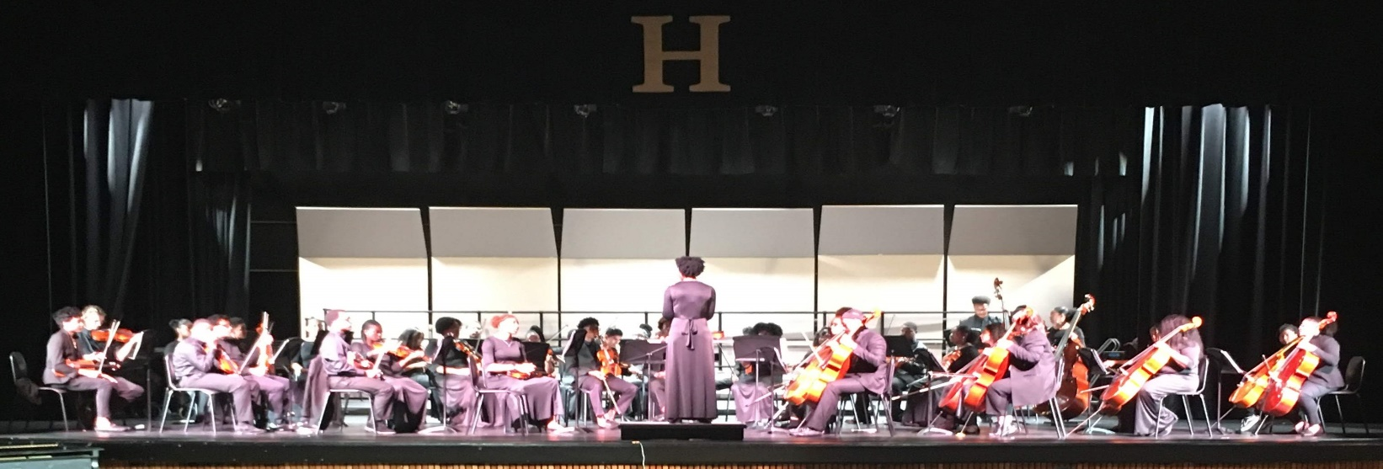

MEMPHIS CENTRAL HIGH SCHOOL
CHORAL ARTS DEPARTMENT

The Memphis Central High School Choral Arts Department is composed of five choral ensembles, Vocal Music 1 (non-performing), Chorale, Concert Singers, Women's Choir, and CHS Gospel Choir. Vocal Music 1 students typically do not perform, as they are new to the program and are developing skills to progress to one of the auditioned performing ensembles. Membership in Chorale, Women's Choir and Concert Singers is by audition only, with emphasis placed on conduct, sight-reading skills, vocal development, and dedication to the choral department.

Vocal Music 1 is comprised of students who have never taken a choir class at Central High School. During their enrollment in Vocal Music 1, students are introduced to high school sight-singing methods, rhythm reading and assessment, high school vocal development, and appropriate literature for the vocal level of the ensemble. Many of these students are continuing previous study from area middle schools, so Vocal Music 1 is intended to build upon the foundations they should have received in middle school choral programs. Vocal Music 1 typically does not perform, but there are occasional exceptions.

Chorale is the intermediate ensemble at Central High. These students are auditioned and are usually graduating from the Vocal Music 1 program. These students participate in annual concerts, as well as Fall and Spring choral assessments. The prerequisite is graduation from the Vocal Music 1 classes at Central or demonstrated ability by audition and sight-singing screening.

Women's Honor Choir is an advanced choral ensemble of young female singers at Central High School. These young ladies are in grades 10-12. Requirements for membership include completion of Vocal Music 1 and/or previous membership in Choral or Concert Singers. The students in this class sing advanced repertoire for women's voices. Admission is by audition and conductor selection only. These students are required to participate in Fall Honor Choir auditions, Spring Solo & Ensemble assessment and Spring Choral Performance Assessments.

Concert Singers is the advanced choral ensemble at Central High School. These students are typically juniors and senior choir students who have been performing together for 2-3 years, but sophomores and freshmen with advanced vocal and sight-singing skills are sometimes admitted. This ensemble represents Central High School at regional and national level competitions. These students are also required to audition for WTVMEA Honor Choir as well as participate in WTVMEA Choral Festival and WTVMEA Solo & Ensemble. This group travels frequently and is often invited to perform at special occasions throughout the city. Membership in this ensemble is by audition/conductor selection ONLY.

CHS Gospel Choir is a specialized ensemble that meets weekly after school. It is open to all Central High School students who are interested in singing in an ensemble of this type. This group performs gospels, spirituals, and contemporary choral arrangements. This group participates in many after school concerts and events across town, appearing regularly at church and inspirational programs throughout the school year. Many students who join this ensemble move on to become a member of Chorale, Women's Choir and/or Concert singers. There is NO audition required for this ensemble.

For more information, contact Roland Wilson, CHS Director of Choirs at wilsonrr@scsk12.org

