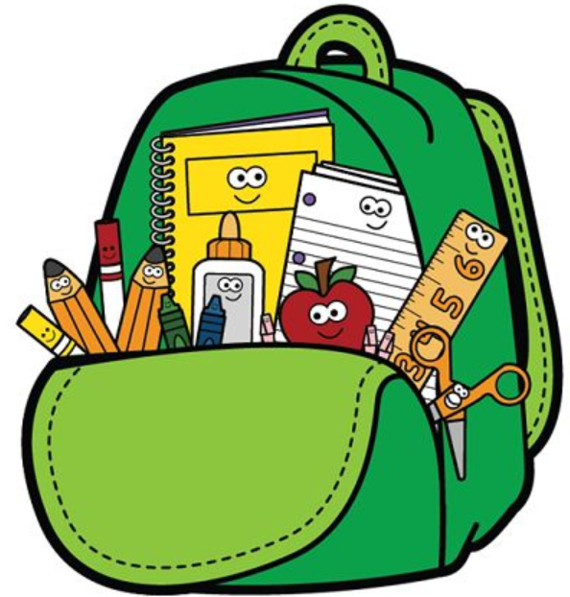
3rd Grade Supply List

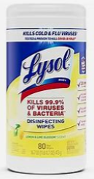
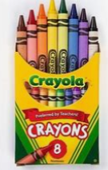

- 2-inch Clearview Binder
- Pencil Pouch with zipper (No Boxes)
- LARGE Lysol/Clorox Wipes
- Folders with prongs and pockets (Red, Blue, Purple, Yellow)
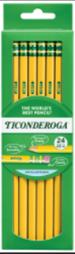
- Spiral Notebooks (Wide Rule)
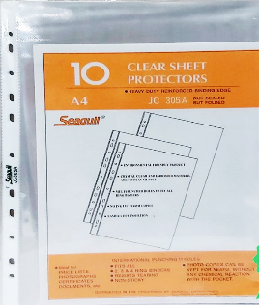
- 24 count Wooden Pencils
- 4 Count Expo Markers
8 oz Hand Sanitizer with pump
A pair of Headphones
8 pack Crayola Crayons
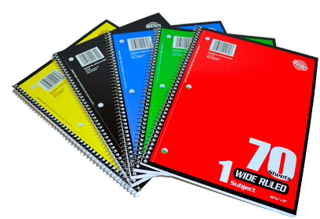
10 Sheet Protector sheets
