8140 RoboManiacs Branding Guide

Brand Identity Overview
The 8140 RoboManiacs brand represents a bold and futuristic aesthetic with a strong visual presence. This guide outlines the team's visual identity, ensuring consistency across all platforms.

1. Brand Colors
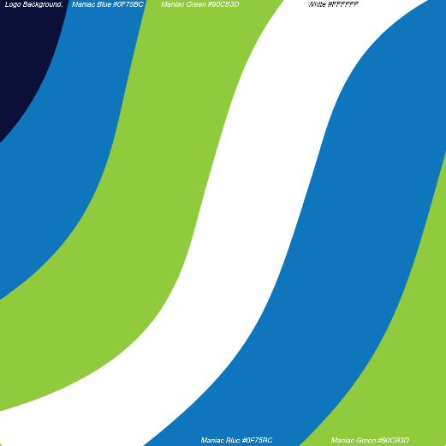
The primary colors define the teams’s identity and should be used consistently in all branding materials.
Color Name | Hex Code
Maniac Blue | #0F75BC
Maniac Green | #90CB3D
White | #FFFFFF
Black | #000000

Usage:
- Maniac Blue and Maniac Green serve as primary colors for logos, accents, and branding materials.
  - For applications that require physical print materials, such as paint or vinyl, “Limetree Green” and “Lake Blue” are appropriately close alternatives, though we will trust the judgement of our sponsors and partners to use the closest available colors that are accessible.
- White is used for contrast and clean backgrounds.
- Black is used for text and monochrome designs.

2. Logo Variations

a. Full-Color Logos
- Graphic Logo 2025 – Used in primary branding, digital, and print.
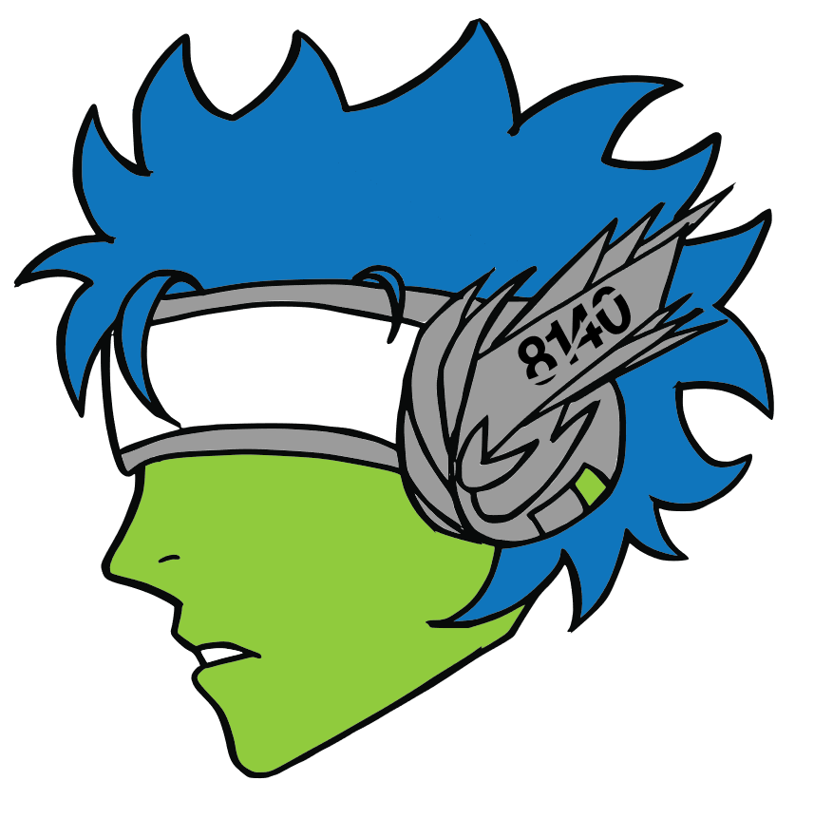
- Simplified Logo – Use for applications that require simple linework. The white element of this logo may be changed to a reflective color
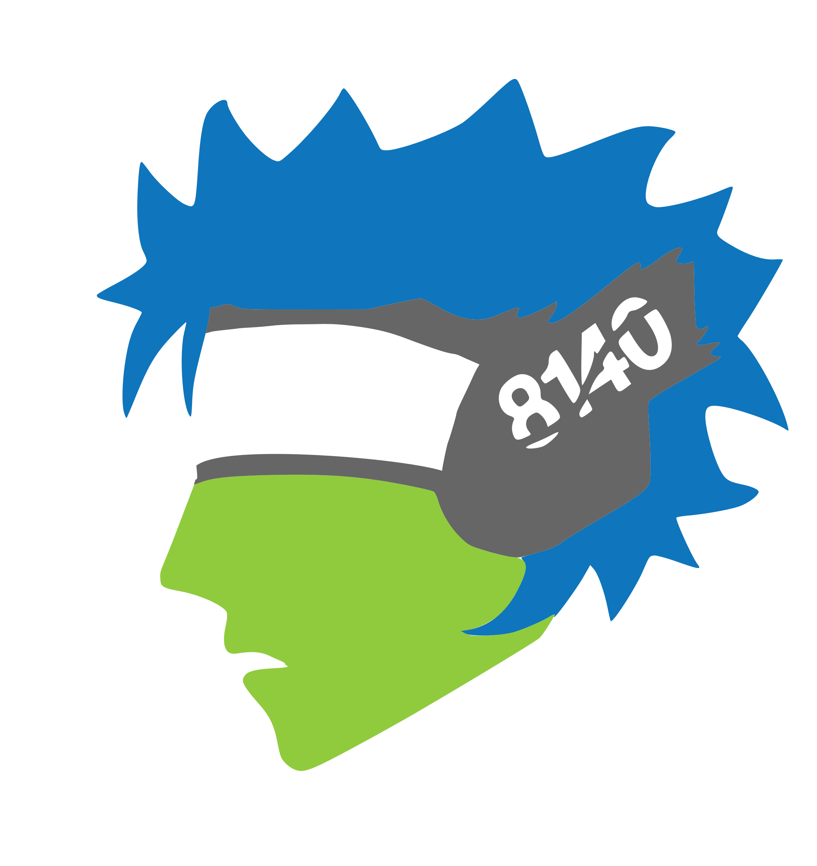

- Number Textmark – Used for brand identity where space constraints exist.
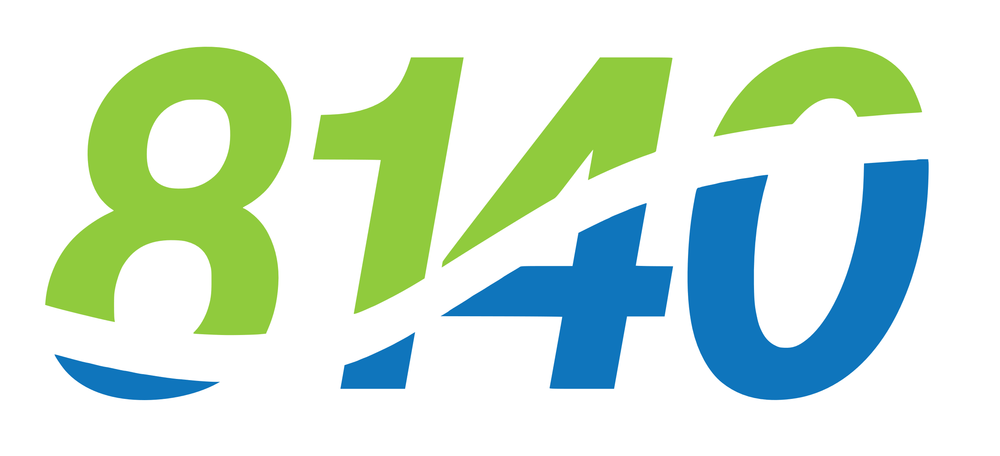
- Name Textmark – Used for brand identity when typed lettering can only be used
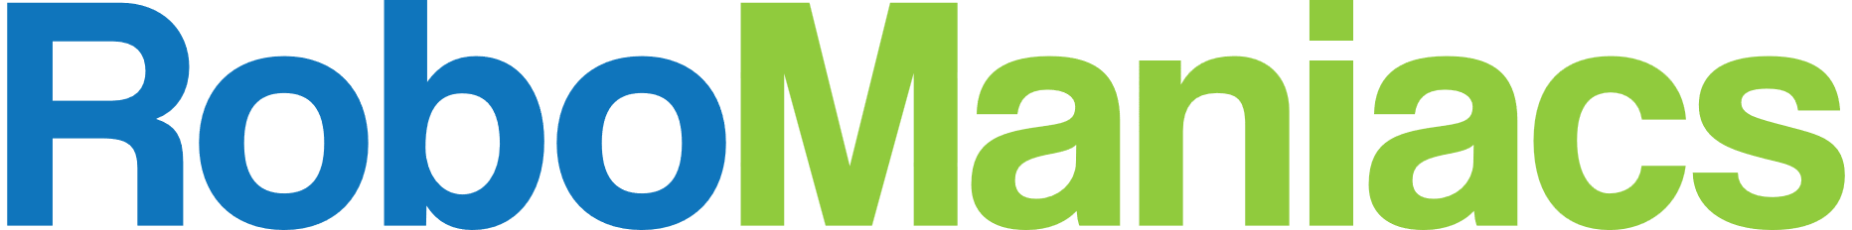
- School logo – Used when referencing other MC²STEM High School events and programs.


b. Single color Logos
- Graphic Logo 2025 – Used for monochrome printing and minimalistic designs. Use with any team color
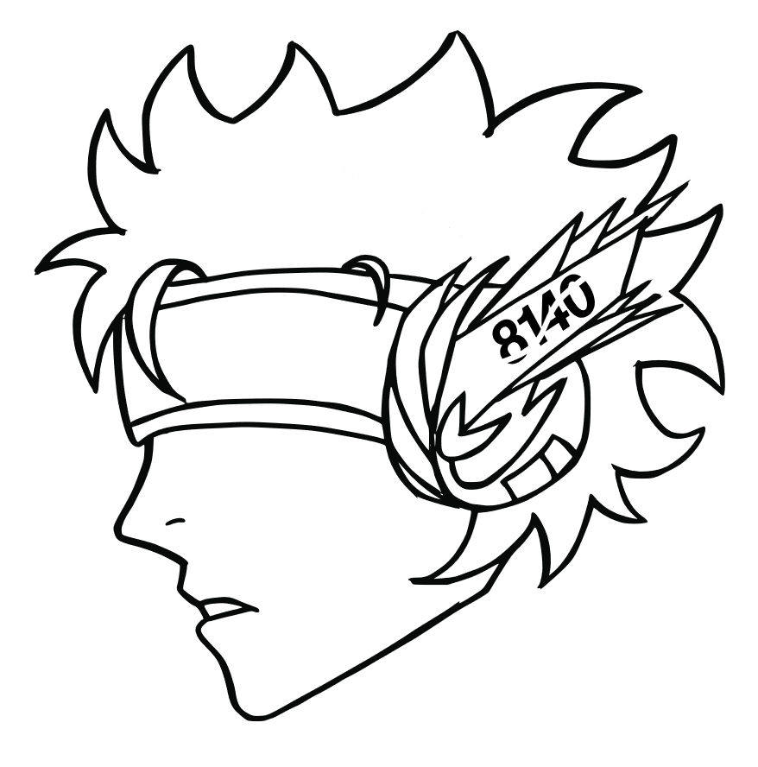
- Number Textmark – Used when only typography branding is needed. Use with any team color.

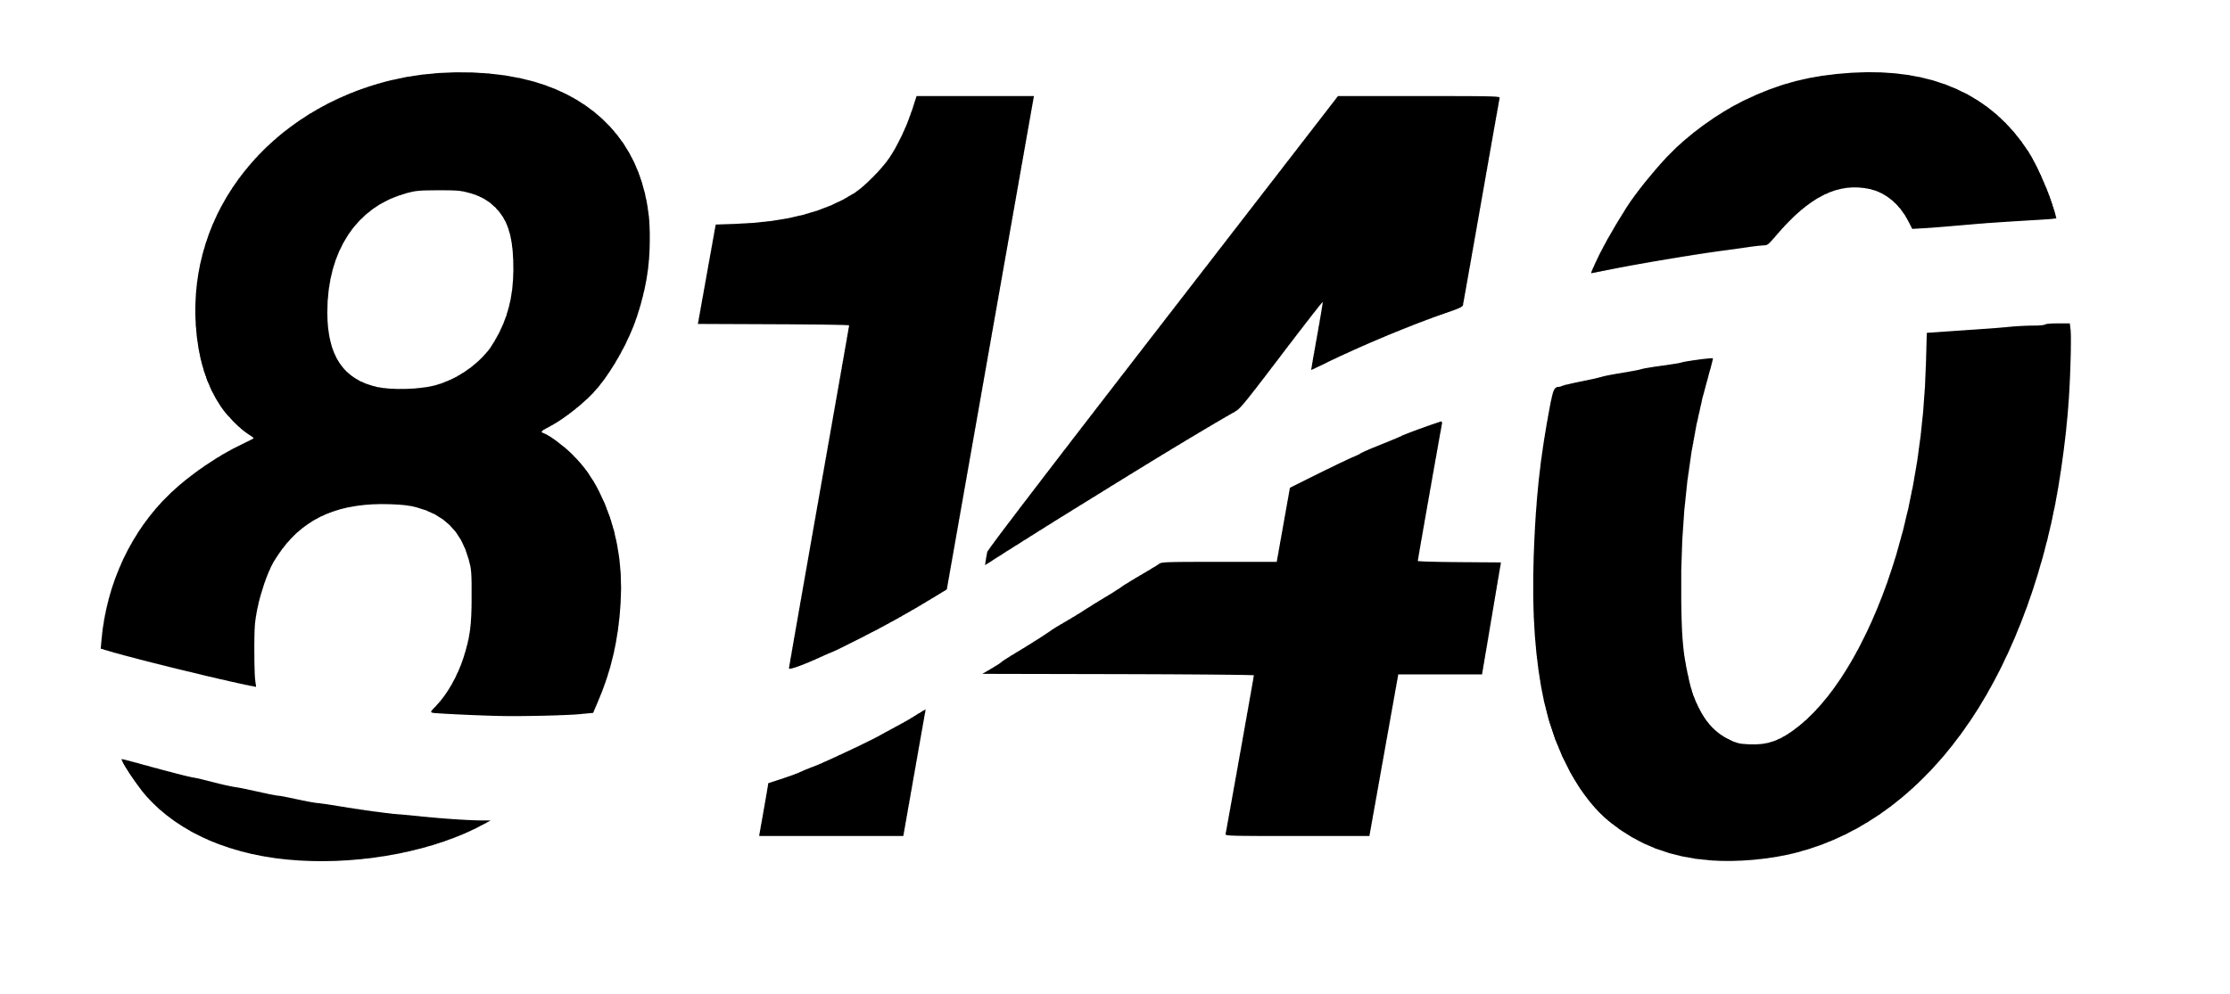
- Name Textmark - Used for brand identity when typed single color lettering can only be used
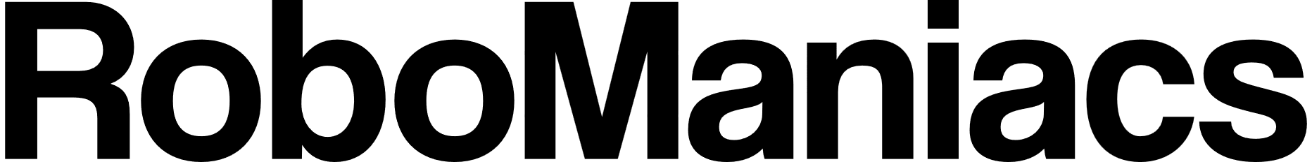
- School logo – Use when referencing other MC2STEM projects or events

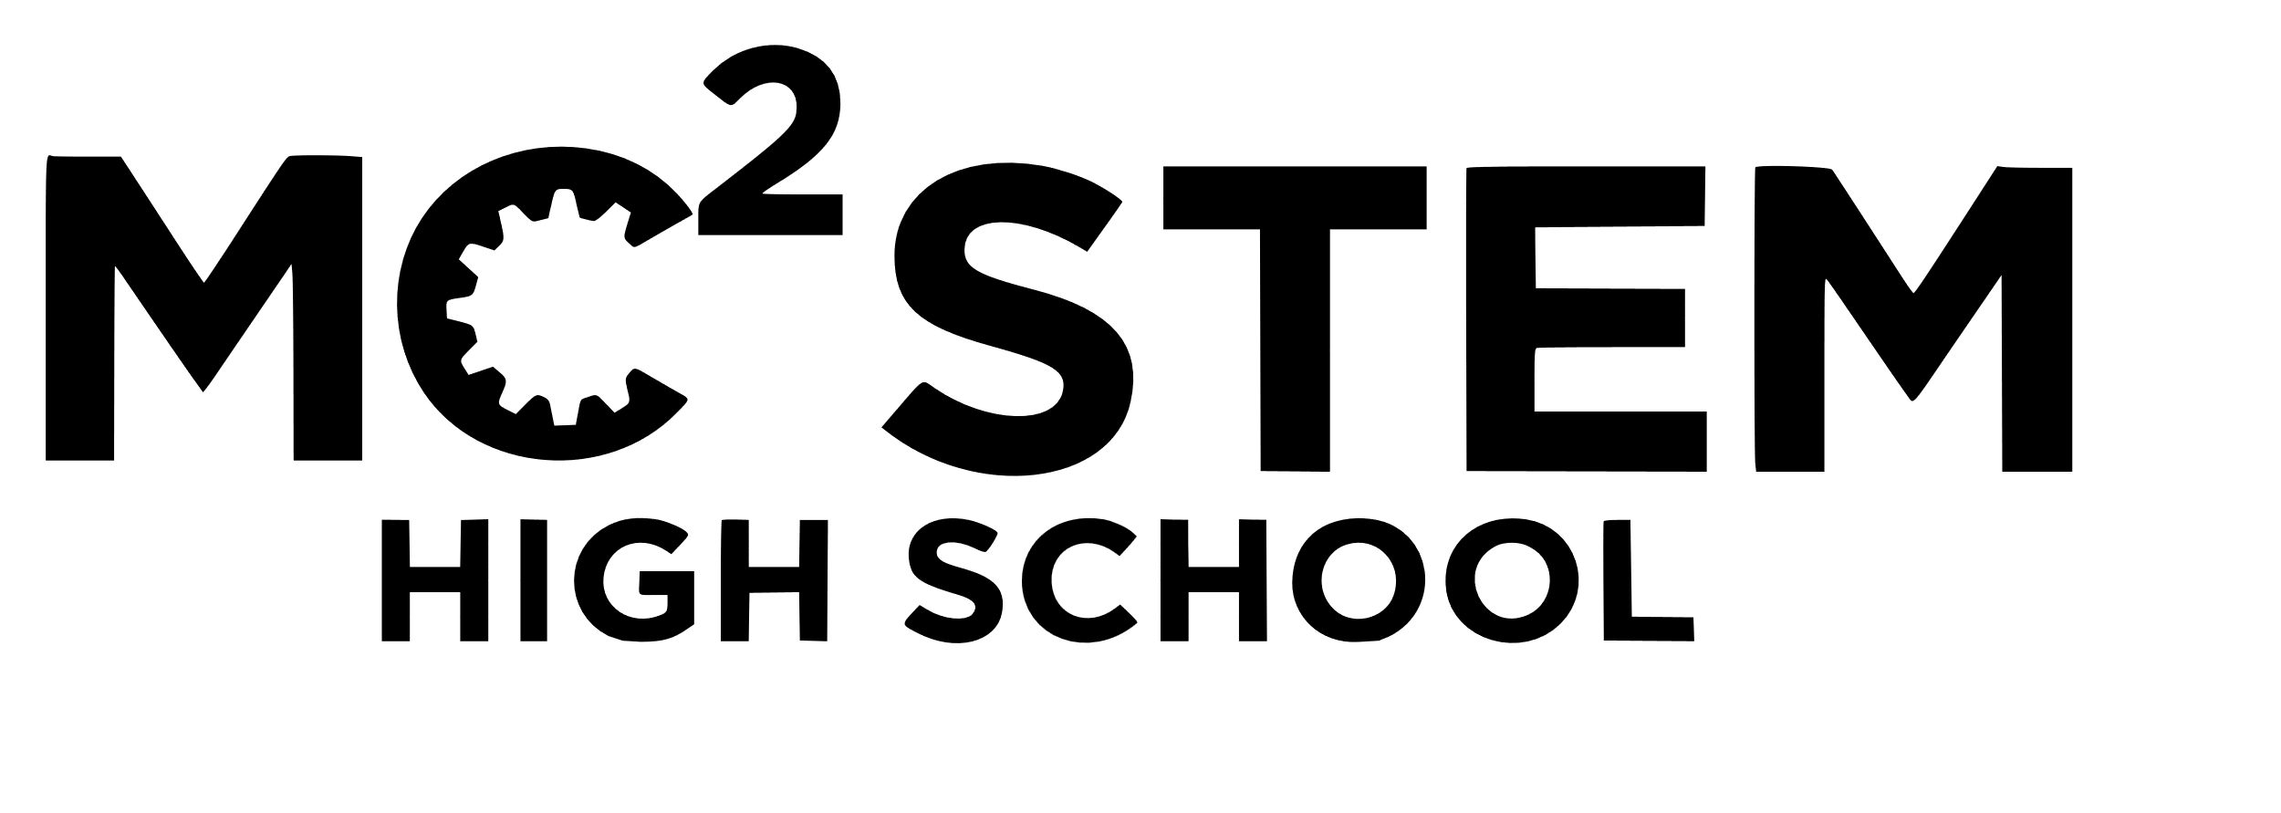

Usage Guidelines:
- Always maintain clear space around the logo.
- Do not stretch, distort, or alter the colors of the logo.
- Ensure high contrast when placing the logo on backgrounds.

3. Typography
The team’s primary typeface is Coolvetica.
Usage:
- Headers and titles should use Coolvetica Bold.
- Body text should maintain readability while aligning with the teams's modern look.
- The Helvetica font may be used as a substitute if necessary.

4. Background Guidelines
- Use Maniac Blue or Maniac Green backgrounds with white or black text for a vibrant, high-energy look.
- Use White or Black backgrounds for professional and minimalistic designs.
- Avoid cluttered or low-contrast backgrounds that reduce logo visibility.

5. Do’s and Don’ts

✅ Do:
✔ Use the correct color palette. ✔ Keep logos proportional. ✔ Maintain brand consistency across platforms.

❌ Don’t:
✖ Alter the logo’s colors. ✖ Use outdated or unofficial fonts. ✖ Overcrowd the design with too many elements.

6. Team Name
The team’s official name is RoboManiacs. Note the capitalization of both the “R” and the “M”. “8140” or “RoboManiacs” can both be used in reference to the team, but the name should not be abbreviated or changed.

