Mary Mcleod bethune school

PRE-KINDERGARTEN SUPPLY LIST

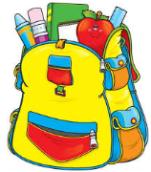
1 back-pack or book-bag (large enough for a pocket folder and lunchbox if sending your child to school with lunch)
1 small blanket (used for nap time)
Package of Tissues
6 large glue sticks
1 container of dry erase markers
1 box of Ziplock sandwich bags
2 boxes of Ziplock gallon bags
2 containers of disinfecting wipes
1 bottle disinfectant spray
2 bottles hand soap
1 change of clothes labeled with child’s name (include: underwear, socks, pants, and shirt – may need to be updated throughout the year once clothes are used)

With gratitude,
Miss Knauer & Miss Parks

