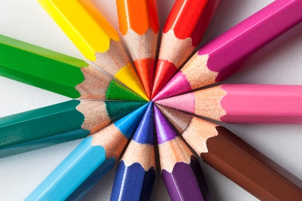
School Supply List

Pencils
1 pack of crayons
1 pack of colored pencils
1 pack of markers
3 2-pocket folders
2 pairs of scissors
Tissues
Clorox wipes
Bottle of hand sanitizer

