7 STEPS ON HOW TO LOG INTO YOUR STUDENT EMAIL ACCOUNT
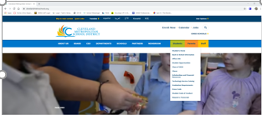
- Open a Web Browser and go to
https://www.clevelandmetroschools.org/

- Select the “Student” tab

- Select the “Office 365” Link

- Students will use their EMAIL and PASSWORD to LOG IN. (Password are case sensitive). This password is universally used with just about any academic application in the district. Student email example below…
STUDENT EXAMPLE EMAIL: firstname.lastname@cmsdk12.org
- Put in your Email and press NEXT

- Put in Password and press SIGN IN

*Click YES to give permission to save your information!

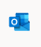
- Once in Office 365, select the “Outlook” icon in the menu bar on the left side of the page

- You are now logged into your email.

NOTE: BE SURE TO CHECK YOUR EMAIL, DAILY!
SET UP YOUR EMAIL IN YOUR MICROSOFT APP ON YOUR CELL PHONES

Any issues check out the HOW TO LOG IN VIDEO on our School Website!

