8 STEPS HOW TO LOG IN &
GET STARTED!
- Open a Web Browser and go to
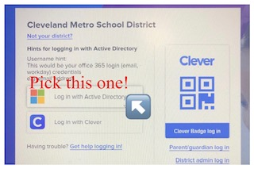
https://clever.com/in/cmsd

- Log in with ACTIVE DIRECTORY

- Students will use their EMAIL and PASSWORD to LOG IN. (Password are case sensitive). This password is universally used with just about any academic application in the district. Student email example below…
STUDENT EXAMPLE EMAIL: firstname.lastname@cmsdk12.org
- Put in your Email and press NEXT
- Put in Password and press SIGN IN

*Click YES to give permission to save your information!
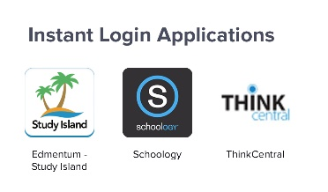
- WELCOME to CLEVER Home Page you will
scroll DOWN to INSTANT LOGIN APPLICATONS
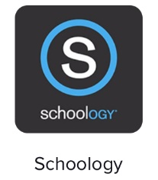
- Hit SCHOOLOGY


Hit the red to make it a favorite and it will appear at the top of the HOME PAGE.

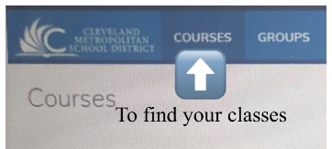
- Click COURSES to find your classes! YOU ARE IN!

Any issues check out the HOW TO LOG IN VIDEO on our School Website!

