LET’S GET GARDENING!
Come join our Learning Garden team at Artemus Ward Elementary School! We are bringing together a committee of passionate community members and partners to work with our scholars to bring our garden program to life! We need YOU!
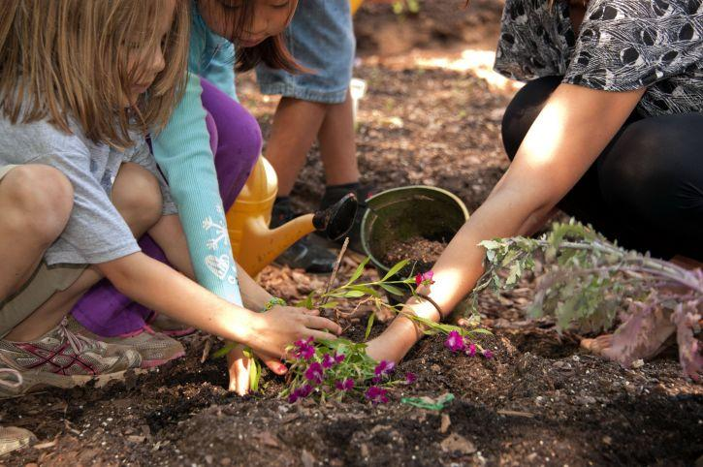
The benefits of school gardens include:
* Academic Excellence
* Social and Emotional Skills
* Teambuilding
* Community Solidarity
* Wellness
* FUN!
For more information and ways to get involved please contact:
Sara Continenza, President of Whole Vision LLC, at:
WholeVisionLLC@gmail.com or 216.640.0342

