**MUST DO…**

* 2 boxes, not in the same row

As You Like It!

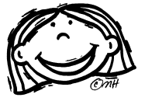 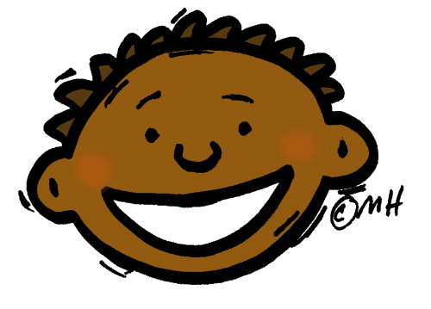 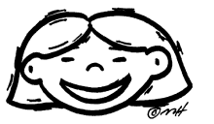 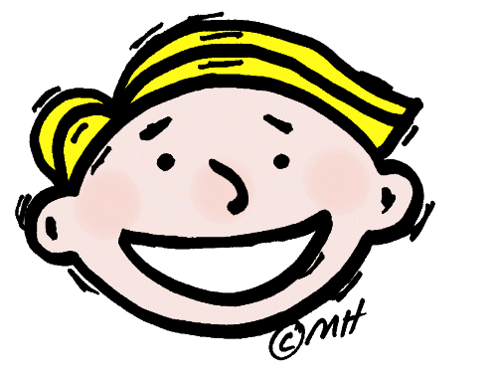

|  |  |  |  |  |
| --- | --- | --- | --- | --- |
| **Verbal-Linguistic pencil character**  **“Words”** | 1. Write a one-page letter to the author giving your reactions to the book. You will be assessed on spelling, punctuation, grammar, and the thoughtfulness of your reactions and references to what happened in the book. | 2. Create another character for the story and describe him/her. Give details about what he or she looks like and, most importantly, acts like and what is going on in their life. Must be at least one page long. | 3. Write a book review that might be published in the newspaper OR pretend that you are a movie critic. Criticize the book as if it were a movie. Give examples from the book and be specific! Must be at least one page long. | 4. Describe the setting of the story, where and when it took place. Think about the setting of this story. Write about why you would or would not like to spend a week visiting this place. Be specific! Must be at least one page long. |
| **Visual-Spatial**  **sketch book**  **“Pictures”** | 5. Draw a picture of your favorite part of the story. Add a caption (4-5 sentences) explaining what is happening in your picture. Picture must be in color. | 6. Summarize the plot of your story by creating a cartoon version of the story. Use about 6 to 8 frames. Include dialogue and descriptions of the scene. Give page reference numbers from your book. | 7. Create a picture time line showing the important events in your story (for a chapter or two). Your time line must include at least 5 events. Pictures must be in color. Give a brief written description next to each picture for the reader to understand. | 8. Redesign the front cover of your story. Include the important information as well as a short summary of the story on the back. You must not copy the summary of the book that is already written! You must write your OWN summary of the book. |
| **Musical-Rhythmic**  **musical note character**  **“Music”** | 9. Choose a familiar melody, such as *Mary Had a Little Lamb*, and change the lyrics so that they go with the story. You must include at least 5 stanzas. Sing it to the class. | 10. Write a poem about one of the characters in the story. It must have at least 12 lines. You can use any poetry format you wish (diamante, bio poem, free verse, acrostic, etc.) | 11. Write 5 haikus about the story that you read. Remember, each line of a haiku has specific syllable requirements:  Line 1 – 5 syllables  Line 2 – 7 syllables  Line 3 – 5 syllables | 12. Write a rap about what happened in your story. It must include 5 stanzas. Give us a beat to rhyme to. |
| **Logical-Mathematical**  **calculator character** “Numbers and logic” | 13. Make a Venn Diagram comparing yourself to a character in your book. You must have at least 6 points listed in each section (for a total of 18, or more). It must include character traits – not physical traits (ex. NOT saying you’re both girls or you both have brown hair!!) | 14. Make a prediction about what will happen to your character in the next chapter or in the future. You must begin by giving background on the characters and what has happened in the novel up until this point. Explain WHY you made that prediction. Must be one page long. | 15. Choose 15 of the most important words from the story. Group these words into categories and then explain why you chose the groups that you did in a paragraph (5-8 sentences). | 16. Think about an important decision that a character made during the book. Interview at least 10 people asking if they agree or disagree with the character’s decisions. Then make a graph of your results. Reflect on your results. |
| **Bodily-Kinesthetic**  singing ballerina  **“Body”** | 17. Rewrite a portion of your story as a play. You may choose a friend or two to act it out with you in the hallway (QUIETLY). Your play must be at least 3 minutes in length. (one page written) | 18. Make a T-chart of responsible and irresponsible things the characters did in the story. You must include at least 12 items total. | 19. Make up your own board game about the story. Be sure to include questions about what happened in the book. Your board game must include color and instructions about how to play. | 20. Write a commercial about your story. Try to “sell” the story to your viewers! You may act this out with a friend in the hallway quietly. Must be one page long. |
| **Interpersonal**  **”People”** | 21. Pretend that you are a newspaper reporter whose job is to interview one of the characters. Write your interview. This must include at least 10 interesting questions and your character’s responses. | 22. Pretend you are a character in your story and write a poem from that person’s point of view. Your poem must be at least 5 stanzas long. It may or may not rhyme. | 23. Write a one-page letter to the main character of the book asking questions or making complaints about the situations in the book. You must include proper friendly letter format (greeting, date, body, closing, signature). | 24. Plan a party that your characters would want to attend from your book. Where would they enjoy going? What kind of food would they want to eat? What would they wear? What would they do? Explain in one page. Include an invite. |
| **Intrapersonal**    **“Self”** | 25. If you had written this book, what part would you have written differently? Explain what would have happened if some major event did happen differently. Must be one page long. | 26. Rewrite your favorite part of the book using yourself as a character and a favorite place as a setting. Must be one page long. Give details!!! | 27. What object, person, or animal from this book would you most want to have at your house? Explain why. Must be one page long. | 28. If you could change places with one of the characters, who would it be and why? Must be one page long. Include examples and details from the book to support your response. |
| Naturalist **butterfly**  **“Nature”** | 29. Create a picture from your story using objects only found in nature (at-home project). Write 5-8 sentences explaining what your picture shows and why you chose to use those materials. | 30. Make a list of at least 5 things that are found in nature that have to do with your story. Write down each of the items and 3-4 sentences about why you chose to include EACH item. (for a total of 15-20 sentences!!) | 31. Write about how your story would change if it took place in a different climate or location. For example, how would the story change if it were raining instead of snowing? Must be one page long. | 32. Choose an animal or insect from your story and research it at the library or on the internet (at home). Write down ten interesting facts that you learned. Include a picture of your animal or insect (can be hand drawn or a real picture or clip art). |

**Due dates:**

**First selection:**

**Second selection:**