Hello First Grade teachers,

Attached is a choice that I created for you to use during reading intervention/enrichment time. Your first grade learning targets are incorporated into the activities. This choice board can be used with any fiction book. Many of you have students in easy chapter books already. These activities would be great summary projects for those books.

Give it a try and let me know your thoughts. Anything can be adjusted!

Happy reading!
Brenda

Book Bonus
Create a new book cover for your book on paper. Write the title and author’s name. Add a picture of the most important part of the story.   | Read your favorite part of the book to a friend. Tell them why you like that part the best.  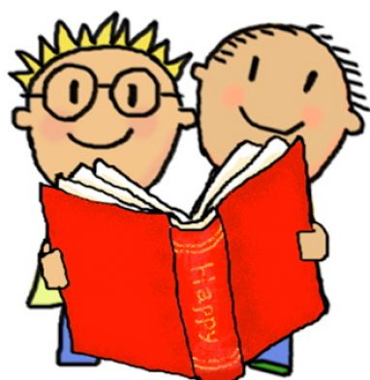 | Make a puppet of the most important character in the story. Using your puppet, act out a part where the character makes a big decision in the story.  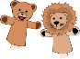
Draw and color a picture of where the story happened. Add 3 details about the setting that were given in the story. (street address, season, etc.)  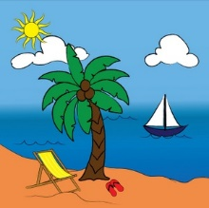 | Write two questions about the story to ask a friend.   | What was the lesson that the author is trying to tell you? Make a poster showing the lesson. (FRIENDSHIP, TRUST. KINDNESS, etc.)  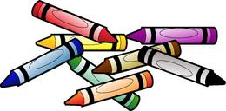
Rewrite the ending of the story. How could you change it to make it different?   | Write a song about your story. Sing your song to a friend    . | Draw a picture of each character. Write 3 describing words about each of them under their picture.  

Marshfield Grade 1 Reading Enrichment

