Here’s a Halloween word ladder. Enjoy!

Start with “kin” a word that describes one’s family:

**Kin** Add 1 letter to make a ruler of a county (married to a queen)

King Change 1 letter to make a part of an airplane or bird

Wing Take away 1 letter to make the opposite of lose

Win Add a letter to make a person who looks exactly like his or her brother

Twin Take away 1 letter to make a metal

Tin Change the last letter to make what you give a server at a restaurant for good service

Tip Change the vowel to make what you do with your finger as you hit it lightly against a table

Tap Change 1 letter to make a hat worn by a baseball player

Cap Change 1 letter to make a mug or something you drink coffee out of

Cup change 1 letter to make a young dog

Pup Add 1 letter to make a mechanism for drawing water or oil out of the ground

**Pump**

Now put the first and last words together and what do you get? PUMPKIN!

Happy Halloween!

Tim Rasinski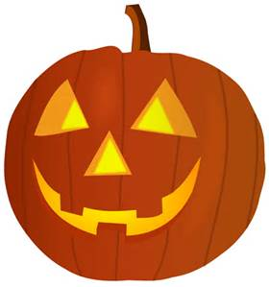

For more see: Rasinski, T. *Daily Word Ladders, K-1, 1-2, 2-4. 4-6.*