Evolution Study Guide
Name: Due:___________

1) Life on earth began more than ________________________________________years ago. The way we gain information about what life looked like billions of years ago is through ___________________________________. It is believed that the first organisms were simple, ________________________________________ organisms. The idea that attempts to explain this change is known as _____________________________.

2) The formation of Earth was most likely created by the _____________________________. This theory thinks the following events must have occurred in order for life to form on Earth. First gases must have condensed, this allowed for ______________ formation. This was followed by ____________________________ in the atmosphere, which caused temperatures to cool. Once the temperature dropped then water vapor condensed into _________________, which in turn created the oceans.

3) Most of the evidence for evolution is heavily supported through the _______________ record. What are the 4 steps necessary for creating a fossil?
1)

2)

3)

4)

4) There are four major developments that lead to life on Earth. First, simple _________________ compounds must be formed, an example of one of these compounds would be ______________________________________. Second, the complex organic compounds would be created from these simple compounds; an example of this complex organic compound would be _________________________. These compounds would then need to be combined into specific ________________________________ which would lead to the development of links between chemical reactions of growth, __________________________, and reproduction. This process is unable to be recreated due to the presence of ___________________________in the atmosphere.

5) The first life forms on earth were most likely__________________________. These organisms also most likely found food from their ________________________________, which makes them _____________________ organisms. They also likely used that food for energy through the process of ______________________. Later on, due to competition for food, autotrophs were created. These first autotrophic organisms most likely used the process of ___________________________________rather than photosynthesis. After photosynthesis occurred, _____________________ was produced as a waste product during the reaction. Oxygen destroyed many ____________________but gave rise to aerobic respiration which traps free oxygen.

6) Eukaryotes were most likely created through the process of _____________________________. Which was when a mitochondria and _____________________ are thought to have entered a eukaryote for ____________________________and happened to perform a function within them. This thought also supports the idea that mitochondria and chloroplasts have their own DNA and ribosomes, which means they can produce their own proteins.

7) Who is the father of modern evolutionary theory?

Where did he make most of his observations about evolutionary theory?

8) Define theory:

9) The theory of evolution is based on 4 categories of evidence. ______________________________, common ancestry, homologous structures, and vestigial structures.

10) Define fossil record:

11) Fossil record spans much of ________________________________, which is billions of years of earth’s history. There are a few ways that fossils can be compared based on their age. Most simply, ____________________fossils will be closer to the top while older fossils will be ___________________________ in the bedrock. Scientists can also use ____________________________________ which utilizes the radioactivity of ____________________ and compares it to the stable form of carbon known as ________________________________.

12) Evolution does not necessarily produce _______________________________________in a certain direction. Evolution is more like a tree. Trees that show evolution are known as _____________________________trees. In these trees, if a branch reaches the top of the diagram then that would be considered an existing species. If a branch ends before the end of the diagram those species are considered to be ______________________. The bottom of each branch is where you would find a _____________________ for all organisms that come after it.

13) Use the tree below to answer the following questions:
a) In tree 1, how can you determine the Pig and the Peccary are most closely related than the Pig and the Camel?

b) In Tree 1, circle where the common ancestor for the Pig and Cow can be found.
C) Name at least 2 changes in ancestry that occurred from the revisions in tree 2.

d) In tree 2, circle the common ancestor of the hippo and the whale.
e) In tree 2, put a square around the common ancestor of the camel and cow.

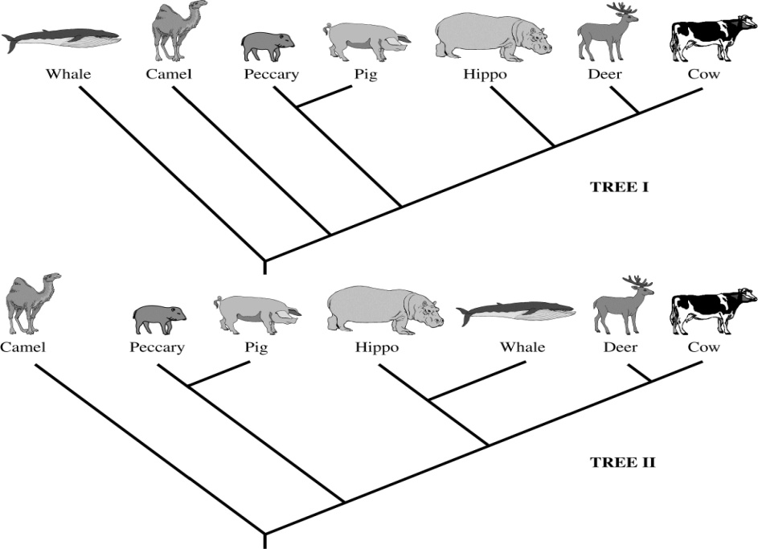
14) Define the theory of spontaneous generation

15) What two scientists supported the spontaneous generation idea? What were their experiments?

What scientist disproved the spontaneous generation theory?

What theory then replaced the theory of spontaneous generation?

16) Define the theory of biogenesis:

17) Darwin’s ideas were well supported by his suggestions of how evolution worked and how organisms evolved over time. He thought it was similar to _____________________________, which is purposefully breeding organisms for certain traits. His main idea was “_______________________________” which indicated that evolution was controlled by nature. The idea is that individuals that ______________________ are able to pass on their genes while those that do not survive will not be able to _____________________________. This is given the common name of survival of the ___________________. This highlights the thought that in any given environment, an individual may be born with characteristics that make them __________________________, faster, or in general has an advantage over another organism to survive long enough to pass on their genetic information. Over time these beneficial traits should become more _______________________ in the population. The change in prevalence of traits from more or less common is simply defined as ______________________________________.

18) It is important to remember that the ______________________changes over time and not the _________________. The genetic information each organism is born with does not change over time but the genetic information in the population as a whole can.

19) Failure to adapt causes __________________________.

20) What is the difference between extinction and extirpation?

21) List the four conditions that make evolution a vital process:
1)

2)

3)

4)

22) Define overproduction:

23) Species that reproduce rapidly would easily overrun the earth if the four conditions of evolution were not in place. Name at least four species that fit into this category.

24) Overproduction leads to _____________________________ among members of a species. This is what allows for the number of a species to stay level over a given amount of time. There are several factors that can help determine which organisms will survive and which will die, even though chance places a roll as well. Often _______________________________ conditions can play a large role in selection of which species will survive and which will perish. Examples of such conditions are _____________________________, disease, parasites, and ________________________. Available resources such as, _______________, food, oxygen and _____________________, are also a large factor. Resources are _______________ which is a synonym for limited. This means that many resources will be competed for.

25) _____________________ in a species allows for new traits to occur within a population which leads to evolution. Species within a population are never exactly ________________. These differences are a result of genetic variation which is the unique _____________________________ of traits from _______________________. Variation helps organisms survive because if there were an environmental change some members of the species should be able to ______________________ that environmental change. ____________________________ species have difficultly surviving environmental changes because there is not enough variation within the population.

26) Environmental changes create evolutionary changes. State the relationship between minimal/maximum environmental change and changes in species.

27) Stable environments create ________________________________, like horseshoe crabs. Changing environments create ________________________________, like bacteria and ______________________________________.

28) Define adaptive value: Give an example of adaptive value.

29) How does adaptive value change the population over time?

30) Some evolution can still occur without much change in the environment. Explain why the beaks of the finches Darwin observed in the Galapagos were so different even though there was no real environmental change occurring.

31) The arrangement of _____________bases determines a person’s characteristics. Any change in bases or their order can change characteristics. Only changes in __________________________ can be passed on to the next generation. This is the basis for evolution. There are two ways that organisms can wind up with genes that are different from those of their parents. One is known as ______________________, which is defined as any change in the DNA. The other is known as ____________________________, which is known as the sorting and __________________________ of genes during sexual reproduction. Both are random and cannot be predicted. Both can create either harmful or beneficial results. This can also lead to the creation of new species such as ________________________ which have white fur that was an adaptive value over brown bears in the white snow covered areas of the north. It should be noted that sexual reproduction results in recombination of genes that results in endless combination of new genes, similar to shuffling a _________________ of cards. Even though mutations play a roll, genetic shuffling is the main source of variation in ___________________________________.

32) Variation results in changes in the following 3 categories:
1)

2)

3)
33) Structural changes result in the structure of an organism changing due to an entire evolutionary ________________________. There are millions of examples of these structural changes. For example, polar bears developed ______________________ on their feet to keep them warm and improve __________________________________. The limbs of several animals can be compared to show the similarities and differences among those individuals. These structures can also give clues to their evolution. For example, some __________________________ have tiny, nonfunctional leg bones. This suggests that they evolved from ________________________________, lizard like ancestors.

34) Functional changes are a result of __________________________ or ___________________________ changes affecting how an organism works. Ells for example created a functional change that allows it to emit an _______________________________ that is created by its muscles to stun or _________________ prey. These functional changes can be seen through changes in DNA . Example, a change in a uni-cellular organism can now produce an enzyme that digests _____________, or snakes that produce _________________.

35) Behavioral changes are those that have evolved to help with reproductive success. For example, Walrus’s have been known to _________________ for groups of females. This supports the idea of survival of the fittest because the ___________________ and ___________________ male should win the battle which would then pass on the better genes. We also discussed the rate of blinking between male and female firefly species.

36) Variations are important because individuals that cannot adapt to changes will __________. Also, variations allow the environmental changes to be less drastic for a species as a whole. Endangered species are worrisome because their numbers are so small the variation within the population is very ______________.

37) The rate of evolution is believed to be related to the quickness of reproduction in species. Organisms with few _____________________ that live longer and reproduce less will have a slow rate of evolution. Those with short lives and quick ________________________ rates with have a faster rate of evolution.

38) Extinction occurs when the ____________rate is higher than the _________________ rate. Variation can help combat this cycle. This generally occurs during times of _________________________ change. What are some examples of environmental change? (name at least 4)

39) Define divergent evolution:

40) Define convergent evolution:

41) Define co-evolution.

42) Define homologous structures: give an example

43) Define vestigial organs: Given an example

44) During the early stages of development embryos of different species can develop almost _____________________. Different species can also have very similar _______________ which would lead to commonalities in their proteins. _________________ structures are those that are similar in ______________________ but do not share physiological traits.

45) _________________ came before Darwin but does not receive as much credit for evolution as Darwin does because he was missing some pieces and did not have evidence for his idea like Darwin did. Darwin got his evidence by sailing on the ship, S. S. _____________ to the ______________________ islands and studying ___________________and tortoises.

46) Label Each fish: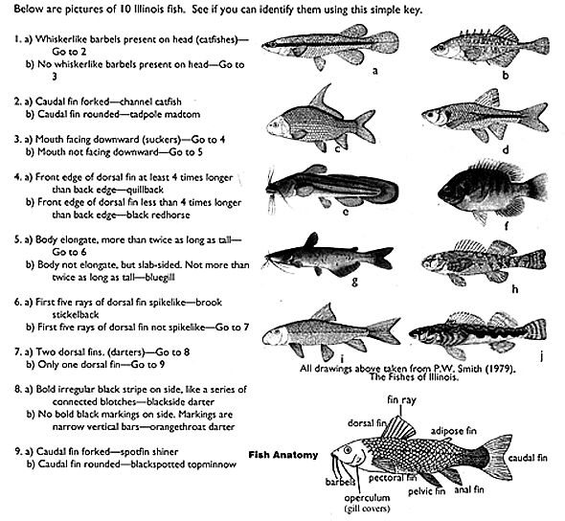
A. F.

B. G.

C. H.

D. I.

E. J.

