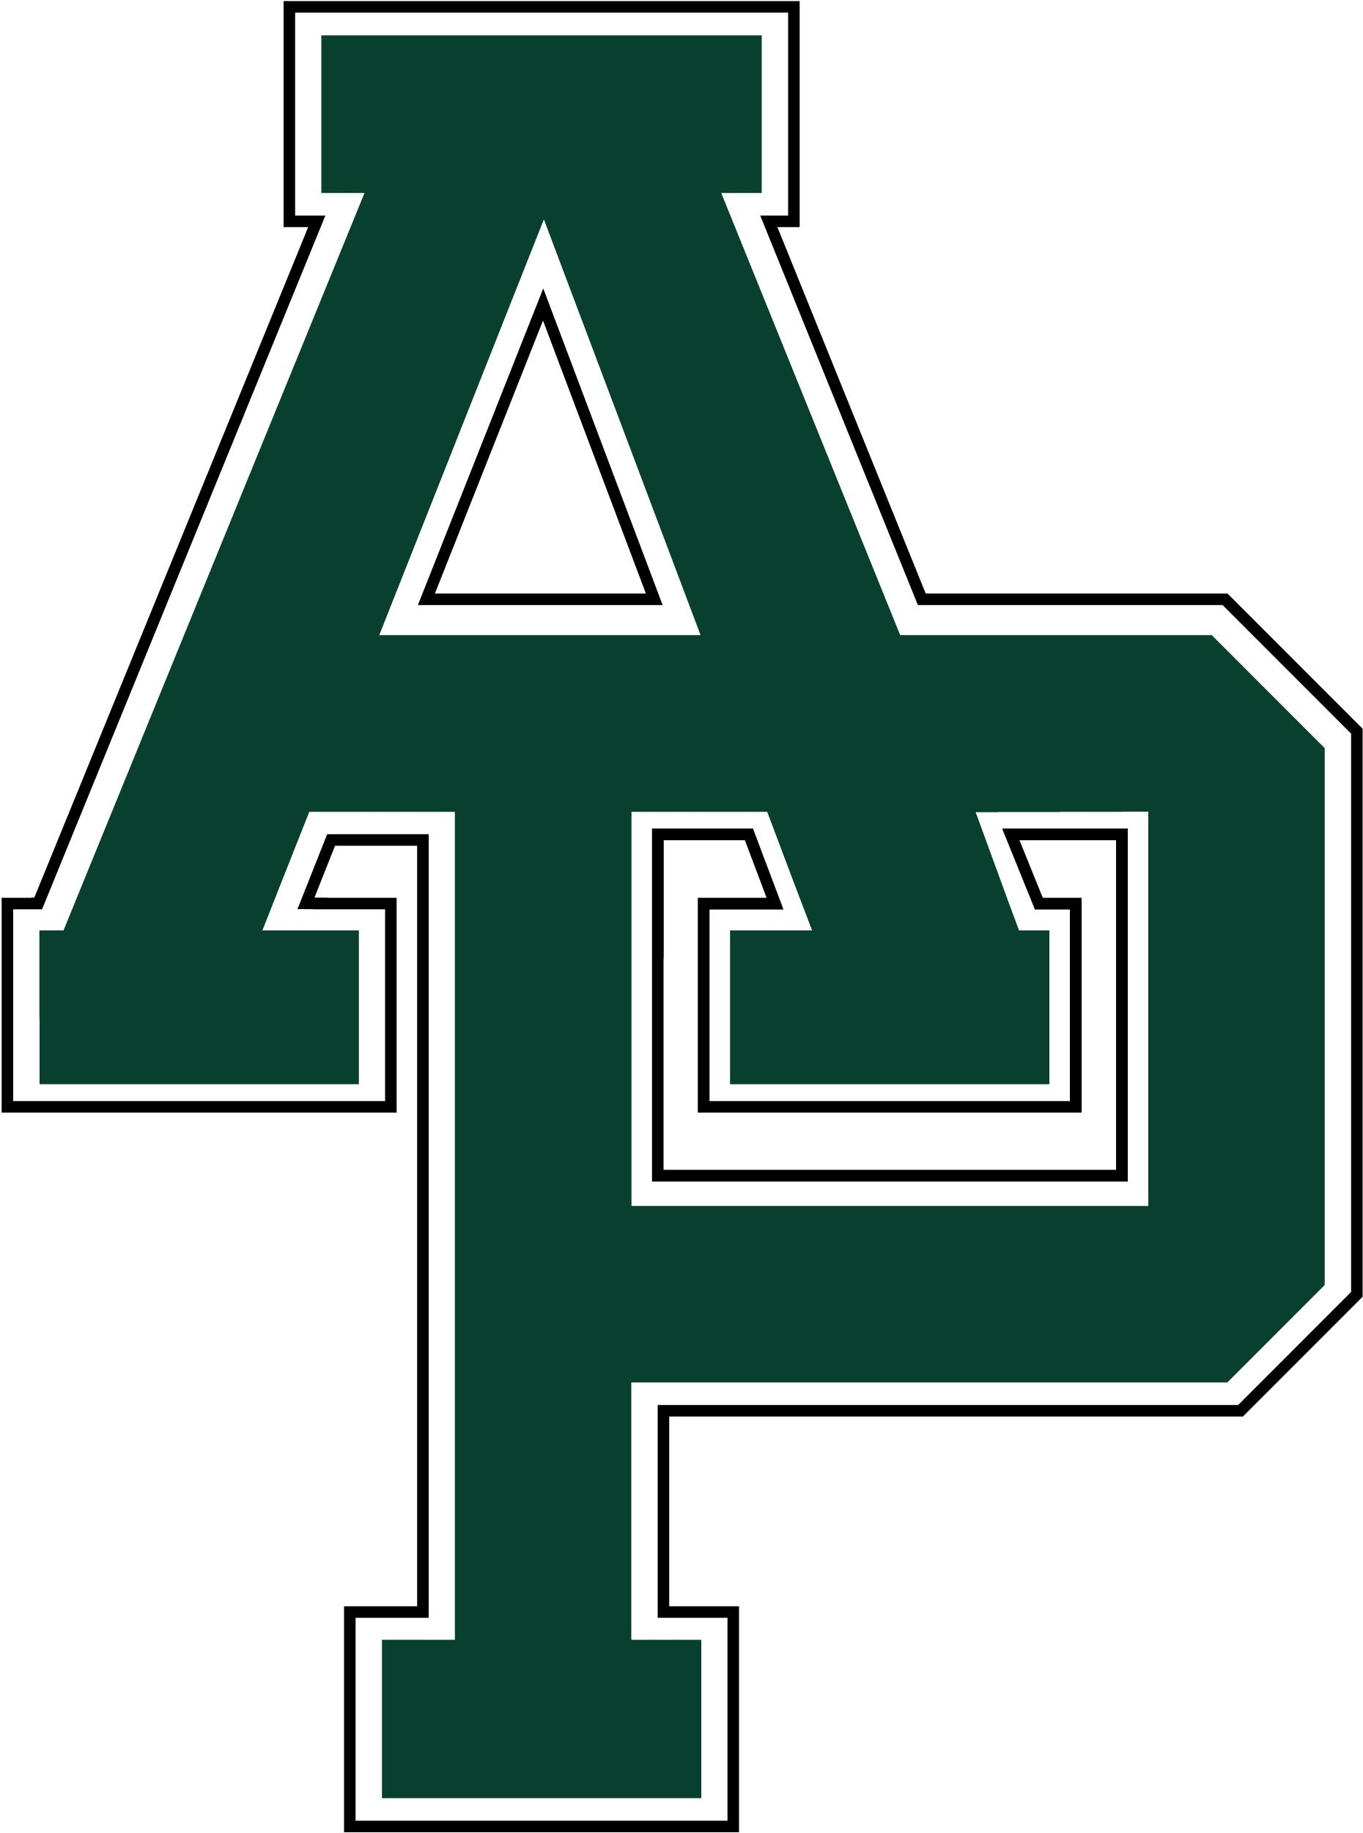 | School Profile  Class of 2024  Allen Park High School  18401 Champaign  Allen Park, MI 48101-2299  (313) 827-1200  FAX (313) 827-1237
The Allen Park Community
Allen Park is primarily a residential community of about 7 square miles that rests in Southeastern Michigan. Three public school districts are within the City’s boundaries. A portion of the South end of town is within the Southgate Public School District and a portion of the North end of town is within the Melvindale-North Allen Park Public School District. Allen Park has 28,638 residents of which 92.7% have a high school education or higher. The median household income is $73,792. (Source: US Census Bureau, Census 2020)
Allen Park High School  Public - opened 1950  60 classroom teachers  3 counselors, 2 school social workers, media specialist, district teacher consultant, district school psychologist a district speech/language pathologist.  Grades 9 - 12  1109 students  6 class periods of 58 minutes  Classes begin at 7:45 AM and  end at 2:40 PM  30-minute lunch period  In-house lunch for all students  Report card issued every 10 weeks, 4 per year.  Curriculum  Comprehensive College Preparatory, Tech Prep, Special Education and General Course of Study  Honors Courses  (Began Fall 2015)  Honors courses are offered for English 9, English 10, Geometry, Algebra 2, Chemistry, Biology  Honors Courses are not weighted  Advanced Placement Courses  English Language and Composition, Calculus AB, Calculus BC, Statistics, Computer Science Principles, Chemistry, Biology, Environmental Science, U.S. History, World History, Human Geography, English Lit and Composition, Psychology, Precalculus, and Spanish.  Advanced placement grades are weighted. |  | Advanced Placement Results  Spring 2022  Total AP Students Taking Exams: 319  Number of Exams: 470  Scores 3 or higher: 60%  Graduation Requirements  Minimum 22 credits  English - 4 years/8 semesters  Math - 4 years/8 semesters  Science - 3 years/6 semesters  History – 3 years/ 6 semesters  Required classes:  ELA 9, ELA 10,  ELA 11/AP Lang or Lit  Biology, Chemistry/Physics  Algebra, Geometry, Algebra 2  U.S. History, World History  Econ/AP Human Geography  Government (1 semester)  Physical Education (1 semester)  Health Education (1 semester)  Michigan Merit Exams  Grading System  A=4.00, A-=3.67  B+=3.33, B=3.00, B-=2.67  C+=2.33, C=2.00, C-=1.67  D+=1.33, D=1.00, D-=0.67  E = 0.00  I = Incomplete  W – Withdrawal |  | Class of 2024  SAT composite score  Overall: 949  Reading & Writing: 484  Math: 465  Allen Park High School Administration  Jason Skiba  Principal  Giovanni Foster  Assistant Principal  Sean Laura  Assistant Principal  James Victor  Athletic Director, Club Activity Director  Allen Park High School Counselors  Matthew Behta  (last name A-F)  Nanette Gribble  (last name G-O)  Matthew Morang  (last name P-Z)

